|  |  |
| --- | --- |
| **Asian Development Bank** | **Government of Vietnam**  **Ministry of Natural Resources**  **and Environment** |

**TA7629-VIE: Capacity Building for River Basin Water Resources Planning**

**Component 2: Planning Tasks for the Red-Thai Binh River Basin**

**Red-Thai Binh River Basin Water Resources**

**STATUS REPORT**

**For the preparation of Planning Tasks for the Red-Thai Binh River Basin**

Prepared for**:**

**The Department of Water Resources Management on behalf of the Government of Viet Nam and the Asian Development Bank**

Prepared by

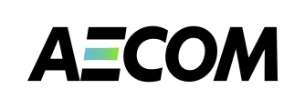**AECOM Asia Co. Ltd.**

**June 2013**

Acknowledgments

This component of *CDTA 7629-VIE: Capacity Building for River Basin Water Resources Planning* supports the Ministry of Natural Resources and Environment in undertaking activities related to the preparation of Planning Tasks for the management of water resources of the Red-Thai Binh river basin. Planning tasks are prescribed in the revised Law on Water Resources and precede the formulation of a Water Resources Plan. Planning tasks make prioritised recommendations and a framework for the preparation of river basin planning. The CDTA also aim to develop and pilot a cost-effective framework for formulating Planning Tasks that could be replicated in other basins of Viet Nam.

The contributions to this report are acknowledged: Des Cleary (Water Basin Planning Expert (International), who led the preparation of the report), Mr Eric Biltonen (TA Team Leader) and Ms Nguyen Thi Phuong Lam (Deputy Team Leader).

Limitations Statement

The sole purpose of this report and the associated services performed by AECOM is to set out the status of water resources in the Red-Thai Binh river basin - their occurrence and condition, their exploitation and use, their vulnerability to risks, their overall management - as well as to identify the issues that need to be considered in the development of Planning Tasks for the basin. River basin Planning Tasks provided for under Article 20 of the Law on Water Resources Management, 2012. The report has been prepared in accordance with the scope of services set out in the contract between AECOM and ADB.

AECOM’s consultant prepared this report primarily based on the Terms of Reference provided by the ADB and an inception report prepared by consultants engaged by the ADB to lead the TA. A number of special studies were also undertaken to obtain data and information for the status report. The passage of time may require re-evaluation of the findings, proposals and conclusions expressed in this report.

No warranty or guarantee, whether express or implied, is made with respect to the information reported or to the findings, observations and conclusions expressed in this report. Further, such information, findings, observations and conclusions are based solely upon information in existence at the time of report preparation.

**TA7629-VIE: Capacity Building for River Basin Water Resources Planning**

**Component 2: Planning Tasks for the Red-Thai Binh River Basin**

**STATUS REPORT**

**for the preparation of Planning Tasks**

**for the Red-Thai Binh River Basin**

**Table of Contents**

EXECUTIVE SUMMARY 6

1. INTRODUCTION 22

1.1. Basin overview 22

1.2. Context for the Status Report 24

1.3. Preparation of this Status Report 27

Assessment Indicators 27

1.4. Structure of this report 28

2. SURFACE WATER RESOURCES STATUS AND MAJOR ISSUES 28

2.1. Surface water 28

Surface water occurrence 28

Water Availability 33

Water Exploitation 37

Water Quality 42

Flood mitigation 50

Drought 52

Salinity Intrusion 53

Climate change 53

2.2. Surface water management 54

Legislation 54

Surface water assessment 58

River basin planning for water resources management 59

Data, Information and Analysis 61

Legal setting for Data, Information and Analysis 61

Institutional Situation for Data, Information, and Analysis 62

Hydrological and Water Quality Data, Standards, and Technical Guidelines 66

Licensing 66

Regulation and allocations of water resources 67

2.3. Surface water issues 68

3. Groundwater 72

3.1. Groundwater occurrence 72

Groundwater areas 72

Groundwater recharge 72

Groundwater availability 73

Groundwater exploitation 75

Groundwater quality 77

3.2. Groundwater management 81

Legislation 81

Groundwater assessment 81

Groundwater planning 82

Licensing of water exploitation 82

Regulation and allocations of groundwater resources 82

3.3. Groundwater quantity issues 83

4. Socio-Economic Development of the basin 86

4.1. Social Development 86

Populations and birth rates 86

Ethnicity 87

Migration 88

Population density 89

Poverty 90

4.2. Economic Development 90

Gross Domestic Product 90

Economic structure 91

Employment 92

5. WATER RELATED SECTORS: STATUS & MAJOR ISSUES 94

5.1. Urban water supply and sanitation 94

Urban administrative units 94

Urban Water supply 95

Main Issues for Urban Water Supply 102

Urban Sanitation 103

Main Issues for Urban Sanitation 106

5.2. Rural water supply and sanitation 107

Provision of rural water and sanitation services 107

Management of rural water supply and sanitation (RWSS) 110

Main Issues for Rural Water Supply and Sanitation 112

5.3. Irrigation and Agriculture 114

Current status of irrigation development 114

Irrigation in the RTBRB 122

Drainage 124

Irrigation management 126

Main Issues for Irrigation 137

Main Issues for Drainage 137

5.4. Industry 141

Main issues for Industry 147

5.5. Hydropower 148

Development of small and medium hydropower 151

Main issues with hydropower 154

Potential solutions to main issues 157

5.6. Navigation 158

Main issues for Navigation 160

5.7. Aquaculture 161

Main issues for Aquaculture 162

6. MAJOR WATER SECTOR ISSUES 163

6.1. Summary by basin group 163

6.2. Water resource status: major issues 170

Surface Water Issues 170

Groundwater Issues 172

6.3. Water use sectors: major issues 174

Main Issues for Urban Water Supply 174

Main Issues for Urban Sanitation 175

Main Issues for Rural Water Supply and Sanitation 175

Main Issues for Irrigation 176

Main Issues for Drainage 176

Main issues for Industry 179

Main issues with hydropower 179

Main issues for Navigation 181

Main issues for Aquaculture 181

6.4. Cross cutting water sector management issues 182

7. CONCLUSIONS 185

8. References 186

Annex A:– 187

Maps and Graphics for the Red-Thai Binh River Basin 187

Annex B: Guidelines for Assessment Indicators 194

Water Resource Indicators 195

Groundwater Indicators 198

Economic Development Indicator 200

Social Development Indicators 202

Environment Indicators 204

Annex C: Hydro-Meteorology Observation Stations (from Decision 16) 209

Annex D: Environment Monitoring Sites (Decision 526) 213

Annex E: Comparison of Sampling Parameters 216

**ABBREVIATIONS**

|  |  |  |
| --- | --- | --- |
| ADB |  | Asian Development Bank |
| DoNRE |  | Department of Natural Resources and Environment (Provincial) |
| DWRM |  | Department of Water Resources Management (MoNRE) |
| EIA |  | Environmental Impact Assessment |
| EVN |  | Electricity Viet Nam |
| GDP |  | Gross Domestic Product |
| GSO |  | General Statics Office (of Viet Nam) |
| GWh |  | Gigawatt hour |
| HCMC |  | Ho Chi Minh City |
| IWRM |  | Integrated Water Resources Management |
| MARD |  | Ministry of Agriculture and Rural Development |
| MDG |  | Millennium Development Goals |
| MoC |  | Ministry of Construction |
| MoH |  | Ministry of Health |
| MoLISA |  | Ministry of Labour, Invalids, and Social Affairs |
| MoNRE |  | Ministry of Natural Resources and Environment |
| NGO |  | Non-Government Organisation |
| NWRC |  | National Water Resources Council |
| RTBRB |  | Red-Thai Binh River Basin |
| SoE |  | State of Environment |
| SPP |  | Stakeholder Participation Plan |
| TA |  | Technical Assistance |
| VEA |  | Viet Nam Environment Administration (MoNRE) |
| VND |  | Vietnamese Dong |
| VWSA |  | Viet Nam Water Supply and Sewerage Association |
| WASECO | | Water Supply and Sewerage Companies |
| WHO |  | World Health Organization |
| WSR |  | Water Sector Review |

**TA7629-VIE: Capacity Building for River Basin Water Resources Planning**

**Component 2: Planning Tasks for the Red-Thai Binh River Basin**

# EXECUTIVE SUMMARY

**STATUS REPORT**

**for the preparation of Planning Tasks for the Red-Thai Binh River Basin**

**INTRODUCTION**

1. This Status Report is the results of a major activity for the preparation of the Planning Tasks for the Red-Thai Binh River Basin. According to the Law on Water Resources, Planning Tasks provide a framework for the subsequent water resources planning activities for the river basin. River basin planning is necessary so that water resources are effectively managed for the mutual benefit of all stakeholders. This is especially necessary when water resources are not available in sufficient quantities and quality to meet all demands, and/or where pollution, degradation, and natural hazards pose a threat. Planning allows water resource policy decision makers and managers to make well-informed decisions to meet current and future challenges based on sound information and analysis. Without effective planning, water management will lack purposeful direction and possibly cause harm to those who depend upon the water resources.
2. This Status Report provides an assessment of the current status of water resources in the Red-Thai Binh River Basin including the physical water resource, demand and use, protection of quality and environment, and protection and mitigation against negative impacts caused by water. This assessment also examines the socio-economic features of the basin as related to water management. This Status Report is designed to present enough information for sound decision-making, without going into excessive detail.
3. The main purpose of the Status Report is to identify the major issues facing the Basin, so that they can be formulated as priorities, options, and tasks. Issues cover water resources management aspects such as water monitoring, water availability, water related disasters, water quality, water related environments, water sources (including reservoirs), sand & gravel extraction, etc., as well as issues involved with the various economic sectors - irrigation, agriculture, urban water and sanitation, rural water and sanitation, industry, hydropower, aquaculture and navigation. This Status Report also assesses the adequacy of the institutional, legal, and capacity situation for effectively managing water resources, especially for MoNRE.
4. Following completion of the Status Report, planners will identify and prepare a range of subsequent planning activities for addressing the key issues (based on those identified in this report. These will be presented in a separate Planning Tasks Report.

**DESCRIPTION OF BASIN AND SUB-BASINS**

**Red-Thai Binh River Basin**

1. The total average annual surface water volume in the Red-Thai Binh River Basin (RTBRB) is about 131.4 billion m3, including water generated within China. This volume is about 16% of the national water volume. The RTBRB is one of the most important in Viet Nam: it contains the Nation’s capital city; it comprises 27% of the National land area; it has a significant proportion of the Nation’s water resources (16%), its GDP (25%), its hydropower development (42%), and its irrigation development (90% of total area). It supports about a third of the country’s population, of which the number of poor people is the highest of all river basins (14.8 %). It has a high average population density (303 people per km2). Despite an apparent richness in water, the annual water availability per capita is low compared with other parts of the country (48% of the National average). It receives almost 40% of its water from China, so it is vulnerable to changes in upstream water use. The Basin accounts for about a quarter of the Nation’s water use, particularly for agriculture. Today, there are concentrations of large and increasingly urban populations, and high concentrations of some of the most significant industrial developments in the country, including most craft villages (60% of the total). Navigation is also important in the Basin, particularly for transport to the industrial areas of heavy construction and plant materials that are difficult to transport by other means.

**Da Sub-Basin**

1. The Da Sub-basin holds 6% of the total population of the RTBRB. Its population density is currently only about 52 people per square kilometer. However, the Da had the highest rate of household poverty at 39% and about 77% the Da sub-basin’s total population is classified as ethnic minority. The economy of the Da sub-basin accounts for only 3% of total RTBRB GDP. Agriculture is very important for the Da’s economy, and accounts for 35% of total sub-basin GDP. Industry in the Da accounts for 31% of GDP and services account for 34%. Employment in agriculture still accounts for 83% of all employment in the Da sub-basin.
2. The Da River Sub-Basin accounts for 31% of the total land area in the Vietnamese portion of the RTBRB. The Da sub-basin accounts for 42% of the total RTBRB annual flows. About 43% of the water flowing through the Da Sub-Basin comes from outside of Vietnam, primarily China. During the 7 month dry season, the Da sub-basin averages only 24% of its annual flow volume. Thus, the Da is highly dependent upon international flows which account for 41% of its dry season flows. The Da overwhelmingly has the largest share of reservoir storage volume in the RTBRB at 71% of total. This amount will increase with the completion of the Son La reservoir. Most of its storage volume is dedicated to the production of hydropower and wet season flood protection, but very little is for irrigation.
3. Due to its high volume of water and low relative population, the Da Sub-Basin experiences the highest per capita water availability in the RTBRB at over 32,000 m3 per year. Even for projected 2025 populations, the Da Sub-Basin is comfortably above water stress limits, both annually and for the dry season. The Da is currently in a low water stress range given current estimated water use levels, both annually and for the dry season.
4. For groundwater, the Da sub-basin has by far the greatest availability. . Groundwater use in the Da accounts for only 15% of total groundwater use in the RTBRB. Rural water supply is the dominant use of groundwater, accounting for 61% of the sub-basin’s groundwater use. In all sub-basins, monitoring of groundwater is inadequate.
5. The upstream basins are prone to severe flash floods from rain events. This situation has been made significantly worse with growing deforestation. The Da River’s flood flow and peak are the biggest in the RTBRB. This is caused by the large area of the sub-basin (52,500 km2), high rainfall intensity, and the steep inclination of both the mountains and the river bed. Floods in the Da River contribute up to 69% of flood flows in the downstream portion of the RTBRB. While drought can occur anywhere in the RTBRB, few serious droughts have occurred in the Da Sub-Basin.

***Conclusions for the Da-Sub-Basin***

1. Overall, the Da Sub-Basin is in relative good condition with its water resources. There are concerns over water quality near the border and downstream of urban areas. Its high degree of forested area and water generating capacity make the Da a good target for increased forest and watershed conservation efforts, particularly around its reservoirs and where it serves as municipal water supply source. Given the large storage potential of its reservoirs, the Da will be a critical basin to include in efforts to achieve more coordinated and effective management of dam operations for multiple uses (irrigation, navigation, flood control, and municipal water supply).
2. The relatively low population and high ethnic minority population and high rate of poverty indicate that the Da Sub-Basin should be a key focus area for efforts to educate the public on water management, conservation, and use issues. This will be particularly important for protecting water quality (as a source for municipal water supply) and for helping to mitigate the negative impacts from floods.
3. Water quality and water dependency issues related to receiving water from international sources indicate that the Da River will be a critical river to include in efforts to develop international arrangements aimed at beneficial sharing and coordinated management of the river.
4. The Da will increasingly serve as a major source of fresh water for Hanoi City. Protecting the water source for water quality will take a major effort.

**Thao Sub-Basin**

1. The population in the Thao Sub-basin accounts for 7% of the total population of the RTBRB. Population density for the Thao is currently at about 159 people per square kilometer. The poverty rate in the Thao Sub-basin is currently around 26% and about 37% the Thao sub-basin’s population is classified as an ethnic minority. The economy of the Thao sub-basin accounts for only 4% of the total RTBRB GDP. The growth rates of all sub-basins’ GDPs are roughly equal ranging from 10% in the Da up to 4% in the Lo-Gam. Agriculture is very important for the Thao’s economy and accounts for 28% of total sub-basin GDP. Industry in the Thao accounts for 37% of GDP and services account for 34%. Despite the declining share of agriculture in the sub-basin GDP, employment in agriculture still accounts for 72% of all employment in the Thao sub-basin.
2. The Thao River Sub Basin accounts for 31% of the total land area in the Vietnamese portion of the RTBRB. The Thao accounts for 20% of total annual flows of the RTBRB. The Thao is most directly dependent on international water flows with 56% of its annual flow coming from outside of Vietnam. The Thao is particularly dependent upon international flows during the 7 month dry season, which account for 67% of its total flows during this period. Moreover, the Thao Sub-Basin experiences only 32% of its annual flow volume during the 7 month dry season.
3. The Thao is comfortably above adequate water levels for both current and 2025 projected populations, annually and for the dry season. The Thao is currently in a low water stress range given current estimate water use levels, both annually and for the dry season.
4. Groundwater could not on its own support the population in the sub-basin. Groundwater use in the Thao accounts for only 6% of total RTBRB groundwater use. Rural water supply is the dominant use of groundwater, accounting for 60% of the sub-basin’s groundwater use. In all sub-basins, monitoring of groundwater is inadequate.
5. The Thao sub-basin is prone to severe flash floods from rain events. This situation has been made significantly worse with growing deforestation. While drought can occur anywhere in the RTBRB, few serious droughts have occurred in the mountainous provinces.

***Conclusions for the Thao Sub-Basin***

1. The Thao Sub-Basin is in relatively good condition concerning its water sources and use within the sub-basin. Current levels show that it is not in a stressed condition. However, water quality problems are becoming more serious, particularly in the segment upstream of Viet Tri down to the confluence. As this water serves many other uses downstream, it will be very important for Viet Nam to begin effective control, mitigation and rehabilitation of polluted segments in the Thao.
2. The Thao Sub-Basin is the most dependent on international flows to maintain it annual and dry season flow averages. Thus, it is critical that the Government include the Thao in any efforts to develop international cooperation on this shared resource.
3. The Thao Sub-Basin will also be a good basin for conservation or restoration of forestry land to better mitigate flood events and help store water in the basin.

**Lo-Gam Sub-Basin**

1. The population in the Lo-Gam Sub-basin accounts for 9% of the total population of the RTBRB. Population density for the Lo-Gam is currently at about 124 people per square kilometer. The household poverty rate is currently about 31% and about 55% the Lo-Gam sub-basin’s population is classified as an ethnic minority. The economy of the Lo-Gam accounts for only 6% of the RTBRB’s GDP. The growth rate of the sub-basin GDP is 14% in the Lo-Gam. Agriculture is very important for the Lo-Gam’s economy, but only accounts for 27% of total sub-basin GDP. Industry in the Lo-Gam accounts for 39% of GDP and services account for 34%. Despite declining shares of agriculture in the sub-basin GDP, employment in agriculture still accounts for 76% of all employment in the Lo-Gam sub-basin.
2. The Lo-Gam River Sub-Basin accounts for 22% of the total land area in the Vietnamese portion of the RTBRB. It accounts for 25% of total annual flows volume for the RTBRB. The Lo-Gam depends on international inflows for 28% of its annual flow amount. During the 7 month dry season, the Lo-Gam Sub-Basin reaches only 29% of its annual flow volume. The Lo-Gam is important for water productivity in the whole basin including during the critical dry season, when preservation of natural water flows is important. The Lo-Gam holds about 22% of the total reservoir storage volume for the RTBRB.
3. The Lo-Gam is comfortably above adequate water levels for both current and 2025 projected populations, annually and for the dry season. The Lo-Gam is currently in a low water stress range given current estimate water use levels, both annually and for the dry season.
4. Groundwater could not on its own support the population in the sub-basin. Groundwater use in the Lo-Gam accounts for only 6% of total RTBRB groundwater use. Rural water supply is the dominant use of groundwater, accounting for 63% of the sub-basin’s groundwater use. In all sub-basins, monitoring of groundwater is inadequate.
5. The Lo-Gam is prone to severe flash floods from rain events. This situation has been made significantly worse with growing deforestation. While drought can occur anywhere in the RTBRB, few serious droughts have occurred in mountainous provinces.

***Conclusions for the Lo-Gam Sub-Basin***

1. The Lo-Gam Sub-Basin has relatively low population and economic development pressures being placed on its water resources. However, there appear to be some growing water quality problems, particularly at points receiving international waters. It will be important to include the Lo-Gam in efforts to implement international arrangements for improved cooperative management on this shared resource.
2. Agriculture will remain important in this sub-basin as well as remain a dominant user of water. Efforts should be made to improve efficiency of water use in agriculture and expand its coverage as possible.
3. The Lo-Gam is home to a significant amount of reservoir storage for the RTBRB. Thus, it will need to be included in efforts to develop more coordinated operational rules for the reservoirs to serve the mutual benefits of multiple uses.
4. The Lo-Gam will be a good target for increased conservation efforts to mitigate flood events through preservation and restoration of forested lands.

**Cau-Thuong Sub-Basin**

1. The population in the Cau-Thuong Sub-basin accounts for 16% of the total population of the RTBRB. Population density for the Cau-Thuong is currently at about 357 people per square kilometer. The household population in the Cau-Thuong is currently about 17% and about 18% the Cau-Thuong sub-basin’s population is classified as an ethnic minority. The economy of the Cau-Thuong is the second largest in the RTBRB, but still only accounts for 15% of RTBRB GDP. The growth rates of the sub-basin GDPs are roughly equal, ranging from 10% in the Da up to 14% in the Lo Gam. Agriculture is moderately important for the Cau-Thuong’s economy, but only accounts for 20% of total sub-basin GDP. Industry in the Cau-Thuong accounts for 54% of GDP and services account for 36%. Despite the declining shares of agriculture in the sub-basin GDP, employment in agriculture still accounts for 63% of all employment in the Cau-Thuong sub-basin.
2. The Cau-Thuong River Sub-Basin accounts for only 8% of the total land area and only 6% of total annual flow volume for the RTBRB. The Cau-Thuong receives no water from outside of Viet Nam. The Cau-Thuong reaches only 29% of its annual flow volume during the 7 month dry season. The independence the Cau-Thuong has from international sources give MoNRE more complete responsibility for its management. This will be important as the Cau-Thuong is also the most water stressed sub-basin in the RTBRB.
3. The Cau-Thuong is significantly below the adequate water levels for both current and projected 2025 population levels, annually and for the dry season. The Cau-Thuong is currently in a moderate water stress range when considering estimated water use. However, the Cau-Thuong moves into a high water stress range during the dry season. It should be noted that this does not consider water quality and there are significant water quality issues in the Cau-Thuong. The Cau-Thuong is the most serious case for dry season water availability, as estimated water demands currently account for almost all available water.
4. The Cau-Thuong has very little groundwater capacity per capita. Groundwater could not on its own support the population in the sub-basin. Groundwater use in the Cau Thuong accounts for only 4% of total RTBRB groundwater use. Rural water supply is the dominant use of groundwater, accounting for 73% of the sub-basin’s groundwater use. In all sub-basins, monitoring of groundwater is inadequate.

**Conclusions for the Cau-Thuong Sub-Basin**

1. The Cau-Thuong Sub-Basin is a much more complex and problematic sub-basin then the other three upstream sub-basins. The Cau-Thuong is already experiencing high water stress under current conditions, and it is projected to be under even more stress in the future. It is very important that efforts be taken to increase water use efficiency, develop new sources of water if possible, increase implementation and enforcement of a sustainable and rational allocation plan. This will take careful development of comprehensive and effective water resource plans for water allocation and water source protection.
2. Dry season water availability is especially critical in the Cau-Thuong, which is already in an elevated water stress condition. As the basin is independent from international inflows, a solution will rely entirely on water managers in Viet Nam. Given that little available water is unused and there is a very limited potential to increase groundwater supply, the Cau-Thuong will be a very pressing and challenging case for MONRE and should be given highest priority.
3. Water quality is a very serious and growing issue in the Cau Thuong Sub-Basin.
4. Industry is a very important economic component for the Cau-Thuong Sub-Basin. It will be a key issue for managers to develop management policies to support industrial water use, while protecting the water source from industrial waste water and other pollutants. It will also need to continue to protect agricultural activity and employment while the economy transitions to a more industrial economy.
5. Irrigation is still the largest user of water in the basin and agriculture is still a very significant employer. The Government should look at possibilities for allocating water more efficiently while still supporting agriculture and maintaining or improving employment opportunities.

**Red-Thai Binh Delta**

1. The population in the Delta Sub-basin accounts for 62% of the total population of the RTBRB. Population density for the Delta is currently at about 1,173 people per square kilometer. The household poverty rate is currently at 9% for the Delta sub-basin and about 3% of the Delta sub-basin’s population is classified as an ethnic minority. The rate of rural to urban migration is quite high in this basin. Hanoi City has been a main recipient of rural migrants both within the Delta and for the RTBRB as a whole. Urban water supply and treatment of urban waste water will be considerable issues for water management for the foreseeable future. Increasing urban populations will continue to overwhelm inadequate treatment systems. Moreover, declining water supplies and quality may make it a problem to supply adequate safe water for urban populations in the basin.
2. The economy of the Delta sub-basin dominates the RTBRB economy, accounting for 72% of all economic output by value. The growth rates of the sub-basin GDPs are roughly equal ranging from 10% in the Da up to 14% in the Lo Gam. It should be noted that it is much more difficult to grow a large economy rapidly, so that even with similar rates of growth, the Delta’s economy is growing significantly faster than the other sub-basins in absolute terms. Agriculture is still important for the Delta’s economy, but only accounts for 15% of total Delta GDP. Industry in the Delta accounts for 44% of GDP and services account for 40%. Despite the declining share of agriculture in the sub-basin GDP, employment in agriculture still accounts for 51% of all employment in the Delta sub-basin.
3. The Red-Thai Binh Delta Sub-Basin accounts for only 8% of the total land area and accounts for only 6% of total annual flow volume of the RTBRB. While the Delta does not directly receive water from outside of Viet Nam, it is highly dependent on international flows that flow through the upstream sub-basins (except for Cau-Thuong). During the 7 month dry season, the Delta reaches only 22% of its annual flow volume.
4. The Red-Thai Binh is below adequate water levels for current population levels, but rises above that level when accounting for upstream inflows. However, water availability is still below the national average. For the dry season, the Delta is just above the adequate water level for current population, but falls below the adequate water level for projected 2025 populations. As for water exploitation and use, the Delta is by far the highest water user. Considering the volume of water generated within the Delta, the current situation finds the Delta in a high water stress situation. However, when considering the significant inflows from upstream, the Delta falls into the low water stress range. During the dry season, the Delta moves into a moderate water stress range when including the upstream inflows.
5. The Delta has very little groundwater capacity per capita. Groundwater could not on its own support the population in the sub-basin. Nearly 70% of the total basin groundwater use is in the Delta sub-basin. Rural water supply is the dominant use of groundwater, accounting for 42% of the sub-basin’s groundwater use. Industrial groundwater use accounts for 30% of total groundwater use in the sub-basin and urban water supply accounts for 29%. The Delta has the largest area affected by lowering groundwater tables, as well as related land subsidence. This problem may grow worse in the future. Arsenic is a growing problem for groundwater quality in the delta. In all sub-basins, monitoring of groundwater is inadequate.
6. River flooding has historically been a serious problem. However, this problem is largely under control since the construction of several major upstream dams. Currently, the Red River delta is protected by 2,500 km of river dykes and 2,000 km of sea dykes (against typhoon surges) to protect 38 flood-prone-areas of about 1,440 km2, where about 19 million people live. There have been several droughts in the Red-Thai Binh River Delta with the affected area ranging up to 114,301 ha as happened in 1998. The drought was caused by an early end to the 1998 rainy season. Salinity intrusion is another issue that affects the Red-Thai Binh River Delta, especially during water short periods. Since Hoa Binh reservoir has been put into operation to supplement the water source during the dry season for the Delta, the salinity boundary in the river estuaries of Red-Thai Binh River system has moved back to the river estuary to help lessen its influence on head works.
7. In both the dry and wet seasons, water levels and stream flows in the delta are heavily impacted by human activities. If integrated operational procedures for reservoirs in the Da and Lo-Gam Rivers were developed to coordinate and re-allocate water sources, many droughts that have occurred in the past could have been reduced.
8. The coastal zone of the Red River Delta supports a great diversity of wildlife, but with the high population and intensified aquaculture production, the delta is at risk of losing the natural and semi-natural wetland habitats and the essential functions they provide.

***Conclusions for the Red-Thai Binh Delta Sub-Basin***

1. The Red-Thai Binh Delta Sub-Basin is the most complex sub-basin in the RTBRB. It is highly dependent on receiving upstream inflows. It is also the highest user of water in general and for agriculture specifically. The Delta produces that vast majority of economic output in all three major sectors and a significant population. The growing population will continue to raise pressure on available water resources, both as a fresh water source and as a receiver for waste water. It is also home to Vietnam’s capital of Hanoi. Water resources management in the Delta will be critically important as it seeks to achieve a sustainable balance between water use by different sectors while also protecting the water sources from very intensive water use with a high potential for pollution.
2. Maintaining sufficient water flows is a key issue and will likely require a more sophisticated and coordinate management approach involving the major upstream reservoirs and international cooperation. Adequate flows will also be necessary for supporting waterway transportation, protecting against salinity intrusion, supporting aquaculture, and protecting aquatic ecosystems.
3. The Delta is experiencing major growth in industrial production. Maintaining sufficient and reliable sources of water will be necessary to guarantee that economic growth and employment are protected. However, the Government must also make move to protect the water source from toxics and pollution from industrial production. This applies to both large manufacturing and smaller craft villages. This will involve increased monitoring and enforcement of environment protection regulations. While industry brings many benefits, it also holds the potential to introduce pollutants that are very toxic to human and animal life.
4. Flooding and drought will continue to be significant threats to the Delta region. Floods have largely been brought under control with the construction of the Hoa Binh and Son La Dams. However, poorly maintained dykes and climate change will work to raise this threat in the Delta. In addition to controlling floods, the upstream dams also allow greater potential for combating the negative impacts of drought. However, this will require much greater cooperation on setting the operational rules for the dams.
5. As they major water using sub-basin and highly dependent upon upstream flow, it will be critical to include the Delta in efforts to develop an effective water resources plan that addresses upstream and downstream water issues. This will be particularly important for coordinated management between key sectors such as upstream hydropower production and downstream irrigation, flood control, and navigation.

**WATER RESOURCE STATUS: MAJOR ISSUES**

***Surface Water Issues***

1. International dependency on water inflows. Viet Nam needs medium to long term clarity about water inflows from China, both quantity and quality. This is a significant risk to supply, and therefore economic and social security in the medium to long term.
2. A lack of data, information, and analysis on water resources & water use. The lack of good-quality water data is proving a major impediment to planning, decision-making, and implementation of policy. The Government has approved a monitoring plan to the year 2020, the financing of this plan is currently being developed through an ADB loan. However, getting this underway is still some years off.
3. Protecting areas of high water productivity. The Da and Lo-Gam sub-basins are the areas of high water productivity. This needs to be protected through watershed management activities to protect the value of these sources of water.
4. The Delta sub-basin is heavily dependent on through-flows of water from other sub-basins. Approximately 95% of the water in the upper sub-basins naturally flows to the Delta and is essential for the water security of the Delta and the populations and economic activity. There is a rapidly closing window of opportunity to address this problem before true water stress conditions set in.
5. Low level of dry season water availability will cause increasing conflicts. With significant population growth forecast for most of the Basin, and rapid economic development, dry season surface water availability is an increasingly critical issue, both for people, and for the health of river systems that support social and economic values.
6. Sustainable limits to water extraction have not been set. Without definitive action, new developments may be undertaken for which there is simply not enough water. Increasing amounts of extraction in already stressed systems will undermine the water security to existing uses, and put further stress on the water and ecosystems that underpin the existing economic and social values and activities in the Basin.
7. Water security is being threatened by the drive for energy security. The reservoirs in the upper sub-basins are large and can significantly impact on the flows to the Delta. There is currently no formal agreement on their operation, particularly in the dry season. Careful management of these is required to ensure that water security to the Delta is not being jeopardized by too great a focus on energy security.
8. Water regulation and allocation measures and procedures are not in place to effectively manage access to water*.* Only with effective regulation and allocation can ‘*water for living’* be protected in practice, and can water users understand the supply risks associated with water shortages, and prepare accordingly. Ideally, water allocation strategies should be examined as part of a planning process at the river basin scale. In the absence of plans, however, the government should have in place policies and practice for allocating river flows in times of water shortage, under Article 54.
9. There are currently no means to control water extractions or diversions. Currently, very few major extractions/diversions from rivers, nor major structures on rivers, are licensed. Any licensing of extractions or structures that is occurring is happening well after the development ‘decisions’ have been made, or even after the development is in place. In terms of achieving greater water security in the RTBRB, MoNRE must be able to more significantly assess all major projects that will impact on water resources quantity and quality, in accordance with the LWR.
10. Water pollution is increasing and is not being effectively controlled. Water quality deterioration is probably the greatest single environmental issue facing Viet Nam. There are no clear and coordinated national approaches or strategies to deal with pollution.
11. There is a great lack of awareness of water resource and the various interactions with people. At both the central government and provincial levels, there is generally very poor appreciation of water resource management issues, in particular the need to integrate consideration of these into assessment of development proposals, and to plan and manage in an integrated way to optimize the benefits for all.

***Groundwater Issues***

1. Only a very small proportion of the Basin’s groundwater resources have been assessed in any detail. A priority must be to provide a greater understanding of the groundwater potential of the Cau-Thuong sub-basin, given the potential water constraints it faces.
2. Most groundwater bores are not registered or licenced. Vietnamese authorities have no record or registration of bores or wells – neither numbers of bores/wells not their location is know, and very few are licensed.
3. Groundwater is not planned on a comprehensive aquifer basis. For the Da, Thao and Lo-Gam sub-basins this may not be an issue as the use is very small compared to the exploitation capacity, and groundwater quality is currently not a major issue. For the Delta this appears to be an urgent requirement. However, a suitable model for integrated groundwater management planning that addresses the issues identified in this report on a system (aquifer or group of aquifers) basis, including extraction limits, water sharing, water level management, management of impacts on rivers and other dependent ecosystems, and water quality protection, has not yet been developed.
4. Water availability/sustainable levels of extraction at an aquifer scale. The assessed exploitation capacities for the RTBRB are only estimates at this stage. There is currently little delineation of groundwater resources at a finer level. The assessed exploitation capacity is currently much less than the natural recharge, which is consistent with good IWRM practice. Increasing amounts of extraction in already stressed aquifers will undermine the reliability of supply to existing uses and increase their pumping costs, and put further stress on the groundwater and ecosystems that underpin existing economic and social values and activities. If no action is taken, this will result in inefficient and wasted investments into the future.
5. Groundwater quality protection:
6. *Land use activities*. Viet Nam faces major challenges associated with contamination of shallow groundwater by industries, agricultural pesticide and fertiliser use, aquaculture activities, mining, and waste disposal. Groundwater vulnerability to contamination is not considered in socio-economic development plans of the State, provinces or local authorities. With the exception of large landfills, the impacts of individual developments on groundwater quality are rarely assessed during the EIA process.
7. *Bore construction and abandonment*. Regulations on bore drilling and abandonment, as well as drillers licensing, have been issued, but are rarely followed, and implementation at the provincial level is very slow. Technical standards are yet to be approved. Many drillers are not licensed and drilling supervision by Provincial authorities is very poor.
8. *Salinity intrusion and contamination*. Over exploitation of groundwater in some areas is causing intrusion of salt water into the freshwater groundwater reserves, making them unusable for many purposes, especially in coastal areas this is a problem. Aquaculture, as well as mineral sands extraction processes, use sea water for their operations. These activities are taking place on top of fresh groundwater reserves, and the use of salt water can contaminate the limited fresh groundwater resources.
9. *Arsenic contamination*. In Hanoi, water level declines are also causing increased concentrations of arsenic in the deeper aquifers from which the public water supply is drawn. Currently, the arsenic is being removed from known contaminated supplies by filtration. In areas where high arsenic concentrations are not accompanied by high iron concentrations, the arsenic is not successfully removed by filtration. In these areas alternative drinking water supplies or alternative methods of arsenic removal need to be explored.
10. Integrating groundwater considerations into broad socio-economic development planning. Groundwater resource availability and vulnerability to pollution is not being considered in the socio-economic development planning of the State, Ministries, provinces, or local authorities, resulting in potential investment in unsustainable development.
11. The water scarcity for domestic use in mountainous areas. In limestone mountainous areas, surface water resources are very limited, and groundwater is often available. However, the groundwater dynamics and storage characteristics of these aquifers are very complicated, and have not been investigated. This has resulted in water scarcity for domestic use and production.
12. Awareness. At both the central government and provincial levels, there is generally very poor appreciation of groundwater management issues, in particular the need to consider groundwater in socio-economic development plans, and to integrate consideration groundwater quality and quantity issues into assessment of development proposals. At the community level, there is even less awareness of the need to conserve and protect groundwater resources, and of the impacts people’s day to day activities may have on groundwater.
13. Strengthening legal/administrative frameworks. The existing legal and administrative frameworks are currently inadequate. Current legal gaps include: regulations for groundwater quality protection, for groundwater planning, and groundwater fees and charges; technical norms for groundwater exploration, investigation, assessment and monitoring, on well construction, and on exploitation thresholds.
14. State water management capacity. State groundwater management capacity is currently very limited. The groundwater bureau within DWRM is far too small in number and capacity to undertake the significant tasks assigned to it. The provincial groundwater resource management capacity is very low in all provinces. This means that licensing assessment, as well as assessment of development proposals for impacts on groundwater resources is not being undertaken. The inspection of groundwater resources exploitation and licensing compliance is very limited even at the central level.

**WATER USE SECTORS: MAJOR ISSUES**

1. This section presents only a few of the highest priority issues for each sector.

***Main Issues for Urban Water Supply***

1. Efficient operations of urban water supply companies. Poor working ratios, leading to inadequate maintenance, and the expansion of the urbanisation process is progressively causing the degradation of the networks. The benchmarking report prepared each year by VWSA is an important management tool which should be supported and further developed to provide a basis for continuing improvement in the operations of the water companies. This should be expanded in scope and analysis, well publicised, and updated each year.
2. The water tariff is not aligned to business needs. Typically the tariffs do not account for the norms on labour, costs of fuel and energy and materials in the operation of the sector. The inadvertent impact of this is a non-targeted subsidy for a service for which consumers are willing to pay more. The practice encourages wastage and benefits high endusers.
3. Urban water supply infrastructure is not keeping pace with economic development. The capacity of urban water supply systems is still limited - only about 65% of the urban population has access to tap water.
4. Towns under district control have much less access to basic water supply services. While in urban areas under direct control of the central or provincial governments around 50% to 60% of people have access to tap water, at the district level this is between only 15% and 22%.

***Main Issues for Urban Sanitation***

1. Urban sewerage and drainage infrastructure seriously lags behind economic development. The few existing treatment plants are not fully effective.
2. The social and environmental damage from untreated or poorly treated wastewater is not understood and is not a factor in planning. Less than 10% of towns have any form of central wastewater collection and treatment systems. An estimated 75% or more of urban households use septic tanks. No data are available on the efficiency of their functioning. The scale, complexity and cost of the programs necessary to improve urban sanitation on any significant scale are beyond the scope of most provincial and city local governments. Industrial wastewater – which constitutes the largest fraction of the estimated organic waste load on surface water and is likely to contain toxic and refractory substances – is only treated in a few instances and poses the most severe threat to water as a resource.[1]
3. Collecting wastewater fees provides no service incentives. Fee collection for wastewater is assigned to water supply companies and the levied amounts, after deducting the costs of fee collection of about 4–5%, are provided to the budget of provinces or cities and not to the service delivery agency.

***Main Issues for Rural Water Supply and Sanitation***

1. RWSS services are not available to large numbers of people. The proportion of rural populations having household water meeting national standard is low (40%). Also, the rate of public WSS facilities (healthcare stations, schools, People’s Committee offices and rural markets) is low.
2. Financial-Economic Challenges. An estimated VND 70,000 billion is required to complete the provision of RWSS services to all people, and much of that is required for the RTBRB, given its higher poverty rates and proportion of ethnic minority populations. The budget for the NTP III implementation during the period from 2011 to 2015 is VND 46,636 billion.
3. RWSS organisations are many with overlapping functions. Responsibility assignment among ministries and sectors is regulated in the legal documents; however, coordination between different ministries and sectors overlaps.[2]

***Main Issues for Irrigation and Drainage***

1. The hydropower dams and reservoirs located in the mountainous areas have water demand that is different with consumptive use sectors located downstream. All the sectors with higher water demand are concentrated in the midland and Red-Thai Binh River Delta, but less water availability, while in the upper parts – Da, Thao, Lo-Gam have more water. Therefore, the appropriate operation rules on timing, quantity and benefit sharing of inter-reservoirs and the delta is a critical matter.
2. China’s water use and reservoir operations impact water availability both in rainy and dry seasons. This needs to be studied and international cooperation programs need to provide response plans.
3. Infrastructure degradation and performance. Many hydraulic works are now 30-40 years old, and little significant rehabilitation or refurbishment has been undertaken. This potentially poses dam safety issues, and results in inefficient water delivery systems. Compared with other countries in the region the technologies, materials, equipment, facilities used for construction, maintenance and management of the hydraulic works are antiquated. Budgets for operation and maintenance of headworks and main canals are provided by the State; and for secondary and on-farm canals by provincial budgets or farmer contributions.
4. Water quality. Not only does poor water quality pose a public health risk within irrigation schemes, but there is anecdotal evidence that crop yields have been reduced in highly polluted areas. The impact of irrigation on water quality in both the canals, and downstream rivers, is also of concern. The economic impacts of water pollution in reservoirs, irrigation canals and downstream water courses have not been assessed.
5. Multi-purpose use of irrigation reservoirs. Most reservoirs (with the exception of those for hydropower development) have been designed for irrigation water supply. Other downstream water requirements have rarely been considered, and multipurpose use of the reservoirs themselves, including for flood control, has not be planned. The structures have not been designed to pass any significant flows downstream, and now pose major barriers to fair water sharing, downstream social and economic values, and environmental health.
6. Water fee: According to the General Assessment of Water Fee Policy: since the policy of abolishment of water fee with Decree 154 in 2007, the areas of industrial, winter secondary crops has increased and the situation of reduced cultivation areas has stopped. Now, water works, with subsidies from Government, have been gradually repaired and maintained to ensure the irrigation areas; several cultivation areas have been exclaimed and irrigated, the irrigated or drainage increased from 4-10%, some areas 40%. However, the mountainous and central Highland areas faced more difficulties, because of rice fields in scattered distribution, requiring higher expenditures for O&M of water works.
7. Drainage:There remain significant areas that do not have adequate drainage infrastructure (pumping stations and gravity drain works). In some urban and industrial areas, the drainage rate is below the requirement, which is instead dictated by agricultural needs. Almost all drainage head works are in a deteriorated condition. Some pumping stations were installed with poor design or drainage zoning. There is often a lack of sufficient budget for O&M. In other areas, drainage infrastructure has not been constructed, even where plans have been made. Finally, heavy siltation in some main canals has seriously reduced the drainage flow rate. There is a dual issue where drainage needs are increasing because of urbanization and industrialization, which in turn leads to increased areas of prolonged water-logging and increased pollution levels.

***Main issues for Industry***

1. High pollution levels compared to small water use levels: Industry uses relatively little water compared to agriculture; however, discharge of industrial waste water contains serious levels of pollutants that are harmful for water quality, human health, and the environment.
2. Water pollution caused by industrial activities: Implementation Decision 64 is not completed and only a small number of establishments have been moved out of urban areas. The reason is that moving establishments requires significant funds, while their budgets are very limited.
3. Water pollution from craft villages causes great impacts on the community health, especially the craft village of metal production.
4. Antiquated industrial technologies: Old technologies are still applied in Viet Nam in iron processing and other industries resulting in unnecessary levels of pollution. Therefore, reduction of water pollution can be achieved through the adoption of modern technology. The lack of treatment of industrial wastewater cause impacts, not only human health, but also the sources of drinking water and water quality for other sector as irrigation will be effected.

***Main issues with hydropower***

1. Integrated management and sector cooperation: The interaction between hydropower development and other sectors is not considered fully in the hydropower development planning. This leads to unintended, un-costed, and un-mitigated impacts of hydropower development on other sector development and activities.
2. Development and Operations planning is uncoordinated with other Sectors and Areas. Most large hydropower plants in the main rivers have been built and operated for power generation, except for some hydropower plants with other functions as approved in the investment license. When water resources planning is made, river basin planning will be made later possibly leading to a change in the function of these projects, which may result in economic damage accruing to the owner.
3. Multi-purpose hydropower plants: Most hydropower plants with day-night regulation, seasonal regulation, and annual regulation of the reservoir are responsible to supply water for agriculture and living activities of people both upstream and downstream of the dam, because the water supplied for agriculture and irrigation does not have significant effect on power generation of the plants. This is specified and followed in accordance with hydropower plant operation procedures.
4. International cooperation: Information relating to the construction and operation of Chinese reservoirs in flood and dry seasons is very limited. This creates significant challenges for water resources planning and operation of large reservoirs in Viet Nam, in both flood and dry seasons. It is difficult to achieve cooperative arrangements to achieve optimum operation of hydropower plants in the same hydropower cascade system.
5. Hydropower development:

* Hydropower development planning: EVN is the main agency to prepare hydropower development plan with the capacity of plant is greater than 10MW and the plan is approved by MOTI. However, small hydropower development plans are uncontrolled by MOTI and EVN.
* Design and construction of hydropower plants: For large HP, the project design is approved by MOTI and EIA report is approved by MoNRE. Minimum flows are not taken into account in the design stage for hydropower operations. For minor HPs are out of control by EVN and MOTI, therefore, the design and construction is upon PPCs.
* Some regulations and policies have been issued too late compared to the need. As hydropower has developed rapidly, there have been many issues and conflicts between water using sectors and affected communities, but there is no institutional regulation to apply and settle these conflicts.

1. Environmental Protection: Environment impact assessments of projects have not been done or done only on a preliminary basis, and usually after most decisions in design and location of projects have been made. This causes great difficulty for settlement and compliance with the law.
2. Climate Change: The impacts of climate change for hydropower projects are currently not significant, but it will be necessary to consider this in the future. There must be strong action to research the impacts of climate change on hydropower projects in terms of dam safety and on drought potential in both the upstream and downstream areas.

***Main issues for Navigation***

1. Management and cooperation: there is a lack of inter-sector cooperation in both planning, investigation, and design of water works.
2. Increasing periods of low or inadequate river levels: Recently, persistent low river water levels have been creating difficulties in waterways operation. Many river sections do not have sufficient water depth for navigation. In 2010, 11 sites in 4 river lines had less water. Low water levels are mainly due to the operation of hydropower reservoirs (no other sector requirement considered, especially in dry season).
3. Low investment for inland waterways: Only 2% of total investment for the transportation sector is allocated to inland waterways, while 30% of total freight is transported by inland waterways.
4. Sand mining: Sand mining is a dominant factor in the changing of waterways lines. Currently, there is no arbitrator to manage the rivers and solve the conflicts between sectors in general.

***Main issues for Aquaculture***

1. Inter-sector cooperation in planning and operations: Aquaculture development planning and *Thuy Loi* development planning have close linkages in water use. However, while aquaculture cultivation has been taken into account in *Thuy Loi* development planning in land use and water use, the impacts caused by aquaculture on other sector has not been considered in the aquaculture development planning. Therefore, aquaculture development planning is not based on the real conditions and impacts and does not meet the comprehensive demands.
2. Water Pollution: Aquaculture cultivation causes water pollution due to overfeeding fish along with no treatment for this amount of food in the aquaculture areas.
3. Disease: Epidemics in aquaculture production is common due to weather changes as well as presence of water pollution, either from aquaculture cultivation or wastewater from other sectors.

**CROSS CUTTING WATER SECTOR MANAGEMENT ISSUES**

1. Data and Information Collection, Analysis and Sharing: The situation of data and information on water resources is perhaps the most pressing issue. The hydro-met observation and environmental monitoring systems in the Red-Thai Binh River Basin are not well developed or fully functioning. There appears to be no master list of stations that have been installed and are functioning; rather, reliance is given to plans for upgrading and construction. Procedures for data sampling are unclear as well with the range of parameters varying by location and time.
2. The collection, processing, storage, and analysis of data are divided across different divisions, even within MoNRE and access can be difficult. It was reported that payment must be made by one MoNRE department to access data and information held by a different MoNRE department. This leads to very inefficient and illogical management arrangements.
3. It is unclear what the analytical abilities are for departments that will be involved with water resources planning. While MoNRE has a number of institutes and centers that conduct research on water resources, it is not clear how they coordinate in planning exercises and how much weight and influence their research outputs have on planning and policy.
4. It is critical that MoNRE address this lingering problem with data and information collection, analysis and sharing. ADB is currently processing a project to establish a national water resources monitoring network. It will be important that sensible sharing arrangements and enhanced analytical abilities be included in this effort in order to realize the potential benefits of the system.
5. Inter-sector cooperation in planning and operations: Traditionally, water resources planning and use was done on a sector by sector basis with no coordination. No consideration was given for the full cycle of water use and impacts from waste water generation and pollution emissions. Abundant water supplies relative to water demands meant conflicts were easily avoided. However, increased populations and economic development have drastically changed this situation. Water resources are becoming scarcer, and water quality problems are becoming more common. This is increases dissatisfaction with the way water is being managed.
6. MoNRE and Viet Nam must begin pursuing more coordinated planning and operations of water resource works between sectors. In particular, large upstream reservoirs should be targeted to coordinate operations to achieve mutual benefits with other sectors, particularly irrigation, navigation, flood control, and municipal water supplies. Improved upstream planning and management can yield significant benefits for downstream users, while avoiding or limiting any loss of benefits upstream.
7. Dry Season Water Scarcity: Water scarcity in the dry season is a growing problem. Solving this will involve improved data and information capabilities, improved drought prediction, more coordinated planning, water use conservation initiatives, and rigorous analysis of scenario trade-offs to devise sensible plans. Viet Nam is already seeing serious water stress in the dry season, especially in the Cau-Thuong and the Delta. Prolonged water shortages without effective management interventions can have serious negative impacts on regional economies and populations. A loss of water for living or economic activities can spur increased migration that will increase stress on already scarce water and land resources.
8. Fortunately, for most of the RTBRB, Viet Nam still has a window of opportunity to act before the serious consequences are realized. There are also many areas where water use efficiency can be greatly improved relatively easily. Improving infrastructure to reduce water losses in conveyance; public education to reduce overall water use and achieve more efficient water use, especially in agriculture; enforcement and better control of pollution emissions, and more sophisticated planning will all serve to combat growing dry season water problems.
9. Capacity of MoNRE: Water management and planning can only be as good as the capacity of MoNRE allows. The DWRM is still coming to grips about the need, the methods, and the implementation of water resources planning. The DWRM would benefit from long-term, predictable and hands-on capacity building. The DWRM could be paired with experienced water resources planners to lead them through the steps of effective water resources planning. Many of the IWRM principles reflected in the new LWR mark a significant shift from tradition water resources planning.
10. Implementation of Laws and Policies: MoNRE is a relatively new ministry and is still finding its feet. MoNRE needs strong support from the highest levels of government to better implement and enforce its laws and policies. This is particularly true regarding the construction of large infrastructure projects that might seriously impact stream flow or water quality. Too often, MoNRE is informed of plans too late to influence their ultimate design and operation. Moreover, there is a reluctance to enforce regulatory aspects of their mandate such as control of wastewater discharge and punishment of polluting industries. There is too much focus on economic development at the cost of environmental protection, which creates a reluctance to enforce environmental protection laws.
11. Sand Mining: Uncoordinated sand mining activities create significant erosion problems and alter stream flow patterns. This can impact on environmental protection, navigation, and water using activities that are impacts by changing water levels.
12. Climate Change: Climate change will present a serious challenge to sustainable management of water resources in the RTBRB. Climate change will affect both rain patterns and temperatures. These will affect both water supply and water demand, possibly in drastic and unpredictable ways. Unfortunately, modeling capabilities for the impacts of climate change at the basin level are not well-developed. Viet Nam needs to urgently improve the capabilities for both modeling potential climate change impacts and for incorporating the impacts into their water resources planning process.
13. Water Pollution and Environmental Protection: While attention to water pollution and environmental protection are increasing in Viet Nam, efforts to better control them are undermined by a strong focus on economic growth. Many river segments in the RTBRB are seriously polluted and some aquatic species have disappeared. The factors affecting this are cross cutting across sectors and interests. There needs to be a coordinated and effective plan to address and solve these issues involving all sectors.
14. International Cooperation: The RTBRB is highly dependent upon and impacted by inflows from the upstream Chinese portion. Currently, this is a lack of adequate cooperation, particularly on data and information sharing. Data sharing from the Chinese is limited to 4 stations during the flood season. However, it would be beneficial to formulate an arrangement for year around data sharing, especially as drought in the downstream portions is a growing problem. Additionally, water quality issues are beginning to arise, with several segments of the RTBRB being heavily polluted by water flowing in from China.
15. Obsolete technologies, O&M, and modernization: Many sectors in Viet Nam are operating using old, obsolete, or poorly maintained infrastructure. This leads to high levels of inefficient water use. As water becomes more scarce, it becomes irrational to allocate water to uses that refuse to adopt modern technology to use it more efficiently. MoNRE should incorporate consideration of efficiency of infrastructure into the development of their water allocation plans.
16. Stakeholder Participation: Stakeholder participation is a key element of IWRM and planning. Stakeholders are particularly important for providing insights to sector specific demands, plans, and management. However, it is difficult to mobilize stakeholders and get them actively engaged in planning activities – even within MoNRE itself. While it is likely many years off, MoNRE should begin to develop processes and capabilities for enhanced stakeholder participation in order to move away from planning processes that are driven by only a small group of “key” experts.

**CONCLUSIONS**

1. The RTBRB is a very important river basin to Viet Nam as both a contributor to the national economy and as a home to a large population. Additionally, the RTBRB is home to conservation areas and aquatic ecosystems that help the river sustainable provide its benefits. While water is abundant on an annual basis, increasing demands and seasonal variations are significant increasing stress on the water resources; and in some location have moved the river into high water stress conditions. Balancing the many demands for the water resources with the needs of sustainable development (economic growth, social development, and environmental protection) will require more effective and thorough water resources planning and management.

**TA7629-VIE: Capacity Building for River Basin Water Resources Planning**

**Component 2: Planning Tasks for the Red-Thai Binh River Basin**

**STATUS REPORT**

**for the preparation of Planning Tasks for the Red-Thai Binh River Basin**

# INTRODUCTION

## Basin overview

1. From the earliest times, the Vietnamese have had a close relationship with the rivers and water that flow through their territory. Communities formed and developed early in the Red River and Ma River deltas, with people moving to the plains and developing new lands for cultivation. They constructed a system of irrigation dams and dykes to help live with the recurring floods of the Red River. The process of continuous efforts to control water - to fight against flood, storm and drought, to build up dyke systems, irrigation structures and canals for agricultural cultivation - formed the paddy rice civilization and the commune culture. By the Bronze Age, a unique and distinct civilisation had been formed that achieved high levels in technical water management skills.[3]

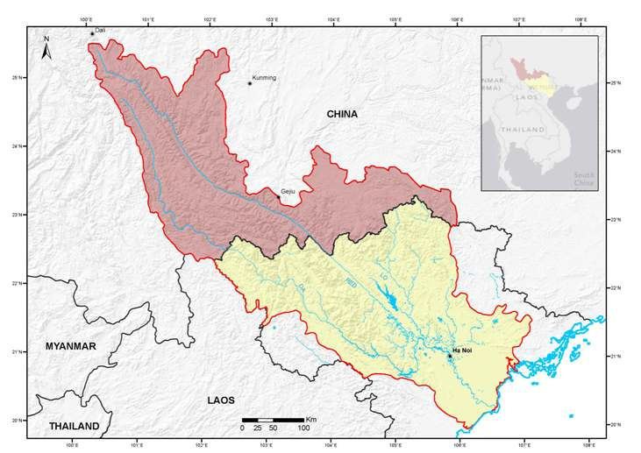

Figure 1‑1: Red-Thai Binh Basin



1. Figure 1‑1 Today, the Red-Thai Binh River Basin (Figure 1‑1) is one of the most important in Viet Nam: it contains the Nation’s capital city; it comprises 27% of the National land area; it has a significant proportion of the Nation’s water resources (16%), its GDP (25%), its hydropower development (42%), and its irrigation development (90% of total required area). It supports about a third of the country’s population, of which the number of poor people is the highest of all river basins (14.8 %). It has a high average population density (303 people per km2). Despite an apparent richness in water, the annual water availability per capita is low compared with other parts of the country (48% of the National average). It receives almost 40% of its water from China, so it is vulnerable to changes in upstream water use. The Basin accounts for about a quarter of the Nation’s water use, particularly for agriculture. Today, there are concentrations of large and increasingly urban populations, and high concentrations of some of the most significant industrial developments in the country, including most craft villages (60% of the total). Navigation is also important in the Basin, particularly for transport to the industrial areas of heavy construction and plant materials that are difficult to transport by other means.
2. Its cultural and political significance, its populations, its long history of extensive systems of irrigation structures and dykes, its extensive hydropower development, and its rapid urbanization and industrialization development, makes the RTBRB especially important to Viet Nam.
3. The extensive agricultural development in the Basin and the rapid levels of urbanization and industrialization are resulting in serious water quality deterioration in some areas, both for surface water and groundwater. Groundwater is a significant resource in the Basin for urban, rural and industrial uses. There are major concerns about the sustainability of current extractions in some areas, and water levels have dropped by up to 30 meters in parts of Hanoi. Groundwater quality is also being impacted by land use activities, posing significant risks to dependent communities.
4. The coastal zone of the Red River Delta supports a great diversity of wildlife, but with the high population and intensified aquaculture production, the delta is most at risk of losing the natural and semi-natural wetland habitats and the essential functions they provide.

Table 1‑1: Basin snapshot

|  |  |
| --- | --- |
| Basin Area |  |
| Total basin area (‘000km2) | 163.8 |
| % basin area in Viet Nam | 53.6% |
| Basin area in Viet Nam as % Viet Nam land area | 26.5% |
| Water volumes |  |
| Total water volume (billion m3) | 131.35 |
| % water volumes generated in Viet Nam | 63% |
| Basin water volume (total) as % National total | 16% |
| Dry season water volumes |  |
| Total dry season water volume (billion m3) | 35.45 |
| % dry season water volumes generated in Viet Nam | 62% |
| Basin dry season water volume (total) as % National total | 18% |
| Water storage volume |  |
| Total reservoir volume (billion m3) | 18.1 |
| Basin storage volume as % National total | 48.9% |
| Population |  |
| Basin population (million) | 28.4 |
| Basin population as % National total | 36.6 |
| Surface water availability |  |
| Basin average water availability (m3 per capita) | 4,627 |
| Basin average water availability as % National total | 48% |
| Water use |  |
| Total water use in Basin ((billion m3) | 22.8 |
| Basin water use as % National total | 29.2% |
| Basin water use as % basin water volume | 17% |
| Groundwater availability |  |
| Total recharge to aquifers (billion m3) | 31.1 |
| Exploitation capacity of aquifers (billion m3) | 11.5 |
| Basin average groundwater availability (m3 per capita) | 404 |
| Access to flush/pour flush toilet (% population with access) | 85 |
| Houses connected to sewerage system (% of households) | 25 |
| Access to flush/pour flush toilet (% population with access) | 85 |
| Houses connected to sewerage system (% of households) | 25 |
| Access to flush/pour flush toilet (% population with access) | 85 |
| Houses connected to sewerage system (% of households) | 25 |
| Access to flush/pour flush toilet (% population with access) | 85 |
| Houses connected to sewerage system (% of households) | 25 |
| Access to flush/pour flush toilet (% population with access) | 85 |
| Houses connected to sewerage system (% of households) | 25 |
| Access to flush/pour flush toilet (% population with access) | 85 |
| Houses connected to sewerage system (% of households) | 25 |
| Access to flush/pour flush toilet (% population with access) | 85 |
| Houses connected to sewerage system (% of households) | 25 |
| Wastewater treatment (% of wastewater treated) | 8 |
| Solid waste collection (% households with waste collected) | 79.6 |

## Context for the Status Report

1. *CDTA 7629-VIE: Capacity Building for River Basin Water Resources Planning* involves support to the Government of Viet Nam’s Ministry of Natural Resources and Environment under two components: (i) support for the preparation of the amended Law on Water Resources (LWR)[4], and (ii) the preparations of “Planning Tasks” for the management of water resources of the Red-Thai Binh River Basin. The first component provided assistance in the preparation of draft Law, which culminated in the passage of the new Law on Water Resources in June 2012. The second component of the TA is providing assistance to formulate Planning Tasks for Red-Thai Binh River Basin water resources. Planning tasks are prescribed in the LWR (Article 20) and precede formulation of a water resources plan. The overall purpose of formulating Planning Tasks is to identify the main issues facing water resources use and management to provide focused guidance for the full planning phase. In essence, the Planning Tasks will serve as Terms of Reference for the water resources planning for a river basin.
2. A major component of the Planning Tasks identified in the LWR involves the overall assessment of: (i) natural, economic, social features; (ii) the current status of water resources; and (iii) the current situation for the exploitation, use, protection and development of water resources, and the prevention of and recovery from impacts caused by water. This assessment provides the majority of content for the Status Report.
3. While the Status Report needs to be comprehensive in scope, it does not need to be very detailed in scale. The Status Report should be just detailed enough to provide a sound basis for decision-making. A more detailed technical status report will be prepared when the detailed river basin plan is prepared, using this report as a basis.
4. As the Red-Thai Binh River Basin (RTBRB) is a large basin, it was necessary to delineate the basin in to more manageable unit. It was decided to divide the basin into 5 sub-basin based mainly on hydrological boundaries. These subdivisions would provide more specific focus to the issues resulting in a more efficient planning process. The 5 sub-basins are divided as follows – see Figure 1‑2:

These 3 Sub-basins are in the upper western parts of the Basin, receiving a significant part of their water from China, and discharging much of their water to the Delta Sub-basin

1. The Da River Sub-basin,
2. Thao River Sub-basin
3. Lo-Gam River Sub-basin
4. Cau-Thuong River Sub-basin - this sub-basin discharges much of its water to the Delta.
5. Red-Thai Binh Delta River Sub-basin.

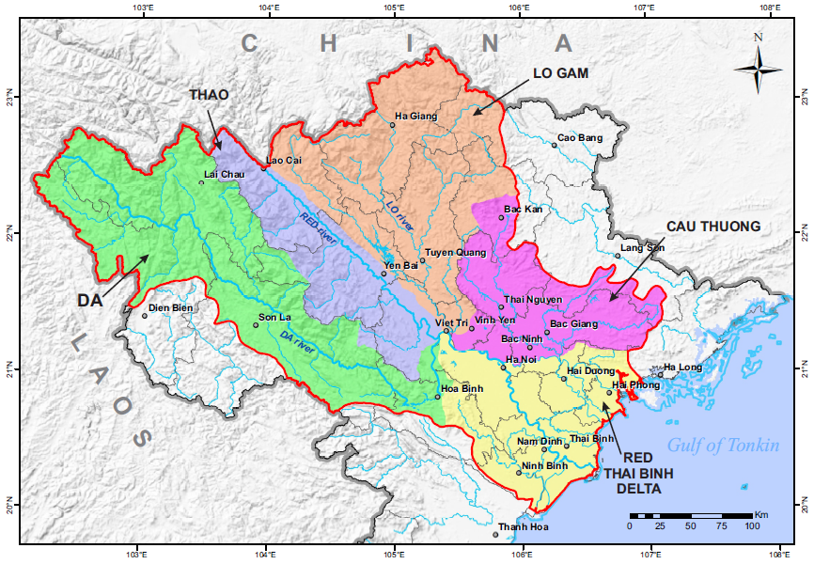

Figure 1‑2: Sub-basins of the Red-Thai Binh Basin

1. The RTBRB is made up of the following Provinces:

|  |  |  |  |  |  |  |
| --- | --- | --- | --- | --- | --- | --- |
| River Sub-basin | Province | % in Sub-basin |  | River Sub-basin | Province | % in Sub-basin |
| Da  Sub-basin | Lai Chau | 100 |  | Cau-Thuong  Sub-basin | Bac Can | 35 |
| Dien Bien | 49 |  | Thai Nguyen | 100 |
| Son La | 74 |  | Bac Giang | 100 |
| Yen Bai | 2 |  | Lang Son | 27 |
| Hoa Binh | 34 |  | Ha Noi | 4 |
| Phu Tho | 8 |  | Vinh Phuc | 79 |
| Thao  Sub-basin | Lao Cai | 68 |  | Bac Ninh | 67 |
| Yen Bai | 70 |  | R-TB Delta  Sub-basin | Quang Ninh | 35 |
| Phu Tho | 77 |  | Hai Phong | 100 |
| Lo-Gam  Sub-basin | Ha Giang | 90 |  | Hai Duong | 100 |
| Cao Bang | 10 |  | Ha Noi | 95 |
| Yen bai | 28 |  | Ha Nam | 100 |
| Tuyen quang | 100 |  | Nam Dinh | 100 |
| Phu Tho | 15 |  | Ninh Binh | 100 |
| Bac Can | 42 |  | Hoa Binh | 32 |
| Vinh Phuc | 21 |  | Bac Ninh | 33 |
| Lao Cai | 32 |  | Hung Yen | 100 |
|  |  |  |  | Thai Binh | 100 |

1. The proportion of the total area of the RTBRB for each sub-basin is shown in Figure 1‑3. This shows that the Da sub-basin has the largest proportions (31%) and the Cau-Thuong and Red Thai Binh the least with 8% each. Maps and summaries and some key issues are provided in Annex A.

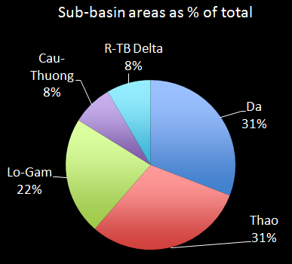

Figure 1‑3: Sub-basin areas as % of RTBRB area

## Preparation of this Status Report

1. The Status Report serves as a synthesis of the efforts to assess the water resources of the sub-basins in order to identify the issues. The Status Report makes use of input from expert consultants, stakeholder participation, analysis of existing data and studies, and the estimation of a set of Assessment Indicators. The use of multiple sources builds credibility in the process and reliability of the results. The Assessment Indicators provide a standardized approach that allows comparisons between sub-basins, including where they are occurring and to what extent.

### Assessment Indicators

1. The set of core indicators was developed for this report and applied to each sub-basin, using existing available information and incorporating future projections including climate change. The core indicators covered:
2. Water Resources (18 indicators): quantity, international linkages, dry season effects, water use, water storages and flooding effects.
3. Groundwater (13 indicators): groundwater recharge, availability, water use, water level drawdown and groundwater quality.
4. Economic (12 indicators): GDP, economic structure, sector production (industry, agriculture, irrigation, hydropower, navigation) and economic value for water use.
5. Social (13 indicators): population, population structure, poverty, ethnicity, employment, water services (clean water, sanitation), and flood impacts.
6. Environment (12 indicators): vegetation cover, biodiversity, conservation areas, cultural heritage areas, natural river flows, water quality, and river obstructions.
7. Management (16 indicators): basic survey (surface water, groundwater, water quality, environment, licensing, application of Government decisions (Decision 64, Decree 67), use of EIA, inspections and efficient service provision.
8. The Assessment Indicators generally show the current situation and in some cases, future projections. Data or information for deriving the indicators was obtained from a wide range of sources and documents, but the information provided by the General Statistical Office formed the basis for core data sets, such as population, area, GDP, etc. Data were checked to ensure they were as up to date and accurate as possible. However, for the purpose of undertaking Planning Tasks, absolute accuracy is not essential, and achieving this would have required many more months, if not years, of data collection and verification. What is most important for Planning Tasks is that the data is able to illustrate the approximate magnitude of issues and challenges, both in an integrated manner for the whole basin and relatively between the sub-basins.
9. The most important function of the Indicators is as a policy tool to assist with the strategic analysis of issues that deserve greater attention within national and provincial water management programs. The indicators provide a useful guide to policy maker’s on the status of the water resource and water resource management challenges in the Basin, highlighting where each particular sub-basin might benefit from increased investment and management attention.
10. The results of the analysis of the Assessment Indicators are presented in detail in the separate report: *Indicator Report for Red-Thai Binh Basin: The indicators and Their Use*. Annex B presents the Assessment Indicators in summary form. The Indicators report is a comprehensive documentation providing a description of each Indicator, the data required to calculate the Indicator, and the specific results for the RTBRB. While the analysis for all Indicators was used as collective input to this Status Report, only the Indicators showing the more important findings are reported here. Names of the indicator area shown in the accompanying charts.

## Structure of this report

1. The report is structured as follows:
2. An analysis of the status, management and issues for the water resources of the RTBRB: surface water, groundwater, flooding and natural hazards and assessments of climate change projections.
3. An analysis of the status, management and issues that the key water sectors are facing – urban water and sanitation, rural water and sanitation, irrigations, industry, hydropower, navigations and aquiculture.
4. Summary of the major issues facing the 5 sub-basins and the sectors.
5. Annexes

# SURFACE WATER RESOURCES STATUS AND MAJOR ISSUES

## Surface water

1. This section analyses the condition of surface water resources in the different sub-basins and the whole Basin. The indicators are designed to show the inter-linkages between international parts of the sub-basins, and the inter-linkages between the sub-basins. See Annex A for a map and summary charts.

### Surface water occurrence

1. The total average annual surface water volume in the RTBRB is about 131.4 billion m3, including water generated within China. This volume is about 16% of the national water volume.
2. Three of the sub-basins have a significant part of their upstream catchment areas in China and therefore rely on water inflows from those areas – the Da receives 43% of its annual water volume from China, the Thao 56% and the Lo-Gam 44% - see Figure 2‑1. Overall, nearly 37% of the Basin water volume is generated outside of the Basin in China.

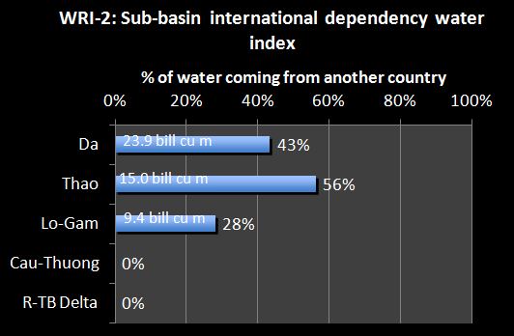

Figure 2‑1: Water dependency – % water generated in China

1. The majority of the water generated within the entire Basin comes from the Da River Sub-basin (42%) – see Figure 2‑2. The Delta generates relatively little water within its sub-basin area – only 6% to the Basin total water – and relies heavily on inflows from the upper western sub-basins for its water. Of the water generated solely within Viet Nam, the Da sub-basin provides 37% and the Lo-Gam 29%.

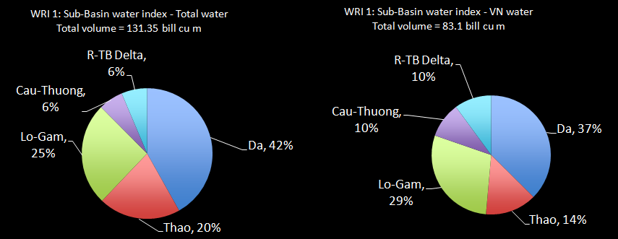

Figure 2‑2: Water generated within the sub-basins

1. It is estimated that 93% of the water generated in the Da sub-basin is currently not used in that sub-basin and eventually flows naturally to the Delta – see Figure 2‑3. Similarly, 94% of the Thao water, 89% of the Lo-Gam water and 45% of the Cau-Thuong waters flow naturally to the Delta. Together these natural flows between the sub-basins increase the surface water in the Delta by over 13.5 times the volume naturally generated within the Delta.

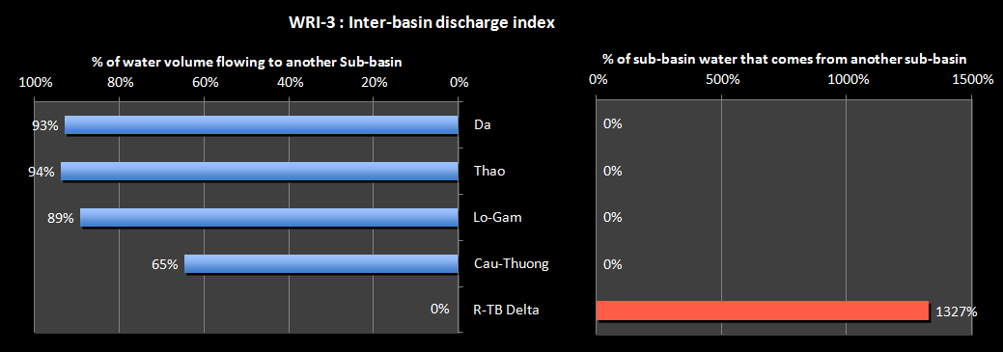

Figure 2‑3: Natural discharge between the sub-basins

1. The dry season for the RTBRB lasts for 7 months between November and May. During that period, only 35.5 billion m3 is available – just 27% of the total annual water is available. The RTBRB provides 18% of the total national dry season water volume. 37% of this dry season volume is provided in the Da sub-basin, 24% in the Thao and 27% in the Lo-Gam sub-basin.
2. During the long dry season the sub-basins receive only a small proportion of the annual water – see Figure 2‑4. The Da receives only 24% of its annual water volumes over those 7 months. The Thao receives the highest proportion, almost a third of its annual water during the dry season. The Delta sub-basin receives only 22% of its natural water over the dry season, but this water is augmented by inflows from the upper sub-basins.

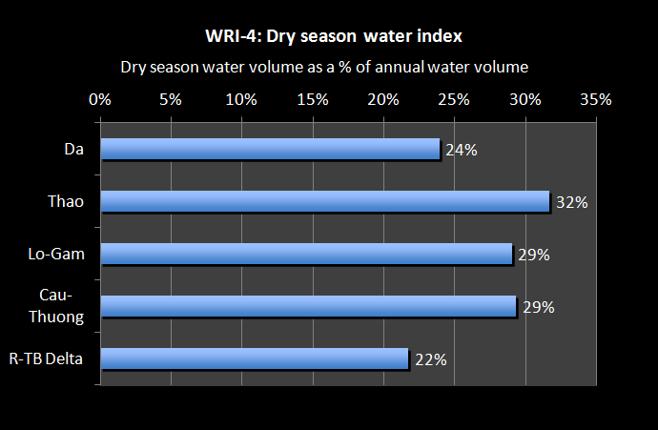

Figure 2‑4: Proportion of annual water volume available over the 7-month dry season

1. Over the dry season, 27% of the overall water volume in the Basin comes from China. 67% of the water volume for the Thao sub-basin comes from China, and 41% for the Da – see Figure 2‑5. This emphasizes the importance of establishing agreement with China over water flows and water sharing in order to secure water security.

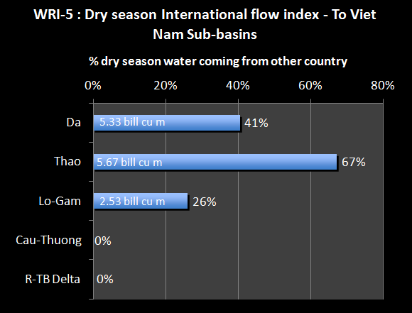

Figure 2‑5: Dry season international dependency

1. Water productivity is the amount of water volume generated per land area, and shows the locations that provide the most water within the RTBRB. In terms of water generated within Viet Nam’s territory, the Da sub-basin is by far the most productive, with the Lo-Gam next – see Figure 2‑6 . The Da has a productivity factor 7 times that of the Delta, where little water is naturally generated. For the area outside of Viet Nam’s territory the Da is again significantly more productive than the other sub-basins. During the dry season, for the sub-basin areas within Viet Nam, the Da and Lo-Gam are the most productive – over 5 times more so than the Thao and the Cau-Thuong. For the dry season, the sub-basin area outside of Viet Nam in the Da is not as highly productive as for the annual water productivity, and indeed is less productive than the area within Viet Nam.

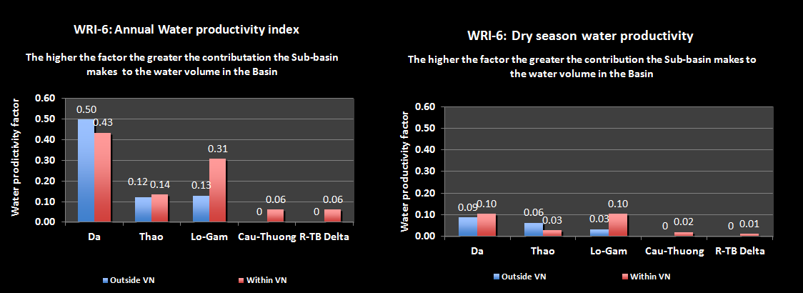

Figure 2‑6: Water Productivity per sub-basins

1. The RTBRB contains nearly 50% of the total reservoir storage volume in Viet Nam. Most of this, 71%, is located in the Da sub-basin (a total of 12.9 billion m3) – see Figure 2‑7. This proportion is expected to increase into the future as further hydropower reservoirs are built. The current reservoir storage volume in the Da sub-basin is 23% of the annual water volume – meaning that on average the reservoir could fill three or four times each year. This figure is 22% for the Lo-Gam, and only a small percentage for the other sub-basins.

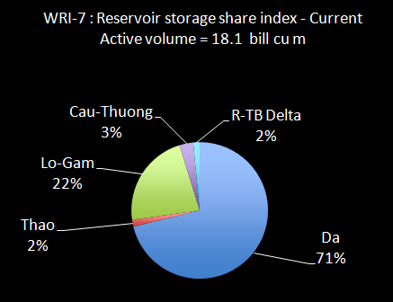

Figure 2‑7: Reservoir storage share per sub-basin

1. In the Da and Lo-Gam sub-basins, the reservoirs are virtually all used for hydropower generation – see Figure 2‑8. In the Thao sub-basin, about 60% of the storage volume (only a total of 0.3 billion m3) is used for hydropower and the rest for irrigation. The reservoirs in the other sub-basins are small and are used for irrigation. The figure also shows the benefits derived from the reservoir storages, and makes a distinction between the storages that add to the water security[5] of the RTBRB and hydropower storages. Water storages for irrigation or water supply or flood mitigations are all providing water security benefits – additional water supply or protection from water disaster impacts. However, hydropower storages are built and operated primarily to provide energy security to the country. As such, they do not explicitly provide water supply benefits, although these can occur as incidental benefits. The figure shows that the energy security benefits of the reservoirs are much larger than the water security benefits.
2. Figure 2‑8 shows that most of the water storage is in the Da sub-basin, resulting in that sub-basin having a very high water storage per capita figure (11,696 m3 per person). However, this is as expected because the overall storages volumes in the sub-basin are very large and the population small. The water security storage volume is also quite high at 4,163 m3, mostly because of the high flood mitigation component of the storages (7 billion m3 – note that this capacity is just the part of the active storage that is allowed to be used for flood mitigation in the wet season). The figures for the Lo-Gam sub-basin are also quite high overall, but the water security figure is only 559 m3 a person.

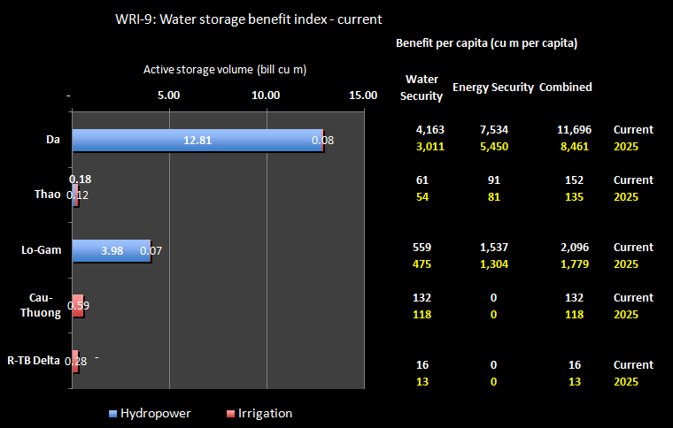

Figure 2‑8: Water storage benefits per sub-basin

1. The storage volume per capita for Viet Nam is quite low at 411 m3 per person compared to many other countries – see Figure 2‑9. However, this figure is for total storage, including hydropower. If only the water security amount is considered (storage volume for irrigations, water supply and flood mitigations) then the National figure drops to 82 m3 of storage per person, a relatively low number.

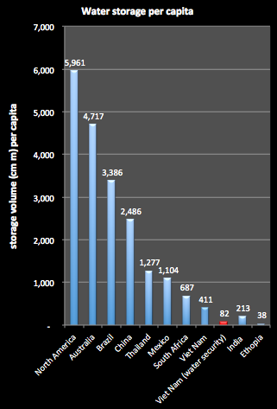

Figure 2‑9: Water Storage Per Capita

1. Currently in the Da and the Lo-Gam sub-basins hydropower reservoirs are used to divert water via infrastructure directly to the Delta sub-basin – 2.4 billion m3 from the Da and 1.57 billion m3 from the Lo-Gam. These inter-basin diversions represent about 4.5% of the total water volume of each sub-basin.

### Water Availability

1. Several of the Assessment Indicators relate the water resource volumes in the sub-basins to society’s needs for water. These include the water volumes available (cubic metres per person), the uses made of the water for different demands (irrigation, urban, industry, etc.), and the impacts on the water resources of that water use.
2. Per capita water availability shows the relative availability of surface water resources for the population of the sub-basin. The international standard[6] for water availability is shown in Figure 2‑10. The standard for having adequate water per person is 4,000m3 a year, with the possibility of having irregular or local water shortages with annual water availability of between 1,700m3 and 4,000m3. Below 1,700m³ per capita a year water stress appears regularly; below 1,000m³/capita/year water scarcity is a limitation to economic development; and below 500m³/capita/year water availability is a main constraint to life. Nationally, and based on the total surface water volume in Viet Nam, the surface water resources equate to 9,856m3 per person per year, suggesting plentiful water. By comparison the water resources (including both surface water and groundwater) of Lao PDR are 63,180m3, Cambodia 36,330m3, Thailand 6,530m3 and China 2,260m3 of water per person per year.

Figure 2‑10: International standards for water availability limits

1. The average surface water availability for the RTBRB is 4,627 m3 per capita, less than half the National average. Figure 2‑11 shows that the Da sub-basin has a water availability of over 32,353 m3 per capita, meaning plentiful water compared to its population. The Thao sub-basin (13,599 m3 per capita) and the Lo-Gam (12,896 m3 per capita) also have bountiful water for its populations. The Cau-Thuong, however, is in a difficult situation with water availability of only 1,785 m3 per capita, meaning that water shortages are already occurring. At projected 2025 population; the availability figure for this sub-basin would be 1,600 m3 per capita, meaning water availability stress will be increasingly apparent.
2. The water that is naturally generated in the Delta sub-basin is only 474 m3 per capita. However, this is a misleading figure, and it must be recognized that the majority of water within the Delta comes from the four upper sub-basins, particularly the Da, Thao and Lo-Gam. When the average inflows from these sub-basins to the Delta are included, the water availability is 6,982 m3 per capita (this is shown as the red column in Figure 2‑11).

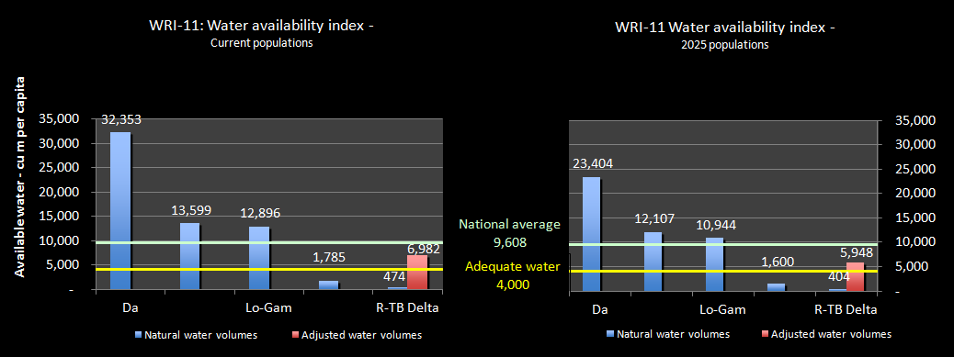

Figure 2‑11: Average annual water availability in the sub-basins

1. Although consideration of the annual figures suggests adequate water per capita, water availability over the 7 month dry season that affects the RTBRB tells a very different story. Overall, the dry season water availability[7] for the RTBRB is 1,250 m3 per capitaat current populations, which puts the Basin below the adequate water level and approaching the water shortage levels. At 2025 populations, the Basin figure is 1,062 m3 per capita (less than half the National total), which is at about the dry season water shortage level. At current populations, the dry season water availability for the Da sub-basin is significantly reduced to 7,741 m3 per capita– see Figure 2‑12. The Thao sub-basin is 4,310 m3 per capita and the Lo-Gam to 3,745 m3 per capita. Even at projected 2025 populations, these sub-basins would have adequate dry season water. For the Cau-Thuong, the dry season water availability under the current population is 523 m3 per capita, and for the projected 2025 population is 469 m3 per capita. These levels are of serious concern, meaning increasing water shortages and scarcity, and conflicts over access to water.

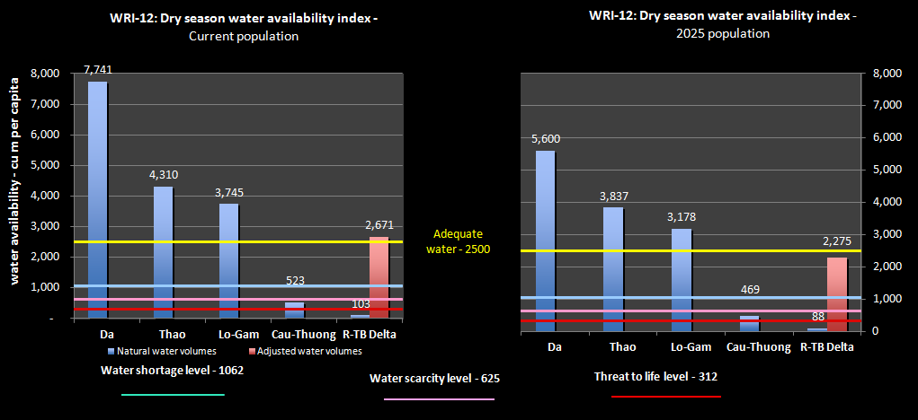

Figure 2‑12: Dry season water availability

1. Figure 2‑13 and Figure 2‑14 present maps of the RTBRB for water availability annually and for dry season only. Figure 2‑14, in particular, shows an increasing problem with water availability in the dry season.

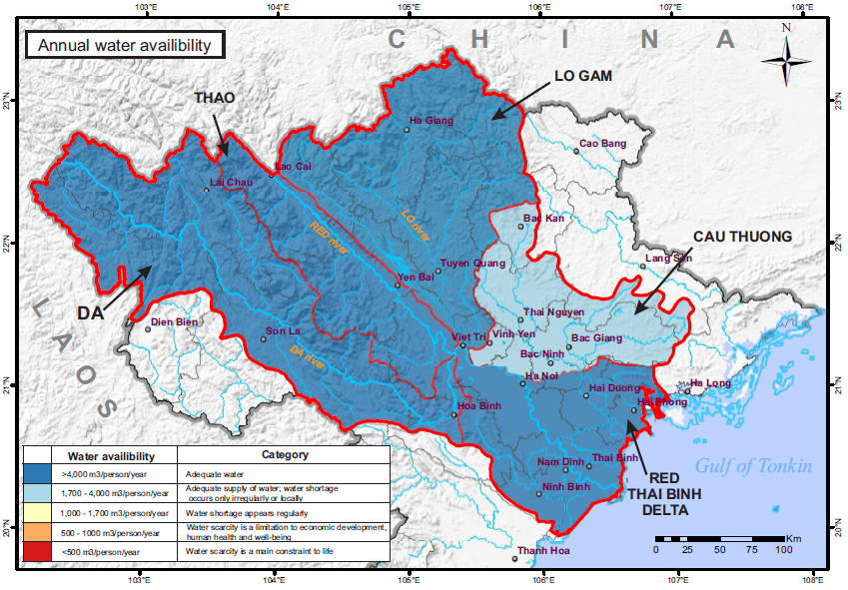

Figure 2‑13: Annual Water Availability for the RTBRB

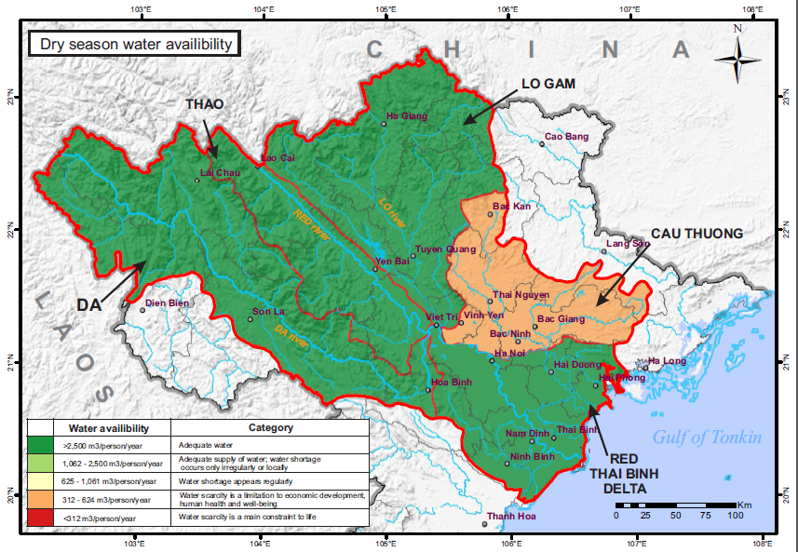

Figure 2‑14: Dry Season Water Availability for the RTBRB

1. For the Delta, when adjustments are made for the water inflows from the upper sub-basins (the red column in Figure 2‑12), the water availability figure is 2,650 m3 per capita, providing adequate water. However, at projected 2025 populations, the figure is 2,262 m3 per capita, which is just below the adequate water level. There would therefore be an increasing risk of shortages in the Delta into the future. Given this risk, an analysis was undertaken to show what level of reduced inflows to the Delta from the upper basins would be required to take the Delta water availability to the adequate water level or below – see Table 2‑1.

Table 2‑1: Reduction in inflows to the Delta that would reduce water availability to the adequate water level or less

|  |  |  |  |  |
| --- | --- | --- | --- | --- |
|  | **Annual water** | | **Dry season water** | |
|  | Current population | 2025 Population | Current population | 2025 Population |
| Reduction required in inflows to bring the Delta to the adequate water level | 45% | 34.3% | 2% | (already below the adequate water level) |
| Reduction required in inflows to bring the Delta to the water shortage level |  |  |  | 45% |

1. In terms of the annual water situation, it would take a large reduction in inflows to take the Delta water availability to the adequate water level. However, the dry season situation is of great concern – it would take only a 2% reduction in dry season inflows from the upper basins to the Delta to drop water availability to the threshold of adequate water level. At 2025 populations, the Delta would already be below that level.

### Water Exploitation

1. The water exploited in the sub-basins for all sectors - irrigations, agriculture, industry, urban, aquaculture – compared to the available water volumes, indicates the intensity of use of surface water resources. High level of water use can lead to stress on the water source. The international standard for water exploitation stress is that moderate stress begins when more than 20% of average annual flow is extracted, and high water stress is felt for indicator values above 40%, which indicates strong competition for water, but which does not necessarily trigger frequent water crises[8].
2. Figure 2‑15 shows that, based on the water resources generated within the sub-basins, current levels of estimated water use are within the low water stress zone, except for the Cau-Thuong and the Delta. However, when the water available in the Delta is adjusted to account for the inflows from the upper sub-basins (the red column in Figure 2‑15), the current level of exploitation of the Delta is also in the low stress zone. The Cau-Thuong sub-basin already has a moderate water exploitation stress level based on annual water use and water availability. The figures do not change significantly when projected 2025 water exploitation levels are used.

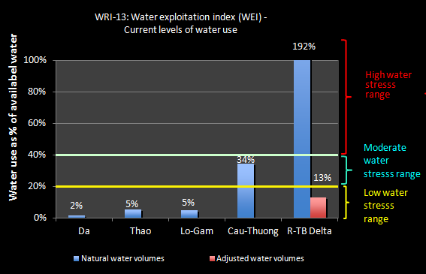

Figure 2‑15: Water exploitation levels

1. Water exploitation and use in the dry season compared to the water availability in the dry season can help identify if dry season exploitation and use rates are sustainable. Figure 2‑16 shows that the Da, Thao and Lo-Gam sub-basins are at the low stress level. When the Delta is adjusted to account for the dry season inflows from the upper sub-basins (the red column in the figure), the current level of exploitation of the Delta is in the moderate stress zone. This is much the same result at the projected 2025 dry season water exploitation levels. However, the figures for the Cau-Thuong are of major concern. At current levels of dry season water exploitation and available water, the sub-basin is in the high stress range (with 88% of the available water being used to meet the demands), and this is further accentuated at projected 2025 level of water exploitation. Then, over 100% of the available water would be required to support water exploitation, an impossible figure producing great stress on the river system and the communities that depend on the water sources of the sub-basin

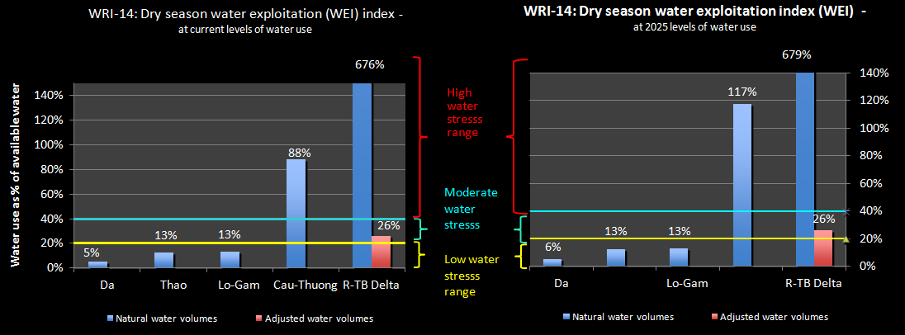

Figure 2‑16: Dry season water exploitation

1. The analysis also showed that the water exploitation per capita for the Delta (currently 909 m3 per capita) is less than the National average of 985. However, this is much higher than the other sub-basins, mainly because of the strong irrigation sector, and perhaps suggesting that water use in the Delta is currently not as efficient as it could be. This will be further considered later in this report.
2. Figure 2‑17 and Figure 2‑18 show annual and dry season water exploitation relative to water availability. Figure 2‑18, in particular, shows the increasingly critical problem in the dry season.

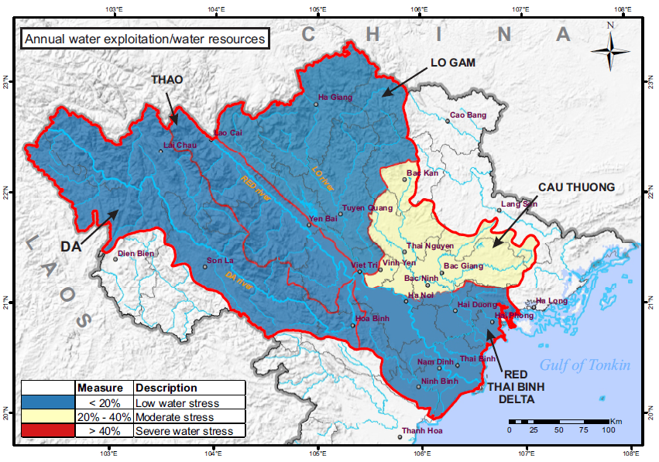

Figure 2‑17: Annual Water Availability/Water Resources

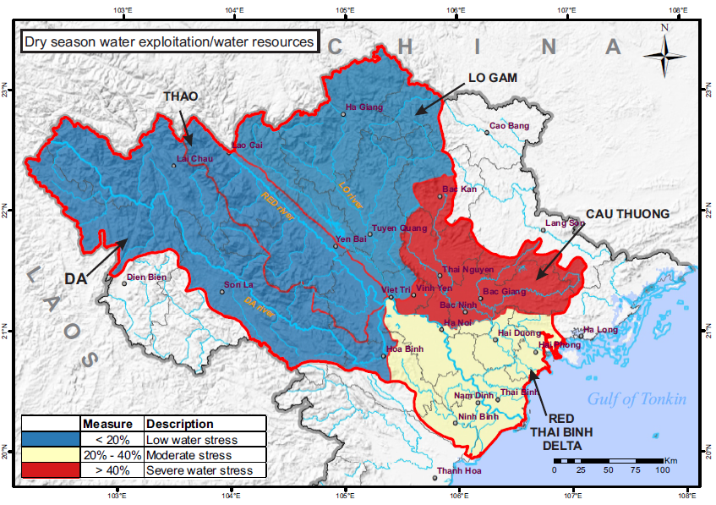

Figure 2‑18: Dry Season Water Exploitation/Water Resources

1. 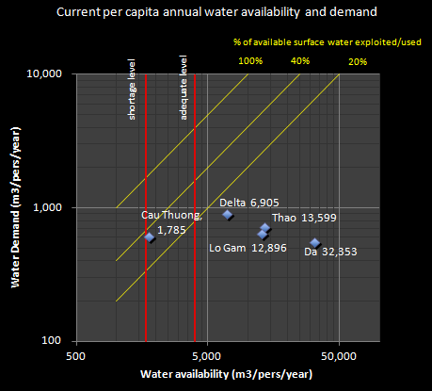It is useful to bring together different water indicators and show a composite picture. Figure 2‑19 combines the per capita annual water availability and water exploitation and use by river basin, (combining the outputs of Indicators WRI-11 and WRI-13). Another is to do this for the dry season - the per capita dry season water availability and demand by sub-basins (combining the outputs of WRI-12 and WRI-14) – see Figure 2‑20. Note, that these figures include the water volumes in the Delta sub-basin adjusted for the natural inflows from the upper sub-basins.

Figure 2‑19. Annual availability and demand per capita

1. Figure 2‑20 shows the current vulnerability of the Cau-Thuong sub-basin. It is below the adequate water level and almost at the water shortage level in terms of water availability per capita, and it is close to the 40% water exploitation, thus at the upper end of the moderate stress zone.
2. The other sub-basins currently have adequate water availability and are all in the low stress zone.
3. 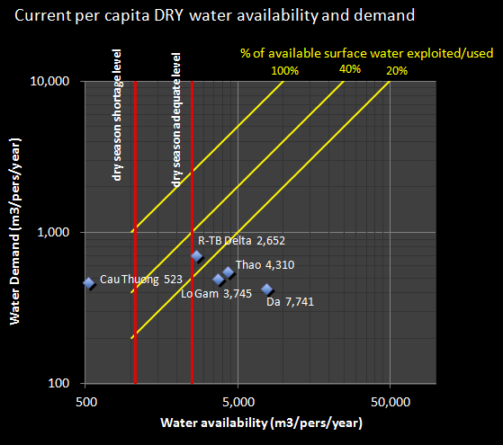Figure 2‑20 shows the situation for the dry season, based on current levels of population and water demands. This shows that the Cau-Thuong sub-basin is now well into the danger zone, passed the red water shortage line and into the high stress range (above the 40% line).
4. The Delta is close to the dry season adequate water line, and is in the moderate stress range (between 20% and 40% of exploitation of the available water).
5. However, looking specifically at volumes of current water demand compared to water availability shows that current water demands are not yet causing serious water stress, for both annual or dry periods (see Figure 2‑21 and Figure 2‑22). This does not mean that there is plenty of water, but rather that Viet Nam has a rapidly narrowing window of opportunity to improve water management before serious water stress sets in, especially in the dry season.

Figure 2‑20: Dry season availability and demand per capita

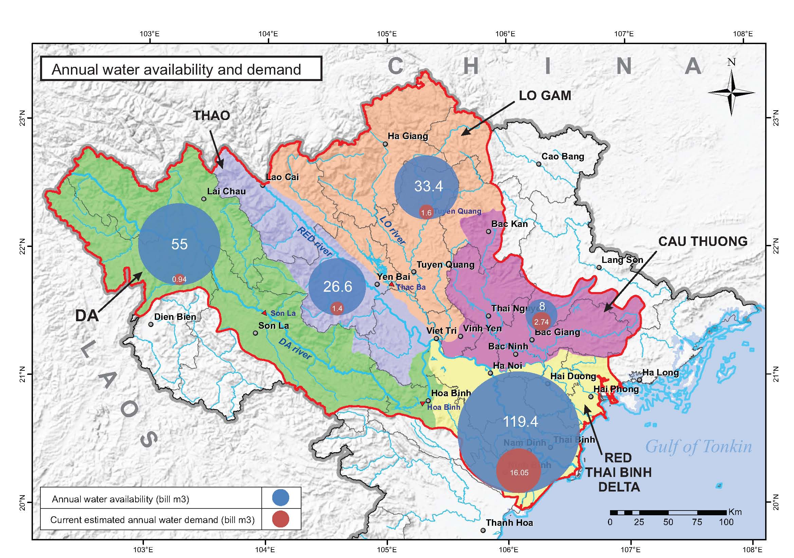

Figure 2‑21: Annual Water Availability and Demand

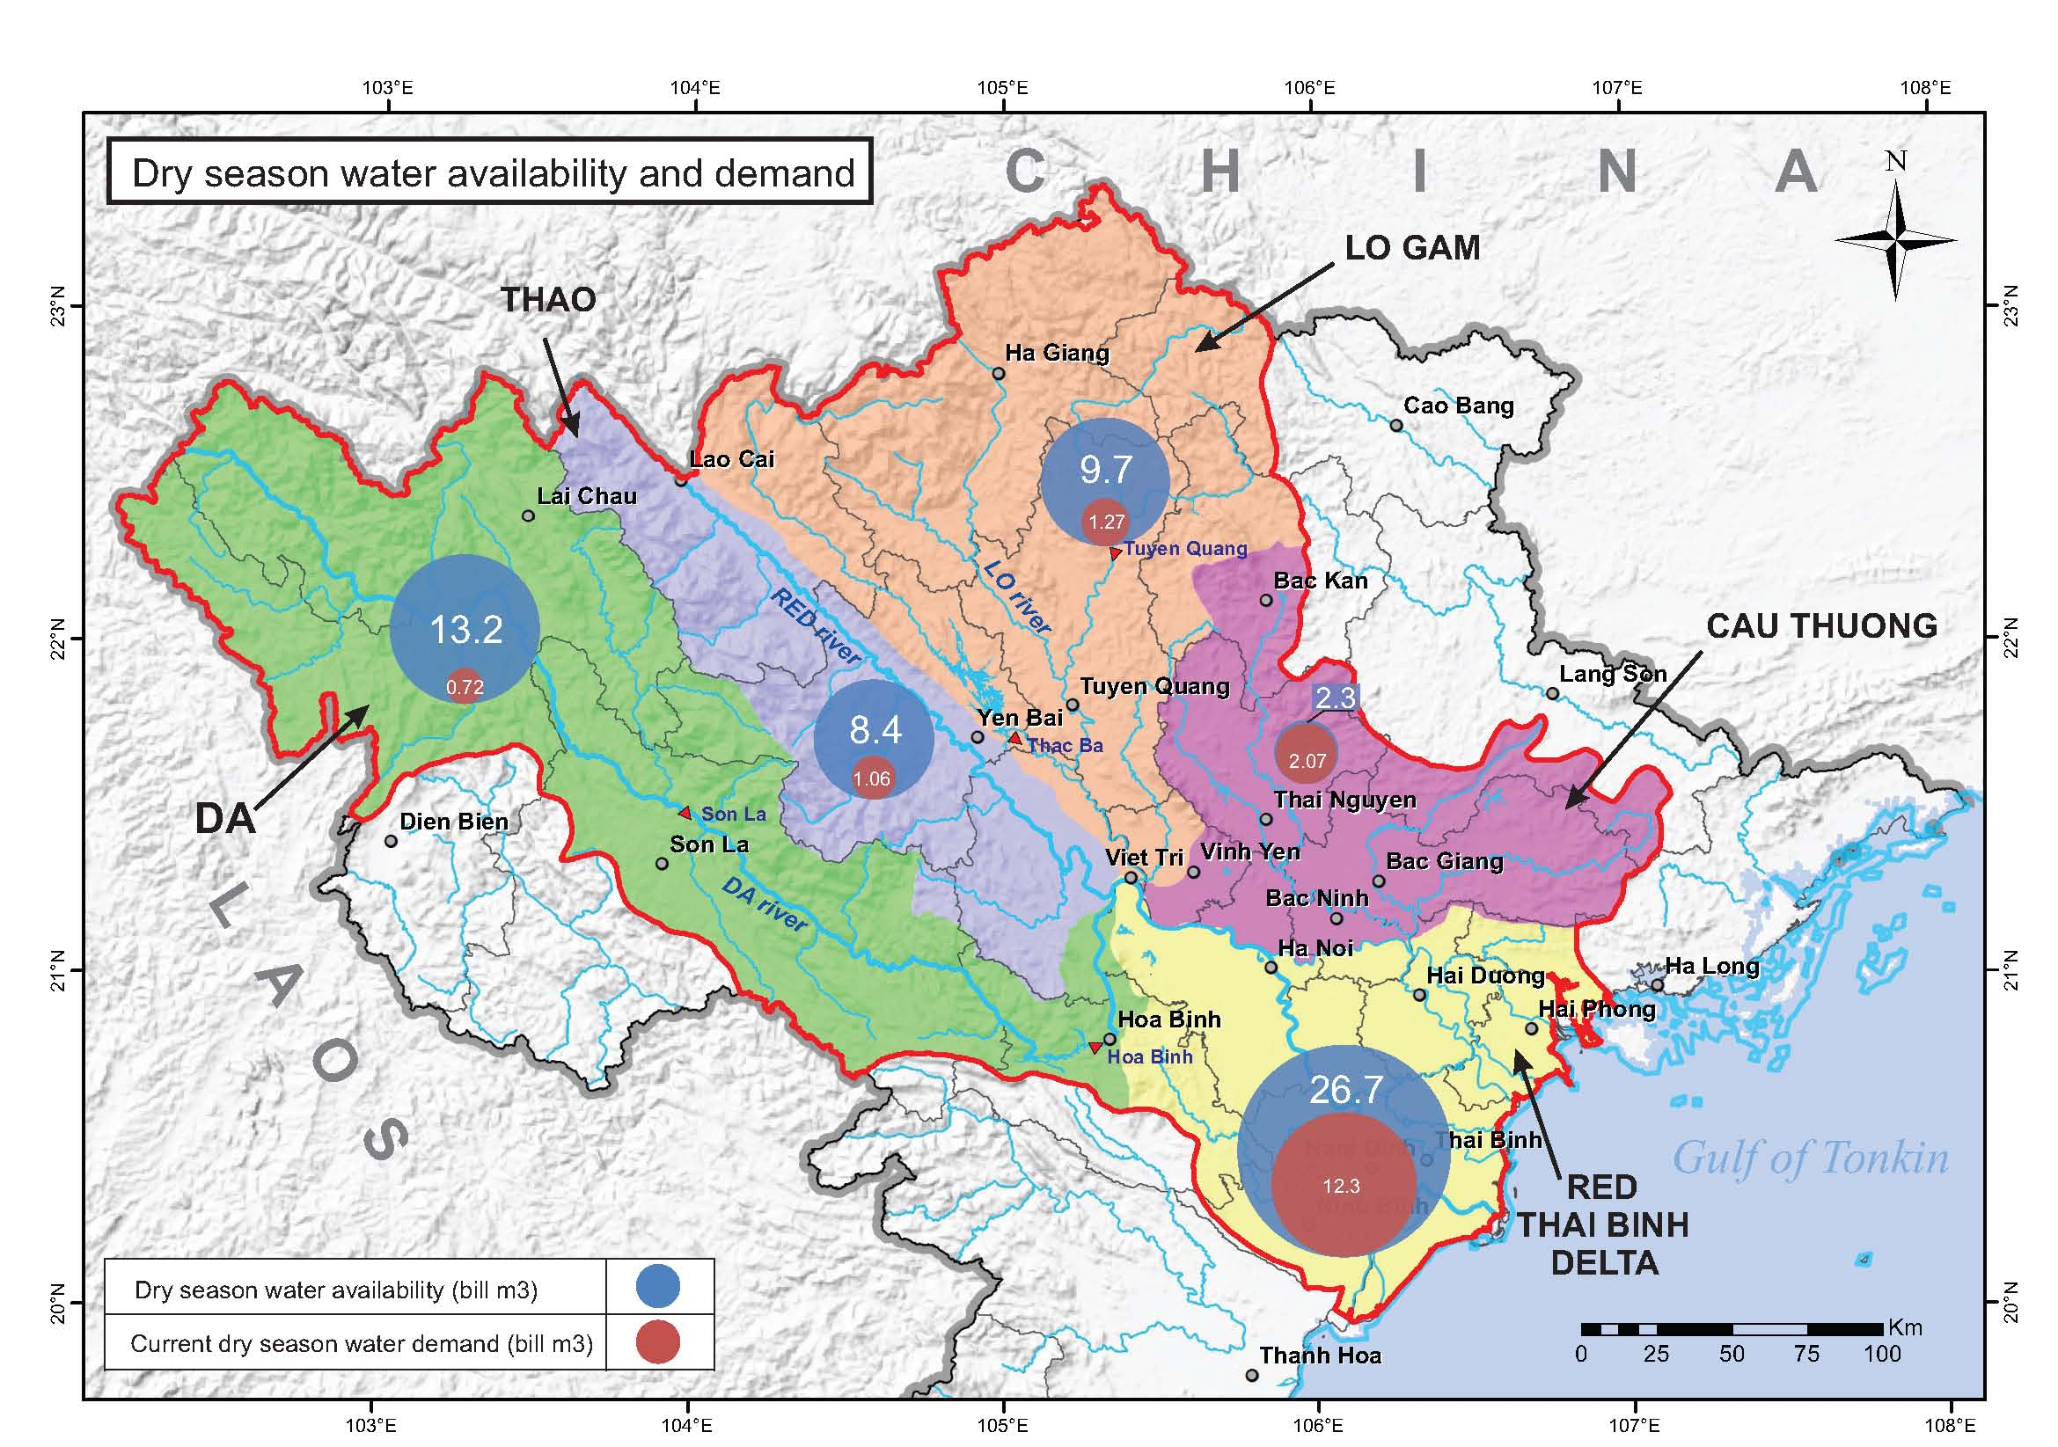

Figure 2‑22: Dry Season Water Availability and Demand

1. Figure 2‑23 shows the water use in each sub-basin by each main water-using sub-sector - irrigation, agriculture, industry, urban, aquaculture. Accurate data and information on water use in Viet Nam is generally not available, except for the urban sub-sector where most use is measured. Figures therefore must be based on the best available estimates. Nationally, irrigation accounts for over 80% of the total water use, aquaculture 11%, industry 5%, and cities, towns and villages 3%. In the RTBRB irrigation water use is greatest in the Delta sub-basin, at 81% of total estimated water use. Irrigation use is at or just less that 80% in the Da, Thao and the Lo-Gam sub-basins, but is only 74% for the Cau-Thuong. This helps explain why this sub-basin has a relatively low water use per capita. Water use for aquaculture is very high in the Cau-Thuong at 17%. Urban and industrial water use is small in comparison to irrigation and aquaculture water use.

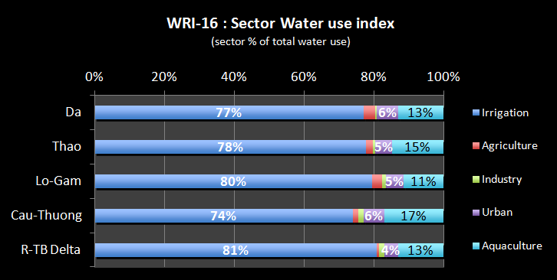

Figure 2‑23: Water use by sector

### Water Quality

#### Basin wide water quality assessment

1. The RTBRB is home to a rapidly growing industrial sector as well as many old industries, intense agriculture and livestock raising, thousands of craft villages and over 28 million people; all of which produce large volumes of wastewater and pollutants. Very little domestic, industrial or agriculture wastewater is treated. It is not surprising then that its rivers are increasingly contaminated with various pollutants, and in some sections heavily polluted, and The Ministry of Health has established standards for surface water quality in QCVN 08:2008. The MOH standards set out 4 categories ranking water quality from A1 (suitable for water supply), A2 (requires treatment), B1 (suitable for irrigation), B2 (low quality, suitable for transportation.
2. In Viet Nam, it is difficult to get consistent and comprehensive water quality data for the RTBRB as a whole. While Decision 16/2007/QT-TTg sets for a plan to upgrade or install a national system of monitoring stations for environmental health, with a focus on water, implementation has been slow. In response, the Vietnam Environment Administration has issued Decision 526/QD-TCMT which sets forth a system of 108 monitoring points in the RTBRB. In 2012, 81 of these sites were operational and conducted sampling 3 times per year.
3. For this report, 2012 data was collected from the Center for Environmental Monitoring for 30 sites along the Da and Red-Thai Binh River. This included 18 parameters: pH, t0, turbidity, EC, TDS, DO, ORP, BOD5, COD, TSS, NH4 +, NO3-, NO2-, PO43-, Fe, Pb, Cd, and coliform. Sampling was done three times at each site and for each parameter. The samples were taken during May, June and August of 2012, which it should be noted are during the rainy season missing the important dry season. Figure 2‑24 shows that overall, the three parameters most frequently found exceeding MoH standards were TSS, coliform, and iron.

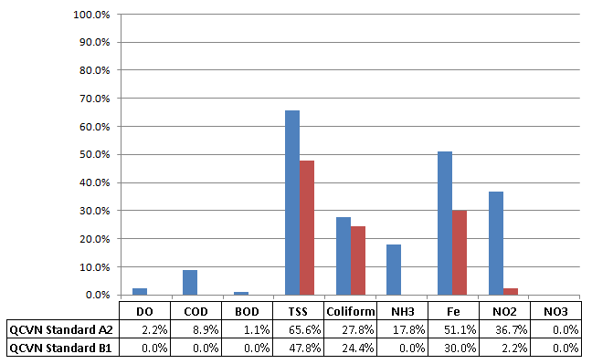

Figure 2‑24: Percentage Samples Exceeded QCVN Standards in 2012

1. The 2012 sampling data was further assessed using the General Department of Environment’s water quality index (labeled WQI, not to be confused with this project’s Assessment Indicators) according to Decision No. 879/QD-TCMT. This index is used to describe the quantity of water quality. The index score is assigned 1 of 5 categories as follows:

* 91-100: suitable for water supply;
* 76-90: suitable for water supply, but needs treatment;
* 51-75: Use for irrigation and similar purposes;
* 26-50: Use for navigation and similar purposes; and,
* 0-25: Polluted water, needs treatment measures.

The results are presented in Figure 2‑25.

Figure 2‑25: The WQI quality index on the Red-Thai Binh river basin

1. The General Department of Environment’s Water Quality Index shows that for the upper Red River near Lao Cai in Lao Cai Province and Yen Bai, Van Phu Yen Bai, Ha Hoa, Cho Me in Phu Tho Province, there are very low WQI values indicating the water quality at this location is polluted and remedial measures are required. The remaining monitoring sites on the Red River show better water quality better suitable for irrigation purposes and other similar purposes. For the Da River, water quality is of generally good condition and can be used for water supply purposes. Water quality in the Thai Binh River is generally suitable for irrigation purposes and for other similar purposes. On the Lo River, the WQI value is low indicating that the water is polluted and remedial measures are required.
2. An analysis of the Day/Nhue River system that drains Hanoi dominates the internationally funded studies.[9] Data was assembled for the Second Red River Project (ADB TA 3892) covering faecal bacteria, BOD, NO2, Cd and dissolved oxygen. However, the data is now old - the data presented are basically coming from the Vietnamese monitoring system between 1999 and 2002 – and the extent of pollution is far greater today than would have been measured then. The water quality values will differ by time, depending on river flows, location of sampling, closeness to outlets points, etc. It is understood that the table assembled gives more average values for the river system in general.
3. The results of the monitoring are shown in the following figures - Figure 2‑26 to Figure 2‑29 . Faecal bacteria and nitrate present the most serious threats to human health. The most common health problem associated with faecal bacteria is diarrhea, but typhoid, infectious hepatitis and stomach infections may also occur. Especially in some rural areas, contamination has resulted in the spread of diseases like parasitic worms, malaria, haemorrhage and Japanese encephalitis. Water with faecal bacteria is not potable, but according to Vietnamese standards is treatable under 5,000 bacteria/100 ml, which actually is a very high level. The consumption of nitrite rich water by young children may give rise to a condition known as “blue baby syndrome”.

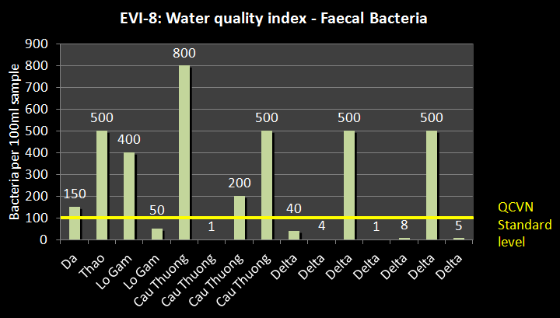

Figure 2‑26: Water quality samples - faecal bacteria

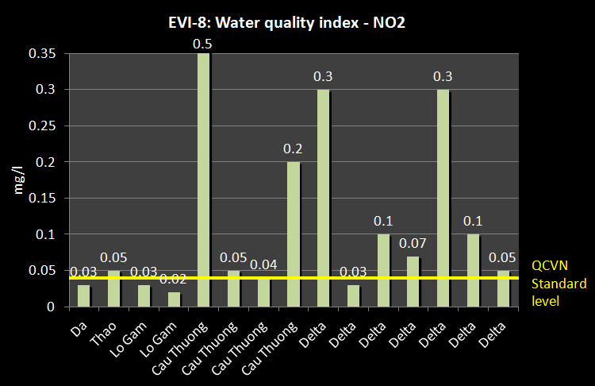

Figure 2‑27: Water quality samples - NO2

1. Both faecal bacteria and NO2 are found at levels many times the standard for drinking water throughout the RTBRB. The highest readings were for the Cau-Thuong sub-basin, where the NO2 reading was 50 times the standard. Even in the more pristine western sub-basins, high levels of pollutants were found. The faecal bacteria and NO2 results show that it will be very difficult for any part of the RTBRB to find potable surface water and that a high proportion of the population will be exposed to contaminated drinking water. Even concentrations as ‘low’ as 200 bacteria/100 ml will represent contaminated water that should be boiled or otherwise treated before being consumed. Also, the nitrite level is high and represents a general health threat to people who drink water from many parts of the rivers. For this reason, priority attention must be given to domestic wastewater discharge. Reduced bacteria levels will be important for public health as well as for the environment, while the organic load should be reduced in order to improve biodiversity and to protect and sustain the potential aquatic food production.

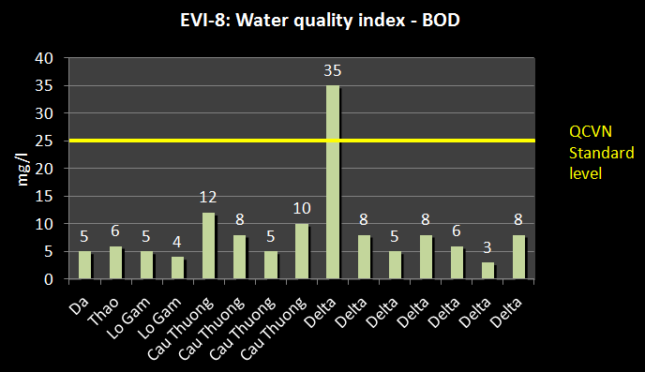

Figure 2‑28: Water quality samples - BOD

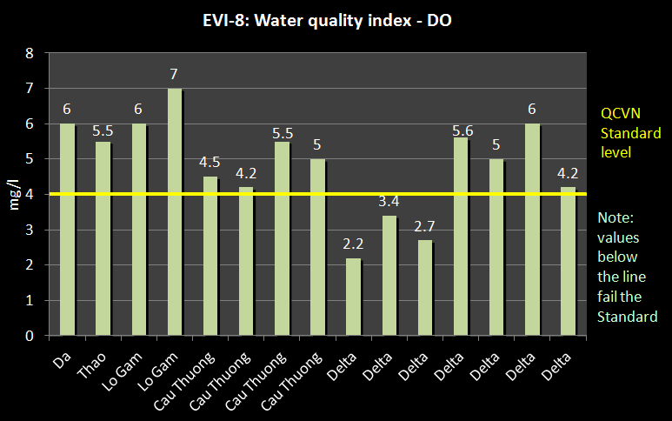

Figure 2‑29: Water quality index - DO

1. Low Dissolved Oxygen (DO) levels indicate high organic loads (BOD) consuming the available oxygen. Sources of organic load normally are domestic, agriculture and food processing industries, including aquaculture. The standards are exceeded in all parts of the RTBRB, but particularly in the Delta areas around and downstream of Hanoi.
2. In general, the area downstream of confluence of the Thao, Da, and Lo-Gam Rivers (Viet Tri) is generally much heavier polluted than areas upstream. Figure 2‑30 shows the areas of the Basin where there are serious water quality problems and issues. The areas with the most serious water pollution are:

* The Day-Nhue river system that drain Hanoi in the Delta sub-basin (Van river, Day river in Ninh Binh province receiving wastewater from Ninh Binh city and mining; and whole Nhue river receiving wastewater from ha Noi city);
* The Cau river system in the Cau-Thuong sub-basin; and
* Da river: China – Viet Nam border at Muong Te and ma Lu Thang in Nam Na tributary water polluted with high turbid due to mining
* Thao river: Receiving wastewater from Lao Cai, Yen Bai, Lam Thao, Viet Tri cities and industries zones
* Lo river: Wastewater from ha Giang city and industrial wastewater before discharging into Red river
* Kien giang river – Thai Binh province: receiving wastewater from Thai Binh city.

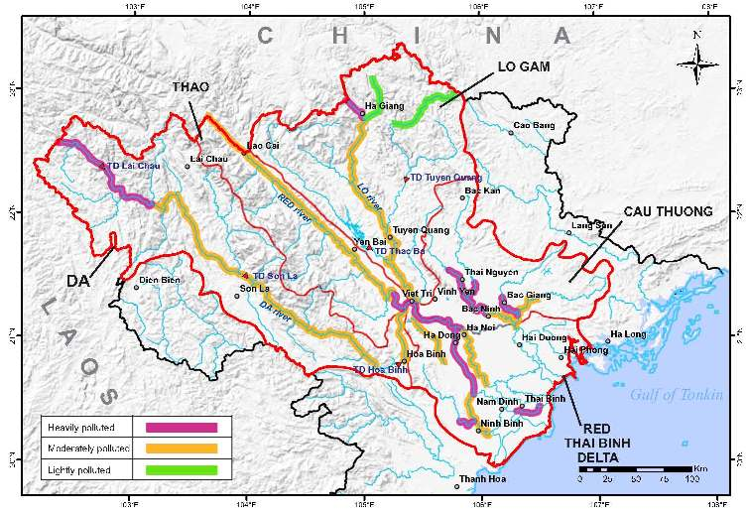

Figure 2‑30: Water quality hot spots

#### Day/Nhue River water quality assessment[10]

1. Of the rivers in the RTBRB, the Day-Nhue River system is considered the most polluted. The Nhue River is seriously polluted in its upper reaches as it receives most of the urban drainage and domestic wastewater from Hanoi. According to ICEM the main pollutants in the sub-basin are generated by eight main categories of development:
2. Eight industrial zones and complexes with 157 projects;
3. 358 handicraft villages;
4. Wastewater from urban and residential areas;
5. Tourist activities;
6. Hospitals;
7. Small industrial enterprises;
8. Agricultural activities; and
9. Inland waterway transport.
10. Wastes from these sources are generally not treated at all or not treated to national TCVN standards.[11] Each of these sources has a very different set of pollutants and pathways which affect ambient water quality conditions of the rivers.
11. In terms of organic matter, most of the monitoring sites in the Nhue River, To Lich River, Kim Nguu River, Lu River and Set River have DO values ranging from 1.6 to 5 mg/l. DO values measured in Lu, Kim Nguu and To Lich Rivers are well below the TCVN standard of 2 mg/l. Long periods of DO below 5 mg/l can harm larval life stages for many fish and other aquatic organisms. COD values range from 6.1 to 384 mg/l from 18 surveys, 585 water samples at 50 different sites in the river system. 99% of COD values exceeded the standard of 10 mg/l for domestic use (Category A) and 22% exceeded the TCVN standard of 35 mg/l for use in agriculture (Category B). A COD of 60 mg/l in a natural system is in emergency need of treatment. BOD values have a range of 2 to 297 mg/l, including 150 samples with values exceeding the TCVN standard of 25 mg/l for agricultural purposes and 582 samples with values that exceed the standard of 4 mg/l for domestic use. Typical natural water has a BOD from 0.8 to 5 mg/l. BOD levels above 6 mg/l needs to be treated as it will deplete the water of needed oxygen for the fish. Municipal sewage that is efficiently treated by a three stage process would have a value of about 20 mg/l. In summary, over 99% of monitoring sites have organic matter pollution concentrations exceeding the national standards for domestic water supply, especially in Ha Nam Province.
12. Monitoring results for nutrients show ammonium (NH4+) ranges from 0.01 to 60.76 mg/l, with 564 samples having ammonium concentration exceeding TCVN standard of 0.05 mg/l for domestic use and 184 samples exceeding the standard 1 mg/l for agricultural and industrial use. The content of nitrite (NO2-) ranges from 0.001 to 11.71 mg/l compared to the standard 0.01 for domestic use and less than 0.05 mg/l for agricultural and industrial use. With such high concentrations of ammonium and nitrite, the surface water in the river system tends to be eutrophic and prone to algae growth and blooms typified by the green and turquoise water, observed in Ha Noi lakes.
13. 223 samples with concentrations of suspended solids that exceed the standards of 20 mg/l and less than 80 mg/l for domestic use (category A) and for agriculture (category B) respectively. The presence of high levels of solids in the waterways increases the turbidity of water, which affects lights penetration and in turn the biological life within it. High concentrations such as these can also make the water unsuitable for domestic use and industrial applications and irrigation.
14. Monitoring shows that coliform were present at most monitoring sites in the river system. In the Lu River, total coliform levels were 160,000 MPN/100 ml, which exceeds the standard of 5,000 MPN/100 ml for domestic use by 32 times and by 16 times the standard of 10,000 MPN/100 ml for agricultural and industrial use. The presence of these organisms in the water indicates a high degree of organic pollution, which would result primarily from human and animal wastes. This is particularly significant for human health and sanitation.
15. Many areas of the river system are also affected by oil, grease, and unpleasant odors from various vehicle servicing and industrial locations. High heavy metal concentrations such as Cr, Cu, Pb, Cd, Zn and Fe, have been found to be above national standards at some monitoring sites.
16. ICEM also focused on the sources of pollution. In terms of estimated BOD5 and SS pollution loads at the basin and provincial level, domestic wastewater sources are by far the largest contributor when compared to industrial and craft village sources. On average, domestic sources represent over 89% of the potential BOD5 load and industry represents over 61% of estimated SS load at the river system level. However, when the analysis drills down to the district level, industrial sources play a larger role in defining the overall BOD5 and SS profile in a number of districts. For example, Phu Ly (Ha Nam), Phu Xuyen and Phuc Tho (Ha Tay), Hai ba Trung and Hoang Mai (Hanoi), Ky Son (Hoa Binh), and Nam Dinh (Nam Dinh) have estimated industrial BOD5 load shares greater than 20%. Industry is even more significant in terms of its share for estimated SS load at the district level.
17. For industry and hazardous substances, the areas of most interest for pollution sources are largely confined to districts in Hanoi and Ha Tay. This holds true for more conventional pollutants such as BOD5 and SS, as well as for substances that are more toxic to human health. Estimated domestic BOD5, SS and solid waste loads are primarily concentrated in the districts of Hanoi with some exceptions for rural solid waste in Nam Dinh and Ha Tay. Agricultural pesticide and fertilizer-related pollution are most intensive in the districts of Ha Noi (Old HaTay) and a few districts in Nam Dinh. The pollution situation for craft-villages is quite clear. Focusing resources in the province of Ha Noi (Old Ha Tay) would serve to target over 75% of estimated craft-village pollution for BOD5, COD, SS, Total N, Total P, Total Fe, Oil and Coliform.
18. Substances and chemicals used in industrial processes can pose significant health risks if not managed properly. In terms of the chemicals that are of most concern, ICEM identified seven considered to be very high risk to human health see Table 2‑2. The top five districts which contain manufacturing processes using or producing these substances are listed, and in
19. Table 2‑3 the manufacturing sectors associated with these chemicals are also listed. ICEM suggests that high concentrations of chlorine-resistant biological pollutants may be capable of moving into the piped water supplies throughout the Day/Nhue River system. Studies conducted in Hanoi identified Cryptosporidium as the most prevalent biological pollutant in vegetables grown in wastewater. ICEM also identified lead and formaldehyde as the top inorganic and organic chemical that presented an extreme health risk to humans in the Day/Nhue River system.

Table 2‑2: Top five districts with the highest estimated pollution load for chemicals presenting an extreme risk to human health

|  |  |  |  |  |  |
| --- | --- | --- | --- | --- | --- |
| **Chemical** | **1: Province/ district** | **2: Province/ district** | **3: Province/ district** | **4: Province/ district** | **5: Province/ district** |
| Ammonium nitrate (solution) | HaTay - Chuong My | Hanoi - Thanh Tri | Hanoi - Hai Ba Trung | Hanoi – Hoang Mai | Hanoi – Thanh Xuan |
| Formaldehyde | Hanoi – Thanh Xuan | Hanoi – Hai Ba Trung | Hanoi – Dong Da | Hanoi – Thanh Tri | Ha Tay – Phu Xuyen |
| Phenol | Hanoi - Hai Ba Trung | Hanoi – Hoang Mai | Hanoi – Thanh Tri | Hanoi – Dong Da | Hanoi– Ba Dinh |
| Chloroform | Hanoi – Hoang Mai | Hanoi –Hai Ba Trung | Ha Tay – Dan Phuong | HaTay– Phu Xuyen | Hanoi– Tu Liem |
| Lead | Hanoi – Thanh Xuan | Hanoi – Hai Ba Trung | Nam Dinh – Nam Dinh | Hanoi – Dong Da | Hanoi– Hoang Mai |
| Ethylene oxide | Hanoi – Dong Da | Nam Dinh – Nam Dinh | Hanoi – Hai Ba Trung | Hanoi – Ba Dinh | Ninh Binh – Ninh Binh |
| Mercury | Hanoi – Thanh Tri | Hanoi – Hoan Kiem | Hanoi – Dong Da | HaTay– Hoai Duc | Hanoi– Hoang Mai |

Table 2‑3: Top 5 industrial sectors for the district with the highest hazard ranking for the chemicals identified as presenting an extreme risk to human health

|  |  |  |  |
| --- | --- | --- | --- |
| Chemical | **District** | **VSIC-4** | **VSIC-4 description** |
| Ammonium nitrate (solution) | Ha Noi - Chuong My | 1533 | Prepared animal feeds |
| Formaldehyde | Hanoi – Thanh Xuan | 2429 | Other chemical products, n.e.c. |
|  |  | 2413 | Plastics in primary forms and of synthetic rubber Other articles of paper and paperboard Builders' carpentry and joinery Soap and detergents, cleaning and polishing preparations, perfumes and toilet preparations |
|  |  | 2109 | Casting of non-ferrous metals |
|  |  | 2022 | Articles of concrete, cement and plaster Pulp, paper and paperboard Other chemical products n.e.c. Basic chemicals, except fertilizers and nitrogen compounds |
|  |  | 2424 | Builders' carpentry and joinery |
| Phenol | Hanoi – Hai Ba Trung | 2732 | Corrugated paper and paperboard, containers of paper and paperboard Pulp, paper and paperboard Other articles of paper and paperboard Veneer sheets; plywood, laminboard, particle board, other panels and boards |
|  |  | 2695 | Electric lamps and lighting equipment |
|  |  | 2101 | Insulated wire and cable Other fabricated metal products n.e.c. Preparation and spinning of textile fibres; weaving of textiles Basic iron and steel |
|  |  | 2429 | Pharmaceuticals, medicinal chemicals and botanical products Fertilizers and nitrogen compounds |
|  |  | 2411 | Prepared animal feeds |
| Chloroform | Hanoi – Hoang Mai | 2022 | Other chemical products, n.e.c. |
|  |  | 2102 | Plastics in primary forms and of synthetic rubber Other articles of paper and paperboard Builders' carpentry and joinery Soap and detergents, cleaning and polishing preparations, perfumes and toilet preparations |
|  |  | 2101 | Casting of non-ferrous metals |
|  |  | 2109 | Articles of concrete, cement and plaster Pulp, paper and paperboard Other chemical products n.e.c. Basic chemicals, except fertilizers and nitrogen compounds |
|  |  | 2021 | Builders' carpentry and joinery |
| Lead | Hanoi – Thanh Xuan | 3150 | Corrugated paper and paperboard, containers of paper and paperboard Pulp, paper and paperboard Other articles of paper and paperboard Veneer sheets; plywood, laminboard, particle board, other panels and boards |
|  |  | 3130 | Electric lamps and lighting equipment |
|  |  | 2899 | Insulated wire and cable Other fabricated metal products n.e.c. Preparation and spinning of textile fibres; weaving of textiles Basic iron and steel |
|  |  | 1711 | Pharmaceuticals, medicinal chemicals and botanical products Fertilizers and nitrogen compounds |
|  |  | 2710 | Prepared animal feeds |
| Ethylene oxide | Hanoi – Dong Da | 2423 | Other chemical products, n.e.c. |
| Mercury | Hanoi – Thanh Tri | 2412 | Plastics in primary forms and of synthetic rubber Other articles of paper and paperboard Builders' carpentry and joinery Soap and detergents, cleaning and polishing preparations, perfumes and toilet preparations |

1. Across the Day-Nhue River Sub-basin, there is a network of 36 water quality monitoring points. Data collected at each site varies between provinces and years and may include: DO, pH, TSS, BOD5, COD, coliform, heavy metals and sampling for pesticides analysis.

#### Cau River water quality assessment[12]

1. In the upper reaches of the river system, the Cau River flowing through Bac Kan province is generally of good quality, although there is local pollution where the levels of BOD5 and SS have exceeded TCVN (A) by 2 to 4 times. Before entering Thai Nguyen city, the Cau River shows the first signs of serious pollution. This comes from industrial, mining and agricultural activities along the river and two tributaries: (i) the Nghinh Tuong River which is affected by gold mining activities and (ii) the end section of the Du River which receives wastewater from Phan Me coal mine. The Cau River section flowing through Thai Nguyen city is seriously polluted, containing many organic compounds and oil residues. In ICEM, 2007a all provinces in the country were analyzed in terms of their pollution levels. This found that Thai Nguyen had the seventh highest ranking for water pollution of all the provinces. However, Cam Gia Commune in the Province came out on top of the commune pollution rankings nationally. It also ranked highest in terms of pollution from metals and from suspended matter. The report noted that only 5 factories were contributing the majority of the total pollution load in that commune. At Tan Long ward, the water is very turbid, black in colour and with bad odour. The section of the Cau River flowing past the Thai Nguyen Steel Cast Industrial Zone has SS, BOD5 and COD exceeding TCVN (A) by 2-3 times. Its waters contain oil residues and odour. The Phuong Hoang River is a small tributary flowing through Tan Long in Thai Nguyen City. The river is polluted with organic matter directly from the Paper Production Company. Pollutants are BOD5, COD, phenol and nitrates. COD and BOD5 concentrations have exceededTCVN (B).
2. The Cong River is the second largest in the river system and flows into the Cau River at Da Phuc. The river water has shown organic and oil pollution and agricultural chemical residues have been found at some points. The average levels of BOD5 in the river through Thai Nguyen are well in excess TCVN (A). In 2004 and 2005, this river section was impacted by tourism activities on Nui Coc Lake, sand exploitation activities on the river, and wastewater from mining activities and from the Cong River Industrial Zone.
3. Water quality in the lower Cau River (through Bac Giang and Bac Ninh) is polluted by organic substances. Water at the end of the Cau River in Pha Lai has a high density of water traffic and oil levels are consequently high, generally exceeding TCVN (A). The lower river receives water from Ca Lo River in Bac Giang and Ngu Huyen Khe River in Bac Ninh, which is seriously polluted. Oil scum is evident on the river water surface.
4. The Ca Lo River flows through industrial zones and towns in Vinh Phuc and some sections of Hanoi (Soc Son and Dong Anh Districts). Its water is polluted by organic substances from domestic wastewater, urbanization and tourism, and by oil from industrial waste. The level of organic substances and nutrients is above TCVN (A). Oil pollution is clearly evident at Lo Cang Bridge, Binh Xuyen.
5. The Ngu Huyen Khe river is one of the most severely polluted rivers in the Cau River system. The River flows through Bac Ninh town and Tu Son and Yen Phong districts in Bac Ninh province. Wastewater discharge pours to the rivers from production activities, especially from craft villages lying along the river from Dong Anh, Ha Noi to Van An. Sewage from Bac Ninh town and Tu Son and the Yen Phong districts are also a problem. River water is polluted by organic substances and levels of nutrients about ten times higher than TCVN (A) have been recorded.

### Flood mitigation[13]

1. Flooding and natural disaster issues for the RTBRB must be considered in the context of the entire Basin – from the operation of the reservoirs in the upper sub-basins, to the operation of the Day River hydraulic structure and storage areas for flood diversion and flood retarding, to the dyke systems along the lower rivers. All of these affect the hydraulic behaviour of the whole Red River system and are integral to the strategies for dealing with major floods.
2. High volumes of flows, the monsoon climate and frequent typhoons make the basin vulnerable to severe flooding. About six typhoons hit the coastal region of the basin every year, bringing strong winds, high rainfall and storm surges accompanied by high waves. During the 20th century, the Red River system had 26 major floods, the biggest one in 1971. After this historical flood, the government identified strategies for greater levels of flood control. These included.
3. Reforestation: Although reforestation had been promoted in the past, the forest area at the time was shrinking by about 100,000 ha/year. Trees were being cut down to provide fuel and timber or to make room for more agricultural production. Deforestation results in increased runoff and a greater rate of erosion. This leads to flash floods, landslides, mudflows and siltation.
4. Dyke system. The Red River delta is protected by 2,500 km of river dykes and 2,000 km of sea dykes (against typhoon surges) to protect 38 flood-prone-areas of about 1,440 km2, where about 19 million people live. This includes about 1,580 km along the Red River and 750 km of the Thai Binh River, with 600 km covered revetments and 3,000 sluices. The average height of the dykes is 6 to 8 m, up to 11 m at some places.
5. Upper river reservoirs. In the RTBRB, the flood mitigation storage volume of 8,380 million m3 is sufficient to mitigate the 1 in 125 year flood at Son Tay, and achieve a maximum water level at Hanoi of 13.3m. The flood mitigation capacity is provided within some existing reservoirs, mostly in the Da sub-basin (Son La has a flood mitigation capacity of 3 billion m3, Hoa Binh 4 billion m3) and the Lo-Gam (Thac Ba 0.45 billion m3 and Tuyen Quang 1 billion m3).
6. Water diversions and storage. A key part of the flood defence system is water diversion schemes to give added protection to Hanoi. The Day River Flood Diversion Scheme, which was begun under French colonial rule, is located 35 km upstream from Hanoi. The flood diversion to the Day River and the flood retention areas are used when the design conditions are expected to be exceeded. The diversion and flood retention areas provide an extra flood storage capacity of 0.7 billion m3 along the Day River and billion m3 around Viet Tri. However, infrequent use has resulted in siltation of the river channel and this has encouraged habitation and cultivation of the floodplain.
7. There is no storage capacity set aside solely for flood mitigation. The current storage capacity is part of the current active storage capacity and is used for flood mitigation during the wet season. In the RTBRB, storages have a total active volume of 16,733 million m3, and 38% of this is used for flood retention. The wet season total water volume in the sub-basins can be expressed as a percentage of these storage volumes so as assess the potential of the storage volume to absorb the likely wet season flows. A higher percentage means a greater potential for the wet season flows to be managed through a reservoir and minimize impacts down-river. For the Da sub-basin the flood mitigation storage volume is 17% of the wet season water volume, meaning only a limited capacity for the reservoirs to regulate flood flows. There is even less capacity in the Lo-Gam, at just 6%. The other sub-basins have no flood mitigations capacity.
8. The main impact of the flood season is concentrated in the approximately 10,000 km2 area of Vietnam from the Vietnam-China border to the end of the Thao River at Viet Tri. Rainfall in the Chinese portion of the basin is half that as compared to the downstream portion in Vietnam. Large floods in the Thao River often occur from July to September with the biggest floods occurring in August.
9. The Da River’s flood flow and peak are the biggest in the RTBRB. This is caused by the large area of the sub-basin (52,500 km2), high rainfall intensity, and the steep inclination of both the mountains and the river bed. Floods in the Da River contribute up to 69% of flood flows in the downstream portion of the RTBRB.
10. The Lo River is the smallest basin of the three upstream rivers with only about 75% of the area of the Thao or Da River. However, the Lo River’s flood flows rank second after the Da River and equal 125% of the Thao River’s flood flows. The Lo River’s flood peak is quite high in comparison to its basin area. Rainfall in this area is high and quickly runs off into the Lo River causing the large floods.
11. In the Red River and its tributaries from Viet Tri to Hanoi, floods from the Da, Thao, and Lo-Gam Rivers flow into one stream, so the flood flow velocity at Son Tay can be very high.
12. An assessment of floods over the last 100 years shows that the Da River contributes up to 68% of the large floods, while the Lo River contributes 47% and the Thao River contributes 44%. During this time, 34% of large floods were caused by Da and Lo Rivers, 25% were caused by Da and Thao Rivers, and 13% were caused by Da, Lo, and Thao Rivers.
13. Flooding in the upstream of the Thai Binh River is a mountainous flood with many peaks, many single peaks, fast decline and increase, and normally lasting for 3 to 8 days. In the downstream of the Thai Binh River, besides the contribution of local rainfall to the flood of Thai Binh River downstream, the impact of flood water of Duong River spreads over the Cong River estuary of Cau River, over Ben Thon in Bac Giang Town of Thuong River, and over Chu town in Luc Nam River. The downstream of the Thai Binh River is affected by the tide. The water level is affected by dykes and embankments built close to the river.
14. Recently, the percentage of the Red River flow that is distributed through the Duong River has increased because of changes in the river bed affected by Hoa Binh reservoir. It is necessary to measure this to determine the water resources of distributaries in Thai Binh River downstream.
15. Flash floods in the mountainous areas are natural events caused by a combination of high intensity rainfall and land area with slopes over 20%-30%. Flash floods are especially likely in areas with sparse vegetation cover. Large volume, high flow flash floods that contain large debris are the most destructive type.
16. In recent years, flash floods in the mountainous areas have trended to increase both in its quantity and destructiveness. This has been caused by people welfare and economic development in the mountainous area, caused by upstream forest destroy, caused by construction of infrastructure works out of given planning leading to block flood drainage system. Although the flash flood only occurs in the small basins and does not cause serious economic damage, it is very serious because it has destructive nature with many indirect losses, especially mentality of local people who suffered from serious flash flood. The fact shows that, the flash flood often occurs in the remote areas with low economic development, poor infrastructure, and high ethnic minority population. However, the losses from flash flood are mainly people, houses, gardens, paddy, and irrigation works. It is considered a loss of value to people in mountainous areas. The losses caused by the flash floods are increasingly serious. Many flash floods swept away whole villages and many households had members killed. The most common conditions for where flash floods occur include a basin inclination of 30% or less with less than 10% of vegetation cover.

### Drought

1. While drought can occur anywhere in the RTBRB, few serious droughts have occurred in mountainous provinces. There have been several droughts in the Red-Thai Binh River Delta with the affected area ranging up to 114,301 ha as happened in 1998. In 1999, drought affected 97,076 ha, which include 86,140 ha of rice area with 17,077 ha in serious drought. The drought was caused by an early end to the 1998 rainy season. In this year, rainfall was 20 - 30% below the normal average. Additionally, there were continual dry conditions and above average evaporation rates.
2. Analysis shows that droughts in the delta are caused by an early end to the previous year’s rainy season, which causes a 10% - 30% reduction in rainfall compared to the average. Dry season river flow is then around 20% below average, causing a shortage of incoming water along with high temperature and evaporation rates. Finally, drought has also been exacerbated by an absence of coordinated operation procedures for Thac Ba, Tuyen Quang, and Hoa Binh reservoirs to augment water for the downstream in dry season.
3. In both in dry and flood season, water levels and stream flow in the delta are heavily impacted by human activities. If integrated operational procedures for reservoirs in the Da and Lo-Gam Rivers were developed to coordinate and re-allocate water sources, many droughts that have occurred in the past could have been reduced.

### Salinity Intrusion

1. Salinity intrusion is another issue that affects the Red-Thai Binh River Delta, especially during water short periods. In the dry season, sea tide and wind often cause the sea water to rise to form reverse flow from the sea into river estuary. Salinity intrusion in the estuaries is shown by salinity boundary (1g/l or 4g/l). This is an acceptable level of salinity to ensure the river water can be used for agriculture production and irrigation for farmed plants, as it will not affect growth and productivity.
2. Since Hoa Binh reservoir has been put into operation to supplement the water source during the dry season for the Red-Thai Binh River Delta, the salinity boundary in the river estuaries of Red-Thai Binh River system has moved back to the river estuary to help lessen its influence on head works. However, in the dry season, especially from January to March, water demand by various economic sectors in the delta is increased, mainly due to agriculture. The regular flow downstream of Hoa Binh, Thac Ba, Tuyen Quang is maintained as power generation is not operated in coordination with downstream water demand. Salinity intrusion is deeper in comparison to the time before there were reservoirs.
3. In general, distributaries of the Thai Binh River downstream have the greatest distance for saline intrusion of 6 - 27 km, with salinity of 1‰ and 4‰. The greatest length of saline instruction with salinity of 1‰ in Thai Binh River is 12 - 40 km (depending on each distributary): 32 km in Ninh River, 20 km in Tra Ly River, 20 km in Day River and 14 km in Red river. Many coastal areas are still able to take fresh water in some months of dry season and some hours in the saltiest day because the saline intrusion length with 1‰ is the lowest salinity in Thai Binh river is 0.5 – 5 km, 8 km in Ninh Co River, and 1 km in other rivers.
4. The highest salinity level for the Red River, Luoc River, and Hoa River is mainly in February. The highest salinity level for the Thai Binh River, Day River and Ninh Co River is often in March. During this time, irrigation demand for agriculture is low, but it is the time of the highest salinity in rivers. Water quantity of Red River and its distributaries in January is 20 - 40% higher than that in March, but it is the time when water is needed for land preparation and irrigation for winter-spring crop, so the quantity taken in January is twice that of March. Irrigation water is mainly taken from main stream of Red River.

### Climate change[14]

1. Viet Nam is rated as one of five countries that will suffer most severely from climate change. The impacts of climate change on Viet Nam as a whole are already being felt and are predicted to increase during this century in the following aspects:

* Increased rainfall in the rainy season and decreased rainfall during the dry season. The number of rainy days will decrease markedly, while out of season and anomalous heavy rainfall will occur more often;
* The frequency of large floods will increase in the Central and Southern regions;
* Droughts will occur every year in most areas of the country;
* Typhoon will tend to move southward and the typhoon season will tend to end later;
* The frequency of cold fronts in northern Viet Nam has declined sharply over the last three decades. The number of days of extreme and damaging cold surges has reduced remarkably. However, anomalous events can occur more frequently;
* The number of hot days in the decade 1991- 2000 was more frequent compared to the period of 1961-1990, particularly in the central and southern regions of Viet Nam.

1. In addition, the sea level rise is projected to reach between 0.65 m to 1.0 m by 2100, meaning that the Red River delta will be subject to more severe inundation, flooding, and salinity intrusion. At the same time, population growth and socio-economic development will significantly increase water demand, especially during the dry season when the river flow is often quite low. In the context of climate change, water availability in the dry season can decrease dramatically, leading to the risk of water shortages becoming more acute.
2. For the RTBRB, the main impacts of climate change on water resources are projected to be:

* An increase in the water volumes in the wet season, but a decrease in the dry season.
* Sea level rise and the impacts on the river mouth (further inland).

1. The consequences of these impacts are expected to be:

* Increase in demands for water, especially in the dry season.
* More frequent and more severe droughts.
* Increase in the area affected by floods and more intense floods.
* Due to increased flooding combined with sea level rise, the risk of overflow of the coastal and lower river dykes in the Delta sub-basin is greater - already in the flood seasons, the maximum water level at river mouths can reach the top of dyke.
* An increase in salinity intrusion in the Delta sub-basin.

## Surface water management

### Legislation

1. The main Laws affecting the management of surface water resources are:

|  |  |  |
| --- | --- | --- |
|  | Directly affecting | Indirectly affecting |
|  | Law on Water Resources | Law on Environment Protection |
|  | Law on Dykes | Land Law |
|  | Decree 149/2004 (licensing) | Law on Forest Protection and Development |
|  | Decree 120/2008 (river basins) | Law on Fisheries |
|  | Decree 112/2008 (reservoirs) | Law on Inland Waterway Navigation |
|  | Ordinance 26/2000 (on dykes) | Law on Biological Diversity |
|  | Decree 72/2007 (dam safety) |  |
|  | Decree 67/2003 (pollution charges) |  |
|  | Decision 64/2003 (thoroughly handling pollution establishments) |  |

1. On 21 June 2012, the National Assembly passed the new Law on Water Resources (LWR). The 2012 LWR establishes the framework for State administration and protection of water. Ownership of water resources lies with the entire population, under the unified management of the State. MoNRE has primary responsibility for water resources management in Viet Nam, including the administration of this Law, with the main tasks falling to the Department of Water Resource Management (DWRM), which has a staff of 90 people. The water resource management functions of MoNRE were defined by decree No.25/2008/ND-CP. Provincial governments (and their DoNREs) also exercise functions under the Law. The primary surface water quantity management tools in Law includes water resources assessment (Chapter 2, Section 1), the development of river basin plans (Chapter 2, Section 2), licensing of wastewater discharge and protection of water sources (Chapter 3), licensing of water exploitation and use, and the construction and operation of reservoirs (Chapter 4, Section 2), regulation and allocations of water resources (Chapter 4, Section 3), dealing with harm caused by water (Chapter 5), economic instruments (Chapter 6) and international relations (Chapter 7) and inspections and disputes (Chapter 9
2. The LWR strengthens Vietnam’s commitment to IWRM principles. A few of the most relevant sections include:

* River Basin planning approach: a water resources river basin planning approach should be based on hydrologic boundaries as much as possible, but may also consider administrative boundaries (Article 3, para. 1).
* Multiple uses: water is a resource that is used for many purposes and planning and management must incorporate this factor. Planning processes must unify management and planning so that all needs and impacts are considered together (Article 3, para. 5).
* Holistic management: planning and management of water must consider both the supply of and demand for water in management strategies, plans and policies. This effectively moves Vietnam away from sector only planning that was only concerned with meeting water supply needs (Article 3).
* Multiple perspectives: water is an economic, social and environmental good. This idea is reflected in the new concept of functions of water source. Planning and management is not limited solely to economic activities that use water as an input, but includes a broader range of ‘uses’ include cultural and environmental uses.
* Participatory approaches: stakeholders must have a role in planning process (Article 16, para. d).

1. The LWR introduces several new concepts that are important for water resources planning. These include:
   1. The definition of *Functions of Water Sources*. The LWR states that Functions of Water Sources are the specific water use purposes depending on the benefits of water sources. Currently, there is a lack of clarity on the definition of “benefits of water sources” and “water use purposes”. A solid understanding of Functions of Water Sources will be critical to implementation of Water Resources Planning as they provide the basis for identification of the key issues.
   2. The definition of *minimum flow*s in the LWR states that minimum flow is the minimally necessary flow level to maintain a river or a river reach in ensuring the normal development of aquatic ecosystems and the minimum level of water exploitation and use activities by water users. This definition varies from the more widely known definition in that it includes water for exploitation and use activities, not only environmental concerns.
   3. The roles and responsibilities of *River Basin Organizations*. Article 24 states that River Basin Organizations shall have the responsibility to propose and recommend to the authorized state organizations the measures to ensure the implementation of the water resources plans; recommend the handling of the potential problems during the implementation of the water resources plans.
2. The Law on Environmental Protection (LEP), 2005 regulates activities that ‘illegally exploit, or cause damage to, natural resources” including surface water and groundwater resources, and water related environments. The Environmental Protection Law provides for the protection of the environment, in order to assert and maintain the special importance of the environment for the life of humans, animals and the development of economic, cultural, social country. In general, there are no contradictions in state management activities related to environmental protection and management of water resources as outlined in the Environmental Protection Law and LWR. However, there remains a need to coordinate a number of issues to help effectively protect water resources and the environment, such as the granting of permits for discharge of wastewater into water sources.
3. Land use planning at all administrative levels is established under the Land Law, which is currently being revised. The overall aim is to review previous land uses and to establish land use target according to different purposes, land areas that need to be used for another purposes, land areas that need to be revoked, and new land areas. The Land Law provides the most basic principles of land ownership, the State's commitments related to ownership, legal land use rights of the individual, organization, types of land and resources State land management rules.
4. The Land Law set forth rules that defined state land management; the authority of the Government and the People's Committee in the field of inspection, survey, measurement, evaluation and classification of land, cadastral mapping; Government regulations tasks, the specialized agencies, People's Committees of provinces and cities directly under the Central Government in the planning, land use planning. In addition, there are provisions identifying competent authorities and addressing land acquisition, time allocation, competence and procedures for granting land use right certificates, land use conversion to change the purpose land use; competence in land inspection, and resolving disputes relating to land.
5. The Mineral Law passed by the National Assembly of the Socialist Republic of Vietnam at its 8th session of the XII through November 17, 2010. The scope of application of the Law is the management, protection, basic geological surveys on account resources and mineral activities, including surveying, exploration, mining and mineral processing in solid , gas, natural mineral water and hot water. The Mineral Law defines "mineral resources in the ground, on the ground in the form of accumulation of natural minerals, minerals are useful in solid, liquid, gas now or later can be exploited," meaning is mineral including groundwater. With the above definition, the exploitation and protection of mineral and water resources-related activities can also work together objects, such as sand and gravel mining operations management, land and river bank, streams, etc.
6. The Government also passed a number of Decrees to guide water resources management. These include:
7. Decree 149/2004 on regulation of licensing of water resources exploration, exploitation, and use and wastewater discharge into water sources;
8. Decree 112/2008 on the protection, management and integrated exploitation of the natural resources and environments of hydropower and irrigation reservoirs;
9. Decree 120/2008 on river basin management.
10. The first of these is used extensively for licensing water exploitation. However, with the passing of the new LWR in 2012 this is likely to be repealed. The second and third are being used to prepare minimum flows and reservoir operation rules, but this work is difficult and complex and MoNRE is struggling to achieve effective implementation. It is likely that these two decrees will be revised to remove provisions that are covered in the new Law. Also, a Decree on the Implementation of the Law on Water Resources 2012 is currently being finalized, which will provide greater detail for the implementation of many of the provisions in the Law.
11. On the river health and environment side, two legal instruments have a significant impacts on water pollution:
12. Decision No. 64/2003 approved the plan for thoroughly handling establishments that cause serious environmental pollution. The Decision identified 4,295 polluting establishments, with the worst of these, 439 in total, to be dealt with in Stage 1 (2003–2007). These included immediately dealing with the 51 highest priority polluting establishments (29 production businesses, 3 toxic chemical storage zones, 1 wartime bomb warehouse, 15 plant protection chemical warehouses and 3 rubbish dumps); preparing plans to handle the remaining 388 establishments including upgrading technologies at 55 establishments, building waste treatment works at 200 establishments, controlling pollution, renovating and building pollution treatment systems at 49 former and existing rubbish dumps, and treating environmental pollution at 84 hospitals. By 2010, 313 of the 439 are no longer causing pollution (71%) and 126 are implementing strict pollution control measures. To overcome delays the Government issued instructions 17/2008/CT-TTG to promote the implementation of Decision 64. This provides new targets to 2012 and assigns specific tasks and deadlines to Ministries.

In the survey of provinces seeking information for this report, a total of 132 Decision 64 establishments were identified – 112 of these were dealt with, 11 were under treatment and 9 were not dealt with – see Figure 2‑31. The Cau-Thuong has the largest number of establishments not completed or not dealt with. Given the poor water quality in key parts of that sub-basin, this is not a good outcome. It also surprising to see so few establishments specified for the Delta sub-basin, where much of the industrial production occurs.

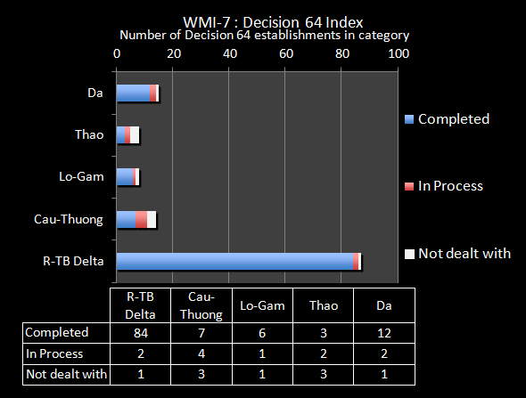

Figure 2‑31: Decision 64 establishments in the sub-basins

1. 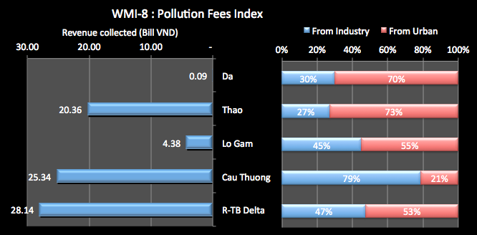Decree No. 67/2003 seeks to use pollutions charges to limit the environmental pollution caused by wastewater, to use clean water economically and to create a funding source for the Environmental Protection Fund - used to protect the environment and address the environmental pollution. The People's Councils decides on the specific rates of the environmental protection charges for domestic wastewater, but the rate must not exceed 10% of the non-VAT clean water selling price. The Finance Ministry coordinates with MoNRE in prescribing the charge rate for each pollutant in industrial wastewater. The Central budget receives 50% of the income, which is added to the operation capital of the Viet Nam Environmental Protection Fund under Prime Minister's Decision No. 82/2002. The local authorities receive the other 50% to be used for environmental protection, new investment projects, sewerage, dredging, and repair and maintenance of local water drainage systems. The Environment Protection Fund provides finances for environmental protection nationwide (but not for profit)[15].

Figure 2‑32: Pollution fees collected

In the survey of provinces seeking information for this report, a total of 78.32 billion VND pollution fees were collected – see Figure 2‑32. This shows that most of the fees are collected in the Delta sub-basin (36%). However, given the size of the population and industrial activity in that sub-basin, these fees appear relatively small compared to other sub-basins. The fees in the Delta sub-basin amount to 1,593VND per head of population, compared to 5,670 for the Cau-Thuong and 10,386 for the Thao sub-basin. Fees for the Da are only 53VND per head of population. Of the fees collected, about half comes from both industry and urban sources. In the Cau-Thuong sub-basin nearly 80% of fees come from industrial sources, which is probably appropriate. In contrast, in the Thao sun-basin 73% of the fees come from urban sources.

### Surface water assessment

1. Decree 102/2008/ND-CP deals with the collection, management, and exploitation and use of natural resources and environmental data. Decree 102 replaced Decree 162/2008003/ND-CP which dealt specifically with water resources data. Decree 102 addressed data for land use, water resources, geological and minerals, environmental, hydrometeorological, and marine and island natural resources and environment. Specifically for water resources, Decree 102 specified that this includes data on quantity and quality for surface and groundwater, hydro-geological survey, exploitation and use, river basins planning, management exploitation and protection, results from licensing for exploitation, exploration, and use; and water resources affecting element. Decree 102 also outlined several principles for data collection including that it be timely, accurate, and truthful. The decree also state that those using and exploiting data must fulfill financial obligations
2. MONRE oversees the national level water observation and monitoring networks through the National Centre for Hydro-Meteorology (NHCM). The National Hydro-Meteorological Service (NHMS) carries out basic meteorological, hydrological and air and water environmental observations, provides weather and hydrological forecasts, and specialized services in support of natural disaster prevention and preparedness. The NHMS is largely decentralized, with 9 regional hydro-meteorological centres across the country, and about 3,000 staff. NHMS is responsible for the Level 1 monitoring network, which in the RTBRB is made up of the following number of gauging stations.
3. Figure 2‑33 shows that there are 49 Level 1 gauging stations in the RTBRB, with 45% of these being in the Delta sub-basin. The Cau-Thuong sub-basin has only 3 stations, around 6% of the total. There is a long history of record for at least some of these stations providing good confidence in the data recorded.

|  |  |  |
| --- | --- | --- |
| Sub-basin | No Level 1 Stations | Monitoring.png |
| Da Sub-basin | 9 |
| Thao Sub-basin | 4 |
| Lo-Gam Sub-basin | 11 |
| Cau-Thuong Sub-basin | 3 |
| Red-Thai Binh Delta | 22 |
| Total for RTBRB | 49 |

Figure 2‑33: Level 1 gauging stations in the RTBRB

1. The overall data collection system for surface water quality and quality is uncoordinated, with multiple actors even within MoNRE with overlapping monitoring functions. NHMS monitors surface water quantity and quality (mainly for 5 parameters). The DWRM is also tasked with developing a national water resources database and information exchange. Supporting the DWRM is the Centre for Water Resources Data Management. There are plans now for this to begin. Also, the Environment Department undertakes periodic monitoring (perhaps 3 times a year) usually covering about 20 parameters. Environmental monitoring is also undertaken by the DONREs or Centres for Environmental Monitoring in each province. In addition, every five years, the PPCs are responsible for developing state of environment reports, which must be submitted to the Provincial People's Council and MONRE. Reports on the provincial status of water quality are also prepared by DONRE yearly. Water quality monitoring is also been undertaken on an ad-hoc basis by water resources planning institutes, usually for project specific needs. However, few of the monitoring results are shared.
2. There also appears to be excessive monitoring, mainly justified on the basis of historical continuity of data, not on the basis of 'data for purpose'. There are no information systems that allow water quantity and quality data to be geo-referenced and analyzed on their own or interfaced with other types of environmental data.
3. While this data does provide point source information on water quality, the usefulness of the data is limited because of uncertainties relating to monitoring program design and seasonal coverage and variability in analytical results. At best, the data provides an indication of ambient water quality at the time and point location at which sample were collected. Even so, through a combination of site visits, community complaints, point source monitoring and anecdotal evidence, the provincial DONREs have developed an overall picture of the main pollution sources and of the extent and seriousness of the problems.

### River basin planning for water resources management

1. Vietnam has a long history in attempting to create functional RBO type organizations beginning in 1961 with the Red River Committee for Water Management and Exploitation. The 1998 LWR assigned MARD the responsibility for river basin planning. In 2001, Decision 39/2001/QD-BNN-TCCB established the Planning Management Council for the Red-Thai Binh River Basin. Membership for the Planning Management Councils did not include membership at the local levels or other important mass organizations such as the Farmer’s Association or the Women’s Union. To date, the Planning Management Councils have failed to operate effectively.
2. In 2006, an overall scheme on protection and sustainable development of ecological environment and landscape of the Cau River Basin was passed in 2006. In 2007, Prime Minister’s Decree 171/2007/QD-TTg formerly established the first Environmental Protection Committee for the Cau River. The Environmental Protection Committee was established under the Law on Environmental Protection. The EPC was primarily focused on protecting the environment of a particular river basin. A similar arrangement was enacted with Decision 57/2008/QD-TTg which outlined the General scheme for environmental protection of the Nhue-Day River Basin. In 2009, an Environmental Protection Committee was established for the Day-Nhue River Basin. The Day-Nhue EPC operated for similar purposes as the other EPC. To date, the Environmental Protection Committees also failed to perform effectively due to a lack of projects to implement. Moreover, these organizations did not deal with IWRM issues but instead focused on the various water-related mandates of MARD – such as irrigation, flood protection, rural water supply, etc.
3. State management of river basins for water resources management is now the responsibility of MoNRE under the provisions of the LWR. The 2012 Law includes a strong emphasis on river basin planning and Decree 120/2008 sets out many of the water resources activities and processes.

Table 2‑4: Outline of River Basin Organization Experience in Vietnam

|  |  |  |
| --- | --- | --- |
| **Institution** | **Year** | **Responsibility** |
| Red River Committee for Water Management and Exploitation | 1961 | Flood prevention planning; water supply and drainage planning; transport planning; transport planning; hydropower planning; and general outline of master planning for exploitation |
| Planning Management Council for the Red-Thai Binh River Basin | 2001 | (MARD) River basin planning; inventory and assessment of WR; preparation and monitoring of implementation; and conflict resolution |
| Environmental Protection Committee (Cau and Day-Nhue River Sub-basins) | 2007-2008 | (MONRE) Project implementation for protecting the environment of a particular river basin |

1. Decree 120 stipulates that River Basin Organizations (RBOs) shall recommend measures to ensure the implementation and adjustment of river basin plans; recommend to related authorized agencies solutions over conflicts between state agencies, organizations, or individuals during the implementation of the river basin plan; and report annually to MONRE about the plan’s implementation. MONRE will have responsibility for overall monitoring and controlling the implementation of river basin plans and report to the Prime Minister annually on the implementation of basin plans nationally. According to Decree 120, Article 30, RBOs are to monitor and coordinate activities of ministries and sectors related to the implementation of river basin plans. RBOs are also to make proposals for policies and measures for water environment protection, water resources exploitation, utilization and development, and mitigation of damage caused by water in the river basin.
2. The 2012 LWR strengthened the river basin planning and management approach, but only slightly addressed the issue of River Basin Organizations. Article 24 states that RBOs shall have the responsibility to propose and recommend to the authorized state organizations the measures to ensure the implementation of the water resources plans; recommend the handling of the potential problems during the implementation of the water resources plans.
3. Article 72, which contains the majority of detail related to river basin organizations, pertains to the coordination and monitoring of all activities for exploitation, use and protection of water resources, prevention combat against and overcoming of the harms caused by water. Article 72 states that for river basins, river basin organizations are given an advisory role to make recommendations on the regulation and allocation of water sources; monitoring activities on exploitation, use and protection of water resources, and prevention and overcoming of water-related natural disasters. This deals specifically with interprovincial river basins. For provincial river basins, the provincial Peoples’ Committees will lead the regulation and allocation of water sources and monitoring activities. Provincial river basins are defined as river basins totally located with a single province.
4. Article 72 directs MONRE to unify the direction and coordination of activities of river basin organizations, PPCs agencies, and organizations in the regulation and allocation of water sources and related monitoring activities. The government is tasked with making regulations on the management, coordination and monitoring of water resources use; the protection and prevention of harm caused by water; and the organization and operation of RBOs.
5. Article 72 of the LWR gives the responsibility for coordination and monitoring to RBOs who are tasked with making recommendations for exploitation, use and protection of water resources, prevention, combat against and overcoming of the harms caused by water in one or more interprovincial basins.
6. MONRE has not established a River Basin Organization for the Red-Thai Binh River Basin, although the legal basis is now in place. The LWR states that the task of an RBO is primarily advisory “to make recommendations”; while the earlier Decree 120 states that the function of an RBO is to more active regarding monitoring and coordinating activities of ministries and sectors as related to river basin plans and to make recommendations of policies and measures to address water resource issues. These provisions have yet to be effectively applied.

### Data, Information and Analysis

1. The observation and monitoring network in the Red-Thai Binh River Basin is a complex system divided across different administrative levels and agencies. There are existing observation and monitoring networks, yet access to good data remains constrained. As data, information and analysis are fundamentally critical to effective river basin planning, this section reviews the legal and institutional setting.

### Legal setting for Data, Information and Analysis

1. According to Decree 25/2008/ND-CP in Article 2.6(f), MONRE is tasked “to build, manage and exploit a water resource observation network; to organize basic surveys on and inventory and assessment of water resources nationwide; to notify branches and localities of water source potential so that they can adopt master plans and plans to use water rationally, economically, and efficiently. This is supported by the LWR which states in Article 4(2) that it is a state policy to build water resources monitoring systems, information systems, and databases, in order to improve the capacity to forecast water resources, water source pollution, flood, drought, salinity intrusion, sea level rise, and other harm caused by water; to support water resources development; and water resources infrastructure development.
2. The LWR gives the Government, MONRE, and ministerial-level agencies the responsibility to “develop database and information system on water resources; manage and store data and information on water resources; publish documents and information on water resources; to conduct baseline surveys on water resources Article 70 2(h).” Article 8 of the LWR states that water resources information storage is a specialized archive. Article 8 further states that organizations and individuals must pay charges for using water resources information as determined by law.
3. Decree 102/2008/ND-CP deals with the collection, management, and exploitation and use of natural resources and environmental data. Specifically for water resources, Decree 102 specified that this included data on quantity and quality for surface and groundwater, hydro-geological survey, exploitation and use, river basins planning, management exploitation and protection, results from licensing for exploitation, exploration, and use; and water resources affecting element. Decree 102 also outlined several principles for data collection including that it be timely, accurate, and truthful. Importantly, the decree stated that those using and exploiting data must fulfill financial obligations.
4. Decree 120/2008/ND-CP on river basin management makes investment in basin level monitoring and assessment activities, networks, and databases a state priority. Specifically, river basin plans must assess water resources with a focus on water quantity and use in allocation plans as well as water quality for plans for the protection of water resources (Articles 14-16). Decree 120 specified MONRE as the lead government agency in the monitoring and assessment of water quality. Finally, Article 38 gives RBOs the responsibility to “organize the development of environment and water resources database and directory for a river basin.”
5. Decision 16/2007/QĐ-TTg dated January 29, 2007 on approval of the master plan for a national monitoring network for natural resources and the environment by 2020. Decision 16 specifies several principles for a network, including that it make best use of existing infrastructure. Investment in the network should be focused and be suitable with socio-economic conditions and requirements of resources and environmental protection. The proposed network should be of modern quality but in line with staff capabilities. Decision 16 states that the monitoring network is to be an opened system, continuously updated, and upgraded to ensure data is online and can be shared from central to local levels with the governance from MONRE.
6. The provides ample guidance and authority for establishing and operating an observation and monitoring system. It should be noted that there is a difference between observation and monitoring systems. Observation stations simply collect normal data, while monitoring stations are expressly monitoring conditions to identify problems that might arise. During the course of the project, it became apparent that there may be some reluctance toward monitoring stations for this reason. Moreover, the monitoring and observation stations are operated by different divisions under MONRE. Finally, Article 8 in the LWR that requires fees for the use of data and information may severely constraint the use of collected data, which would serve to undermine its value.

### Institutional Situation for Data, Information, and Analysis

1. This section provides a brief overview of the institutional setup for data, information and analysis in the field of water resources. Figure 2‑34 presents a map of the monitoring and observation sites in Vietnam.

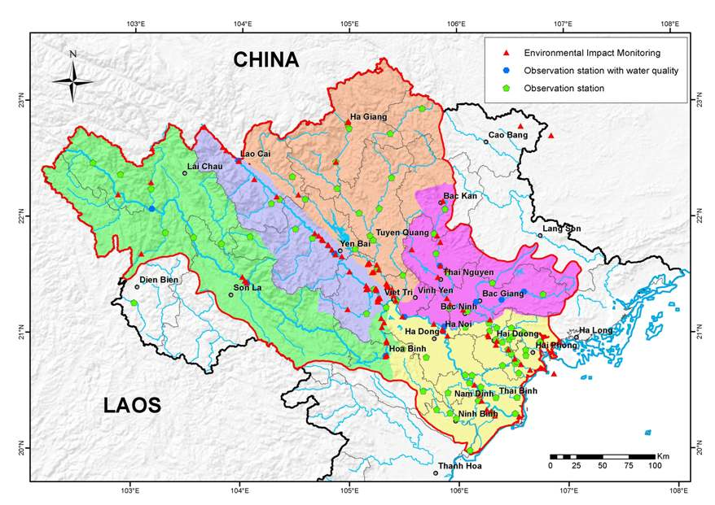

Figure 2‑34: Observation and Monitoring Stations in The RTBRB

1. MONRE is the ministry responsible for fulfilling the statement management function for water resources in Vietnam has specified in the Law on Water Resources. There are two major divisions under MONRE that are relevant to water resources data and information: the Department of Water Resources management (DWRM) and the Vietnam Environment Administration (VEA). The Department of Water Resources Management. According to Decision 600/2003/QD-BTNMT, the overall function of the DWRM is to assist the Minister in the state management of surface and groundwater resources in Vietnam. The DWRM is to compile data, manage results of basic investigations, inventories and assessments of water resources. The DWRM is also tasked with developing a national water resources database and information exchange. Supporting the DWRM is the Center for Water Resources Data Management.
2. The national level river observation network is maintained The Center for Hydrology, Meteorology, and Environment Network (CHMEN). As stipulated in Decision 758/2008/KTTVQG, CHMEN is an administrative organization of the National Hydrological and Meteorological Center (NHMC) under MONRE. CHMEN has the responsibility to assist NCHM to direct and organize implementation of baseline surveys for hydrology and meteorology. Some relevant tasks of the HMENC include, among other tasks:

* Assist with strategy, planning, plans on the baseline surveys of hydro-met and water environment monitoring and direct and organize the implementation.
* Involve in directing and organizing the development of national hydro-met station network and water environment monitoring network.
* Inspect the implementation of Regional Centers for hydro-met regarding to analysis of the environment, and assessment and classification of baseline surveys’ quality in hydro-met and environment.
* Direct and coordinate with units under the NCHM to conduct hydro-met measurements, to supply data for forecasts and warnings for flood diversion and retention in the Red river system to ensure safety for Hanoi capital city.
* Implement tasks regarding to analysis of content of suspended matter and samples of water environment for various Regional centers including those covering the Red-Thai Binh River Basin.

1. Data collected by HMENC is archived with a different agency. Accessing the historical records requires both authorized permission and the payment of a fee. The list of hydrometeorology observation stations maintained by HMENC is listed in Annex C and presented in Figure 2‑34. There are 8 observations stations planned to monitor hydrometeorology along Vietnam’s border where rivers are shared internationally.
2. At the national level, the National Hydrological and Meteorological Center (NHMC) under MONRE, operates and maintains the monitoring stations that collect data on rainfall, stream flow, water level, water temperature, turbidity, water quality. The HDMC stores and maintains meteorological archives including specialized hydro-meteorological data collected from the measuring stations across the country. The hydro-meteorological data base and is used to meet the specialized hydro-meteorological data and information needs for scientific research, hydropower, ports, bridges, roads and other public infrastructure projects of the country.
3. The archives include the following types of documents:

* Rainfall document: For rainfall, there are 1,800 points measured with an average of 10-15 years of data.
* Surface meteorological document: Since 1880-1930, there are 52 stations and in 1930-1955 there were 211 stations. From 1956 to now, there are 250 stations. The meteorological factors include temperature, humidity, pressure, precipitation, sunshine, wind, evaporation and other weather phenomena.
* Hydrological documents: From years 1902-1954 224 stations and from 1955 to now, there are 236 of which 128 stations are in unaffected tidal areas and 108 tidal stations are in affected areas. Hydrological factors are frequently exploited as: water, water flow, turbidity, suspended matter flow meter, water temperature and extracted floods etc.
* Meteorological documents for agriculture: Since 1955 to now, there are about 27 stations. The data is used mainly by crop research institutes and agricultural university students.
* Customs document text: Since 1955 to now, there are about 26 stations including stations with relatively long operation periods, such as Hon Dau station (since 1902). Measured factors include wave direction and wave height, water level, water temperature, salinity, sea level, sea state, etc.

1. The National Center for Hydro-Meteorological Forecasting (NCHMF) is an operational unit under the National Hydro-meteorological Service of MONRE. The NCHMF carries out hydro-meteorological forecasting and implements specialized hydro-meteorological telecommunication networks for the whole country to meet requirements for the disaster prevention and preparedness. The NCHMF is responsible for providing various hydro-meteorological forecasts to meet the growing requirements of socio-economic activities. Hazardous weather warnings are transmitted to Governmental Authorities, which are responsible for organizing and guiding the disaster prevention and preparedness for the people.
2. The Vietnam Environment Administration (VEA) was established according to the Decision 132/2008/QĐ-TTg. The purpose of the VEA is to advise and assist the Minister of MONRE in the field of environmental management and to provide public services in compliance with the laws. Some main functions include:

* Protecting the environment in river basins and handling environmental pollution hot-spots.
* Developing the master plan for national environmental monitoring network; developing and managing national environmental data, environmental statistics; formulating environmental status reports.
* Implementing nationwide survey, inventory, monitoring, assessment of biodiversity;
* Establishing, managing, utilizing, and developing environmental database, data and environmental information system.
* Assessing inter-provincial or trans-boundary degraded ecosystems and proposing measures to conserve, rehabilitate, and maintain sustainable use of biological resources.

1. The Center for Environmental Monitoring (CEM) maintains and is expanding a network of environmental status and impact monitoring sites. CEM collects data under the auspices of the Vietnam Environmental Administration. The monitoring network is based on master planning prescribed by Decision 16 and incorporates the various QCVN standards issued by MONRE. The CEM network shares NHMC and various provincial sites. The purpose of the network as established in Decision 526 On approval of General Monitoring Program on Red-Thai Binh river basin and Da river water environment for period of 2012-2016. This general monitoring program conducts annual monitoring of the surface water environment to provide data in support of the management and protection of the water environment management in the Red-Thai Binh and Da river basins. The program aims to monitor the water quality in whole basin and identify urgent environmental issues in order to propose solutions for the protection of water environment in the river basin.
2. The general program for the Red-Thai Binh and Da River Basins has 108 monitoring points identified, with 80 of these functioning in 2012 due to budgetary limitations. CEM chooses monitoring sites to include river sections that:

* Receive water from neighboring countries;
* Are polluted;
* Are “hot spots” (e.g. areas highly active with industry, agriculture, transportation, natural mineral exploitation, etc.);
* Are near or on boundaries between provinces/cities;
* Are locations where water is exploited for domestic supply; and,
* Receive water from river tributaries.

1. Annex D presents the list of monitoring sites as listed in Decision 526. A summary of CEM’s full monitoring system for the Red-Thai Binh and Da River Basins is given below:

Table 2‑5: Environmental Monitoring Points for Red-Thai Binh and Da River Systems

|  |  |  |  |
| --- | --- | --- | --- |
| **Monitoring area** | **Number of monitoring points by type of monitoring** | | |
| **Basic physical & chemistry** | **Biology** | **Bottom deposit** |
| Red river | 56 | 56 | 15 |
| Lo river | 16 | 16 | 4 |
| Ninh Co river | 1 | 1 | 01 |
| Nam Thi river | 1 | 1 | 01 |
| Cau river | 10 | 10 | 5 |
| Thai Binh river | 8 | 8 | 2 |
| Da river | 14 | 14 | 6 |
| **Total** | **108** | **108** | **34** |

1. The Center for Environment Information and Data (CEID) is responsible to design, integrate, process, manage, store, total up, preserve, exploit and develop databases, documentations and national environment information system for state and community management. The CEID supports the development and applications of information technology, databases and environment information system for common use of the offices, departments under the VEA and the environment state-management agencies of the provinces, cities. A key function of CEID is to design and develop environment data and database standards; set up strategies, development planning, annual, 5-year and long-term plans for the development of the environment databases, information systems and documentations of the VEA.
2. Provincial Water Monitoring: The provinces also maintain their own networking system. The LWR authorizes the various Provincial People’s Committee to develop database; manage and store data and information on water resources (Article 71 1(h)). These systems are decided and maintained by the local People’s Committees. The data that is collected is maintained at the provincial level. If the NHMC needs data from the province, they must pay a fee to obtain it.
3. Water Monitoring in China: During the course of the project, it was repeatedly noted that there was a lack of hydrometeorology data for the Chinese portion of the Red-Thai Binh River. Despite a history of limited data sharing and an international agreement that expired in 2006, there is currently no formal agreement with China for full and timely sharing of water resources data. Since 2001, the Chinese have provided data to Vietnam for four stations during the annual flood season from June 15 to September 30. The data includes water level, stream flow, and rainfall (Δt = 6 h) only during the flood season. The stations include two stations on the Da River (Central Ai Kieu (54001) and Ly Tien Do (54002) and two stations on the Thao River (Nguyen Giang (54011) and Man Hao (54012). The limited availability of data hampers the forecasting and modeling abilities within Vietnam.

### Hydrological and Water Quality Data, Standards, and Technical Guidelines

1. In addition to basic hydrological data, there are a variety of technical guidelines for water quality and waste water discharge standards. The technical guidelines establish quantitative standards for a variety of parameters and identify technical standards for measuring the various parameters. Decision 16 outlines the water quality parameters for surface water environment monitoring for the national natural resources and environment observation network. Decision 526 outlines a set of parameters to be measured for the general monitoring program for the Red-Thai Binh and Da River systems. Finally, QCVN 08:2008/BTNMT establishes parameters as standards for measuring surface water quality. A comparison of the parameters is presented in Annex E. QCVN 08:2008/BTNMT also establishes a classification system for water quality, defined as:

### Licensing

1. Under the LWR, it is illegal to exploit and use water without a water licence. Decree No.149/2004/ND-CP covers the licensing of exploration, abstraction and use of water resources and the discharge of wastewater and Circular 2/2005//TT-BTNMT guides its implementation, as required under the Law. However, these regulatory instruments may need to be revised with the recent approval of the revised LWR.

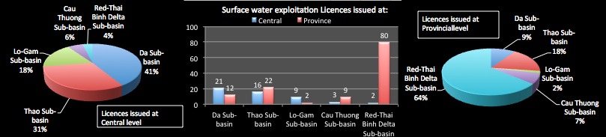

Figure 2‑35: Licences for surface water exploitation and use issued in the RTBRB

1. Under Decree 149, major licences are issued at Central level by MoNRE and other licences are issued by the Provinces (the DoNREs). In practice very few licences have been issued compared to the number of businesses/organizations exploiting and using water. A survey of provinces was undertaken to assess the extent of licensing in the RTBRB, and for surface water the results are shown in Figure 2‑35. A total of 176 licenses have been issued for the exploitation and use of surface water, 51 at central level and 125 at Provincial level. At Central level the majority of licenses have been issued in the Da Sub-basin (44%) with only 2 licenses issued in the Delta sub-basin. The Provincial level licenses have concentrated on the Delta area, accounting for 64% of licenses issued. At this level, only 2 licenses have been issued for the Lo-Gam sub-basin. The combined Central and Provincial data shows that nearly half of the licenses issued are in the Delta sub-basin.
2. The results of the survey of provinces undertaken for this project in relation to wastewater discharge licensing are shown in Figure 2‑36. A total of 224 wastewater discharge licenses have been issued, 217 of which were issued at Provincial level. Of the 7 licenses issued at Central level, 4 are in the Delta sub-basin. Not surprisingly, most of the Provincial licenses are also issued in the Delta – 114, or 53% of the Provincial total. There are also 74 licenses issued in the Cau-Thuong sub-basin. There are only a total of 3 wastewater discharge licenses issued in the Lo-Gam sub-basin.

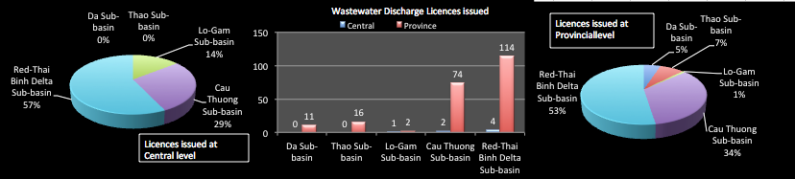

Figure 2‑36: Licences for wastewater discharge issued for the RTBRB

### Regulation and allocations of water resources

1. Current water allocation practices have generally evolved to serve local interests and a limited range of objectives. The cumulative long-term impacts of these practices on river health and on third party interests is generally not appreciated or factored into management. Current practices have also been developed at a time when private sector involvement in the development and use of water and pressures on the resource were much less than today and for the future. Very limited explicit policy has been developed and comprehensive water allocation arrangements have not been put in place.
2. The consequences are that water is often not explicitly shared out, it is just taken, and the water sharing decisions that are made are often dominated by immediate concerns about water shortages. Rights to water are not defined, making business investment decisions inefficient and the application of licensing measures very difficult. Decisions that are taken are administrative decisions of the GoV. to ensure critical supplies, rather than decisions based on good policy backed by water allocations plans and strong licensing provisions. Preparation of river allocation plans does not happen, but is now a part of the revised LWR, and protection of the environment and communities that depend on a healthy river can be given effect.
3. The main mechanisms for water allocation can be found in Decree 120/2008/ND-CP on River Basin Management which grants MONRE authority to carry out river basin planning and management. It further specifies that chief tasks for river basin management include determining measures for water resource protection and for preventing and overcoming damages caused by water in river basins. Decree 120 further states that river basin management has the tasks to regulate and allocation water resources and maintain minimum flows.
4. Decree 149/2004/ND-CP deals with permitting for exploration, exploitation and use of surface water, while Decision 17/2006/QD-BTNMT addresses licensing the underground water exploration, exploitation and drilling practice. These two decrees grant MONRE the authority and provide a licensing mechanism to regulate and control the allocation and use of water. Finally, Decree 112/2008/ND-CP deals with the management, protection and integrated exploitation of resources and environment of hydropower and irrigation reservoirs. Decree 112 is important as it puts into law a real call to integrate and coordinate water management between sectors. People and organizations holding a right to use and exploit water resources have the right to use data and information on water resources Article 43 1(d), LWR 2012 while also having the legal obligation to provide data and information relevant to their use of water as requested by the responsible State authorities (Article 43 2(f)). They also have an obligation to facilitate scientific research activities authorized by the State.
5. The main mechanisms for protection of water resources include the Law on Environmental Protection. Decree 149/2004/ND-CP deals with permits for discharge of wastewater into water sources. Decree 149 is the key mechanism for MONRE’s ability to regulate wastewater discharge and prevent or control pollution of water sources. Decision 64/2003/QD-TTg provides a specific plan for handling establishments which cause serious environmental management, including specifying the 4,295 establishments to be handled. Decree 88/2007/ND-CP addresses urban and industrial park water drainage. Decree 88 assigns MONRE the responsibility for state management of environmental protection with water drainage activities. Decree 67/2003/ND-CP established Environmental Protection Charges for wastewater, which gives MONRE an economic instrument to help regulate wastewater within sustainable limits. The LWR requires that people having the legal right to discharge waste water into a water source provide adequate and honest data and information on their waste water discharge as required by the authorized State organizations (Article 38 2(e)). Decree 120, Article 22 specified that ministries, ministerial level agencies, governmental agencies, Provincial People’s Committees, and state owned companies and economic corporations would have responsibility for monitoring waste water discharge. Finally, a set of water quality standards has been issued, two pertinent ones which are QCVN 8: Surface Water Quality Standards and QCVN 38 Surface Water Quality for Protection of Aquatic Life. These two regulations provide a list of testable parameters and legal limits for satisfied the given use purposes.

## Surface water issues

1. International dependency on water inflows. In order to effectively plan for the management and distribution of the water resources of the RTBRB, Viet Nam needs medium to long term clarity about water inflows from China, both quantity and quality. This is a significant risk to supply, and therefore economic and social security in the medium to long term. The upper sub-basins receive large quantities of water from China – as much as 56% for the Thao sub-basin - which they in turn pass substantial water to the Delta sub-basin.
2. The serious lack of data and information on water resources & water use. The lack of good-quality water data is proving a major impediment to decision-making, and is seriously impeding the application of IWRM in the Basin. The Government has approved a monitoring plan to the year 2020, the financing of this plan is currently being developed through an ADB loan. However, getting this underway is still some years off. The major issues are:
3. *Overlapping roles and responsibilities*. The roles and responsibilities of NHCM, DWRM and the environment agency for monitoring are not clear, and there is potential for overlap and duplication. A clear delineation of mandates and activities within MoNRE is required.
4. *Data sharing*. Data coordination and sharing in Viet Nam is very poor. The systems are not in place to share data on the water resources themselves, their behaviour, extraction, or licensing status. The culture within organisations militates against data sharing, despite attempts to overcome this through legal documents.
5. *IWRM focused data and information*. Existing monitoring stations have been established for the era of water resources development – construction of dams, irrigation systems, water supply for industrialisation and dyke construction. New systems are required to meet a future of IWRM requirements, including more accurate monitoring of international river flows, of flows between the sub-basins, of variations and trends in flows and their seasonality, of water quality, of environmental health, of water extractions from rivers, of return flows and their quality, and to be able to link socio-economic information with water resources information;
6. *Forecasting and modelling*. The projected scale of climate change impacts on the RTBRB makes it critical that the water resources monitoring system can provide accurate forecasts of imminent events, and can also provide long term trend analysis. Increasingly, hydrologic and catchment models will become an important water resource management tool. Without reliable data to populate these models, they are all but useless.
7. *Planning.* Monitoring both the water resource, and the exploitation of the resource (structures and extraction volumes, and wastewater discharge), provide the foundation for all water resource management activities. Without monitoring information, Viet Nam cannot plan for future development, and cannot protect existing environmental, social and economic values.
8. *Monitoring of water extraction volumes*. This does not currently occur – water for irrigation comprises around 80% of surface water use, yet the water volume used for irrigation is not measured. Without an understanding of the actual extractions, it is very difficult to assess the response of the rivers to stress, particularly in dry seasons and therefore to assess the real exploitation potential. It is also important to ensure compliance with licence conditions, once these are imposed.
9. Protecting areas of high water productivity. The Da and Lo-Gam sub-basins are the areas of the higher water productivity. This needs to be protected through watershed management activities to protect the value of these sources of water.
10. The Delta sub-basin is heavily dependent on through-flows of water from other sub-basins. The water naturally generated within the area of the Delta is totally insufficient for the population and to meet the water uses in the Delta. Approximately 95% of the water in the upper sub-basins naturally flows to the Delta and this is essential for the water security of the Delta and the populations and economic activity that now exist there. However, this water is not plentiful compared to the demands. Analysis shows that in the dry season only a 2% reduction of inflows to the Delta sub-basin would take the dry season water availability down to the adequate water level (so that any further reduction would mean less than adequate water at current levels of population). At 2025 populations the dry season water availability is already below the adequate water level - increasing shortages and conflicts over access to water.
11. Low level of dry season water availability will cause increasing conflicts. According to international standards, the overall dry season water availability for the RTBRB is low – at less than the adequate water level. At projected 2025 populations the Basin would be at about the dry season water shortage level. For the Cau-Thuong the dry season water availability under the current population is already at levels of serious concern, meaning increasing water shortages and scarcity, and conflicts over access to water. The Delta situation is discussed in the previous paragraph. With significant population growth forecast for most of the Basin, and rapid economic development, dry season surface water availability is an increasingly critical issue, both for people, and for the health of river systems that support social and economic values.
12. Sustainable limits to water extraction have not been set. The Cau-Thuong is also in a critical situation because of the large amount of water exploitation compared to the available water. At current levels of dry season water exploitation and available water, the sub-basin is in the high exploitation stress range, with 88% of the available water being required to meet the demands. At 2025, if no remedial action is taken, over 100% of the available water in the dry season would be required to support water exploitation, producing irredeemable stress on the river system and the communities that depend on the water sources of the sub-basin. The Delta sub-basin is also in the moderate stress range in the dry season. With the Cau-Thuong and the Delta sub-basins classified as stressed in the dry season, there is now an urgent need to define the sustainable limits of water extraction in each sub-basin, and to manage total extractions to within those limits, particularly for the Cau-Thuong. Without such action, new developments may be undertaken for which there is simply not enough water. Increasing amounts of extraction in already stressed systems will undermine the water security to existing uses, and put further stress on the water and ecosystems that underpin the existing economic and social values and activities in the Basin. No action will result in rapidly deteriorating river systems and inefficient and wasted investment.
13. Water security is being threatened by the drive for energy security. The reservoirs in the upper sub-basins are large (50% of Viet Nam’s total storage) and can significantly impact on the flows to the Delta. There is currently no formal agreement on their operation, particularly in the dry season. Careful management of these is required to ensure that water security to the Delta is not being jeopardised by too great a focus on energy security.
14. Surface water exploitation issues. There are a number of issues associated with managing exploitation. These include:
15. Water regulation and allocation measures and procedures are not in place to effectively manage access to water*.* Currently, water sharing is only undertaken as an emergency measure in times of ‘drought’ – very limited explicit policy for sharing water has been developed and comprehensive water sharing arrangements are not in place. The consequences are that water is generally not explicitly shared out - it is just taken - and water sharing decisions that are made are often dominated by immediate concerns and quick fix solutions to deal with shortages. However, the so-called ‘droughts’ of the Cau-Thuong and the Delta are occurring more and more often as a result of over-exploitation in the dry season. With the level of exploitation in these two sub-basins, active water allocation, as provided for under Article 54 of the LWR, is now needed in the dry season. For the Delta this may involve protecting the through-flow of water from the upper sub-basins, and for the Cau-Thuong a formal water allocation proves to share the water that is available in the river systems at any time, coupled to programs of water efficiency and optimization of water use. Only with effective regulation and allocation can ‘*water for living’* be protected in practice (as required by the LWR), and can water users understand the supply risks associated with water shortages, and prepare accordingly. Ideally, water allocation strategies should be examined as part of a planning process at the river basin scale. In the absence of plans, however, the government should have in place policies and practice for allocating river flows in times of water shortage, under Article 54.
16. There are currently no means to control water extractions or diversions. Water resource availability issues, including impacts on other uses or the environment of the Basin are only narrowly considered in the early phases of development planning processes. There is still an assumption for the RTBRB that water resources are plentiful, and that water resource availability and impacts will not be a constraining factor to continuing development. Currently, very few major extractions/diversions from rivers, nor major structures on rivers, are licensed. Any licensing of extractions or structures that is occurring is happening well after the development ‘decisions’ have been made, or even after the development is in place. The ability to influence or condition the exploitation at this stage is very limited. Hydropower licensing is a case in point where the water license application is submitted well after the decisions on plant operations are made. The operating rules of the plant, which form part of the license, are approved by the Ministry of Industry and Trade before the license application is made, leaving MoNRE with little opportunity to introduce conditions dealing with the needs of lower river communities or river system sustainability. In terms of achieving greater water security in the RTBRB, MoNRE must be able to more significantly assess all major projects that will impact on water resources quantity and quality, in accordance with the LWR.
17. Water pollution is increasing and is not being effectively controlled. Water quality deterioration is probably the greatest single environmental issue facing Viet Nam. The human health and livelihood consequences of pollution of surface waters and groundwater are significant but poorly understood. There is no comprehensive picture of the extent and scale of pollution. Yet there is growing community concern about the increasing levels of pollution and the impact this has on people’s lives. Once polluted, waters are extremely difficult and costly to clean up, and the impacts on dependent ecosystems, as well as dependent social and economic values, will be felt for a long time by the entire community, but particularly by poor and vulnerable communities that have a direct dependency on these resources. The water quality impacts of the various sectors are discussed in the following chapters of this report. However, there are no clear and coordinated national approaches or strategies to deal with pollution.
18. There is a great lack of awareness of water resource and the various interactions with people. At both the central government and provincial levels, there is generally very poor appreciation of water resource management issues, in particular the need to integrate consideration of these into assessment of development proposals, and to plan and manage in an integrated way to optimize the benefits for all. Impacts on the resources themselves, on other users and the environment are not understood and considered. Regulatory requirements, such as the need to obtain licenses for water exploitation, are not well known by government agencies or private industry. At the community level, there is even less awareness of the need to conserve and protect Viet Nam’s water resources. The NWRS found that “*public awareness and consciousness in protecting and preserving the resource is still limited. The poor result in this area hinders the participation of the entire society in the protection of water resources*”.

# Groundwater

1. There are large quantities of good quality groundwater in the RTBRB. However, the overall groundwater resources are poorly assessed and understood. Much of the information presented in this analysis is based on fragmented information, developed over many years in different projects. See Annex A for a map and summary charts.

## Groundwater occurrence

### Groundwater areas

1. 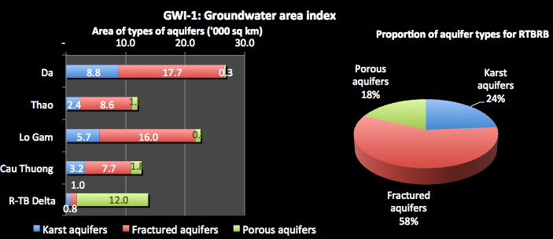The total groundwater area in the Basin is estimated at 87,880 km2. Fractured rock aquifers are the most common aquifer type, comprising over 50,000 km2 or 58% of the total aquifer area – see
2. Figure 3‑1. This aquifer type dominates the aquifer areas in the upper sub-basins. However, the Delta is dominated by porous aquifers formed through the deposition of sands and gravels over the centuries.

Figure 3‑1: Areas of aquifer types

### Groundwater recharge

1. For the sustainable management of groundwater, the ‘groundwater potential’ or the dynamic reserve or natural recharge to the Basin’s aquifers is the key measure for water exploitation. Recharge is generally assessed based on a number of factors such as rainfall, infiltration rates in the areas, the groundwater flow rate, and others. It is a detailed technical assessment based on methodologies that are commonly used. It is made difficult in Viet Nam because of lack of basic data.
2. The natural recharge to the aquifers in the RTBRB is estimated at over 31 billion m3 a year. Most of this recharge occurs in the Da sub-basin (36%), with only 7% in the Cau-Thuong sub-basin – see Figure 3‑2. For the Delta, 86% of the recharge (nearly 5 billion m3 a year) occurs to the porous aquifers. In the other sub-basins around 60% of the recharge is to the fractured rock aquifers, which receives 55% of the total recharge (karst receives 28% and porous aquifers 17%). Most of the recharge to the karst aquifers is in the Da Sub-basin (4.5 billion m3 a year). Notable, the Cau-Thuong sub-basin, which is highly stressed for surface water, does not receive much groundwater recharge – less that 2.3 billion m3 a year.
3. 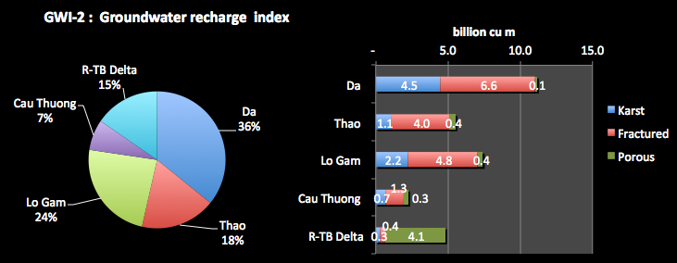The aquifer areas and the recharge to them can be combined to determine which locations produce the most recharge to groundwater. This is shown in Figure 3‑3, which indicates high recharge potential for the aquifers in the Da, Thao and Lo-Gam sub-basins, with lesser potential in the Delta. The Cau-Thuong sub-basin has a relatively low recharge potential for all aquifer types.

Figure 3‑2: Natural recharge of aquifers

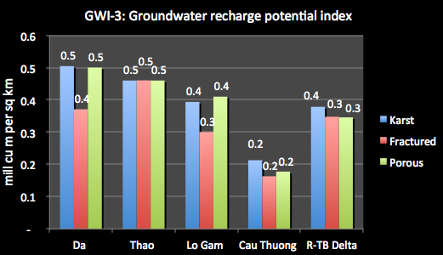

Figure 3‑3: Groundwater recharge potential (recharge per unit area)

### Groundwater availability

1. The groundwater exploitation capacity of the RTBRB is assessed at almost 11.5 billion m3 a year. Note that this exploitation capacity is only about 9% of the total surface water volume of the RTBRB.
2. The majority of the exploitation capacity is from the karst aquifers (42%). The exploitation capacity for the other aquifer types is fairly uniform. Most of the exploitation capacity is in the Da sub-basin, which amounts to 3.3 billion m3 (36% of the total). The Lo-Gam sub-basin has the second highest level of exploitation capacity, with the Cau-Thuong only a very small exploitation capacity – see 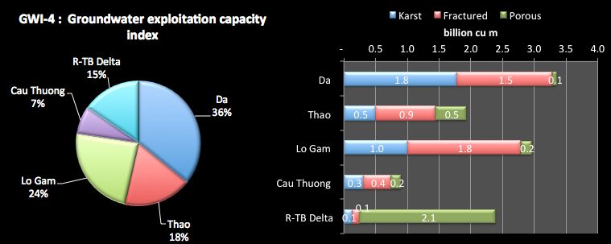Figure 3‑4. The exploitation capacity for the karst and fractured aquifers is about the same in the Da sub-basin, but fractured aquifers have greater capacity in the Thao, Lo-Gam and Cau-Thuong sub-basins. In the Delta, porous aquifers have by far the greatest capacity.

Figure 3‑4: Groundwater exploitation capacity

1. Groundwater sustainability is a critical factor and this can be determined by considering the natural recharge compared to the exploitation capacity of the aquifer. A proportion greater than 100% is mining the groundwater, meaning that the groundwater of the aquifer is being extracted at greater than the recharge rate, which means that water is being taken from the aquifer storage volume, which may not be replaced. For a sustainable aquifer system, the assessed exploitation capacity should be less that the natural recharge, recognizing that some of the recharge is required to sustain aquifer processes and some surface environment such as wetlands, and provide low flows to some rivers. In some countries a general level of 70% is taken as the default ratio. The proportion must be determined by groundwater specialists taking into account the characteristics of the aquifer (permeability, transmissivity, recharges mechanisms, groundwater flow and surface connections, etc.).
2. 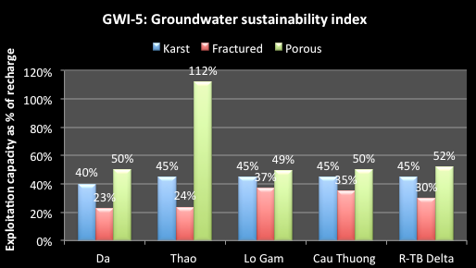Figure 3‑5 shows the results, with most sub-basin and aquifer types at or below 50%, which is suggesting that most groundwater use is sustainable. The clear exception is for the Thao sub-basin, which is at 112%. This is because of induced recharge in that river system. There are strong connections between the river and the aquifer and the significant withdrawals actually induce more recharge than would occur naturally. It must also be remembered that this indicator is calculated as aquifer averages. There will be some areas of intense water exploitation where the current levels of extraction are not sustainable and are resulting in lowering water levels.

Figure 3‑5: Groundwater sustainability

1. As with surface water, groundwater availability can be expressed in terms of the water volume available per head of population. The same international standards for water availability can apply here, as set out in Figure 2‑10. However, they are indicative only as groundwater is seldom used solely to meet water demands – river flows provide a much greater part of the water. Figure 3‑6 shows that Da sub-basin has by far the greatest availability, with the Delta and Cau-Thuong having very little groundwater capacity per capita. Groundwater could not on its own support the populations in the sub-basins, and this will be even less so in the future. However, groundwater is a very important resource in many specific locations.

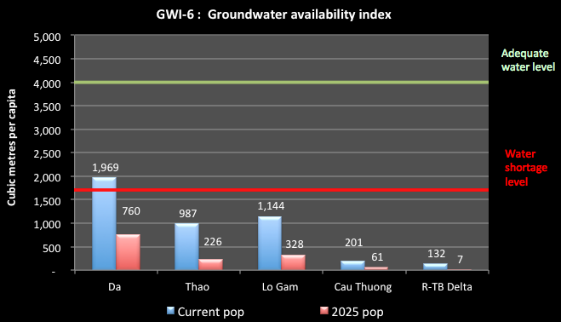

Figure 3‑6: Groundwater availability per capita

### Groundwater exploitation

1. Current groundwater use is currently estimated at 1.18 billion m3 a year. Nearly 70% of the use is in the Delta sub-basin, and 15% in the Da – see Figure 3‑7. The other sub-basins have only a small proportion of the total use.

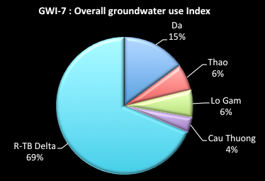

Figure 3‑7: Overall groundwater use by Sub-basin

1. Figure 3‑8 shows the proportion of the groundwater use within each of the sub-basins. It indicates that the Delta sub-basin accounts for 69% of the use, showing the importance of groundwater in the area. Although it has substantial groundwater resources, the Da sub-basin has relatively small use – only 15% of the overall total. The Cau-Thuong has the smallest proportion of use at only 4%. About half of the use is for rural water supply (602 million m3 a year) – see Figure 3‑8. The remaining use is shared between urban use and industry. In the Delta sub-basin, there is also substantial use made of groundwater for urban water supply (for Hanoi) and for industrial development.

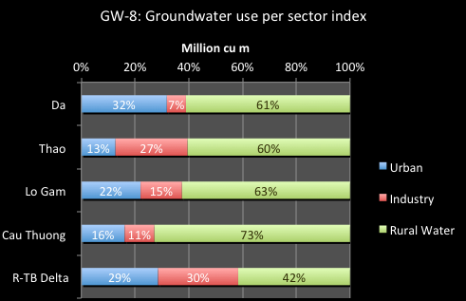

Figure 3‑8: Groundwater use per sector

1. 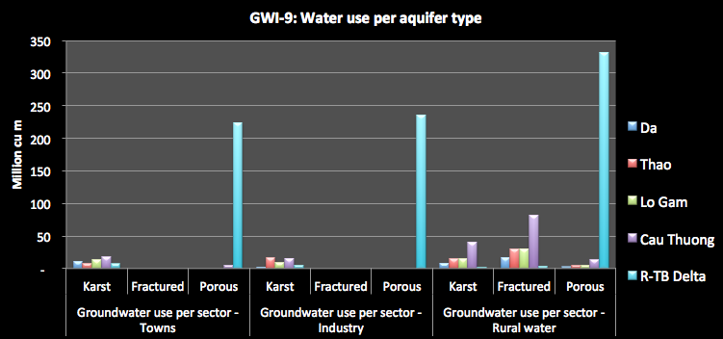Figure 3‑9 shows groundwater use per sector and per aquifer type. This clearly demonstrates: the significant groundwater use in the Delta compared to the other sub-basins; the dominance of rural water supply as the water use purpose, from all aquifer types and locations; the importance of the karst aquifers in the upper sub-basins; and the use of fractured rocks in the Delta but not in the other sub-basins.

Figure 3‑9: Water use per sector and per aquifer type

1. In the future, groundwater use is expected to increase in all sub-basins, but more particularly in the Delta – see

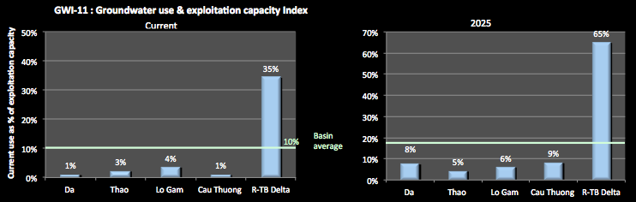Figure 3‑10. This increased use in the Delta will bring the use to around 65% of the exploitation capacity – same figure. Given that the recharge is spread out over the areas of the aquifer, such high levels of use is likely to mean very intense use at the local level and drawdown of the water levels unless there is very careful management of extractions. For all other sub-basins, the increase in use does not threaten the resource.

Figure 3‑10: Groundwater Use and Exploitation Capacity Index

1. 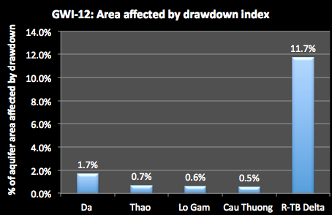The level of groundwater drawdown of the aquifers is shown in Figure 3‑11. All sub-basins are affected by lowering water levels to some extent. Although for most sub-basins this issue appears small, the analysis shows that there are areas in all sub-basins where lowering of water levels without recovery through natural process is already occurring. This means that the aquifer is being mined in some localities, and aquifer storage is being extracted. Extraction will progressively cost more (higher pumping cost), the likelihood of drawing in poor quality water increases, and land use impacts can result, such as compaction and settlement. This is worst in the Delta where lowering water tables around Hanoi now extend to an area of over 1,600km2. Studies have shown a water level depletion of 8 m and 14 m in two measured areas, and this is on going. This has resulted in a threat to the sustainable supply of water for Hanoi, and land subsidence on the southern bank of the Red River. Of the 91 monitoring bores, 17 have shown water level lowering of up to 10% and a further 8 have shown a water level lowering of up to 40%.

Figure 3‑11: Area affected by drawdown

### Groundwater quality

1. Degradation of aquifers by a variety of land use activities is a common and growing problem affecting many people, particularly the poor who generally depend on natural water sources for their water supply. Pollution is coming from inappropriate handling and disposal of solid and liquid wastes, particularly in urban areas and industrial parks, contamination from poorly constructed bores and wells, and contamination of drinking water supplies from sewage (septic pits). This is particularly a problem in rural areas, and can have major public health implications. Contaminated aquifers are extremely difficult and expensive to reverse, and in some cases this may be impossible. Preventing the degradation of aquifer quality is the best, and in many cases the only, option for successful management.
2. Inorganic arsenic and manganese are the most widespread elemental contaminants of potable water around the world. Being mainly of natural (geogenic) origin, arsenic and manganese are released from sediments in the subsurface as a result of unfavourable geochemical conditions and can occur in groundwater at concentrations of more than 1000 micrograms per litre of water. Arsenic leads to chronic poisoning if ingested regularly in small doses and is an acute problem in Viet Nam. Manifestations of chronic arsenic poisoning are severe health problems, such as skin lesions, hyperkeratosis, melanosis, skin cancer and cancer of internal organs. Manganese is particularly harmful for newborns and children as it hampers the intellectual development of the child.[16]
3. Groundwater in the Delta sub-basin (Ha Nam and Nam Dinh provinces and parts of Hanoi) are seriously polluted with arsenic, covering an area of over 2,500 km2. In Hanoi, groundwater polluted with arsenic has been found since 1996. Of some 165,000 samples tested, 31,048 have had an arsenic concentration greater than 0.05 mg/l, the Vietnamese standard, and a further 26,722 recorded levels of between the standard and 0.01 mg/l, the WHO standard. Samples are hundreds of times greater than the WHO standard. All other sub-basins have some record of arsenic contamination above the standard – 4 samples in the Da, 2 in the Thoa, 7 in the Lo-Gam and 30 in the Cau-Thuong.
4. The Eawag study[17] notes that, to identify safe and unsafe areas over the entire Red River delta, a large-scale hydrogeochemical groundwater survey was launched in 2005. It included the analysis of arsenic, manganese, selenium, boron, iron, salinity, phosphate, ammonium, sulphate, dissolved organic carbon, and 30 further chemical parameters. Concentration maps and arsenic risk modelling suggest that several million inhabitants of the Red River delta are at risk of chronic arsenic and/or manganese poisoning. The data, maps and figures available on the website are based on comprehensive groundwater analysis and risk modelling (2D and 3D) of the Red River delta.
5. Figure 3‑12 shows the level of arsenic pollution in the Delta prepared by Eawag. The proliferation of ‘red dots’ showing extremely high levels of contamination is of major concern. According to the MOH, at present, 21% of the National population has used arsenic contaminated water which is at higher contamination level than the standard. Arsenic contaminated water has caused obvious and severe impacts on people. According to a study of the National Institute of Occupational and Environmental Health, 4.6% of people have skin problems leading to color change; 32% of people have blood vessel disease; 32% of population have symptoms of reproductive disorder; 4% of people using arsenic contaminated water over 3 years have tumours.

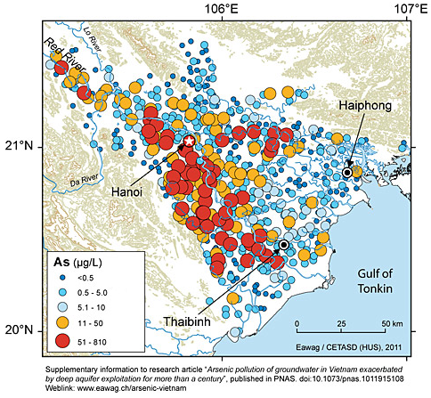

Figure 3‑12: Eawag figure for arsenic in groundwater for the Delta

1. Figure 3‑13 shows the magnesium concentrations (note that the drinking water standard is 0.1 mg/l) and there are many results showing contamination levels many times greater than the standard.

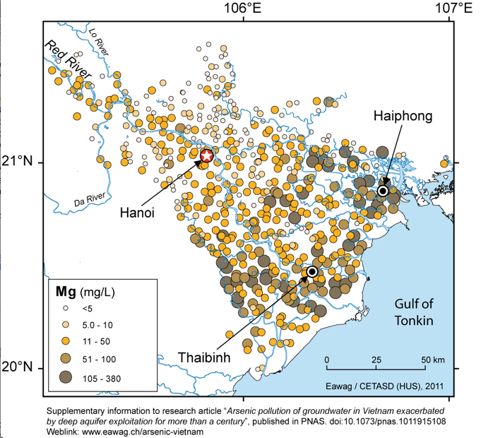

Figure 3‑13: Eawag figure for magnesium contamination for the Delta

1. Figure 3‑14 shows the lead contamination (for which the drinking water standard is 0.05 mg/l). Given the impacts of lead on human life, the high levels of contamination across the delta are of major concern.

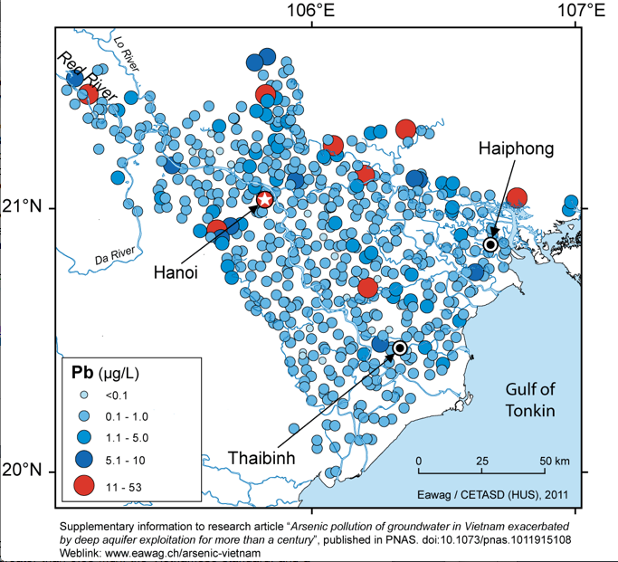

Figure 3‑14: Eawag figure for lead contamination in the Delta

1. Salinity is only a problem in the Delta sub-basin, where over 5,100 km2 are affected (Figure 3‑15 shows the electrical conductivity levels). Irrigating with water that has excess amounts of salt can adversely impact soil structure, making plant growth difficult. Highly saline and sodic water qualities can cause problems for irrigation, depending on the type and amount of salts present, the soil type being irrigated, the specific plant species and growth stage, and the amount of water able to pass through the root zone.

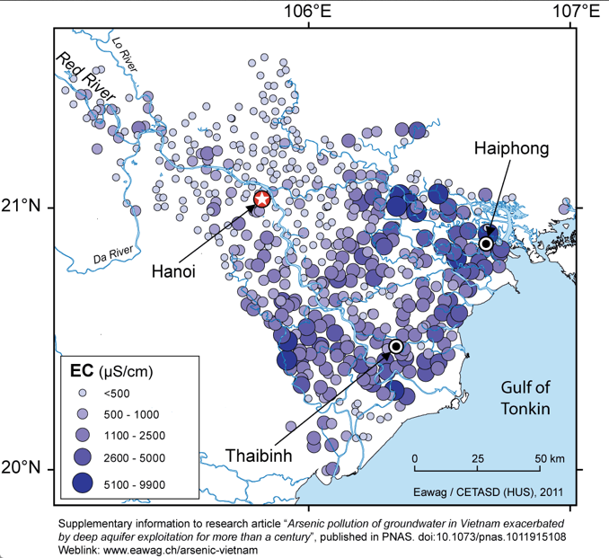

Figure 3‑15: Eawag figure for EC levels in Delta groundwater bores

## Groundwater management

### Legislation

1. The LWR 2012 establishes a stronger framework for State administration and protection of groundwater, and confirms with ownership of groundwater resources lies with the people, under the unified management of the State. MoNRE Decision 13/2008QD-BTNMT dated 31/12/2008 regulates the preparation of geological survey maps.
2. The function of state management of groundwater resources is undertaken by the Groundwater Bureau within the Department of Water Resource Management within MoNRE. The primary groundwater management tools in the LWR and associated regulations include licensing of groundwater exploitation, groundwater quality protection measures, and monitoring and compliance (sanction) powers. The Department of Geology within MoNRE also has three hydrogeological and engineering units including one in the North to cover the RTBRB, which undertake groundwater investigations and mapping. Each unit has about 400 staff. Provincial governments (and their DoNREs) also exercise functions under the LWR. The provincial DoNREs are responsible for implementation of state groundwater management on behalf of the provincial peoples committee. In most provinces, there are no groundwater professionals.

### Groundwater assessment

1. In Viet Nam the groundwater monitoring system includes types of 3 networks: the national network, provincial network and monitoring at groundwater exploitation works.
2. Before 2007, the National network of groundwater monitoring was established in the three areas: Red River Delta, Southern Delta and Central Highland. In 2007 the GoV approved a new National network for water resources basic survey, including surface and groundwater monitoring. The number of National level groundwater monitoring stations and works is showed in Table 3‑1.

Table 3‑1: Groundwater monitoring stations in the RTBRB area

|  |  |  |  |  |  |  |
| --- | --- | --- | --- | --- | --- | --- |
| Region | Total stations and works | | Number of station and works at 2007 | | Number of planed station and work (2007 – 2020) | |
|  | **Station** | **Works** | **Station** | **Works** | **Station** | **Works** |
| Northwest Viet Nam | 23 | 28 | 0 | 0 | 23 | 28 |
| Northeast Viet Nam | 36 | 56 | 0 | 0 | 36 | 56 |
| Red River delta | 144 | 318 | 108 | 210 | 59 | 84 |

1. Some provinces have established a local groundwater monitoring network, including Hanoi. The monitoring network of Hanoi includes 120 observation boreholes and has been in operation for about 20 year. Most of the monitoring network was established in 1998 to 2000.
2. The Northern network was started in January 1982, but most stations and works were installed in 1990-1992. The observation frequency of water levels in Northern and Southern areas are that one observation is carried out every 3 days in the wet season and every 5 day in the dry season, for areas not affected by the ocean tide. The frequency is every 2 hours for areas with tidal influence). Other than water level, the observation norms are temperature, chemical composition and flow (where appropriate). Chemical composition is assessed twice per year and the following norms are analysed: Na, K, Ca. Mg, NH4, Al, Cl, SO4, HCO3, CO3, NO2, NO3, PO4, hardness, SiO2 and TDS and pH. The water level and temperature are measured by hand; some monitoring boreholes are now monitored automatically.
3. Observation records are summarized and filed at the office located at the Planning and Investigation Water Resources Centre, with annually reports being provided to Department of Water Resources Management and the Provincial departments. At provincial level, the Environment Monitoring Centre implements the management and operation of the monitoring network. Management and sharing of provincial monitoring data is not good, and few records are provided to the Department of Water Resources Management.

### Groundwater planning

1. Planning for the sustainable use and for the protection of groundwater resources on an aquifer basis has not yet occurred in Viet Nam. Some provinces may do some local planning but it has not occurred on a comprehensive aquifer basis. Neither has planning for the conjunctive use of groundwater and surface water.

### Licensing of water exploitation

1. Decree No.149/2004/ND-CP covers the licensing of exploration, abstraction and use of water resources, including groundwater, and and Circular 2/2005//TT-BTNMT guides its implementation. However, these regulatory instruments may need to be revised with the recent approval of the LWR. Under the Decree, major licences are issued at Central level by MoNRE and other licences are issued by the Provinces (the DoNREs). In practice very few licences have been issued compared to the number of businesses/organisations exploiting groundwater. A survey of provinces was undertaken to assess the extent of licensing in the RTBRB, and the results for groundwater are shown in Figure 3‑16. A total of 494 licences have been issued for the exploitation and use of groundwater, 12 at central level, all for the Delta sub-basin, and 482 at Provincial level. The Provincial level licences have also been concentrated on the Delta area, accounting for 64% of licences issued. Only 2 licences have been issued for the Lo-Gam sub-basin. The combined Central and Provincial data shows that nearly 70% of the licences issued are in the Delta sub-basin.

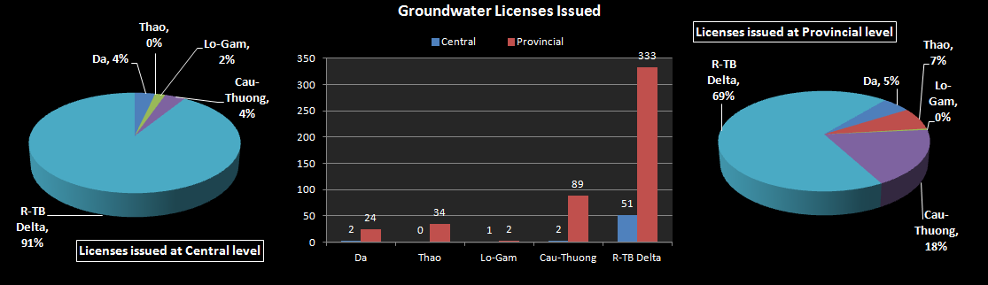

Figure 3‑16: Licences for groundwater exploitation and use issued in the RTBRB

### Regulation and allocations of groundwater resources

1. Current groundwater allocation practices have generally evolved to serve local interests and a limited range of objectives. The cumulative long-term impacts of these practices on aquifer sustainability (especially water table levels) and on third party interests is generally not appreciated or factored into decisions. There are no policies for fairly sharing groundwater resources between the different users. Bores and wells are simply constructed and the water pumped, with the impact on other users not considered. The consequences are that groundwater is not explicitly allocated, it is just taken. People who want access to groundwater simply drill a bore and start extraction. Rights to groundwater are not defined, making business investment decisions inefficient and the application of licensing measures very difficult.

## Groundwater quantity issues

1. Only a very small proportion of the Basin’s groundwater resources have been assessed in any detail. Only in the Delta have there been any substantial assessment, and even in these regions the availability of good quality data is low. A priority must be to provide a greater understanding of the groundwater potential of the Cau-Thuong sub-basin, given the potential water constraints it faces. Groundwater survey and monitoring issues include:
2. *Characterisation of resources*. While the very general geological structures in the Basin are known, the location and characteristics of the water bearing zones (aquifers) are poorly understood, particularly in the mountainous and coastal regions. Better characterisation is required if groundwater resources are to be developed sustainably, and supplies, particularly for domestic uses, are to be assured.
3. *Monitoring groundwater status and behaviour*. Monitoring networks are inadequate to support groundwater resource management activities, including assessment of natural recharge, licensing and water sharing, and water quality protection. This is particularly a problem in dry years, and in areas where extraction is increasing, and where there is potential for saline intrusion. The new monitoring strategy approved by the Government plans to improve this situation, and funding for the strategy is likely to be via an ADB loan, which is still a few years off. The quality of the monitoring data currently collected is also questionable, particularly the groundwater quality data. Laboratory test results are not reliable, and many of the laboratories do not have ISO certification.
4. *Monitoring of water extraction volumes*. This does not currently occur. Without an understanding of the actual extractions, it is very difficult to assess the response of the aquifers to stress, and therefore to assess its real extraction potential. It is also important to ensure compliance with licence conditions, once these are imposed.
5. *Data sharing*. Data coordination and sharing in Viet Nam is very poor. The systems are not in place to share data on the groundwater resources themselves, their behaviour, extraction, or licensing status. The culture within organisations militates against data sharing, despite attempts to overcome this through legal documents. Very few monitoring records of the provincial monitoring are provided to central level.
6. Most groundwater bores are not registered or licenced. Vietnamese authorities have no record or registration of bores or wells – neither numbers of bores/wells not their location is know, and very few are licensed (less than 500 out of the thousands thought to exist in the RTBRB).
7. Unregulated drilling and abandonment of wells. Although there is a legal requirement for drillers to be licensed, this mechanism is not effective in controlling the drilling of new bores/wells. Additionally, there are no regulations for guiding and controlling the closing of abandoned wells, increasing the risk for aquifer contamination. If a bore/well is not properly sealed, then this forms a good conduit for many forms of stormwater or wastewater to enter the aquifer, carrying with it all manner of contaminants.
8. Groundwater is not planned on a comprehensive aquifer basis. For the Da, Thao and Lo-Gam sub-basins this may not be an issue as the use is very small compared to the exploitation capacity, and groundwater quality is currently not a major issue. For the Delta this appears to be an urgent requirement. However, a suitable model for integrated groundwater management planning that addresses the issues identified in this report on a system (aquifer or group of aquifers) basis, including extraction limits, water sharing, water level management, management of impacts on rivers and other dependent ecosystems, and water quality protection, has not yet been developed.
9. Water availability/sustainable levels of extraction at an aquifer scale. The assessed exploitation capacities for the RTBRB are only estimates at this stage. They are assessed for very large areas and are generally based on rainfall recharge assumptions or back-calculated from measured river discharge. The figures are broad scale and do not recognise that groundwater extractions are often concentrated in much smaller areas, and that there is significant risk of more local water level declines, and interference between extraction bores. There is currently little delineation of groundwater resources at a finer level. The assessed exploitation capacity is currently much less than the natural recharge, which is consistent with good IWRM practice. There is now an urgent need to define the sustainable limits of groundwater extraction in the Delta and Cau-Thuong sub-basins, and to manage total extractions within those limits. Without such action, new developments may be undertaken for which there is simply not enough water. Increasing amounts of extraction in already stressed aquifers will undermine the reliability of supply to existing uses and increase their pumping costs, and put further stress on the groundwater and ecosystems that underpin existing economic and social values and activities. If no action is taken, this will result in inefficient and wasted investments into the future.
10. Groundwater quality protection:
11. *Land use activities*. Viet Nam faces major challenges associated with contamination of shallow groundwater by industries, agricultural pesticide and fertiliser use, aquaculture activities, mining, and waste disposal. While no detailed scientific assessment has been undertaken, the areas most “vulnerable‟ to the effects of groundwater pollution, are those where the aquifers are unconfined, the concentration of these potentially polluting activities is high, and where communities and cities are dependent on groundwater as a source of drinking water supply. This is particularly the case in the Delta sub-basin, and the Cau-Thuong. Once groundwater is contaminated, it is very difficult to clean up, and the costs are very high. If not avoided or remedied, groundwater pollution not only poses a major threat to public health, but also to other activities and industries that require good quality groundwater for use. Ecosystems dependent on groundwater discharge (such as rivers and wetlands), and the economic and social values in turn dependent on these (such as tourism and fisheries), will also be affected. Groundwater vulnerability to contamination is not considered in socio-economic development plans of the State, provinces or local authorities. With the exception of large landfills, the impacts of individual developments on groundwater quality are rarely assessed during the EIA process.
12. *Bore construction and abandonment*. Poorly constructed and abandoned bores and wells for exploitation, mining exploration, and geological investigations can act as a conduit for contaminants, or allow salty water to mix with fresh groundwater resources. With many thousands of bores and wells in the RTBRB, this can be a major threat to groundwater quality. Regulations on bore drilling and abandonment, as well as drillers licensing, have been issued, but are rarely followed, and implementation at the provincial level is very slow. Technical standards are yet to be approved. Many drillers are not licensed and drilling supervision by Provincial authorities is very poor.
13. *Salinity intrusion and contamination*. Over exploitation of groundwater in some areas is causing intrusion of salt water into the freshwater groundwater reserves, making them unusable for many purposes – see Figure 3‑15. In all coastal areas this is particularly a problem, with movement of the marine/freshwater interface. In other areas, the salt water may be contained in other groundwater units above, below, or adjacent to the fresh groundwater resources. Aquaculture in some areas, as well as mineral sands extraction processes, use sea water for their operations. These activities are taking place on top of fresh groundwater reserves, and the use of salt water can contaminate the limited fresh groundwater resources.
14. *Arsenic contamination*. In Hanoi, water level declines are also causing increased concentrations of arsenic in the deeper aquifers from which the public water supply is drawn (being drawn into these from the shallow aquifers). In other mountainous areas, arsenic concentrations have increased as a result of mining activities. Currently, the arsenic is being removed from known contaminated supplies by filtration. While this approach does not achieve the WHO standard of 0.001mg/l for drinking water, it substantially reduces arsenic concentrations to below 0.005mhg/l (the Vietnamese standard). In areas where high arsenic concentrations are not accompanied by high iron concentrations, the arsenic is not successfully removed by filtration. In these areas alternative drinking water supplies or alternative methods of arsenic removal need to be explored.
15. Integrating groundwater considerations into broad socio-economic development planning. Groundwater resource availability and vulnerability to pollution is not being considered in the socio-economic development planning of the State, Ministries, provinces, or local authorities, resulting in potential investment in unsustainable development.
16. The water scarcity for domestic use in mountainous areas. In limestone mountainous areas, surface water resources are very limited, and groundwater is often available. However, the groundwater dynamics and storage characteristics of these aquifers are very complicated, and have not been investigated. This has resulted in water scarcity for domestic use and production, particularly at high mountainous areas, as at Meo Vac (Ha Giang) and Luc Khu (Cao Bang).
17. Investments. Levels of investments in groundwater investigation and management are low. Significant investment is made in the activities that rely on groundwater in the Basin, be they water supply for cities and towns, or for other uses and other purposes. The important groundwater resources on which they rely are largely ignored, assuming that the water will simply continue to be there. This is a very high-risk approach to take to development and water resource management.
18. Awareness. At both the central government and provincial levels, there is generally very poor appreciation of groundwater management issues, in particular the need to consider groundwater in socio-economic development plans, and to integrate consideration groundwater quality and quantity issues into assessment of development proposals. Impacts on the aquifers, other users and the environment are not understood and considered. Regulatory requirements, such as the need to obtain licenses for groundwater exploitation, are not well know by government agencies or private industry. At the community level, there is even less awareness of the need to conserve and protect groundwater resources, and of the impacts people’s day to day activities may have on groundwater.
19. Strengthening legal/administrative frameworks. This is a particular issue for groundwater resource management. The existing legal and administrative frameworks are currently inadequate. Current legal gaps include: regulations for groundwater quality protection, for groundwater planning, and groundwater fees and charges; technical norms for groundwater exploration, investigation, assessment and monitoring, on well construction, and on exploitation thresholds. The new LWR provides a much stronger platform for overall groundwater management but in many areas supporting provisions for its implementation is urgently required.
20. State water management capacity. State groundwater management capacity is currently very limited. The groundwater bureau within DWRM is far too small in number and capacity to undertake the significant tasks assigned to it. The provincial groundwater resource management capacity is very low in all provinces. This means that licensing assessment, as well as assessment of development proposals for impacts on groundwater resources is not being undertaken. The inspection of groundwater resources exploitation and licensing compliance is very limited even at the central level. The reason is the lack of human and associated resources.

# Socio-Economic Development of the basin

1. In planning for the management of the water resources of the RTBRB, it is important to understand the relationship between the social and economic conditions in the Basin, and the sub-basins, and their linkages to water resources and the provision of basic water services. See Annex A for a map and summary charts.

## Social Development

1. Understanding the population dynamics is important to water resources management for a number of reasons. Firstly, populations put pressure on water resources in terms of both the demand for the use of water and the pollution and degradation they cause. Secondly, by the demand for high cost infrastructure-based water services such as water supply and sanitation, irrigation, drainage, flood protection, etc. Thirdly, by the demand for other water dependent services such as electricity generation. Aspects such as population numbers and their locations, growth, density, age structure etc. are all important considerations for water resources management.

### Populations and birth rates

1. 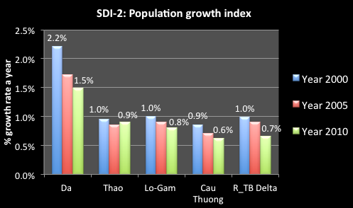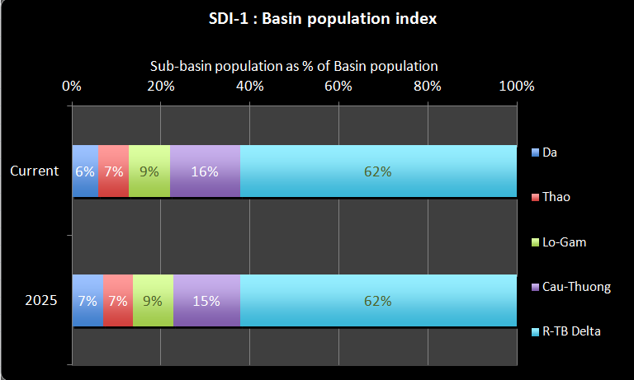The total population of the RTBRB is 28.4 million people (at 2010). Most of those live in the Delta sub-basin (62%) – see Figure 4‑1. While the 3 western sub-basins host a relatively small part of the population (less than 10% each), the Cau-Thuong has 16% of the people, and this is projected to grow to 20% by 2025. Given its water scarcity situation, this level of population growth will increase the stress on the water resources of the sub-basin.

Figure 4‑1: Populations

1. Figure 4‑2 shows the changes in the population growth rates of the sub-basins from 2002 to 2010. These have declined in all sub-basins. The significance of this change can be appreciated when we think of population growth rate in terms of its "doubling time." A growth rate of 2%, if maintained, would double a population in 35 years, but a rate of 1.4% would require 50 years. At present the highest growth rates are in the Da sub-basin, which is more than twice the rate for the Delta.

Figure 4‑2: Population growth rates

1. 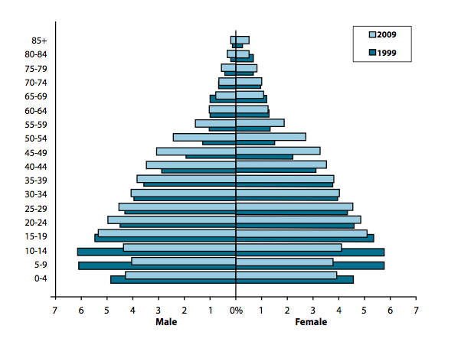The age-sex structure of the population would vary greatly across the Basin overall. Viet Nam has recently made the demographic transition from high to low fertility and mortality. The proportion of children declined while the proportion of the elderly increased – see Figure 4‑3. Whereas in 1990 the age groups 10 to 14 and 5 to 9 dominated (around 6%), by 2009 the 15 to 19 age group was dominant. In rural areas, the proportion of the age group 15–19 is highest and is much higher than in the adjacent age groups. In urban areas, the age group 20–24 is largest but only slightly higher than adjacent age groups[18]. The age-sex structure of the 3 western sub-basins would be more like the 1990 pyramid, whereas the Delta sub-basin would be more like that of 2000. The Cau-Thuong sub-basin would be somewhat in the middle.

Figure 4‑3: Viet Nam age and sex structure

### Ethnicity

1. Viet Nam has 54 ethnic groups and encompassing seven major language families found from western Asia to the Pacific. The Kinh or Viet (ethnic Vietnamese) is the largest group, accounting for 86% of the population. The next largest are the Tay, the Thai, the Muong, the Khmer (ethnic Cambodian), the Hoa (ethnic Chinese), and the Hmong, which together represent 10% of the population, and the remaining ethnic groups make up 4% of the population. The largest minority group, the Tay, has nearly 1.5 million people, while the smallest, the O Du, has barely 300. 75% of minority populations live in two regions, the Northern Mountains and Central Highlands, and most minorities remain rural residents.
2. 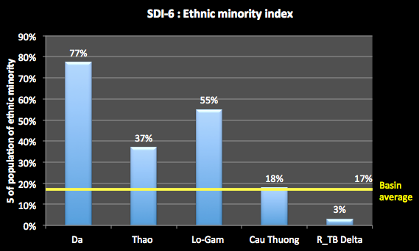Despite government assistance efforts, these groups still lag behind in living and there are concerns that ethnic minority groups are subject to stereotypes that portray them negatively as backward, superstitious, and conservative. The World Bank[19] identifies six areas where ethnic minorities have a disadvantage compared with ethnic majorities, including lower levels of education; less mobility; less access to financial services; less productive lands; lower market access; and stereotyping and other cultural barriers.

Figure 4‑4: Ethnic minorities

1. Figure 4‑4 shows that 77% of the population of the Da sub-basin is of an ethnic minority group, and 55% in the Lo-Gam. The RTBRB average is 17%, and the Delta sub-basin is well below this at 3%.

### Migration[20]

1. While the migrant population is a small proportion of the population, the absolute number of migrants is large. Nationally, of the more than 78 million people aged 5 and older in 2009, 2.1% or about 1.6 million people were intra-district migrants, 2.2% or 1.7 million people were inter-district migrants, 4.3% or 3.4 million people were inter-provincial migrants, and only 0.1% or 40,990 people were immigrants. There has been an increasing migration trend over the last two decades. A clear increase is evident in the size of the inter-provincial migrant population, which increased to 3.4 million people by 2009 (4.3% of the population), from 2 million people in 1999 and 1.3 million in 1989. Figure 4‑5 shows the migration within and from the Basin regions between 2004 and 2009. For example, it shows that there were 195,317 people who lived in provinces in the Red River Delta in 2004 and had migrated to the South East region by 2009. Over that time 338,093 people has moved to different provinces within the Delta. This demonstrates the high significance of migration on the RTBRB.

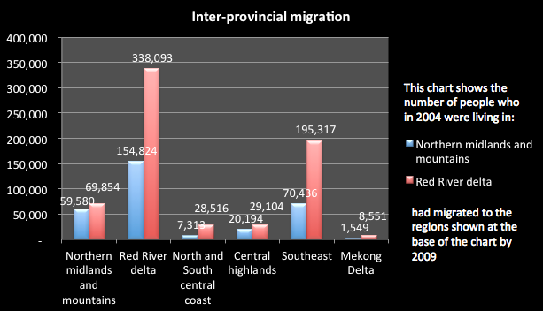

Figure 4‑5: Inter-provincial migration

1. Urban areas are the beneficiaries of the migration. Figure 4‑6 shows the urban-rural migration in the regions covering the RTBRB for 2009. For example this shows that 495,427 people left rural provinces in the Red River Delta in that year. The net result was that about 200,000 people migrated from rural areas to urban areas that year. In the sub-basins, about 80% to 85% of the populations live in rural area, except for the Delta where the percentage is 71%. In many regional countries, more than half the population already live in urban areas, and this is where much of Viet Nam is heading.

The proportion of women in the migrant population has continuously increased over the last two decades. As early as 1989, females already accounted for more than half of intra-district and inter-district migrant populations. By 2009, there were more females than males in all migrant population groups.

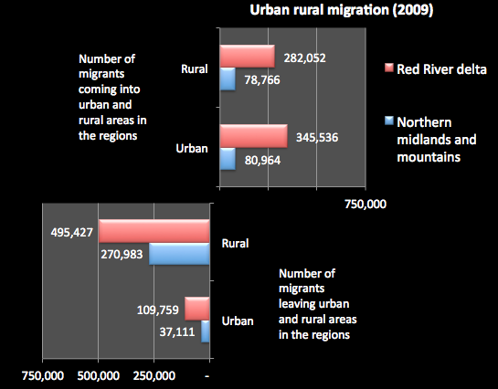

Figure 4‑6: Urban-rural inter-provincial migration (2009)

### Population density

1. Population density is one of the key pressure indicators on water resources and their associated environments. Population density varies across the economic zones, with the Red River Delta over 3.5 times the national average, suggesting great pressure on the water resources of the area. Figure 4‑7 shows the population density of the sub-basins and as expected the Delta is well above the Basin average. In Hanoi City, the density is even greater at 1,962 people per km2. This compares to 3,530 people per km2 for HCMC, around 14,450 for Jakarta, 7,400 for Beijing, 6,415 for Hong Kong and 4,478 for Bangkok. As Hanoi’s population density is below the levels of some regional cities, there is still time to create a much more sustainable city for the ongoing development of Hanoi. However, some immediate actions are required - already in Hanoi some river sections are considered “dead” rivers, unable to support any life, and this is expected to worsen as populations increase.[21]

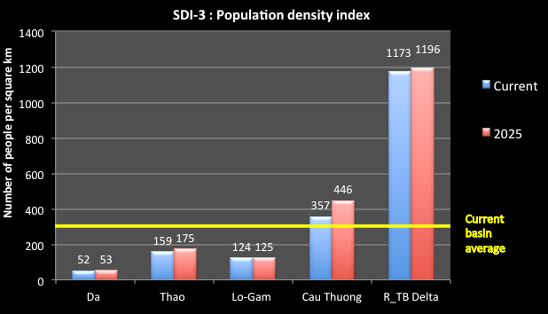

Figure 4‑7: Population density

### Poverty

1. Poverty in Viet Nam has been significantly declining. The high political commitment of the government in fighting poverty and hunger has resulted in the poverty rate declining from 58.1% in 1993, to 20.2% by 2005 and 9.45% by 2010. However, the incidence of poverty varies significantly across regions. While ethnic minority groups account for only half of the total population, they make up more than half of the poor. In 2006, ethnic Vietnamese experienced a poverty rate of only 10%, while other ethnic groups averaged a 52% poverty rate. Rates of hunger and food poverty remain higher among minorities as well.[22]
2. Figure 4‑8 shows that while the Delta sub-basin has more people living in poverty (nearly 1.5 million), the Da has more persistent poverty with nearly 40% of households affected. In the Da sub-basin, the poverty affected people are likely to be scattered and living in remote areas, making it difficult to assist them. The Lo-Gam also faces a difficult poverty situation with over 800,000 people and nearly a third of households affected by poverty.

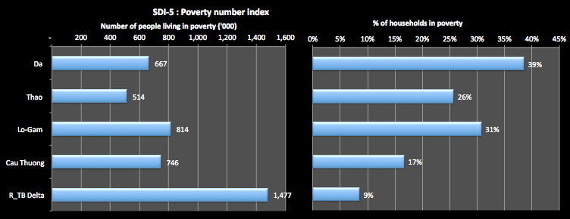

Figure 4‑8: Poverty - people and households

## Economic Development

1. Economic development impacts on water resources in a number of ways. Economic growth generally depends on access to water
2. Viet Nam has achieved rapid economic growth over the past two decades by continuously implementing market-oriented reforms. With average annual GDP growth of 6.6% from 2007 to 2011, Viet Nam’s GDP per capita rose from $642 in 2005 to $1,169 in 2010.[23]  The IMF ranks Viet Nam 132 out of 183 countries in terms of GDP per capita, above neighbours Laos and Cambodia, but below India, Philippines and Indonesia. [24]. The country is now classified as a lower middle-income country (MIC).

### Gross Domestic Product

1. Viet Nam’s GDP has increased over 47-fold since 1990, to a current value of 1,980,914 billion dong. The total for the RTBRB is 649,366 billion dong, a third of the national total. As expected, most of the GDP – 72% - is provided by the Delta sub-basin – see Figure 4‑9. The Cau-Thuong provides 15% of GDP and the other sub-basins less that 10% each.
2. 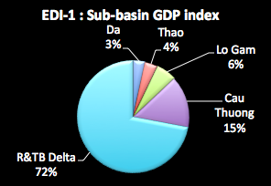The GDP per capita is often used as an indicator of standard of living, with higher per capita GDP being interpreted as having a higher standard of living. The international average is about 223 million VND per person. The national average and the RTBRB average are about 22.8 million dong per capita. The figures for the sub-basins are shown in Figure 4‑10. As expected, the Delta sub-basin has the highest level, with the Cau-Thuong also high. The other sub-basins are much smaller, meaning a lower standard of living overall.

Figure 4‑9: GDP contribution by the sub-basins

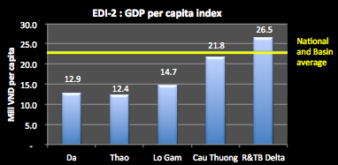

Figure 4‑10: GDP per capita

1. The GDP growth rate for Viet Nam has recently been at around 7% a year[25]. However, the RTBRB has a growth rate at twice that level – see Figure 4‑11. The Lo-Gam and the Cau-Thuong have the highest rate, higher than the Delta sub-basin.

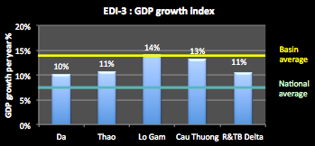

Figure 4‑11: GDP growth rate (constant 1994 prices)

### Economic structure

1. Nationally, agriculture, forestry and fishing make up about 21% of GDP, industry and construction 41% and services 38%. The economic structure of the RTBRB is shown in Figure 4‑12.
2. The GDP of the Delta sub-basin dominates the picture, where the industrial sector provides 44% of the total and agriculture provides only 15%. The Cau-Thuong is interesting as it has a very high proportion of its GDP from industry (54%) and a relatively small proportion from services (36%). The Da has the highest proportion from agriculture, at 35%.

### Macintosh HD:Users:Des:Desktop:Screen Shot 2012-08-29 at 2.21.52 PM.png

Figure 4‑12: Economic structure

### Employment

1. Nationally, the employment contribution of the agricultural sector in total employment remains very high (54% in 2009), and quite disproportionate to its contribution to GDP (17%). It remains high compared to that of the neighbouring countries. While there has been general economic growth in Viet Nam over the last decade, the diversification of sources of income in rural areas has been minimal.[26]
2. Figure 4‑13 shows the employment structure of the sub-basins. The Da sub-basin is quite striking in that, of those people employed, 83% are employed in agriculture despite the fact that agriculture only contributes 35% to GDP. In many respects, the economic structure of this sub-basin is more like the Viet Nam structure of 1990 than that of today. As well, employment in the agriculture sector in the Delta sub-basin remains at 51% with agriculture providing only 15% of GDP.

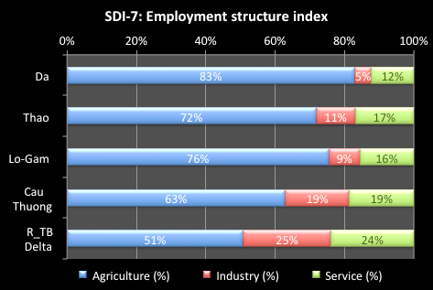

Figure 4‑13: Structure of Employment

1. Recorded unemployment is very low in Viet Nam at between 2%-3%. In the RTBRB, unemployment ranges widely between the sub-basins and between urban and rural areas. The highest rate is for the rural areas of the Delta sub-basins at 3.8% - see Figure 4‑14. As expected, unemployment is generally greater in rural area. However, even in the Da sub-basins, overall unemployment is a small rate.

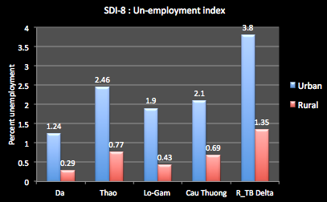

Figure 4‑14: Unemployment Index

# WATER RELATED SECTORS: STATUS & MAJOR ISSUES

## Urban water supply and sanitation

### Urban administrative units

1. Urban areas in Viet Nam are classified in two ways: (i) by administration, and (ii) by hierarchy. Nationally, at 2011, the administrative classification involved 778 urban units (not including wards) included 5 cities directly under central government and 47 urban districts within those, 103 cities and towns under provincial government, and the remaining 623 small towns administered by the districts concerned.

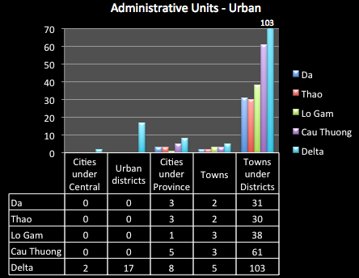

Figure 5‑1: Urban administrative units in the RTBRB

1. In the RTBRB there are 317 urban administrative units, including 2 cities under central control (Hanoi and Hai Phong) and their 17 urban districts – see Figure 5‑1. There are 35 cities and towns under provincial control, and just over a third of these are in the Delta sub-basin. By far the greatest number of urban administrative units are the small towns under District control – some 263 in the Basin. Most of these are also in the Delta sub-basins (103), although the Cau-Thuong has 61 such towns. The 3 western sub-basins have a relatively small number of cities and towns under provincial control and between 30 to 40 towns each under District control.

The hierarchical classification is based mainly on population, with additional parameters such as proportion of labour force in non-agricultural occupations, population density, level of infrastructure, administrative role and position of urban centres within regions.[27] In addition to the two special cases of Ha Noi and HCMC, five classes of city are recognised, and the number of each in the RTBRB is as in Table 5‑1.

Table 5‑1: Classes of cities in the RTBRB

|  |  |  |  |  |  |
| --- | --- | --- | --- | --- | --- |
| Sub-basin | Class 1  Pop > 500,000 | Class 2  Pop >250,000 | Class 3  Pop > 150,000 | Class 4  Pop >50,000 | Class 5  Pop > 4,000 |
| Da |  |  | 3 (Dien Bien Phu, Hoa Binh, Son La) | 31 | |
| Thao |  | 1(Viet Tri) | 2 (Lao Cai, Yen Bai) | 30 | |
| Lo-Gam |  |  | 3 (Ha Giang, Tuyen Quang, Song Cong) | 38 | |
| Cau-Thuong | 1 (Thai Nguyen) |  | 4 (Bac Giang, Bac Ninh, Lang Son, Vinh Yen,) | 61 | |
| Delta* | 2 (Ha Noi, Hai Phong,) | 3 (Nam Dinh, Hai Duong, Ha Long, ) | 4 (Hung Yen, Phu Ly, Thai Binh, Ninh Binh) | 103 | |
| RTBRB | 3 | 4 | 16 | 263 | |

*\* The Delta also includes Hanoi as a Special City*

1. Viet Nam is one of the fastest urbanising countries in the East Asia and Pacific region with the urban share of the population expected to grow to 50% by 2025 from the current 30%. The urban growth rate during the 1999-2009 inter-census period was 3.4 % p.a. compared with 0.4% for rural areas. Rapid urban growth is largely fuelled by significant rural urban migration and urbanisation is in turn fuelling economic growth. While the highest rates of in-migration are found in the larger cities, medium cities will also play an essential role in Vietnam‘s urbanization process, not least in addressing the Government‘s desire to reduce the rate at which the bigger cities are growing, and to develop a strong network of well-resourced and capably managed urban centres throughout the country.[28]

### Urban Water supply

#### Status

1. Water supply systems in urban areas of Viet Nam have seen a rapid growth in coverage. The result of the Viet Nam household living standards survey 2010[29] provides important information on people’s access to water supply. Nationally, 90.5% of households use safe drinking water, and in urban areas 67% of households use tap water provided by a supply organisation – see Figure 5‑2. The other more common source of supply is groundwater.

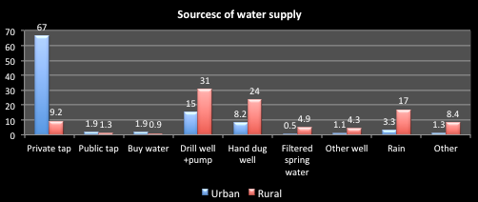

Figure 5‑2: Sources of water supply - the Delta

1. The living standards data was unable to be separated into the specific sub-basins of the RTBRB. However, Figure 5‑3 presents the results for the Delta regions and although it includes both urban and rural responses, it does show some trends. Firstly, the strong growth in water availability from a tap – up towards 30%. There is also a decreasing dependence on groundwater over time, and a strong dependence on rainwater.

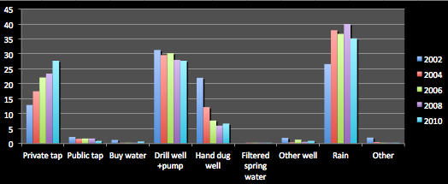

Figure 5‑3: Sources of water supply – urban and rural

1. Figure 5‑4 shows the percentage of the urban population that has access to clean water in the home for the sub-basins. This shows that a high percentage of people in urban areas in all of the sub-basins have access to clean water in the home - from 55% up to a high of 72% in the Cau-Thuong sub-basin.

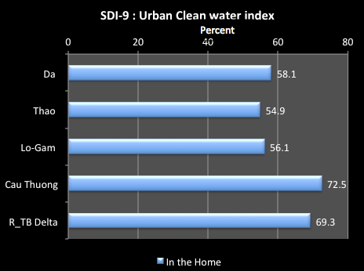

Figure 5‑4: Urban clean water access

1. Water use for domestic all needs in the RTBRB is only around 6% of the total water use, at around 1 billion m3. This is projected to increase to 1.36 billion m3 by 2025. Of the current domestic demands, about half of this occurs in urban areas and half in rural areas. In the urban areas, the current combined installed water supply by the water supply companies in the RTBRB is 447 million m3 compared to the assessed urban domestic demand of 545 leaving a deficit of about 100 million m3 a year, at current levels. This will increase to 457.5 million m3 a year by 2025 with the population growth and the continuing migration to urban areas. Table 5‑2 shows that all sub-basins have substantial water supply deficits, except the Delta where 94% of the urban population is served by the water companies. The Cau-Thuong is by far the largest deficit. The Lo-Gam has a relatively large deficit and only about a third of the urban population of the sub-basin is served by a water company.

Table 5‑2: Urban water supply requirements (million m3 a year)

|  |  |  |  |  |  |  |
| --- | --- | --- | --- | --- | --- | --- |
| Sub-basin | Current  (million m3 a year) | | | 2025  (million m3 a year) | | |
| Domestic water demand in Urban centres | Installed supply capacity | Deficit | Domestic water demand in Urban centres | Installed supply capacity | Deficit |
| Da | 27 | 18.5 | 8.5 | 52 | 18.5 | 33.5 |
| Thao | 31 | 25 | 6 | 54 | 25 | 29 |
| Lo-Gam | 39 | 9.5 | 29.5 | 70 | 9.5 | 60.5 |
| Cau-Thuong | 89 | 38.5 | 50.5 | 128 | 38.5 | 89.5 |
| Delta | 358 | 355 | 3 | 600 | 355 | 245 |
| RTBRB | 543 | 447 | 96 | 904 | 447 | 457.5 |

1. It is difficult to estimate the potential cost of meeting the supply deficit. The ADB reports an estimate of the investment required for the urban water supply sector at $2 billion (for 100% coverage of the urban population, program to 2020; 2008 estimates).[30] On this basis, a crude estimate of the investment requirement for the RTBRB would be in the order of $700 billion. Based on the O&M costs of water production by the water supply companies (about 2,000VND per m3 of water produced[31]), the O&M costs of meeting the current water deficit would be nearly 200 trillion VND, and over 900 trillion VND for the 2025 deficit.
2. Some characteristics of the supply are as shown in Table 5‑3. This shows that water supply is not always provided 24 hours a day - about half of the cities or towns in the RTBRB get a disrupted daily supply. In terms of water supply, the national target is to provide 120 to 150 litres per capita per day (l/c/d). Nearly 80% of the cities/towns in the RTBRB receive a water supply of less that 120 l/c/d. Only one city/town gets greater than 150 l/c/d (Bac Kan at 180 l/c/d, serving a population of 15,255), and 4 get a supply between 120 to 150 l/c/d.

Table 5‑3: Features of urban water supply[32]

|  |  |  |  |
| --- | --- | --- | --- |
| Sub basin | Duration of supply (hours per day) | Volume provided  (liters per capita per day) | No. population served  per connection |
| Da | 20 to 24 hours | 71 to 141 | 4.5 |
| Thao | 16 to 24 hours | 60 to 107 | 3.6 to 6 |
| Lo-Gam | 20 to 24 hours | 85 to 180 | 4.5 to 4.7 |
| Cay Thuong | 16 to 24 hours | 60 to 109 | 3.9 to 9.4 |
| Delta | 16 to 24 hours | 61 to 132 | 4 to 7 |

1. The number of the population served by the water companies to the number of household connections is an average of 4.7 people for the Basin overall. While this is quite uniform for the Da Sub-basin (at 4.5) it varies greatly in other sub-basins suggesting an imbalance between the supply infrastructure and the population. The greatest variation is in the Cau-Thuong sub-basin, with as many as 9.4 people served by the system per connection. In the major cities tens of thousands of connections are added to the network each year.
2. Clean water is mainly provided for residential use, which makes up 70% out of total water sold. However, in the larger cities such as Hanoi and Hai Phong, which have many industrial zones, the non-residential water consumption is up to 35% of the total water sold.

#### Urban water supply management

1. Viet Nam's water supply and wastewater policies are comprehensive and ambitious, seeking to transform the water sector from a social to a business focus. Responsibility for water and wastewater is decentralised to local government, and private sector participation in service delivery is encouraged. Greater emphasis is being placed on increased cost recovery through user charges to cover capital investment requirements and to reduce the need for subsidies. Government’s policies for urban infrastructure development are set out in the Orientation Plan for Urban Development to 2025 and Vision to 2050, which places emphasis on the role of comprehensive town development projects to promote socioeconomic growth.
2. The primary legal instrument governing urban water supply is Decree 117/2007 on clean water production, supply and consumption, covering concentrated water supply systems in urban areas, rural areas and industrial parks and other areas of concentrated economic activity. Its provisions cover water supply planning, water supply investments for development, connections and water supply service contracts, clean water prices, the rights and obligations of organisations, individuals and households, and assurances of supply safety. In essence, the Decree requires that water supply companies are fully equitised and that they operate on a full cost recovery basis with a reasonable profit.
3. Towns in Class 3 and higher are generally served by water supply systems that are managed by dedicated water supply companies, members of the Viet Nam Water Supply and Sewerage Association (VWSA) and subject to national benchmarking. These water supply companies have completed the equitisation process as required by Prime Minister Instruction 854/2009. Equitisation would constitute a first step towards being able to take loans from commercial banks[33]. For the RTBRB, the water supply companies that are currently operating are sown in Table 5‑4.

Table 5‑4: Water supply companies[34]

| Sub-basin | City/Class | Water supply company | Population served | No. population served  per connection |
| --- | --- | --- | --- | --- |
| Da | Hoa Binh (3) | Hoa Binh Water Supply Jointstock Company | 120,000 | 4.5 |
|  | Lai Chau | Lai Chau Water Supply & Construction Company | 30,888 | 4.5 |
|  | Son La (3) | Son La Water Supply Joinstock Company | 151,270 | 4.5 |
| Thao | Lao Cai (3) | Lao Cai Water Business One Member Company Limited | 103,790 | 3.6 |
|  | Phu Tho (2) | Phu Tho Water Supply Joinstock Company | 239,800 | 5.0 |
|  | Yen Bai (3) | Yen Bai Water Supply Company | 60,000 | 6.0 |
| Lo-Gam | Bac Kan | Bac Kan Water Supply One Member Company Limited | 15,255 | 4.5 |
|  | Ha Giang | Ha Giang Water Supply One Member Company Limited | 30,262 | 4.5 |
|  | Tuyen Quang (3) | Tuyen Quang Water Supply One Member Company Limited | 90,273 | 4.8 |
| Cau-Thuong | Bac Ninh (3) | Bac Ninh One Member Water Supply And Sewerage Company Ltd | 118,496 | 3.9 |
|  | Vinh Phuc (3) | Vinh Phuc No.1 Water Supply Joinstock Company | 59,040 | 4.5 |
|  |  | Vinh Phuc No.2 Water Supply, Drainage And Environment Company | 87,400 | 9.4 |
|  | Bac Giang (3) | Bac Giang Water Supply One Member Company Limited | 111,300 | 3.8 |
|  | Thai Nguyen (1) | Thai Nguyen Water Business One Member Company Limited | 319,820 | 6.7 |
| Delta | Ha Nam (3) | Ha Nam Water Supply Joinstock Company | 57,600 | 4.5 |
|  | Ha Dong | Ha Dong Water Supply One Member Company Limited | 176,000 | 4.5 |
|  | Hai Duong (2) | Hai Duong Water Business One Member Company Limited | 312,000 | 4.9 |
|  | Hung Yen (3) | Hung Yen Water Business One Member Company Limited | 30,415 | 7.0 |
|  | Nam Dinh (2) | Nam Dinh Water Business One Member Company Limited | 385,618 | 4.5 |
|  | Nimh Binh (3) | Ninh Binh Water Business One Member Company Limited | 172,250 | 5.0 |
|  | Thai Binh (3) | Thai Binh Water Business One Member Company Limited | 181,400 | 4.4 |
|  | Hanoi | Hanoi Clean Water One Member Company Ltd | 2,186,000 | 4.8 |
|  |  | Ha Noi No.2 Clean Water Business Company | 331,600 | 5.0 |
|  | Son Tay | Son Tay Water Supply Joinstock Company | 100,000 | 5.0 |
|  | Hai Phong | Hai Phong Water Supply One Member Company Limited | 866,000 | 4.0 |

1. There are 25 companies providing urban water supply in the RTBRB: 11 in the Delta sub-basin, 5 in the Cau-Thuong, and 3 each in the Da, Thao and Lo-Gam. The Table shows that for all of the sub-basins except Delta, the population served is generally quite small – in the range 15,250 to 150,000 – except at Thai Nguyen (nearly 320,000 people) and Phu Tho nearly 240,000). In these sub-basins, the number of population served per connections is in the range 4 to 6, with most at around 4.5, but with two very high rates: 9.4 at Vinh Phuc and 6.7 at Thai Nguyen. For the Delta sub-basin, largest populations serves are n the 2 main cities: nearly 2.2 million at Hanoi and 870,000 at Hai Phong. The population served ranges from a low of 30,000 to nearly 400,000.
2. Most investment over the past two decades has gone into expanding production (intake, treatment and transmission) with less than 15% being directed at distribution improvement. Financially, water supply sustainability has been hampered by low tariffs. Despite the legislation that enables water supply companies and local government to increase tariffs, local political considerations often prevent the timely application of tariff adjustments. Affordability and willingness-to-pay surveys have indicated that consumers are prepared to pay for improved services. Water bills on average are 1.1% of urban household income.[35]
3. In the RTBRB, some management features of the water supply companies are shown in Table 5‑5. This shows that there is tremendous variation between the companies. The overall range of staff per 1,000 connections is from around 4 to 28, compared to a national average of 7.8. It is generally greater for companies with fewer connections: the highest is at Bac Kan with a staff of 95 for only 3,400 connections. Other companies with a high rations are Lai Chau (15.9, however the Lai Chau Water Supply Company is a newly established company setting up the distribution network for a large area but a thin population), Hai Giang (12.2), Vinh Phuc (No1 Company at 13.2 and No 2 at 11.7) and Hung Yen (22.8).

Table 5‑5: Water supply management features in the RTBRB

| **Sub-basins** | No. staff per ‘000 connections | % Non revenue water | Financial working Ratio | Costs of 1 m3 sold | **Water tariff (VND/m3)** | | | |
| --- | --- | --- | --- | --- | --- | --- | --- | --- |
|  | Residential | Admini-stration | Industry | Commercial |
| **Da** | 5.9 - 15.9 | 20 - 24 | 0.2 – 0.58 | 850 - 1766 | 1800 - 4200 | 4200 - 5480 | 4200 - 6850 | 4200 - 9134 |
| **Thao** | 5.7 - 9 | 20 - 27 | 0.26 – 1.01 | 808 - 3588 | 4500 - 5800 | 4850 -6700 | 3500 - 6381 | 6500 - 8381 |
| **Lo-Gam** | 8.6 - 28 | 21 - 44 | 0.44 – 0.68 | 867 - 2075 * | 3400 - 3600 | 5000 - 7000 | 6000 - 6400 | 7500 - 8000 |
| **Cau-Thuong** | 6.1 - 13.2 | 16 - 27 | 0.41 – 1.01 | 1452 - 2340 * | 3000 - 4500 | 3500 - 6000 | 4200 - 7200 | 5000 - 9000 |
| **Delta** | 3.8 - 22.8 | 17 - 39 | 0.25 – 1.12 | 897 - 4730 | 2381 - 7500 | 3810 - 8500 | 4500 - 10000 | 7350 - 12500 |

1. Non-revenue water, a fundamental measure of efficiency, varies from 16% (Bac Giang) to 44% (Bac Kan). The national average is a high 30% (meaning that about a third of the water that is collected, treated and pumped into the reticulation system is lost and receives no revenue. Typically the older and larger cities have less efficiency as they have long reticulation systems that have not been maintained (through lack of revenue) meaning leaks and broken pipes occur frequently. Companies with losses greater than the national average are Bac Kan (44%), Ha Giang (40%), Hung Yen (31%), Ninh Binh (39%), Thai Binh (36%) and Hanoi Clean Water One company (33%).
2. The water tariffs vary enormously across the water companies – from 1,800 VND per m3 for residential water in Lai Chau to 12,500 VND per m3 for commercial connections in Ha Nam. Generally speaking all of the tariffs are greater in the Delta compared to the others. The main issue with the tariffs is that if the input costs (labor, energy, materials) keep increasing whereas water tariff is only adjusted every five years. Therefore, the utilities are facing decreasing cost recovery to maintain the fixed capital assets and improve and expand the services. The urban water sector cannot develop in a sustainable way. VWSA argues that with the average residential income in 2008 of 1,606,000 VND/month, the water expense of one urban person takes up only 0.81% of income. Therefore, it the water tariff is still much lower than affordability of urban residents (≤ 2 ~ 3% of total income).
3. A most critical indicator of the water companies ins the financial working ratio (FWR), which is the ratio of the companies costs and the revenue. A ratio of 1 means that the costs and revenue are equal; less than one means that the revenue exceeds the costs leaving essential funds for system maintenance, refurbishment or expansion. Nationally, the FWR is 0.58 meaning that the revenue is significantly in excess of operating costs. In the RTBRB, the FWR varies between 0.2 (Hoa Binh) and 1.12 (Hung Yen). The other companies that has a FWR greater than 1 (meaning operating costs are not recovered) are Lao Vhi and Vinh Phuc (No 2) both with a FWR of 1.01. In the Delta sub-basin Ninh Binh (0.97), Thai Binh (0.91) and Hanoi No 2 (0.95) are close to 1. However, few if any companies achieve full cost recovery, if depreciation, replacement and financing costs are included. Urban water supply systems are therefore still subsidised to a large measure by their respective governments, on a non-targeted default basis.[36]
4. Class 4 and 5 towns, the district towns, are usually served by state-owned water supply and drainage companies under provincial governments. An unknown number is served by small informal private schemes. For the immediate future, the District towns will require access to concessional Official Development Assistance (ODA) loans for any future capital works.[37]
5. Private sector participation in urban water supply systems in Viet Nam has been limited and nearly exclusively involves bulk water supply, and then mostly in HCMC. The raw water pumping station supplying water to Ha Noi, including a transmission main from Hoa Binh, is owned and operated by Vinaconex, a JSC. At a local level, in response to a consumer demand not being met by public services, the private sector has stepped into water supply provision in some small towns by leveraging funds from fee-paying customers and their own contributions. This level of private sector investment continues growing despite the limited GoV incentives for private sector participation.[38]

### Main Issues for Urban Water Supply

1. Lack of water supply services. Nearly 2 million people in the provincial urban areas in the RTBRB do not have access to tap water in their home; around 5.5 million people provide their own water supply from groundwater sources, many of which are polluted. The domestic urban water supply target of 120–130 litres per person per day has not been achieved in the Basin – supplies vary between 60 to 180 litres per person per day. Achieving the National domestic water supply target will require about an additional 100 million m3 a day of supply at 2010 populations, and an additional 450 million m3 a day at 2025, for a cost of hundreds of billions of dollars. The Lo-Gam has a relatively large domestic water supply deficit and only about a third of the urban population is served by a water company.
2. Efficient operations of urban water supply companies. Although the operation of urban water supply systems is considered better than in other developing countries, the standard of service remains low: many companies can only ensure operations for 16 to 20 hours per day; and the water provided per person by most companies is less that 100 l/c/d, and around 60 to 80 l/c/d for many. Poor working ratios, leading to inadequate maintenance, and the expansion of the urbanisation process is progressively causing the degradation of the networks. Staff per 1,000 connections varies between 4 to 28, compared to a national average of 7.8; non-revenue water varies from 16% to 44% compared to the national average is a high 30%. It should be noted that the national averages are high compared to efficient regional operators. The benchmarking report prepared each year by VWSA is an important management tool which should be supported and further developed to provide a basis for continuing improvement in the operations of the water companies. This should be expanded in scope and analysis, well publicised and updated each year.
3. Non-revenue water can be significantly reduced. The lessons learnt from companies having non-revenue water of below 15% are[39]:
4. Annually, they allocate budget to upgrade or repair old pipelines. They replace pipes that are too old to maintain. They divide the area of water served and separate the distribution network to easily manage and quickly discover and repair leaks or breaks. They divide the water served areas into many small units to install bulk meters and assign the percentage of non-revenue water to the residential area or ward-based management divisions.
5. They provide workers with necessary equipment for checking the distribution network to detect and repair the leaks and breaks.
6. The water tariff is not aligned to business needs. MOF sets a range for the tariff. The joint ministerial circular No. 104 (MOF and MOC) regulates the price of clean water for domestic use, which is determined by each PPC. However, the local pricing board often comprises members with little knowledge of the clean water business. Typically the tariffs do not account for the norms on labour, costs of fuel and energy and materials in the operation of the sector. To maintain a stable water price, many provinces do not adjust the water tariff even though costs of inputs such as electricity, chemicals and salaries continue to increase. Therefore, the tariff cannot cover the costs. The inadvertent impact of this is a non-targeted subsidy for a service for which consumers are willing to pay more. The practice encourages wastage and benefits high-end users. Higher tariffs would encourage resource saving, and would enable government to focus subsidies on essential services where capacity and ability to pay is very much less likely.
7. Access to sufficient capital: The level of autonomy of the urban water supply companies remains limited and tariff levels do not ensure the long term financial sustainability of the utility. Nationally, it is recognised that there is much work to be done to build utilities that can be considered creditworthy to lenders, and in parallel, there is a need to develop a local capital market that provides long-term financing. Improvements in the RTBRB will not occur unless progress is made a the National level. Access to short-term debt from commercial banks is already occurring on a limited basis showing that a range of sources of funds can be mobilised.[40]
8. Lack of clarity of asset ownership. Decision No. 38/2007/QD-TTg on the equitisation of urban water supply and wastewater and drainage companies, in particular in the larger cities, has important implications for the structure of and the nature of control in water supply companies. Lack of clarity on the ownership of the assets of water supply systems (distribution, transmission, treatment) poses a threat to the effective operation and maintenance of the service, and will lead to a gradual deterioration in the value of the assets. Similarly, this lack of clear definition of ownership and responsibility will deter private sector operators – in particular, international ones – from seeking involvement in the sector in Viet Nam.[41]
9. Urban water supply infrastructure is not keeping pace with economic development. The capacity of urban water supply systems is still limited - only about 65% of the urban population has access to tap water. Yet urban areas are growing all the time as people migrate to the cities to look for work. Assuming a population growth rate of 0.7% means an additional 200,000 people year, and about a third of these will seek to live in urban areas. That means an additional 30,000 or so people each year looking for urban water supply. As well, industries are developing and looking to the centralised system for their water supply.
10. Towns under district control have much less access to basic water supply services. A significant population lives in the district towns. While in urban areas under direct control of the central or provincial governments around 50% to 60% of people have access to tap water. However, at the district level this is between only 15% and 22%.

### Urban Sanitation

#### Status

1. Officially, the percentage of the urban population that is using improved sanitation facilities is 84%. Sanitation in the major cities is said to be available to 98% of the population, but this figure includes access to a “sanitary latrine”: it gives no indication how the human waste thus collected is disposed of. In fact, the majority (75%) of households in provincial towns are not connected to any form of local or central sewerage system, but only to a septic tank. With the exception of Hai Phong, no towns offer a reasonable septic tank de-sludging service.[42]
2. 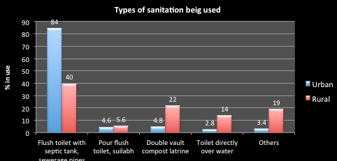The result of the Viet Nam household living standards survey 2010[43] provides important information on people’s use of sanitation types. Nationally, 54% of households use a flush toilet with septic tank or sewerage system, with this figure being 84% in urban areas – see Figure 5‑5. In urban areas there is only a small percentage of the populations not using a flush toilet.

Figure 5‑5: Types of sanitation systems being used

1. 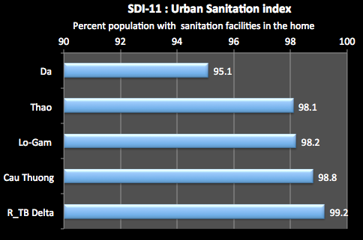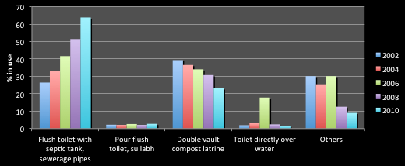The living standards data was unable to be separated into the specific sub-basins. However, Figure 5‑6 presents the results for the Delta regions and, although it includes both urban and rural responses, it does show some trends. There is a strong pattern of growth in the use of flush systems connected to a septic tank or a sewerage system, and decreasing use of double vaulted composting toilets. There is also a decline in the use of non-specified toilet practice.

Figure 5‑6: Types of satiation used in the Red River Delta

1. In provincial urban areas, Figure 5‑7 shows the percentage of the population that has access to sanitation in the home. In the Delta sub-basin the figure is almost 100% (where the total urban population is over 5.1 million people), and is at a high 95% in the Da (where the urban population is nearly 250,000 people). However, while the figures for people having access to a flush toilet in urban areas under the control of the central or provincial governments are high, at the district level, only 70% to 90% of households have access to a sanitary latrine.[44]

Figure 5‑7: Provincial urban population with sanitation facilities at home

1. Nationally, about 6% or people in urban areas do not use a flush toilet nor a composing toilet - they directly defecate to an open water source or some other unspecified means. If these figures are replicated in the urban areas of the Basin then over 400,000 people in urban areas are not using sanitary toilet facilities.
2. The expansion of water treatment and distribution facilities in recent years has increased the per capita water consumption, in particular in urban areas. As a result of this increasing water use, more wastewater is being generated, causing concerns about the environmental impact of untreated discharges. According to 2008 MOC data, less than 10% of urban wastewater is treated (250,000 m3/day, out of 3 million m3/day), although such treatment is a stated Government priority. Serious environmental degradation and health concerns are caused by water pollution from untreated human waste and unregulated discharge of industrial wastewater.[45]
3. Some of this information is shown in Figure 5‑8. This shows the very small proportion of wastewater that is actually treated, and of that the small fraction that receives primary treatment.

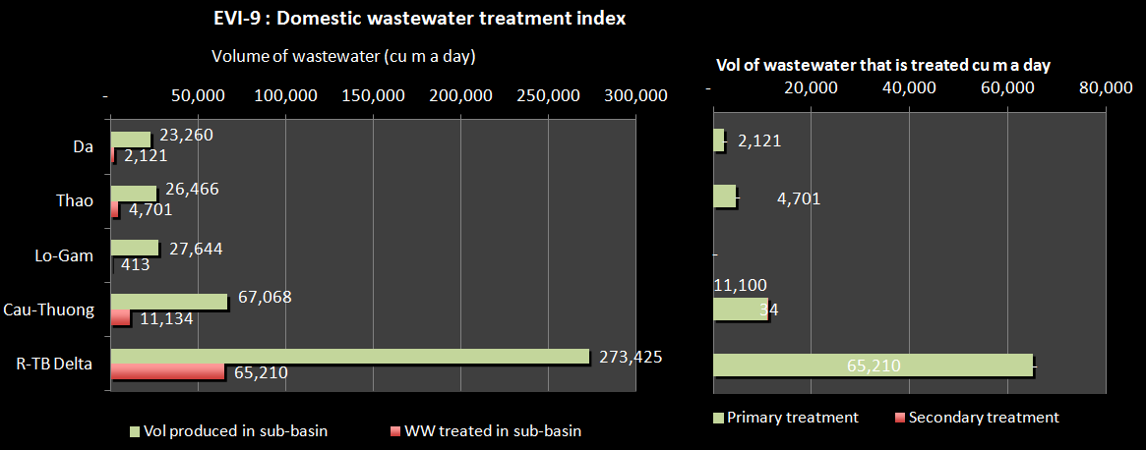

Figure 5‑8: Domestic wastewater produced and treated

1. Hospital waste is a potential health hazard to the health care workers, the public and the environment of the area. Hospital acquired infection, transfusion transmitted diseases, rising incidence of Hepatitis B, and HIV, increasing land and water pollution lead to increasing possibility of catching many diseases. In Viet Nam collection and safe disposal of hospital waste is only partially successful. Figure 5‑9 shows that most treatment of hospital waste occurs in the Cay Thuong sub-basin, accounting for 63% of the total amount of treatment in the RTBRB. The Delta makes up only 7% of the total amount of treatment, and the Lo-Gam only 1%. In that sub-basin only 2% of hospital waste is treated. 57% of hospital waste is treated in the Cau-Thuong but only 24% in the heavily populated Delta sub-basin.

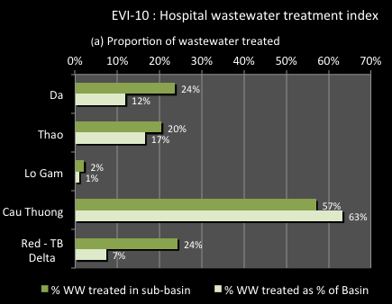

Figure 5‑9: Hospital waste treatment

#### Urban sanitation management

1. Decree 88/2007 (under MOC’s guidance) provides the legal framework for the management of water drainage from urban centres and industrial parks, and for concentrated drainage areas in rural areas. The Decree covers water drainage planning, water drainage development and investment, management and operation of water drainage systems, water drainage services, water drainage charges and the rights and obligations of concerned parties. The Government’s overall strategies on urban sanitation and industrial wastewater are formulated in the Decree, recently accompanied by Decision 1930/QD-TTg, which provides future targets. Decree 88 allows households that are connected to a drainage system to be charged as a surcharge to the water tariff at a minimum of 10%, to achieve cost recovery of running costs. Recovery of O&M is envisaged. Local authorities are to subsidise the remaining costs.[46]
2. Urban drainage companies have many varieties. There are drainage services companies in Ha Noi, and Hai Phong; water supply companies provide drainage services in some provincial cities; and urban infrastructure companies provide drainage services in combination with other services such as solid waste collection, street management, parks, lightings, and funerals. These companies undertake the operation, maintenance, and repair of water drainage systems, including dredging and repairing sewers, operating drainage pumping stations, and dredging canals and ditch systems.
3. Investment in drainage, sanitation and solid waste improvements in provincial and district towns has been relatively small. To date, expansion and rehabilitation of the drainage and sanitation in provincial and district towns has relied primarily on allocation of limited budgets from central or local governments and some ODA funds to complement water supply development. Most investment in the drainage and wastewater subsector has in fact focused on developing drainage infrastructure to reduce flooding in the major cities.[47] Future investment costs for urban sanitation are going to be enormous, given the current very low starting point.
4. Asset management (ownership) is not clearly defined in policies, and is consequently weak in practice. There are no inventory/records on assets, O&M norms and unit costs for sector facilities are not available, recovery of O&M expenditure is not occurring, and financial planning for system O&M is not realistic. O&M equipment is procured using limited government resources.
5. Because drainage projects require large amounts of capital and their product is not sold directly to customers, it is not attractive to private investors. Decree 16/2005/NĐ-CP stipulates that Provincial and District urban drainage projects with an investment capital of less than 5 billion VND are decided by the chairman of the PPC.

### Main Issues for Urban Sanitation

1. Significant numbers of people in urban areas do not have access to a sanitation facility. Despite great gains over recent times, hundreds of thousands of people in urban areas defecate outside of a sanitation facility.
2. Urban sewerage and drainage infrastructure seriously lags behind economic development. Most towns are not sewered, and people use a septic tank, or pour-flush toilet with leach pit, or a composting toilet – or do not use a toilet facility. Most wastewater from hospitals is discharged directly into public sewerage systems and factories in urban areas do not treat wastewater, which is discharged directly into the public sewerage systems where they are available. The few existing treatment plants are not fully effective.
3. Most hospital waste is not collected and treated before disposal.
4. The social and environmental damage from untreated or poorly treated wastewater is not understood and is not a factor in planning. Less than 10% of towns have any form of central wastewater collection and treatment systems. An estimated 75% or more of urban households use septic tanks. No data are available on the efficiency of their functioning. In the absence of de-sludging services, septic tanks do not provide any significant form of treatment, and wastewater will continue to pollute both groundwater and surface waters. In rapidly developing urban areas with increasing population density, higher per capita water consumption, and increasing water use, more environmentally acceptable means of wastewater disposal are required. The scale, complexity and cost of the programs necessary to improve urban sanitation on any significant scale are beyond the scope of most provincial and city local governments. Industrial wastewater – which constitutes the largest fraction of the estimated organic waste load on surface water and is likely to contain toxic and refractory substances – is only treated in a few instances and poses the most severe threat to water as a resource. The financial impact of the poor sanitation practices in Viet Nam has been estimated at 1.8% of GDP. Economic losses, mainly due to health impact, pollution of water resources and the environment in general, were estimated at $780 million.[48]
5. Collecting wastewater fees provides no service incentives. Fee collection for wastewater is assigned to water supply companies and the levied amounts, after deducing the costs of fee collection of about 4–5%, is provided to the budget of provinces or cities (not to the service delivery agency).

## Rural water supply and sanitation

### Provision of rural water and sanitation services

1. Rural water supply coverage in Viet Nam has grown from 43% in 1990 to 79% in 2009. However only 40% of people use water of national standard (Decision No09/2005/QD-BYT) issued by the Ministry of Health (MOH).[49] The coverage for the RTBRB is shown in Figure 5‑10. The greatest coverage is for the Delta and Cau-Thuong sub-basins, at over 77%, whereas the Thao and Lo-Gam are at around 69%, well below the National level.

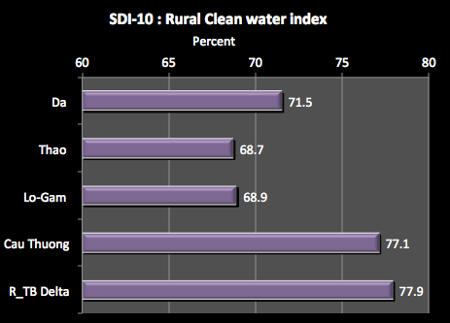

Figure 5‑10: Clean water supply in rural areas

1. In the mountainous provinces, people are still in short supply of domestic water at times. In these areas, due to high terrain and the fact that people depend on water from rivers, ponds or lakes, they are usually short of domestic water in the dry season. The main ways of water treatment used by the households are natural sedimentation or treatment with alum and filter by sand. Chemical and other methods are rarely used.[50]
2. As well, the efficiency and sustainability of existing schemes is variable and often at risk. Nationally, in terms of the level of service for rural people, 11% get piped water in their homes or yards, 63% have access to groundwater via improved or unimproved sources, One of the most popular water supply model is still the traditional hand dug well: nationwide 23.5% of the rural population still rely upon wide diameter hand dug wells. Water from dug well is generally not treated before use. Although this water source is considered as clean, there is still risk of microorganism contamination, especially dug well near pollution sources such as septic tanks, other sanitary areas, livestock sheds or the wells without a platform or if there is stagnant water around the well. Drilled wells are the most common water supply model with an estimated 31% of rural households. Around 10% of the rural population is serviced by piped water supply systems in their homes or yards, 1% use vendors selling bottled water, 17% rely on rainwater and 8% use “other” sources, which are typically unprotected surface water for drinking and food preparation purposes.
3. The result of the Viet Nam household living standards survey 2010[51] provides important information on people’s sources of water. The Northwest region would be close to the rural situation of the RTBRB and the results are shown in Figure 5‑11. This shows the dependence on groundwater sources, although this has been decreasing over time, as has the use of undefined water sources. Tap water access has been increasing, although it is still at a low level. Rain water is hardly used as a water source.

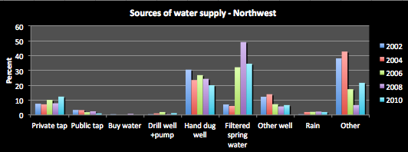

Figure 5‑11: Sources of water supply – Northwest region

1. Figure 5‑12 shows, Nationally, the types of sanitation being used in rural areas – with the most common being a flush toilet with a septic tank. Double vault composting toilets are also popular. Currently, the MOH recognises 4 types of latrines as hygienic, including double-vault latrine, ventilated pit latrine, pour flush latrine and septic tank for households (according to the Decision No. 08/2005/QD-BYT dated March 2005). The promotion of coverage of hygienic latrines nationwide has not achieved satisfactory results compared to the progress of water supply. At 2009, only 43% of the households have hygienic latrines which meet the MOH standards. Nationally, 23% of rural households do not have latrines, the rest have latrines but their use and maintenance are not up to standards.[52] Figure 5‑13 shows the availability of rural sanitation facilities in the home – note that there so not necessarily meet MOH standards. Mostly about half the homes have sanitation facilities, with a higher rate in the Delta Sub-basin.

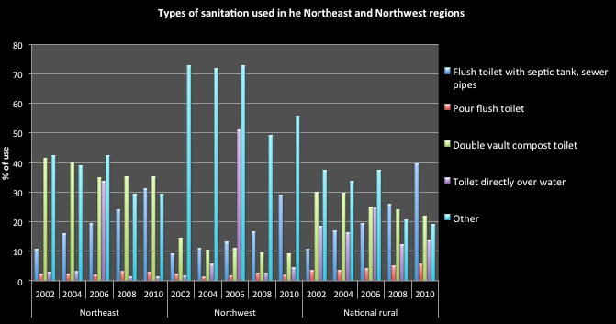

Figure 5‑12: Types of sanitation in the Northeast and Northwest regions

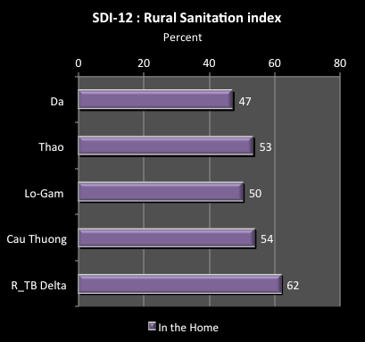

Figure 5‑13: Rural sanitation facilities available in the home

1. For the RTBRB, the Northeast and Northwest regions would typify the rural situation and the living standards survey provides the results over time – see Figure 5‑12. This shows the progressive growth in the use of a flush toilet connected to a septic tank over the period 2002 to 2010 in both regions. However, it also shows the high level of “other” – unspecified sanitation method, probably open defecation – that persisted over the period, particularly for the Northwest region. In that region at 2010 over 55% of the response was “other”, compared to the national level of less than 20%. Sanitation directly over water sources is only a small percentage by 2010. This shows that over half the population of the Northwest, as many as 3 million people use unspecified toilet facilities, probably in the open environment.
2. As well, a high proportion of existing toilets are unimproved, and even the use of those that are termed ‘improved’ is less than sanitary. The widespread practice of using night soil as fertilizer in agriculture or aquaculture has led to toilets being seen primarily as a means to collect and store excreta rather than dispose of it safely. This activity is most popular in the rural areas growing crops and flowers in the Red River Delta.[53]  Furthermore, coverage figures based on infrastructure provision alone must be interpreted with care since provision does not always imply user acceptance. With growing rural population densities and legitimate concerns about water source pollution, poor sanitation behaviour has become a major environmental concern.
3. At the beginning of 2010, approximately 75% of schools, 77% of healthcare stations, 67% of Commune People’s Committee offices and 45% of rural markets nationwide have water supply facility and hygienic latrines. However, as the management, operation and maintenance activities are not effective, the facilities are soon downgraded and they cannot bring about their full effects.[54]
4. The progressive increase in the proportion of households using hygienic latrines has helped reduce the amount of human excreta disposed into the environment, although this remains a problem. Animal excreta, related to the management and treatment of livestock such as pigs, buffalo and cattle, is also being paid greater attention, and there has been a considerable increase in the number of livestock sheds built and upgraded to meet the requirements of waste management. By 2010, about 45% of rural farm households have hygienic livestock sheds; and about 18,000 livestock farms have waste management systems. The number of livestock farms having biogas tanks is 1,000,000 accounting for 17%.[55]
5. For domestic and solid waste, some 3,310 out of 10,345 communes and townships all over the country has waste collecting teams, accounting for 32%. However, the amount and frequency of waste collecting in communes and towns is not equal. In some communes, waste is only collected once per week or twice per week. The waste collected is transported to landfills and dumped but there is almost no treatment solution.
6. Domestic wastewater is generally disposed into pond and lake around the village or into the irrigation canals, adding to the water pollution situation. The Living Standards Survey of 2010, found that environment pollution is getting worse. In 2010, 52.7% of communes reported having environmental problems compared to 41.5% in 2008. Over the two years the percentage of communes reporting water pollution and both air and water pollution increased significantly, up to 27%. In 2010, 39% of communes recorded that the pollution was mainly a result of household living waste (up from 25% in 2008), industrial waste (20% of communes) and waste of handicraft villages (6% of communes), and other causes (17%) also contributed to local environmental pollution. Disposal of household living waste - the high proportion of liquid waste that is being disposed into sewers, ponds, lakes, rivers and streams - is clearly perceived as the greatest environmental threat.[56]
7. Hygiene practices in the rural areas is making only slow progress. Only about 15% of the rural population has the habit of washing hands with soap, and under 5% of the schools have soap at the hand washing place. Sanitation facilities in schools, healthcare stations, People’s Committee offices and rural markets are generally not maintained well. In general, people have low awareness of or pay little attention to the relation between water, latrine, personal hygiene practices – and health. Hand washing with soap and clean water before eating and after using the toilet, although have been disseminated broadly, are rarely practiced due to both economic and awareness reasons.[57]

### Management of rural water supply and sanitation (RWSS)

1. The RWSS National Target Program (NTP) is one of seven nationally funded targeted programs to serve areas considered urgent, inter-sectoral, inter-regional and important for national socio-economic development. In 2000 the GoV introduced the “National Rural Water Supply and Sanitation Strategy (NRWSSS) up to the year 2020” to improve the impact and sustainability of government investments. The National Target Programme on Rural Water Supply and Sanitation Phase II (NTP II) has been the main policy for RWSS sector development. The NTPII sought to achieve a strong focus on sanitation and hygiene, better targeting of subsidies for the poor, greater emphasis on sustainability, improved operation and maintenance, and further decentralisation of implementation. The expected outcome was that some 7.4 million people would be served with water and have had the opportunity to improve hygiene practices. Some 10,000 school and institutional latrines will have been built and some 1.3 million households will have hygienic latrines.
2. A programme of financial support was prepared (State budget 14% of expenditure; local government about 10%; community contributions about 36%; preferential loans about 25%; and donor support about 15%), and support began with a pilot phase of two years, providing budget support in nine provinces using GoV systems. The programme was expanded to 31 provinces in 2009 and all provinces in 2010. However, the planned target was revised to 3.2 million people in 2008. The main reason was a significant increase in construction costs and the leveraging effect of donor funds in NTP II was lower than expected[58]. By 2009, the results of implementing the NTP II are set out in the previous section.
3. On 31/3/2012, RWSS NTP 2011-2015 was approved by the Prime Minister as Decision 366/QĐ-TTg. The targets of NTP III is to archive 85% of rural population having access to hygienic water, 65% of rural households having access to hygienic latrines; 45% of farmer households having access to hygienic livestock pens and 100% of kindergarten and schools, commune health stations having access to hygienic latrines and clean water by the end of 2015. The updated NTP III covers all rural areas in the country, but does not include the Class 5 towns.
4. RWSS delivery models can be divided into two types: (a) small scale works based at the household level such as wells, water tanks and toilets; and (b) piped water supply facilities. Institutional models include cooperatives, cooperative groups, self-provision, private enterprise, commune and district People’s Committees and CERWASS[59]. The programme relies heavily on community-based management when local capacity for operation and maintenance – in organisational, technical and financial terms – is lacking. Investments in capacity building and monitoring and evaluation have proven inadequate so far. Commune People’s Committees guide the establishment of management boards for water supply and sanitation but members – drawn from villages within communes – lack the skills needed to carry out their tasks efficiently.[60]
5. Hundreds of RWSS facilities have been constructed nationwide under the NTP and at the same time, people themselves have constructed a large number of RWSS facilities. However, there has been a change in the structure of different types of RWSS facilities with the proportion of water supply from full piped water supply schemes rapidly increasing (0.12% in 2000 to 25% in 2010), and small water supply schemes correspondingly decreasing. Because the planning and management regulations are insufficient, many drilled wells with small diameter have caused severe impacts on the layer structure of the local aquifer and lowered water level, leading to groundwater pollution. Many localities have demolished such small-diameter drilled wells.
6. Between 2000 to 2010, investment of the Government and assistance of the international donors such as WB, ADB, UNICEF, DANIDA, Ausaid, DFID, JICA, etc. for RWSS has increased significantly. The number of schemes operating effectively and properly account for 75% of the total schemes[61]. For the remaining 25% of constructed scheme, although they are invested heavily, they do not operate properly and even many schemes do not operate at all. There are a number of reasons for this, one being that the financial sustainability of rural schemes is undermined because households are either reluctant or unable to pay for water supply. Willingness to pay often remains a mere indication at the time of project inception and after schemes have been built people either do not use them at all or use them sparingly, supplementing them with water from unimproved sources, resulting in an unintended overcapacity of schemes themselves.
7. Recovery of O&M of water supply schemes is improving in most provinces. In most schemes sufficient revenue is recovered to meet operational costs but there is no provision for depreciation or for the periodic replacement of major facilities. An M&E Indicator Set was piloted, revised and agreed by government in 2008. A detailed M&E manual was prepared and NCERWASS, with assistance of local consultants, provided initial TOT for relevant provincial level officials during early 2009. Recurrent budget has been allocated in 2009 to enable provinces to complete M&E training of district and commune staff.[62]

### Main Issues for Rural Water Supply and Sanitation

1. RWSS services are not available to large numbers of people. The proportion of rural populations provided with hygienic domestic water is quite high (79%) but the proportion of rural populations having household water meeting national standard is low (40%). This means that in the RTBRB approximately 12 or 13 million people do not have access to clean water and have to rely on unimproved water sources, risking their health on a daily basis. The proportion of households having hygienic latrines is 59%. This means that some 11 million people in the rural areas of the RTBRB practice unhygienic sanitation, threatening their health and adding pollution loads to the Basin’s water sources. As shown in Figure 2‑26, high level of faecal coliform are a common feature of the water quality issues in the Basin. As well the rate of public WSS facilities (healthcare stations, schools, People’s Committee offices and rural markets) is low.
2. Financial- Economic Challenges. Average investment in the period of 2000-2010 was about VND 20,000/22,600 billion. Over the 10 years, total investment mobilised was around VND 30,000 billion out of 50,000 billion estimated in the Strategy, accounting for 50% (excluding depreciation) of the construction cost demand for the sector.[63] This means that an estimate 70,000 billion is required to complete the provision of RWSS services to total people, and much of that is required for the RTBRB, given its higher poverty rates (around 4 million people liven in poverty in the Basin, in the Da sub-basin 39% of households are poverty affected) and proportion of ethnic minority populations. The budget for the NTP III implementation during the period from 2011 to 2015 is VND 46,636 billion.
3. Getting contributions for beneficiaries. As a general principle under NTP III, users will be responsible for all construction costs and all operating costs for RWSS facilities. Government will however provide financial support in the form of grants to certain types of users and for certain technologies as follows: for the poor, very poor and the social policy target households who suffer difficulties; for certain types of RWSS technologies, which are promoted by government; and for a number of other special cases
4. Hygiene practices. In general, people have low awareness of or pay little attention to the relation between water, latrine, personal hygiene practices – and health. Hand washing with soap and clean water before eating and after using the toilet, although have been disseminated broadly, are rarely practiced due to both economic and awareness reasons. Due to poor hygiene practices, common diseases are frequent in rural areas, epidemics such as cholera, typhoid and dengue sometimes break out, causing more difficulties to people’s life, especially poor households.
5. RWSS socialisations policy is not clear. Many legal documents have been issued to create a favourable legislative environment for the Strategy implementation. However, there is a lack of or late issuance of specific regulations and guidelines to meet requirement of each period for the good management of RWSS. Particularly, the issuance of RWSS Socialisation document is slow, lacking regulations on water use fees and extending the types of hygienic latrines. Assistance levels regulated in some legal documents are not appropriate to actual situation and some legal documents are slowly implemented at provincial level such as the regulation on clean water standards and common monitoring and evaluation system.[64]
6. There are many technical issues in difficult areas. In especially difficult areas for water resources that occur in the RTBRB such as saline areas, high mountainous areas and the karst limestone areas, there is usually lack of water resources and people have to take the water from distant springs. In these areas are characterized by very deep ground water resources and there is little or no surface water which require appropriate technical solutions. NTP III provides for the following:
7. *Mountainous areas*: These areas usually have a high proportion of poor families. They will therefore receive a higher than average subsidy. They will also be particularly targeted for capacity development since this is a major factor for the implementation of all programs in the region. Information and awareness will take account of the special needs of the users, such as the need to use ethnic minority languages. The main technical problem is lack of readily accessible water resources. In these areas there is very little, or even no groundwater, and rivers or streams are usually in deep valleys. There needs to be many solutions to deal with the water resources situation such as combination with irrigation to build reservoirs and growing forest to protect the watershed. Gravity piped schemes may be built if there is water resource and the elevation is high enough upstream to allow water to gravitate to the village. Water from the river, or finding small springs or limited groundwater can be pumped to villages. Building rain water tanks is an option which can be widely applied.
8. *Karst lime-stone areas*. The social and technical problems in these regions are similar to those of the mountainous areas. However the seasonal variation is more acute as water resources in these areas rapidly infiltrates into caves networks creating arid conditions. Technical solutions include: using deep ground water, leading water from other places, building small dams, lakes or ponds to contain rain water in impervious valleys.
9. *Red River Delta*. Very high population densities and the tradition of using human excreta as fertiliser make sanitation the greatest concern in this area. Implementation will therefore place particular emphasis on this aspect.
10. There are many centers for technology transfer, production and supply of materials and equipment for RWSS have been established but lack of quality control and assurance.
11. RWSS organisations are many with overlapping functions. Responsibility assignment among ministries and sectors is regulated in the legal documents; however, coordination between different ministries and sectors is overlapped. MONRE is responsible for water resource management, MARD is responsible for rural water supply; MOC is responsible for urban supply including class V towns; sanitation and water quality is the responsibility of MOH, although many other ministries also have their responsibilities in the rural environmental sanitation (MARD is responsible for husbandry facilities, MOH is responsible for household sanitation, MONRE is responsible for waste from trade villages and management of wastewater treatment and MOET is responsible for school sanitation). Many centres for technology transfer, production and supply of materials and equipment for RWSS have been established, but they lack of quality control and assurance.[65]

## Irrigation and Agriculture

### Current status of irrigation development

1. Agriculture is a key component of Viet Nam’s economy, acting as a major contributor to national GDP, employment, and food security. Typical with most developing economies, Viet Nam’s agriculture continues to grow, but has a declining share of GDP as growth in the industrial and service sectors outpaces that of agriculture. In 2010, agriculture constituted about 20% of GDP. Agriculture production value has doubled in real terms since 1993, growing at an average rate of just under 4% per annum, and 3.2% for 2011-2012. Agriculture, fisheries, and forest products now constitute 25% of exports. The value of exports of agriculture commodities rose from $1.1 billion in 1993 to almost $20 billion in 2010.[66] Viet Nam has become the world’s second-largest exporter of rice, coffee, and cashews, and the top exporter of pepper (although, rankings can vary by year). Viet Nam is still largely rural, and the sector provides employment to about 70% of rural households.[67]
2. Figure 5‑14 shows for each sub-basin the contribution of agriculture to sub-basin GDP, the percentage of water use accounted for by agriculture, and the percentage of sub-basin employment accounted for by agriculture. In the Da sub-basin, agriculture makes up 35% of GDP, while in the Delta it makes up 15%. Of the total agricultural production of the RTBRB, the Da and Thao sub-basins provide around 6% of the total, the Lo-Gam 9%, the Cau-Thuong 17% and the Delta 61%. While the contribution of agriculture to GDP is shrinking, it remains an important sector for employment and water use.

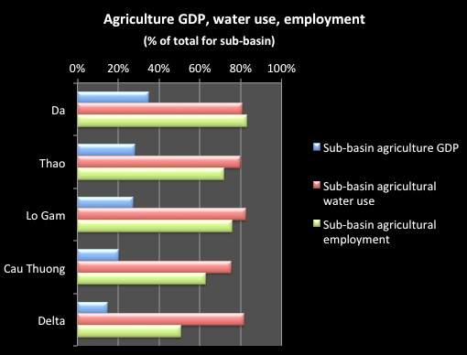

Figure 5‑14: Agriculture share of GDP, water use and employment

1. Nationally, paddy rice dominates agricultural activities: 80% of area planted and 65% of all production. Maize has the second highest planted area (12%) and sugarcane the second in terms of production (26% of the total). Viet Nam has been gradually increasing its production of paddy rice, both in terms of yield and quantity produced - see Figure 5‑15. The area planted decreased steadily up to 2007, with the production actually increasing. The area planted increased 4% from 2007 and 2010. The inset chart shows that the production per area planted has been steadily increasing – from 4.24 tones per ha in 2000 to 5.32 tones per ha in 2010. The growth rate of the livestock subsector is expected to exceed the cultivation subsector and will likely reach 6 - 8% per year. This will result in the value of livestock production soon overtaking cultivation as the economically dominant activity in agriculture. Particularly in the Red River Delta, agriculture will focus on intensive production of special rice varieties, vegetables, flowers, and winter crops; development of industrialized animal husbandry; and development of fresh, brackish and saline water aquaculture.

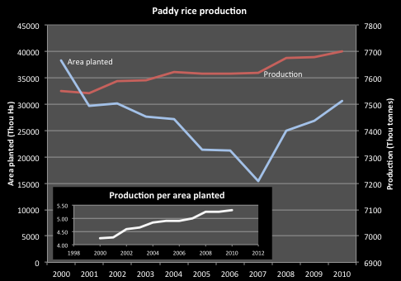

Figure 5‑15: National paddy rice production

1. Figure 5‑16 show cereal production in the RTBRB in 2000, 2005, and 2010. This shows the predominance of the Delta sub-basin in terms of the area planted and the crop production – nearly 3 times that of the other sub-basins. The area planted has been slightly increasing, as has the tones of cereal crop produced. The yield has also been increasing, particularly for the non-Delta sub-basins. There was an increase of 35% from 2000 to 2010 in the Da and Lo-Gam sub-basins compared to only 10% for the Delta. The production per unit area for the Delta sub-basin is a little below the average level nationally for paddy rice (5.32 tones per Ha), suggesting less efficient production. However, the production per unit area for the other sub-basins is well below that level. In some provinces it is only around 1 ton per Ha.

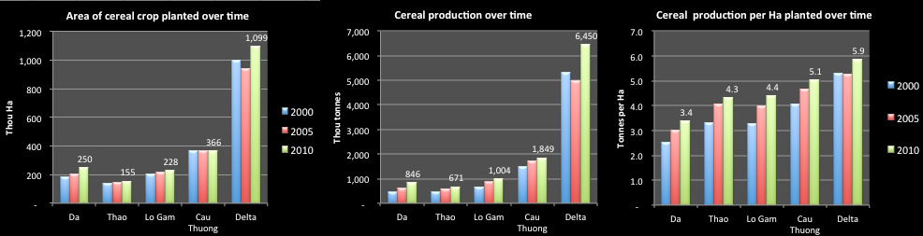

Figure 5‑16: Cereal crop production in RTBRB over time

1. In 2010, agricultural land in the basin was 1,962,406 ha representing a decrease of 6,213 ha compared to 2003 (see Table VI 1). This was mainly from rice fields. Land area for perennial crops, grazing pastures, and aquaculture increased. In 2010, perennial croplands were 269,310 ha, making an increase of 83,713 ha compared to those in 2003. Perennial croplands increased mainly due to the exploitation of unused hilly lands for perennial crops (tea) and fruit trees; and conversion of mixed gardens and poor croplands with fruit trees.
2. It is projected that total agricultural land will be 1,918,640 ha in 2020, marking a decrease of 43,763 ha compared to 2010. The decrease is projected to be mainly from rice fields and upland areas, while annual croplands and perennial croplands, grazing pastures, and aquaculture surface area will continue an increasing trend.
3. Despite significant changes in cropping patterns, water demand for cultivation has seen only an insignificant reduction because the new crops are also water-demanding. Although, water requirements are lower than rice, the cropping areas have increased, particularly for aquaculture and grazing pastures.
4. The average agricultural landholding in Viet Nam is only 0.63 ha per family, but much smaller in the Red River Delta where the average land-holding size is around 0.2 to 0.25 ha per family. Due to urbanization, the growth of industrial activity and the expansion of aquaculture, significant land areas for cultivation are now being lost. For example, between 2000 and 2007, nationally the area of paddy harvested declined by about 360,000 ha. The increasing conversion of previously-unused and more marginal hilly lands to agriculture activities will likely aggravate the land-loss situation in future, as lands more vulnerable to soil erosion are exposed to degradation. Loss of forest cover through excessive logging also has negative effects on land cover and water resources.
5. Agricultural land by 2010 is 1,962,406ha, it is 6,213 ha reduced in compared with 2003 mainly rice land and areas of perennial tree, grass and water surface areas are increased.

* The triple rice crops is 211,435 ha, increased 122,182 ha compared to 2003
* The double rice crops is 612,135 ha, reduced 56,876 ha compared to 2003
* The single rice crops is 122,106 ha, reduced 81,922 ha compared to 2003
* Seeding area is 15,440 ha, reduced 18,228ha compared to 2003

1. Perennial tree land by 2010 is 269,310ha, increased 83,713ha compared to 2003. The increased area is due to change from non-use mountainous to industrial tree area as tea, fruits and mixed garden improvement in to fruit land.
2. Agricultural land by 2020 will be 1,918,640 ha, a reduction of 43,763 ha compared to 2010, mainly rice land and rain-fed rice areas. Other crop land is increased. These changes reflect transition of crop patterns only an insignificant reduction in water demand for crops. As rice area with high water demand is reduced, other crops increased, especially aquaculture, with water demand almost the same as rice. In future the water demand for irrigation is insignificantly increasing due to rice land crop reduced and secondary, industrial areas increased, increasing crop (winter crop from single to double or triple crops). Short and long term industrial, fruit trees will be introduced in the mountainous areas
3. Agricultural Chemical Use: Agricultural chemical are used by a high proportion of the population and on large land areas. MARD (2011) has reported, for Vietnam in general, that 60-65 percent of nitrogenous fertilizer (1.77 million tons ), 60% of phosphate (2.1 million tons) and potassium (344,000 tons) that are applied by farmers are excess to plant nutrient requirements. These over-use figures for N, P and K are similar to fertilizer over-use widely reported elsewhere in Asian agriculture. This excess becomes available for runoff, leaching to groundwater (especially for N) and volatilization into the air (for N).
4. The Vietnam Country Report to the 7th Global Information Network on Chemicals Conference in Tokyo in 2001 [very old now but all I have seen] provided the results of a study of 2,500 farmer households in 4 areas of Viet Nam showing the close link between the use of pesticides and the health of farmers. The analysis showed the following problems:
5. Most of pesticides used were of high toxicity level (Classes I and II) with oral LD50<50 and 50-500 mg/kg. It was found that some organophosphates classified as prohibited or of restricted use, such as methamidiphos, monotocrophos and parathion methyl, were available.
6. The number of sprays per crop season and the dosage applied was usually 2 to 4 times greater than the recommended levels and, most spraying equipment was of low quality. Therefore, levels of exposure were unnecessarily high, costs of chemical use was high but the efficiency low.
7. Most farmers had little awareness of the negative impacts of pesticide use. The majority did not have appropriate protective measures and storage facilities.
8. The awareness of farmers on pesticides and their safety use is reflected in Table 5‑6 (percentage of farmers interviewed).

Table 5‑6: Pesticide Use in survey areas

|  |  |  |  |  |
| --- | --- | --- | --- | --- |
| **Items** | **Survey area** | | | |
| **Rice** | **Vegetables** | **Tea** | **Grape** |
| Householders surveyed (No) | 367 | 500 | 540 | 693 |
| Householders using pesticides (%) | 100 | 100 | 100 | 100 |
| **Pesticide users** | | | | |
| Male | 5.9 | 69 | 62 | 92.7 |
| Female | 94.1 | 31 | 37.1 | 7.3 |
| Awareness of pesticides and their use | 20 | 19.3 | 49.7 | 52 |
| **Protective means** | | | | |
| Sufficient | 0 | 0 | 7 | 0 |
| Partial | 65 | 82.6 | 64.9 | 100 |
| Absence | 35 | 17.4 | 28.1 | 0 |
| **Cleaning the spraying equipments** | | | | |
| Special cleaning area | 0 | 0 | 0 | 20 |
| Lake, pond, rivers | 86 | 29 | 51.4 | 77 |
| Well, or other water sources | 14 | 8 | 49.6 | 31 |
| **Chemical storage and use** | | | | |
| Special storage facility | 20 | 01 | 66 | 80 |
| Disinfecting measures after spraying | 100 | 100 | 100 | 100 |
| First aid availability | 0 | 0 | 0 | 0 |
| Collect wastes after spraying | 40 | 0 | 48 | 70 |

1. The study interviewed 898 farmers and found that 218 of them were suffering from health problems associated with pesticide poisoning, such as hypertension and hypotonic diseases (7% and 13.5% respectively), nerve disorders (39%), digestive problems (29%), stomach and pancreatic intestinal problems (5.5%), skin diseases (53.5%), and dysfunctions of excretory system (24%). The study showed that over 12% of people interviewed suffer various pesticide related problems at least once, over 4% twice, and 0.5% three times during their working lives.
2. In the Nhue-Day River sub-basin, a study was undertaken over two years in order to better understand the impacts of using contaminated water for irrigation. In 2004, irrigation in 6 communes along the river system was studied with a sample size of about 750 farm households and in 2005, it was expanded to 11 communes. The study found that because of the high levels of nitrogen, phosphorus and potassium (NPK) in wastewater, the additional application of chemical fertilizers became unnecessary, or could be considerably reduced. The chemical fertilizer amount needed for rice production in communes with high pollution level is generally lower than in the other communes. However, the rice yield in the pollution-affected locations is lower, especially the summer paddy rice which is 20% lower. The study concluded that using heavily polluted water can save some fertilizer costs, but reduces the income from rice production.
3. Livestock: Raising livestock has grown considerably under conditions of prolonged economic growth. The number of cattle and poultry has increased rapidly (see Table 5‑7). The rapid development of centralized livestock farms and household-scale farms has resulted in increased water demand for this purpose in all sub-basins. This increase in the number of cattle herds and poultry flocks has also led to higher waste and wastewater that can lead to pollution in rivers.

Table 5‑7: Status of Livestock Husbandry in 2010 and Orientations to 2020

|  |  |  |  |  |  |  |  |  |
| --- | --- | --- | --- | --- | --- | --- | --- | --- |
| **Sub-basin** | **Cow (head)** | | **Buffalo (head)** | | **Pig**  **(1000 heads)** | | **Poultry**  **(1000 heads)** | |
| **2010** | **2020** | **2010** | **2020** | **2010** | **2020** | **2010** | **2020** |
| Cau-Thuong | 471,640 | 927,855 | 667,109 | 1,086,651 | 3,328 | 6,546 | 25,288 | 30,839 |
| Da | 256,483 | 417,783 | 587,328 | 869,389 | 1,357 | 2,429 | 13,832 | 19,760 |
| Lo-Gam | 311,554 | 507,488 | 522,282 | 702,904 | 1,519 | 2,720 | 20,682 | 25,222 |
| Thao | 198,415 | 355,330 | 267,384 | 295,359 | 1,013 | 1,813 | 25,500 | 31,097 |
| Red River Delta | 539,696 | 973,637 | 104,413 | 115,295 | 8,489 | 19,250 | 119,760 | 146,047 |
| **Total** | **1,777,788** | **3,182,093** | **2,148,516** | **3,069,598** | **15,706** | **32,758** | **205,062** | **252,965** |

1. In Vietnam, there are 16,700 livestock farms with 37.9 million animals and 215 million poultry which creates 80 million tons of livestock waste each year. According to Badayos and Dorado (cited in Henning et al, 2004) pig waste in Vietnam is estimated at 18 times that of total domestic (human) waste; none is treated and little is managed so that water pollution is minimized. Interviews with officials suggests that, although animal waste management is 'strictly' regulated, the regulations are not strongly enforced on households that may have up to 200 pigs and still qualify as a 'household'. Animal waste in the R-TB basin is generally routed to a (primary treatment) pond and the liquid then pumped onto fields. Animal waste is also used in some 500,000 biogas installations in Vietnam; it is also used as feedstock for fish in some areas (mainly southern Vietnam). Some of the livestock waste will be used as fertilizer but it is probable that much of this will end up as pollution loads to rivers. We do not think that the numbers of biogas installations are sufficient to significantly affect the estimation of livestock pollution, especially as the biogas waste must be processed either back onto the field or disposed of. Furthermore, we are informed that household biogas installations are often built incorrectly or are too small for the number of animals. In general, officials inform us that they believe that only about 30% of animal waste is 'treated' (i.e. recycled as fertilizer) and that farmers in the R-TB basin do not handle animal waste comprehensively for fertilizer use. None of these observations are based on clear technical assessment criteria but reflect general knowledge by knowledgeable staff of government agencies.
2. Aquaculture: Aquaculture in the RTBRB is primarily focused in the Red River Delta. In 2010, the aquaculture area of the basin was 151,700 ha, marking an increase of 57,447 ha since 2000 (see Table 5‑8). Over time, in addition to the natural water surface, many fields has been converted to aquaculture, including low-lying fields for aquaculture (combination of rice-fish; fisheries-fruit trees); and coastal lands for shrimp and crab (e.g. rice fields, rush fields, and salt fields to shrimp and crab). Low-lying fields that have converted (single crop of rice and single crop of fish, for fish purely) is 24,900 ha, making an increase of 21,350 ha since 2000 (mainly in the Red River Delta). In 2010, aquaculture production was 436,870 tons for an increase of 307,174 tons since 2000.

Table 5‑8: Current and Project Aquaculture Development in the RTBRB By 2020[68]

|  |  |  |  |
| --- | --- | --- | --- |
| **Basin/sub-basin** | **Aquaculture area (ha)** | | |
| **2003** | **2010** | **2020** |
| Da | 3,594 | 3,750 | 4,500 |
| Thao | 5,653 | 7,300 | 8,000 |
| Lo - Gam | 6,662 | 6,450 | 7,000 |
| Cau - Thuong | 13,760 | 20,300 | 21,500 |
| Red-Thai Binh River Delta | 82,057 | 113,900 | 147,000 |
| **Whole basin** | **111,727** | **151,700** | **188,000** |

1. Aquaculture will be increased strongly focusing on the Delta both in fresh and salt waters. The practice of aquaculture will change from extensive to intensive cultivation resulting in higher water requirement.
2. A lot of lowland areas have been changed to aquaculture with models of rice-fish or fish-fruits; aquaculture has been introduced into several coastal areas for prawn, shrimp (areas with rice-sedge, salt production into aquaculture). Extensive cultivation or semi-intensive cultivation is applied for fresh aquaculture; extensive cultivation is mainly applied for marine aquaculture with diversified products. Aquaculture production follows goods orientation, diversification in both models and products.
3. Fresh aquaculture is mainly developed in reservoirs in mountainous areas; fish-net along the streams and tributaries; in the Delta, aquaculture is manly fish in the lowland areas and aquaculture farming. In 2010, aquaculture area is of 151,700 ha increased 57,447ha compared to 2000, of which the rice lowland area moves to aquaculture is 24,900ha increased 21,350ha compared to 2000.
4. Forestry: In 2010, the forest area over the RTBRB was 4,532,425 ha in 2010, accounting for 49.6% of the natural area of the basin. Forested land is forecast to grow to 5,384,500 ha in 2020, accounting for 59.2% of the natural area of the basin.

Table 5‑9: Classifications of 3 Types of Forests in The Red-Thai Binh River Basin 2010

|  |  |  |  |  |
| --- | --- | --- | --- | --- |
| **Basin/sub-basin**  **(unit: ha)** | **Total forestland** | **By types** | | |
| **Protection forest** | **Special-use forest** | **Production forest** |
| ***Whole basin*** | ***4,532,425*** | ***2,233,326*** | ***589,798*** | ***1,709,301*** |
| Da | 1,829,122 | 1,107,695 | 272,921 | 448,506 |
| Thao | 676,658 | 225,941 | 35,545 | 415,172 |
| Lo - Gam | 1,198,592 | 568,901 | 173,030 | 456,661 |
| Cau - Thuong | 590,401 | 234,237 | 54,374 | 301,790 |
| Red-River Delta | 237,652 | 96,552 | 53,928 | 87,172 |

1. Nationally, irrigation accounts for over 80% of the total water use. In the RTBRB, irrigation water use is greatest in the Delta sub-basin, at 81% of total estimated water use. Irrigation use is at or just below 80% in the Da, Thao and Lo-Gam sub-basins, but it is only 74% for the Cau-Thuong – see Figure 2‑23. Accurate data and information on water use for agriculture in Viet Nam is generally not available. Figures therefore must be based on the best available estimates.
2. Figure 5‑17 shows the production in the sub-basins for each unit of water used, assuming that all of the irrigation water is used for cereal crops. The Da sub-basin has by far the most productive use of water at 1.12 kg per m3 of water use, with the Delta being the least productive (0.5 kg per m3).

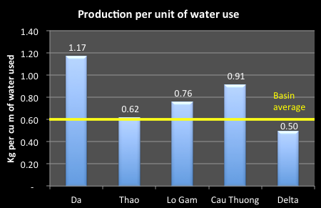

Figure 5‑17: Production per unit of water use

Figure 5‑18 shows a rough estimate of the economic return for each unit of water input. This shows that the Da and the Lo-Gam sub-basins provide a return of over 3,100VND per m3 of water used. This compares to the Delta at only 2,255VND per m3, well below the average for the RTBRB. It should be noted that this estimate ascribes 100% of agriculture production value to water.

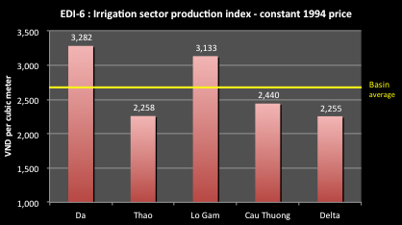

Figure 5‑18: Economic return per unit of water use

1. The area being irrigated is significantly less than the actual design area of the scheme. Figure 5‑19 shows that on average for the RTBRB only 74% of the design areas is being irrigated. The reasons for this include: funding limitations; water availability shortages; under-capacity of systems; changes or deficiencies in planning or design; incomplete construction of works, including lack of secondary or tertiary canal systems; system damage or degradation; and poor system operations. This figure shows that pumping stations consistently underperform in irrigating the design area. The worst performing pump irrigation is in the Da River where 50% of design area is not irrigated. The best performing area is in the delta where 75% of designed area is actually irrigated. Relating this to the actual area irrigated, Figure 5‑20 shows that the Cau Thuong and the Delta have the largest areas irrigated with the whole sub-basin. Thus, targeting pumped irrigation in the Cau-Thuong and Delta could hold particularly high benefits for improving performance of irrigation and agriculture in the basin.

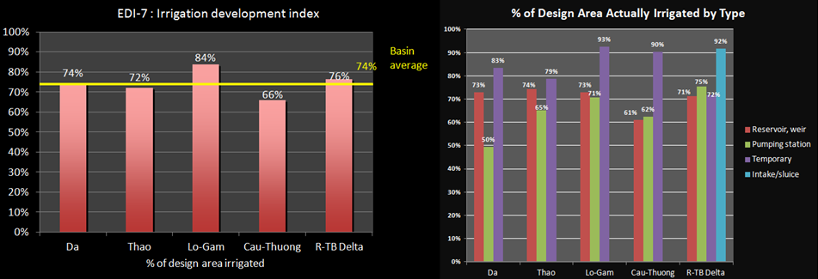

Figure 5‑19: Irrigation - % of design area irrigated

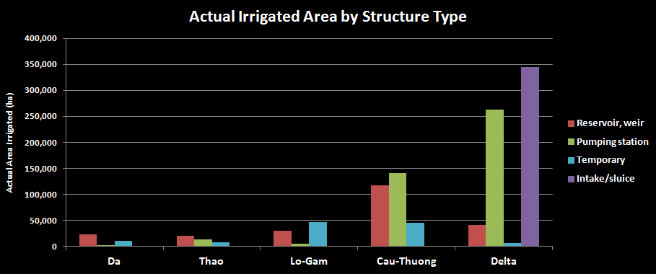

Figure 5‑20: Actual Irrigated Area by Structure Type

1. Most of the hydraulic works and hydraulic work systems in the Da, Thao, Lo-Gam sub-basins and mountainous area of the Cau-Thuong River are small and independent. Very few systems are connected or integrated like those in the delta and midland areas. The irrigation structures and systems in these sub-basins only serve areas ranging from 3 to 500 hectares. The smaller works operate at higher efficiency, while the larger works typically have a low irrigation efficiency ranging between 50% - 65% of the design capacity. This is caused by the fact that the canals are long and earth-filled with high infiltration, leakages, and large losses.
2. Table 5‑10 lists the number of irrigation structures and the areas designed and actually irrigated for each sub-basin.

Table 5‑10: Irrigation structures, design irrigation and irrigated areas by types

|  |  |  |  |  |  |
| --- | --- | --- | --- | --- | --- |
|  | River basin | Number of structures | Required irrigation area | Design irrigation area | Actual irrigated area |
| (#) | (ha) | (ha) | (ha) |
|  | Whole river basin | 11,938 | 1,089,717 | 1,082,487 | 833,101 |
| Reservoir, weir | 3,723 |  | 233,224 | 155,722 |
| Pumping station | 1,792 |  | 424,343 | 299,387 |
| Intake/sluice | 123 |  | 354,914 | 316,419 |
| Temporary | 6,3 |  | 70,006 | 61,572 |
| I | Da | 1,061 | 40,319 | 35,674 | 26,510 |
| Reservoir, weir | 724 |  | 23,339 | 16,990 |
| Pumping station | 20 |  | 2,235 | 1,107 |
| Temporary | 317 |  | 10,099 | 8,413 |
| II | Thao | 1,089 | 57,969 | 41,687 | 30,080 |
| Reservoir, weir | 504 |  | 20,963 | 15,550 |
| Pumping station | 77 |  | 12,986 | 8,450 |
| Temporary | 508 |  | 7,737 | 6,080 |
| III | Lô- Gâm | 6,514 | 90,397 | 82,404 | 69,049 |
| Reservoir, weir | 1,057 |  | 30,572 | 22,275 |
| Pumping station | 39 |  | 5,415 | 3,824 |
| Temporary | 5,418 |  | 46,417 | 42,950 |
| IV | Cầu – Thương | 3,827 | 259,741 | 302,07 | 199,499 |
| Reservoir, weir | 714 |  | 116,702 | 71,292 |
| Pumping station | 825 |  | 140,349 | 87,528 |
| Temporary | 3,716 |  | 45,019 | 40,679 |
| V | Red - Thai Binh Delta | 1,735 | 641,291 | 656,556 | 501,107 |
| Reservoir, weir | 724 |  | 41,647 | 29,615 |
| Pumping station | 831 |  | 263,358 | 198,478 |
| Intake/sluice | 103 |  | 344,914 | 316,419 |
| Temporary | 57 |  | 5,752 | 4,129 |

### Irrigation in the RTBRB

1. The irrigated area in the RTBRB is 74% of the designed area. The remaining area of 251,807 ha is not irrigated reliably or not served (59,113 ha is not yet served). The majority of the area not receiving irrigation service exists mainly in the Cau-Thuong and Red River Delta. A major reason for lack of services is that irrigation structures are commonly in a degraded condition and canals have filled in or are incomplete. During the dry season from December to May, water sources of the rivers in the delta depend largely on water regulation from the large reservoirs located on the Da and Lo-Gam River (i.e. Hoa Binh, Son La, Thac Ba, Tuyen Quang. etc.). Without inter-reservoir operating rules, water shortages occur throughout the delta and midlands during the dry season. Droughts are very severe in January, February and March.
2. Da Sub-basin: Total command area is 40,319 ha, only 35,674 ha with irrigation structures and actual irrigated area of only 26,510ha. There is 4,645 ha not covered by irrigation structure and 13,808 ha has no irrigation structure. The irrigation structure is mainly small reservoir, weirs and temporary structures. Pumping station operate with very low efficiency. Irrigation is for rice mainly, other crops are rainfed.
3. Thao Sub-basin: Total command area is 57,969ha, design irrigation area of 41,687 ha but only 30,080 ha is actual irrigated area accounting for 52%. Rice is main crop irrigated, secondary, fruit and industrial crops are rain-fed. Small reservoir and pumping stations along Thao River are the main irrigation structures and about 70 %-80% design area irrigated.
4. Lo-Gam Sub-basin: Total command area is 90,397ha, only 82,404 ha with irrigation structures and actual irrigated area of only 60,049ha. There is 13,335 ha not covered by irrigation structure and 8,000 has no irrigation structure. The irrigation structure is mainly small reservoir, weirs and temporary structures. There is design of irrigation duty issues and only headworks were completed but not canal systems, therefore, some area is not covered by irrigation structures. Due to deforestation results in high flood warping temporary irrigation structures during flood season and low flow in dry season. High water loss due to poor maintenance.
5. Cau-Thuong: Outside of the delta, the Cau-Thuong River Basin uses water resources in the Nui Coc reservoir, Thac Huong weir, and Cau Son-Cam Son system, but water shortages occur annually. The remaining basins in the mountains areas such as Da, Thao, and Lo-Gam Basins are served by small-scale structures using local water sources. Many areas are not yet served with irrigation. In these areas, irrigation is used only for rice, while vegetables, short and long-term industrial crops, and perennial crops are mainly rain-fed.
6. Delta Sub-basin: The Delta has 31 irrigation schemes servicing around 850,000 ha of irrigated agriculture. This represents about a quarter of Viet Nam’s total area of irrigated agriculture. Most of the irrigation area is served through pump-based extraction systems. Only 18% of irrigated agriculture in the Delta is supplied by gravity-fed systems. The irrigation systems serve a dual purpose: they supply water for flood irrigation of rice crops during the dry season and they drain floodwaters from crop land in the wet season. The extensive use of pumping stations means there are substantial energy costs in operating RRD irrigation schemes. There are 1,700 pumping stations operating in the delta, using more than 7,500 sets of pumps. Energy costs typically account for 30–35% of total operating costs for these systems.[69] Total command area for the Delta is 641,291ha, only 551,488 ha with irrigation structures and actual irrigated area of only 501,107ha. There is 79,112 ha not covered by irrigation structure mainly located in the lower Thai Binh river . .
7. The Red – Thai Binh Delta can be divided by two main zones of the left and the right of Red river. For irrigation in the area to the right of the Red River in the delta, some areas face water shortages due to inadequate structural measures, such as the Tich River and the upper part of Day from Ba Tha to Hat Mon. Moreover, some structures have been changed to other purposes that require alternative irrigation measures, such as Dong Mo reservoir and Suoi Hai , or in some areas water is of poor quality like on the Chau River in Ha Nam Province. Some diversion projects have been built, but their operation does not meet the set objectives, like the Cam Dinh - Hiep Thuan sluice system. In the right Red river, the area is irrigated mainly by small reservoir and pumping stations, intake using local water and main Red mainstream water. The command area in the right river is 304,975ha, irrigated area of 245,844ha as 80% of design irrigation one. The irrigation area on the right of Red river is mainly used local water from small reservoirs and weir. Due to socio-economic development, some reservoirs change the purposes from irrigation to serve for tourism. These issues cause great impact on water allocation for the zone. In addition, the zone has limited water resources; it requires diverting water from the main river (Red or Da river) to the zone not only for irrigation but restoration of Day and Nhue deteriorated rivers.
8. For irrigation to the left of the Red River, there are 3 relatively independent irrigation systems. The first is the Bac Hung Hai system takes water from the Red River through Xuan Quan sluice with a design discharge of 75 m3/s; however, only 40-60 m3/s is taken annually. The rate of intake depends directly on water level – and hydropower reservoir operation from Hoa Binh, Thac Ba, Tuyen Quang. The area for gravity fed irrigation is only 70-80% of the total. The North Thai Binh Irrigation System has abundant water resources. Irrigation structures are reasonably and adequately arranged. Annually, the irrigated area reaches 100% compared to the command area, but the securely irrigated area is only 80%. The South Thai Binh Irrigation system: The status of irrigation status shows that about 2,950 ha are not irrigated because of a lack of infrastructure works. In the Lower Thai Binh, most of the irrigation districts are located near the sea, so water is affected by salinity intrusion. In the irrigation districts in this area, there are about 44,538 ha not irrigated annually, even with adequate structures because of inadequate maintenance (e.g. degradation of the head works, canals that are not dredged).
9. Demand for irrigation water follows the annual dry-wet season cycle. Irrigation water use in the RTBRB peaks in February for all five basins and the lowest demand occurs October.[70]

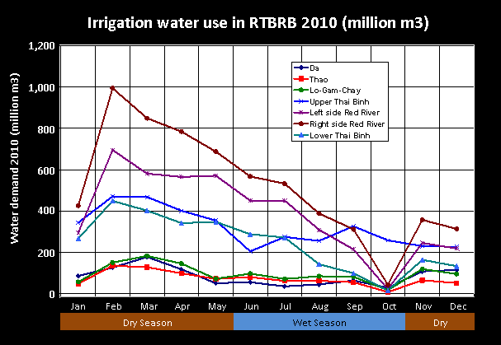

Figure 5‑21: Irrigation water use patterns in 2010

1. Trends in Irrigation and agricultural water supply: Water demand for cultivation will not rise much as the rice land is already contracted, while the land for subsidiary crops and short and long term industrial crops is expanding and the number of crops per year are. Livestock husbandry (cattle, pig and poultry) will see an increase in both the number of animals and farm size (both industrial and household). All sub-basins will see higher water demand, and also higher water standards per head as regulated in relevant programs and strategies. Aquaculture is developing rapidly, especially in the Red River delta (including fresh, salty and brackish water). It is shifting from extensive production to advanced extensive and intensive production. This continued growth will result in higher water demand.
2. Trends in Water drainage in agriculture: It is recognized that planning needs to be carried out to formulate separate urban and rural drainage systems for both rainy and dry seasons as is being done by Hanoi at the moment. Wastewater from agriculture, industry, and domestic use is often discharged into the combined irrigation-drainage canals. Therefore, many canals have been contaminated. It is important that waste water be separated or completely treated before it is discharged into water bodies.

### Drainage

1. Throughout the RTBRB, drainage has been a priority for investment since the 1950s. The Da and Lo-Gam sub-basins are located in the mountains, so gravity drainage and the use of natural rivers and streams is practiced. The mountainous areas in the Cau-Thuong and Thao sub-basins are also drained by gravity. However, in the midlands where it is quite flat, areas are drained by both gravity and pumping. The Red-Thai Binh River Delta is equipped with an extensive system of drainage infrastructure for both gravity and pumping. The inventory of drainage structures in the basin is described below in
2. Table 5‑11.

Table 5‑11: Inventory of Drainage Structures in the RTBRB (Unit: ha)

|  |  |  |  |  |  |  |
| --- | --- | --- | --- | --- | --- | --- |
| **Area and Type** | **Quantity**  **(Unit)** | **Command Area** | **Design Area** | **Securely drained** | **Non-securely drained** | **not covered** |
| **1.Red River Delta** | **1,319** | **975,085** | **953,856** | **792,681** | **160,887** | **11,479** |
| Pumping drainage | 745 | 421,075 | 403,863 | 299,132 | 104,443 | 7,522 |
| Gravity drainage | 574 | 554,010 | 549,993 | 493,549 | 56,444 | 3,957 |
| ***1a. Right Red River*** | ***376*** | ***427,550*** | ***416,431*** | ***330,255*** | ***85,887*** | ***11,479*** |
| Pumping drainage | 254 | 259,932 | 252,770 | 182,448 | 70,033 | 7,522 |
| Gravity drainage | 122 | 167,618 | 163,661 | 147,807 | 15,854 | 3,957 |
| ***1b. Left Red River*** | ***492*** | ***339,441*** | ***329,381*** | ***290,422*** | ***38,960*** | ***0*** |
| Pumping drainage | 438 | 95,955 | 85,955 | 66,717 | 19,239 | 0 |
| Gravity sluice | 54 | 243,486 | 243,426 | 223,705 | 19,721 | 0 |
| ***1c. Lower Thai Binh*** | ***451*** | ***208,094*** | ***208,044*** | ***172,004*** | ***36,040*** | ***0*** |
| Pumping drainage | 53 | 65,188 | 65,138 | 49,967 | 15,171 | 0 |
| Gravity drainage | 398 | 142,906 | 142,906 | 122,037 | 20,869 |  |
| **2. Cau - Thuong** | **254** | **1,416,129** | **1,401,151** | **1,102,201** | **298,950** | **14,978** |
| Gravity drainage | 120 | 1,263,597 | 1,263,597 | 1,010,878 | 252,719 | 0 |
| Pumping drainage | 134 | 152,532 | 137,554 | 91,323 | 46,231 | 14,978 |
| **3. Thao** | **190** | **37,197** | **37,197** | **22,817** | **14,380** | **0** |
| Gravity drainage | 156 | 25,000 | 25,000 | 19,000 | 6,000 | 0 |
| Pumping drainage | 34 | 12,197 | 12,197 | 3,817 | 8,380 | 0 |
| **4. Whole basin** | **1,763** | **2,428,411** | **2,392,204** | **1,917,699** | **474,217** | **26,457** |
| Gravity drainage | 276 | 1,288,597 | 1,288,597 | 1,029,878 | 258,719 | 0 |
| 574 | 554,010 | 549,993 | 493,549 | 56,444 | 3,957 |
| Pumping drainage | 913 | 585,804 | 553,614 | 394,272 | 159,054 | 22,500 |

*Source: Data are referred to the Project on Integrated Red-Thai Binh River Basin Water Resources Use Planning, 2009, Institute of Water Resources Planning*

1. In the RTBRB, there are in total 1,763 drainage works of which 574 gravity sluices draining to 276 channels, and 913 drainage pumping stations. The total drainage command area is 2,428,411 ha, the total design drainage area is 2,392,204 ha, and the securely drainage area is 1,917,699 ha accounting for 75% of the drainage command area. The unreliably drained area is 474,217 ha.
2. In the RTBRB, the total area not covered by any drainage structure is 26,457 ha, and is mostly found in the right Red River; 11,479 ha are located in the Ninh Binh due to a lack of pumping stations and gravity drainage structures. In the Cau-Thuong sub-basin, about 14,978 ha are not served by drainage, including 4,500-5,500 ha in the Vinh Tuong - Yen Lac district (Phan-Ca Lo Rivers), and 9,000 ha in the Man-Chan sub-district (Luc Nam Rriver). Here, the area is partly converted to aquaculture. In the Left Red River and lower Thai Binh, drainage structures (drainage sluices, pumping stations, and channels) have been adequately planned; however, many structures have not been built. Existing structures were often designed with lower probability than required (for example for the South and North Thai Binh, and Bac Hung Hai systems, the designed drainage coefficient was 4-5 l/s/ha, which is lower than the requirement of 7 l/s/ha). Although the head works exist, the drainage capacity is limited; channels are blocked, deposited and encroached without regular dredging and maintenance; and head works are degraded.
3. Demand for drainage services is increasing due to urban and industrial expansion, increased cropping intensity, continued filling up of ponds and lakes, changes in cropped varieties and types, and hydro-meteorological fluctuations. The damage from inadequate drainage is mainly felt by agriculture. However, the benefits from the changes causing the increased drainage requirements fall to industry, urban, and residential areas. On-farm structures were developed without clear plans, and while the capacity of head works is large, flooding still occurs. Generally, operations are localized and fragmented.
4. The existing drainage systems were designed and built mainly for agriculture use to meet drainage standards for rice. However, the reality is that the existing drainage systems serve not only the cultivated areas but also the cities with residential areas, towns, townships, industrial zones, craft villages, all are situated on higher grounds. Rainwater and wastewater flow into the agricultural drainage systems, while the drainage standards are always higher than those for agriculture and with shorter drainage duration. Climate change is leading to higher rainfall intensity and higher sea levels that makes drainage more difficult. On the other hand, the non-coordinated development of industry causes blockages or even breaks the drainage systems. It frequently happens that there is no water to drain at the head works (e.g. pumping stations and sewers), but the fields and cities are inundated in days.
5. For the sub-basin Da, Thao, Lo-Gam and the mountainous area of Cau-Thuong are main gravity drainage along the river; therefore, all the drainage axes need to be cleared. The area with non drainage is mainly located in the lower parts or the area drainage by pumping. Red-Thai Binh Delta and the midland of Thao and Cau-Thuong rivers (provinces of Vinh Phuc, Ha Noi, Bac Ninh, Bac Giang), drainage is a main issues. In future, it is needed to split urban and city drainage into separated drainage system as implemented in Ha Noi city.
6. Agricultural, industrial, urban wastewaters are all discharged into irrigation and drainage systems resulting water polluted in the canals. It is necessary to split waste water or treated wastewater before discharge into the canal system is the most critical issue.

### Irrigation management

1. According to MARD, Viet Nam has about 100 irrigation systems with value of VND 125,000 billion including 1,959 reservoirs with storage greater than 0.2 million m3 (total gross storage of 25 billion m3) and total irrigation capacity for 505,000 ha, salinity prevention for 870,000 ha, acid-sulfate improvement for 1.6 million ha, supply water for domestic and industrial production with over 5 billion m3/year. However, there is still many problems related to the operation of irrigation and drainage systems, main reason is from poor mechanism, policy, institution.
2. Irrigation management in Viet Nam is divided into administrative and technical categories. The administrative institutions are formed at the central level and duplicated at the provincial, district and commune levels. The People’s Committees are the top administrative body for a given administrative level and the commune is the lowest level at which an official administrative division is made.
3. The technical institutions for irrigation management are sub-divided into the planning and management institutions and the operations and maintenance institutions. The technical planning and management institutions are led by the Ministries. The Ministry of Agriculture and Rural Development (MARD) is the ministry responsible for the management of irrigation and drainage services and infrastructure. The Department of Irrigation, Drainage and Flood control (Thuy loi) was established in 2003 and General Department of Irrigation, Drainage and Flood control was established in 2010 with two importance agencies including the Department of Management for Water Sources and Rural Water Supply and Sanitation, and the Department of Irrigation, Drainage and Flood control Structures Management.
4. MARD has the primary responsibility for irrigation management in Viet Nam. The Department of Water Resources within MARD and its associated institutes (including the Institute for Water Resources Planning) lead the planning and development for major irrigation infrastructure and development. There are other agencies under MARD that have responsibilities related to water resources. The Plant Protection Department gives permission for chemicals to be used (herbicides and pesticides), including pesticide registration and residue control, and instructions on how to use them. The Pesticide Division is responsible for conducting pesticide management including pesticide registration and has four Regional Plant Protection Centres.
5. Under MARD are the Provincial Agricultural and Rural Development Services (PARDS) and the District Agricultural and Rural Development Services (DARDS). These institutions are established at the administrative level. Provincial governments all have DARDs (Departments of Agriculture and Rural Development), who provide technical and planning support to irrigation schemes, and may plan for smaller infrastructure projects. Provincial DARDs generally have an irrigation and drainage staff of 10-15, with officers at the district level in some districts. At present, irrigation and drainage works are managed as follows:
   * 1. For large scale works serving several provinces or cities (at present four schemes fall into this category):
        + 1. State run Irrigation and Drainage Management Companies (IDMCs) are in charge of managing the headworks and main canals. However, MARD has taken administrative control of IDMCs where their jurisdiction covers several provinces and central control is necessary because of difficulties is gaining agreement on water charges and administrative issues. Note that at the inter-provincial Bac Hang Hai system the IMC reports to MARD.
          2. IDMCs controlled by the Provinces or cities are in charge of managing pumping stations and sluices for taking water from the main canals, and primary and secondary canals.
          3. Water User Associations (WUAs, including agricultural cooperatives, water use cooperatives, teams, unit, groups, of which there 13,000) enter into water supply agreements with IDMCs, and take care of operation and maintenance of pumping stations and small intakes for off-taking water from the secondary canals; tertiary canals that serve only one commune or cooperative, and on-farm canals, distributing water to individual farmers.
     2. Works serving several districts within one Province:
        + 1. IDMCs take charge of the management of headworks, and primary and secondary canals.
          2. WUAs enter into water supply agreements with IDMCs, take care of the operation and maintenance of tertiary canals and on-farm canals, distributing water to individual farmers.
     3. Small scale structures such as dams and reservoirs or pumping stations that irrigate or drain areas within one commune or in one cooperative will be operated and maintained by the communes or the cooperatives.
6. The operations and maintenance institutions are established at the system level, but within the corresponding administrative level. The traditional system level management institution is the IDMC. It should be noted that significant variations exist and each irrigation system should be analyzed separately to determine its specific institutional structure.
7. In general, irrigation management at the system level is the responsibility of the (Irrigation and Drainage Management Company) IDMC. Management of irrigation at the farm level is typically done by the cooperative. These two institutions have undergone a series of changes over time as well as possessing a significant degree of variability between themselves. It is important to have a broad understanding of these organizations in order to fully understand their current ability to function and their potential as irrigation management institutions. This section will offer an assessment of how well these institutions are functioning, what are their strengths and weaknesses, and what are their implications for the poor.
8. Irrigation and Drainage Management Companies (IDMC) are the primary institution involved in the operation and maintenance of irrigation systems. The IDMC is typically established at the Provincial Level within the Provincial Agricultural and Rural Development Services (PARDS). However, IDMCs can be established at the District level if an entire system falls within a district. The IDMC is supervised by the relevant People’s Committee acting through the PARDS or DARDS under which the IDMC was established. The responsibilities of the IDMC can include provision of irrigation water, construction, planning and management of the operations and maintenance of the system, management of the system’s finances, collection of irrigation fees, and support for Irrigation Enterprises at the district level.
9. At present there are 129 IDMCs, employing over 22,500 people. Three of these are under the direct control of MARD (the Bac Hung Hai, Bac Nam Ha, and Dau Tieng IMCs), with the remaining 126 under the control of the Provinces. At present, 6 provinces in the RTBRB have not established IDMCs (Ha Giang, Lao Cai, Bac Can, Tuyen Quang, Yen Bai, and Dien Bien). Going in line with IDMCs, at present, other organizations and individuals also are involved in irrigation drainage management. According to government data, there are 13,000 irrigation service organizations (including agriculture cooperatives, water user cooperatives, water user groups, etc.) in Viet Nam.
10. Table 5‑12 also shows the widely varying differences between the IDMCs in each area. In terms of the number of staff per thousand of hectares irrigated, the ratio varies from 0.2 in the Cuu Long to 10.5 in the Red River delta. The delta also has the highest number of staff per IDMC suggesting inefficient service delivery. The lowest number of staff per IDMC is 118 in the Central highlands. The World Bank is currently assisting MARD in establishing a n irrigation benchmarking system.

Table 5‑12: Irrigation Management Structures

|  |  |  |  |
| --- | --- | --- | --- |
| Area | Total paddy area ('000 ha) irrigated (2012) | No of IDMCs  (2006) | No of employees |
| Northern uplands (15 provinces) | 465 | 17 | 2,333 |
| Red river delta (11 provinces) | 1,273 | 48 | 1,1764 |
| North central coast (6 provinces) | 695 | 20 | 4,253 |
| South central coast (6 provinces) | 466 | 7 | 1,432 |
| Central highlands (5 provinces) | 194 | 4 | 472 |
| Northeast South (8 provinces) | 215 | 8 | 1,547 |
| Cuu Long (13 provinces) | 4,003 | 6 | 768 |
| TOTAL | **7,312** | **110** | **22,569** |

1. Currently, there is no water licensing mechanism established in Vietnam, although licensing is called for in the Law on Water Resources. Water withdrawal allocations are based on the design capacity of the irrigation system’s designed capacity and approved by MARD and the Provincial People’s Committee. However, there is no monitoring mechanism for the water withdrawals the IDMC makes from the water source. The IDMC does not make any payment for the water it takes. The IDMC is typically responsible for the main canal and principal infrastructure; however, it may take on responsibility down to the secondary canals.
2. For water delivery, the IDMC devises its seasonal plan based on intended irrigated area, cropping pattern and planting calendar (from PARDS), and availability of water. This information comes in the form of requests from cooperatives. In general, this plan does not vary significantly from year to year. The plan for water delivery serves as the basis for the IDMC’s budget, which is submitted to the Provincial authorities for approval.
3. Irrigation Enterprises are normally considered as below the IDMC (normally at the district level); however, in many cases they are not subordinate to the IDMC. The Irrigation Enterprise maintains a technical partnership with the IDMC. It is the District People’s Committee that actually makes decisions on the operation plans of the Enterprise. Their responsibilities are to manage irrigation and drainage infrastructure, such as pumping stations, at the main and secondary levels. They do not exist in all irrigation systems, but are conditional upon need.
4. Irrigation Stations are located under the IDMC. If an Irrigation Enterprise exists, the Irrigation Station is beneath the Enterprise as well. The Irrigation Station may be established at either the district level at the canal level. The irrigation stations possess the technical staff that communicates directly with the communes regarding irrigation. Before each cropping season, farmers submit their irrigation plans to the Irrigation Station, which compiles a report to be filed with the IDMC (or through the Irrigation Enterprise if one exists). The Irrigation Station holds the responsibility for delivering water to the cooperatives. This arrangement is made by negotiated contract.
5. Cooperatives are the organization through which farmers are represented and served. They are an important part of the irrigation management setting. In general, the cooperatives act as a service provider for farmers. Typical services include irrigation water, seed, fertilizer, and extension. The typical arrangement has been for cooperatives to be formed at the commune level; however, this pattern is now changing. A summary of the different forms is presented in Table 5‑13.

Table 5‑13: The forms of I&D management at local level for the whole country

|  |  |
| --- | --- |
| Form of I&D management at local level | Number (#) |
| Agricultural Cooperatives work as multi-services or only I&D service | 4,371 |
| Water use Cooperatives | 2,017 |
| Water use Association | 495 |
| Commune (or Inter-commune ) I&D management Unit | 659 |
| Village or hamlet water management Unit | 2,915 |
| Total | 10,457 |

*Source: Report of Irrigation and drainage water service assessment of water Cooperatives, 2006*

1. Legal Basis of Irrigation Management: Ordinance 32/2001/PL-UBTVQH dated 4 April 2001 of Standing Committee of national Assembly and other by laws regulates the management of irrigation and drainage systems is classified as 4 levels: (i) Central level as Ministry of Agriculture and Rural Development (MARD) with Department of Irrigation and Drainage (*Cuc Thuy Loi* – now changed into General Department of *Thuy Loi*)[71], (ii) Provincial level with provincial Department of Agriculture and Rural Development (DARD) with supported by Sub - Department of *Thuy Loi*, (iii) District level has Division of *Thuy Loi*, (iv) Commune level with the professional staff of transport, irrigation and drainage as showed in Figure 5‑22.



Figure 5‑22: Structure of Irrigation Management

1. Decree 172/2004/ND-CP dated 29 September 2004 stipulated a maximum of 12 professional divisions to be established, of which there is no specific division with the functions of state management on the exploitation and management of *Thuy loi* works but in reality, all the districts they have division of exploitation and management of Thuy loi works. Other laws include the Law of businesses 60/2005/QH11 approved by National Assembly 29 November 2005 and Decision 38/2007/QD-TTg dated 20 March 2007 of Government on the changing the I&D management Companies into form of Single member Limited Liability Company or Joint – Stock Company.
2. The structure of Irrigation and Drainage Management from MARD to lower level is shown in Figure 5‑23 below. The structure of DARD’s management for Irrigation, Drainage and Flood Control works is shown in
3. Figure 5‑24.



Figure 5‑23: Institutional Structure of Irrigation and Drainage Management



Figure 5‑24: DARD’s management for Irrigation, Drainage and Flood Control works

1. Provincial irrigation and drainage management: the State management bodies of irrigation and drainage at provincial level are not united and their functions and tasks are not consistent. Therefore, management from Central to provincial levels faces difficulties. At the provincial level, there are 6 bodies related to irrigation and drainage works as detailed in Table 5‑14.

Table 5‑14: District Division to undertake state management on exploitation and management of Irrigation and Drainage works

|  |  |  |  |  |  |  |  |
| --- | --- | --- | --- | --- | --- | --- | --- |
|  | Total number | Sub- Department | | | | Division | |
| I&D | Water management & I&D works | I&D and Flood control | I&D and Aquaculture | Irrigation and drainage | Agriculture |
| North mountainous | 15 | 8 | 1 | 2 | 0 | 4 | 0 |
| Red – TB River Delta | 11 | 5 | 3 | 0 | 0 | 2 | 1 |
| **Total R – TB river basin** | **26** | **13** | **4** | **2** | **0** | **6** | **1** |
| Whole country | 64 | 37 | 6 | 5 | 1 | 14 | 1 |

*Source: Survey data from MARD- Economic Research Centre – Institute of Science of Irrigation and drainage (Thuy loi)*

1. There is some remaining confusion between the functions of state management and production management. Some Provinces assign tasks to a sub-department that are both state management and water works operation and management. Therefore, the state management body is greater than as required.
2. The process of decentralization is not clear resulting in difficulties in regulation: the decentralize for exploitation and management of water works at of Central, Provincial and district levels is not clear on size, scope, responsibilities resulting in overlaps of procedures and troublesome issues for people.
3. The low education level of management officers and the number of officers is not well balanced for different regions and areas.

Table 5‑15: Capacity of officers of the exploitation and state management for irrigation and drainage works at Provincial level

|  |  |  |  |  |
| --- | --- | --- | --- | --- |
| Area | University and higher  (%) | College  (%) | Secondary  (%) | Primary  (%) |
| North mountainous area | 80.57 | 1.71 | 12.0 | 5.71 |
| R-TB Delta | 82.17 | 2.33 | 10.85 | 4.65 |
| Whole country | 56.84 | 3.78 | 24.44 | 14.94 |

*Source: Survey data from MARD- Economic research Centre – Institute of Science of Irrigation and drainage (Thuy loi), 2006*

Table 5‑16: Number of officers of the exploitation and state management for irrigation and drainage works at District level

|  |  |  |  |
| --- | --- | --- | --- |
| Area | State management | | |
| Total | Staff with I&D professional knowledge | Others |
| North mountainous area | 1226 | 149 | 1081 |
| R-TB Delta | 963 | 181 | 782 |
| Whole country | 4612 | 639 | 3976 |

*Source: Survey data from MARD- Economic research Centre – Institute of Science of Irrigation and drainage (Thuy Loi), 2006*

Table 5‑17: Capacity of officers of the exploitation and state management for irrigation and drainage works at District level

|  |  |  |  |
| --- | --- | --- | --- |
| Area | University  (%) | Secondary  (%) | Primary  (%) |
| North mountainous area | 55.86 | 40.0 | 3.45 |
| R-TB Delta | 71.27 | 28.73 | 0 |
| Whole country | 59.1 | 35.5 | 5.4 |

*Source: Survey data from MARD- Economic research Centre – Institute of Science of Irrigation and drainage (Thuy Loi), 2006*

1. Direct operation and management of Irrigation and Drainage works: At present, there are 110 state enterprises with number of staff of 22,569 persons and about 10,457 I & D Units at local level. However, the form of irrigation and drainage management varies. Among 110 state enterprises, there are 4 inter-province IDMCs (of which 3 companies is under MARD), the remainders are inter-district under Provincial People Committees or District People Committees. Currently, there are six forms of enterprises as follows:

Table 5‑18: Forms of Irrigation and Drainage Management Enterprises

|  |  |  |  |  |  |  |
| --- | --- | --- | --- | --- | --- | --- |
|  | Total number | Type of enterprise | | | | District I&D M enterprise |
| Inter-province I&D Company | Provincial I&D Company | Inter-District I&D Company | District I&D Company |
| North mountainous area | 17 | 0 | 7 | 3 | 5 | 2 |
| R-TB Delta | 47 | 3 | 1 | 9 | 33 | 1 |
| Whole country | 110 | 4 | 34 | 22 | 40 | 10 |

*Source: Survey data from MARD- Economic Research Centre – Institute of Science of Irrigation and drainage (Thuy loi), 2006*

1. Too wide management scope to management capacity of the enterprise, therefore, the participation in the management is limited.
2. Management Policies: The existing financial mechanism still presents a disadvantage for the water enterprises. Enterprises mainly implement water works operation and management. Previously, the water fee was a main source of revenue but it is not enough for operation and maintenance of the works and office operations. However, in 2008, Decree 115/2008/ND-CP was issued to update and improve some articles of Decree 143/2003, particularly Article 19. The Decree effectively abolished the water fee resulting in great benefits for farmers with reduction of expenditures of agricultural production, and canceled all former debts of water fee. Instead, the government now subsidizes the water fee. However, the abolishment of the water fee is not consistent with the IWRM principles to treat water as an economic good.
3. The Decree 67/2012/ND-CP on improving some articles of Decree 143/2003 and other regulations on implementing the Ordinance of Water works Exploitation and Protection. In Decree 67, the water fee will be increased from 1.1-2.7 times greater than that stipulated in Decree 143/2003 in all areas, except for the Cuu Long Delta and the abolishment of water fee for poor households. In addition, the Decree regulates the water charge of non-food production services. Water charges for aquaculture are reduced by 2% of production values
4. Operation rule of reservoir and irrigation schemes: All irrigation and Drainage schemes or reservoirs under MARD cover large beneficial areas of provinces or districts, therefore, right after the scheme/reservoir completed, the operation rules for the them have to be developed and approved either MARD (if large scheme/reservoir) or provincial authority (if provincial scheme/reservoir). These operation rules stipulate how the different parts of the scheme operated and how the management activities cooperate with related partners in operation; for the reservoir, the operation rule for separated flood season and dry season are developed.
5. On August 19, 2008, the Decision 2517/QD-BNN-TCCB of establishment of Centre for participation irrigation management was issued by MARD (CPIM). The decision stipulated the function, responsibility, authority of the Centre. CPIM with tasks of (i) forming annual program, plans, and training on I-D management, operation and protection; (ii) Introduce and apply the scientific studies on investment policy, construction, transfer structures to farmer for management, policy and operation of Water Use Corporation and the studies on impacts from Climate change on community; (iii) Build the experimental models, technology transfer, results of scientific researches on irrigation management with farmer participation; (iv) Provide consulting on on-farm irrigation and setting management unit; (v) participate in editing the procedure, norm, standard, benchmark according to assignment; (vi) organize the training and education on local on-farm irrigation management and apply new technology into irrigation structure operation and management ; (vii) provide scientific information on the sector; (viii) International cooperation on scientific research, technology transfer and joint-name in their activities of PIM and others. CPIM works as public science non-productive organization located in The Institute of Science Research on Irrigation –Drainage-Flood control (Thuy Loi) under MARD.
6. Water use organizations: Currently, there is about 1,500 WUOs including Cooperatives, Associations management 9% of independent irrigation schemes serving for 20% of total irrigated area. In addition, there is about 10,000 WUOs manage tertiary canals and structure on canals (on-farm level) within the irrigation schemes which managed by IDMCs.[72]There are mainly 6 forms of WUOs as shown in Table 5‑19.

Table 5‑19: Types of Water User Organizations

|  |  |  |  |
| --- | --- | --- | --- |
|  | Forms | Abbreviation | Terms |
| **I** | **Cooperatives** |  | **Operation and organization under Law on Cooperatives** |
| 1 | Agriculture cooperative | ACs | Irrigation service at commune, village scale |
| 2 | Water User Cooperatives | WUCs | Specialized in irrigation service at inter-commune and village scale |
| 3 | Irrigation Cooperatives | ICs | Specialized in irrigation service at commune and village scale |
| 4 | Irrigation and Electric Cooperatives | IECs | Integrated service at commune and village |
| 5 | Agriculture and Electric Cooperatives | AECs | Integrated services t commune and village |
| 6 | Agriculture and Forest Cooperative | AFCs | Integrated at commune scale |
| **II** | **Water use organization** |  | **Pursuant to Law on Cooperatives and Civil Law** |
| 1 | Water user Association | WUA | Inter-communes and village scale |
| 2 | Water user group | WUG | Commune and village scale |
| 3 | Water management group | WMG | At village scale |
| 4 | Water management team | WMT | Village scale |
| 5 | Water delivery group | WDG | Village scale |
| **III** | **Management Board** | **MB** | **Inter-district; inter-commune, commune; inter-village, village or independent MB** |
| **IV** | **Equitization, Individuals** |  | **Pursuant to Law on Cooperatives and Civil Law** |
| 1 | Cooperative-Individuals | C, Is |  |
| 2 | Hiring contract WMG, Individuals | HCWM | Inter-village or village scale |
| **V** | **Commune People’s Committee** | CPC |  |
| **VI** | **Village** | Village | Head of village responsible for this duty, no formation of a service organization |

Table 5‑20: Distribution of forms of existing WUOs

|  |  |  |  |  |  |  |  |
| --- | --- | --- | --- | --- | --- | --- | --- |
| Region | Agricultural Cooperatives | | Other organizations | | | | |
| Quantity | Rate (%) | WUCs | | WUA, WUG, WMG, WMT | | Rate (%) |
| Quantity | Rate (%) | Quantity | Rate (%) |
| North midland and mountainous | 3788 | 91 |  |  |  |  | 91 |
| Red river Delta | 2006 | 96.7 | 29 | 1.4 | 40 | 1.9 | 3.3 |
| North Central | 3631 | 86.5 | 256 | 6.1 | 311 | 7.4 | 13.5 |
| South Central | 994 | 67.0 | 331 | 22.3 | 158 | 10.7 | 33 |
| South East | 236 | 62.8 | 101 | 26.9 | 39 | 10.3 | 37.2 |
| Mekong river delta | 406 | 58.5 | 54 | 7.8 | 234 | 33.7 | 41.5 |
| Central Highland | 189 | 73.0 | 42 | 16.4 | 27 | 10.6 | 27.0 |
| **Total** | **11,249** | **76.5** | **958** | **11.5** | **1039** | **12.0** | **23.5** |

1. The status of water use organization (WUOs): In the delta, Agricultural Cooperatives are widely accepted. WUOs create a link between IDMC–CPC-management board- agricultural cooperatives at village scale–households. It is state management operation under service contract with internal relation.
2. In the midland and mountainous areas, Agriculture and Forest Cooperatives are the main bodies; it creates the link between Inter-district–management board–water management groups–households. In this form, there is no IDMC, only inter-district and inter-commune water management board.
3. Most agricultural cooperatives have their revenue from water fees (accounting for 75%, in North east South 96%). This might present that other service is not effectives. With the abolishment of water fee, the operation of these organizations might not be possible.
4. Other forms of water user organization (WUAs, WUGs, WMGs): account for 23.5% of total WUOs in the whole country. In the red river, the form has only 3.3%.
5. To improve the effective operation of PIM, it is necessary to improve (i) awareness on the benefit from PIM, right to participate in discussion and decision making on water management, promoting role of communities together with the role of state, and most importance is water from water works should be considered as economic goods to ensure finance for sustainable development of PIM on the basis of biding responsibilities to interests of water users. The effective and sustainable PIM models do not depend on their scale, name and operation form but only depending on status of each locality on water sources, irrigation scheme scale, awareness of people, knowledge of officials, interest of local authorities on management and implementation of policies on PIM.
6. Until 2008, individual farmers paid ‘irrigation service fees’ (ISF) to cover at least a proportion of the operation and maintenance costs associated with irrigation water delivery by both IDMCs and WUAs. Irrigation-water charges were based on crop type, cropping season (spring/summer), and crop output, as well as on whether partial or full irrigation was supplied. There were exemptions from payment of ISFs for disadvantaged areas, or areas where crops had failed due to natural disasters. Although not adequate to meet operation and maintenance requirements, these fees provided a substantial proportion of the budget for IDMCs. However, in 2008, this fee was abolished for cultivated land less than a specific area. The fees were abolished due to the cost burden on agricultural households that have already comparatively low incomes and rising costs, and with a view to improving capital formation by the farmers and improvements in living standards associated with decreased overall costs of operations.

### Main Issues for Irrigation

1. The irrigation requirement in the Red–Thai Binh River is mainly in the Delta. The existing irrigation structures as sluices built before large dams of Hoa Binh, Tuyen Quang and Son La built, therefore, the taking water for irrigation by these sluice will be impacted by the operations of these dams and reservoirs, especially on water level in the rivers in dry season.
2. The sector with non-consumptive use is hydropower but their dams and reservoirs located in the mountainous areas, their demand is quite different with consumptive use sectors located in lower areas in space, time, quantity and benefits. All the sectors with higher water demand are concentrated in the midland and Red – Thai Binh river delta, but less water availability, while in the upper parts – Da, Thao, Lo-Gam have more water. Therefore, the appropriate operation rules on timing, quantity and benefit sharing of inter-reservoirs and the delta is essential matter.
3. The issues of institutional, legal, inter-sector and private sector mechanism, functions and tasks of individual sector need to be in cooperation and linked
4. Chinas water use has some impacts on Viet Nam’s part: For the Red rivers, impacts from China’s water utilization on water resources and uses in Viet Nam is very important, especially the impacts of Chinese reservoir’s operation on Viet Nam water availability both in flood and dry seasons need to be considered and develop studies, international cooperation programs to provide respond plans.
   * DA River: China’s reservoirs have store water during flood season: from 2007-2009 the stored flood water was 10-20% and it is 30% in dry season (May and June 2009).
   * Thao river: At Lao Cai gauging station, the data and information showed the stored water in June and September (to fill water into reservoirs stage) about 10-15%
   * Lo river: flood flow is changing from 83.65 bill m3 in 1963 to 152.93 bill m3 in 1973, 166.5 bill m3 in 2002 and 106.6 bill m3 in 2003, 95.76 bill m3 in 2006 and 74.68 bill m3 in 2007.
   * The water levels during flood season at Muong Te (Da River) increased suddenly with the amplitude of about 10m on 13 October 2006; it is 4 m at Nam Giang (Nam Na – Da river) on 17 May 2007.

### Main Issues for Drainage

1. In Cau-Thuong: Drainage structures have been built long time ago, therefore, they are in deterioration. Some structures designed with small drainage duty of 1.7 – 3.5 l/s/ha, now drainage requirement is not only for agriculture but industry, domestic use and other, therefore, drainage duty required higher, it is 15 – 16l/s/ha in some areas
2. In the Delta: the drainage structures are in degraded, high tide movement causes great difficulties for drainage especially if rainfall in the fields coincides with high tides. On the other hand, drainage system built mainly headworks not full drainage canals or canal filled up by sediment resulting in water logging in many areas. The drainage duty also designed (4/s/ha) lower than that required of 5 – 6l/s/ha.
3. Agriculture is consuming the majority of input resources but generates only a small proportion of GDP. Figure 5‑14 shows for each sub-basin two of the main inputs used for agriculture – water and employment – and the GDP, which is a measure of the output. This demonstrates the for all of the sub-basins the vast majority of these input resources are being devoted to agriculture but that agriculture only contributes a relatively small part of the GDP. For most sub-basins, 70% to 80% of the input resources are being used to generate only 20% to 30% of the total GDP.
4. The efficiency of irrigation schemes. While the development potential in the REBRB is limited, the scope to improve the agricultural production performance of existing systems is thought to be significant.[73] Concerns have been raised about the way irrigation water resources are managed and number of inefficiencies in water management has been identified through a range of research projects. In some situations, water is unevenly distributed across the system. Some farms are oversupplied and others are undersupplied. Other sources of inefficiency include: (a) the timing of water releases to meet crop requirements; (b) losses that occur through unauthorized water use and inadequate infrastructure to minimize leakages; and (c) an inability for the system to meet peak water requirements because of capacity constraints and the poor condition of infrastructure.  Deficiencies in water management can lead to suboptimal water use. This affects crop yields and the level of farm incomes. It can also lead to higher operating costs for systems based on pumping water from a primary source of supply. While the deficiencies in water management are due to inadequate infrastructure and maintenance programs, they also reflect poor service delivery and operating rules that fail to supply enough water to meet crop demands at different points of the production cycle. Inadequate water delivery schedules have affected agricultural production in some areas.[74]
5. Infrastructure degradation and performance. Many hydraulic works are now 30-40 years old, and little significant rehabilitation or refurbishment has been undertaken. This potentially poses dam safety issues, and results in inefficient water delivery systems. Compared with other countries in the region the technologies, materials, equipment, facilities used for construction, maintenance and management of the hydraulic works are antiquated. Budgets for operation and maintenance of headworks and main canals are provided by the State; and for secondary and on-farm canals by provincial budgets or farmer contributions.
6. Other operation and maintenance issues. Several additional common causes of operation and maintenance inefficiencies have been identified, including: poor communications and transportation; poor data management; poor system monitoring and analysis procedures and equipment an absence of computerized methodologies.
7. Loss of good quality agricultural land. As urban and industrial areas expand they take over some of the better agricultural land from production.
   * Agricultural land use planning (ALUP) should be integrated closely with spatial planning. ALUP is in the sense of defensive with land use planning of other sectors. Lack of cooperation between sectors in land use planning. The implementation of the planning is not monitored carefully. The criteria of agricultural land approved by national Assembly by 2010 is 26.22 million ha, estimated implementation is 25.8 million ha (98%) but agricultural production land is over 0.36 million ha and rice land is 3.882 million ha higher 21,000 ha compared with area approved by National Assembly.
   * Land use planning is not considered as the legal basic in land handing over to farmer, hire land, revoke or change the purpose of land use. In some province, the agricultural land has been revoked. The great change of rice cultivation into non-agriculture purposes in very short time, especially in good rice soil with good condition for rice cultivation (good irrigation facilities) and the changing not taken into account their effects on social-economic-environment future results in negative impacts on life condition and production of farmers and threat the food security at national level. The change in agricultural land in some provinces as follow:

Table 5‑21: Change in agricultural land in some provinces

|  |  |  |  |  |
| --- | --- | --- | --- | --- |
| Province | River | Agricultural land (ha) | Revoked agricultural land (ha) | % of agricultural land revoked (%) |
| Tuyen Quang | Lo-Gam | 531,953 | 98,205 | 18.46 |
| Ha Noi | Delta | 40,805 | 26,470 (other 42,000 ha by 2020) | 57.8 |
| Hai Phong | Delta | 84,963 | 17,455 | 20.53 |
| Hung yen | Delta | 52,217 | 33,296 | 55.4 |
| Hai duong | Delta | 101,667 | 39,203 | 36.3 |
| Vinh Phuc | Cau-Thuong | 89,711 | 43,490 | 46.04 |

*Source: General Department of land management, 2011*

1. Around 80% of revoked agriculture land is almost flat and adequately watered field with good irrigation infrastructure growing two crops per year. These revoked land are considered as 500,000 tons of rice lost per year and affects for 2.5 million farmers. On average, about 73,000 ha of agricultural land (of which about 7,000 ha is paddy land) is revoked for industrial area, urban area, and golf.
2. The paddy areas, there is a reduction of rice cultivation in the Red–Thai Binh River Delta focusing on monsoon rice. The reduction in is area is about 18,000ha – 20,000 ha in Northeast and Delta mainly. The changed areas are either poor land or no water for irrigation. These areas are changed to non-agricultural land and dry crops. The variation is shown in Figure 5‑25 below.



Figure 5‑25: Monsoon rice area of the RTBEB 2000-2011

1. Water fee: According to the general Assessment of Water fee policy: since the policy of abolishment of water fee with Decree 154/2007, the areas of industrial, winter secondary crops are increased and no more the situation of lowed cultivation areas reported as well as in dept of water fee. Before the abolishment of water fee, the IDMCs have to deposit in advantage amount of money for O&M but now water works with subsidies from Government have been gradually more repaired, maintained and ensuring the irrigation areas; several cultivation areas have been exclaimed and irrigated, the irrigated or drainage increased from 4-10%, some areas 40%. However, the mountainous and central Highland areas faced more difficulties, because of rice fields in scattered distribution, required higher expenditures for O&M of water works.
2. Another issue is the use of water fees is restricted by current policies. According to Decree 143/2003, water fee is used for annual O&M including replacement, therefore, some provinces not enough budget for O&M if they spend budgets for replacement. Some recommendation that there is a remaining a complex administration procedures in waiver of irrigation service fee.
3. The policy of abolishment of water fee make significant reduction the sense of peoples responsibility in paying back previous water fee departments and no more water saving.
4. Water quality. Not only does poor water quality pose a public health risk within irrigation schemes, but there is anecdotal evidence that crop yields have been reduced in highly polluted areas. The impact of irrigation on water quality in both the canals, and downstream rivers, is also of concern. The economic impacts of water pollution in reservoirs, irrigation canals and downstream water courses has not been assessed:
5. In reservoirs and their catchments. Water resources within many reservoirs are polluted by activities upstream of the structures such as mining, industrial activities, craft village wastes, residential areas. In addition, there has been encroachment of activities in the immediate vicinity of the reservoirs, including aquaculture within the reservoirs themselves causing addition pollution loads. There is no basin or catchment scale planning for water quality, and regulations regarding activities within reservoir catchments and the reservoirs themselves are inadequate, and awareness is poor. Responsibility for these activities has not been assigned.
6. In scheme canals. Within the irrigation scheme canals themselves water quality is also deteriorating. Wastewater from industries, craft villages, and urban areas is being discharged directly into the irrigation drainage canals, and runoff of pesticides and fertilisers from the irrigated areas is adding to the pollution loads.
7. From canals to river. A significant amount of water from irrigation areas returns to the main river, and passes downstream. The volumes, or water quality, of these return flows have not been documented. The pollution from sources discussed above may impact on downstream uses, including water extracted for urban or other purposes, and instream environmental values and uses such as aquaculture and tourism.
8. Multi-purpose use of irrigation reservoirs. Most reservoirs (with the exception of those for hydropower development) have been designed for irrigation water supply. As discussed previously, downstream water requirements have rarely been considered, and multipurpose use of the reservoirs themselves, including for flood control, has not be planned. The structures have not been designed to pass any significant flows, and now pose major barriers to fair water sharing, downstream social and economic values, and environmental health. The responsibility for state management of these structures needs to be carefully considered, as does their management and operation.
9. Financing irrigation management. One of the main reasons for the degraded state of irrigation infrastructure is the lack of any sustainable financing. State budgets are insufficient to satisfy major refurbishment demands, and provincial budgets are even less capable of such allocations. Viet Nam seems to be relying on ODA to meet critical infrastructure costs. While the irrigation service fees have met some of the day to day running costs of IDMCs, these have fallen well short of full cost recovery. The abolition of these fees will only make the situation worse. A sustainable financing structure needs to be put in place, which considers both the real costs of irrigation management, and the potential impacts on the poor, local needs and conditions, and constraints faced by central government.

**Institutional, legal and policy frameworks**

1. Legal documents: The number of legal documents relating to irrigation and drainage and water infrastructure is enormous. Add to this the new legal framework of the Law on Water Resources and associated decrees and regulations, and the picture is one of gaps and overlaps, inconsistencies and duplications. Such a regulatory environment creates uncertainties in mandates and functions, and promotes both inaction and territorial squabbling.
2. State management of irrigation: MARD needs to strengthen its role as a ‘market-overseer’ or ‘policy coordinator’, rather that as a hands on operator. To date, there has been a very supply driven approach to irrigation infrastructure and management. MARD, and the DARDs, have generally taken a command and control approach to water supply. With the policy of decentralization, there is a good argument for a shift away from such a ‘hands on’ approach by the state irrigation managers, to one of technical advice, facilitation and regulation. Again, this would require both organisational cultural changes, and capacity building.
3. Irrigation scheme management: As many institutions are involved in irrigation management, effective coordination and good communication are vital, particularly between IDMCs and WUAs. Communication and coordination should also be improved within the IDMCs, between the Board of Directors, technical/water management and financial/administration departments, and the field stations. Clear water delivery schedules and requests from the IDMC head office, field stations, and WUAs are needed. Up-to-date information on water availability and deliveries should also be available. Strict monitoring and enforcement of field stations and WUAs on water delivery in secondary and tertiary canals is essential. The administrative environment should ensure rapid and timely action during droughts.
4. There is an urgent need to promote and implement participatory processes, in particular to integrate male and female farmers strongly into the management process (especially the setting of water-delivery schedules). This would make management more transparent, and more responsive and accountable to water users. While there are significant staff numbers in IDMCs, their capacity to deliver the types of changes discussed above is limited, as is the capacity of WUAs and individual farmers to effectively participate in water irrigation management. The importance of PIM is not recognized by administrative authorities. The awareness of commune authorities is low, and their responsibilities in PIM process are not clear. At this stage PIM does not fully empower the WUAs, and their level of commitment is, therefore, low. These factors mean that the sustainability of the PIM processes once project funding ceases has been questioned.
5. Irrigation management capacity: As discussed, a shift in irrigation management philosophy and practice will require substantial changes to the mix of skills at the state, provincial, IDMC and WUA levels. Presently, while central level state irrigation and drainage management capacity exists, such skills at the provincial level, where irrigation services should be facilitated and regulated, are limited. The IDMCs appear to have large staff numbers, although the capacity of these staff to manage the systems, and to provide extension support to WUAs and farmers is limited. Wages are very low, and administrative support systems such as vehicles, computers and other equipment, are limited.

## Industry

1. Industry in Vietnam has been growing rapidly since the introduction of Doi Moi policies in the mid 1980s. Main industrial products in the basin: power, cement, iron/metal, mechanical industry, electronics, electrical equipment and transport equipments. Concentrated industry zones: Thai Nguyen, Viet Tri, Lao Cai, Bac Giang and new areas of Soc Son, Thang Long, Hoa Lac. Total there are 67 industrial zones in the red – River Delta.
2. The private sector occupies an increasing portion of all industrial output. By 2010, industry had accounted for 41% of national GDP. In the RTBRB, industry contribution to sub-basin GDP ranges from 31% in the Da Sub-Basin up to 54% in the Cau-Thuong Sub-Basin (see Figure 5‑26). The main industry is hydropower in Da River and Lo-Gam river, textile and paper in Thao river, structural iron/steel in Cau-Thuong, the high technology, key industry, processing and export industry in the Delta, the others of minor industry accounting 80% of enterprise number. The Delta and midland areas are the aggressive industrial development areas with fast industrialization and urbanization process. Some basic industrial statistics are given in Table 5‑22.



Figure 5‑26: Role of Industry in Sub-Basin Economic Output

Table 5‑22: Basic Statistics of Industry in Vietnam

|  |  |  |  |  |
| --- | --- | --- | --- | --- |
|  | **1986** | **2006** | **2008** | **2010** |
| Industrial activities of GDP (%) | 26 | 41.54 | 39.84 | 41.1 |
| State economy (%) |  | 37.39 | 35.54 | 33.74 |
| Private economy (%) |  | 29.69 | 29.87 | 30.78 |
| GDP by constant price 1994 (bill VND) |  |  | 490,485 | 551,609 |
| Development index compared with 2005 (%) |  |  | 124.8 | 140.4 |

1. The GDP growth rate of 5.03% in 2012, it was less than that of 5.89% in 2011. The contribution from sectors into GDP as 0.44% from agriculture-forestry-irrigation and 1.89% from industry and construction, 2.7% from service activities.
2. GDP per capita: According to 2010 GSO data, per capita GDP by sub-basin had a high of USD 1,322 in the delta and a low of USD 460 per capita in the Lo-Gam (Figure 5‑27). According to a World Bank WB assessment estimated that GDP per capita of Viet Nam is higher than that of Cambodia (897 USD/c), almost equal Lao PDR (1320 USD/c) and much lower that China (5,445 USD/c).



Figure 5‑27: 2010 Per Capita GDP by Sub-Basin (from GSO)

1. The growth of industries is the backbone of Viet Nam’s rapid economic development. The provision of industrial zones is part of the Government’s strategy of attracting international and national investors to the industrial sector. In December 2008, 219 industrial zones were established, occupying over 60,000 ha, with another 91 (on 3,500 ha) planned by 2015. However, only 60 industrial zones have an operating central wastewater treatment plant. There is little data on the functioning of these plants, or on the level of pre-treatment provided by individual industries. With the current weakness in enforcing wastewater discharges, there are few incentives either for industries or for industrial zone managers to incur costs on treating wastewater.
2. Viet Nam has 2,790 craft villages[75] and were classified into 6 types of craft villages based on the traditional production, products, production scale or technology, sources of wastewater and pollution level or materials and markets of consumption. They are classified into 6 types mainly as follows: (i) food processing, animal husbandry and butchery, (ii) Handicraft production, (iii) Construction materials, (iv) Textile production including dyeing and leather processing, (v) Waste recycling, (vi) Others. The rate of each types of craft village as showed in Figure 5‑28.
3. The role of craft villages in the socio-economic development: it attracts several economic components: private 72%, public economy 18%, private enterprises 10%. It has 11 million labors accounting 30% of rural labor forces. Some craft villages have developed strongly with 2,000 laborers and turn-over of 60 billion VND in 2007 (Non Nuoc Stone Art of Da Nang city). Some of Craft village in Ha Nam province have achieved turn-over of 390 VND billion in 2005, mainly rattan, bamboo, etc.
4. The main issues of craft village development: (i) Small scale production, mainly household scales (72%), (ii) agricultural lifestyle of the production master cause great impacts on production procedures resulting in higher environmental pollution, (iii) relations in production has characteristics of family, clan and commune relations; (iv) backward technology and equipments; (v) very low investment for production infrastructure of craft villages results in difficulties in renovation of technology orientated friendly environment; (vi) labor with low skills, mainly handicraft production and apprentice with low education, therefore, low awareness on environmental protection; (vii) technical infrastructures with environmental protection are not taken into account in the craft villages.

|  |  |
| --- | --- |
|  | National Environmental Report 2008 |

Figure 5‑28: Different types of craft village by province

1. Main driving forces on craft village development: (i) The master of the craft village, infrastructure, technology, materials, cultural lifestyle, budget and capacity play important roles to improve the craft village development; (ii) State policies including institutional and policies on management from Central to localities, such as organization of Associations, tax, budget supporting and local management; (iii) impacts from marketing and international integration; (iv) factor of job creation, diversify economy forms in combination with cultural value conservation; (v) Impacts from environmental pollution on community health, landscape, socio-economic disasters.
2. According to the "Master plan development of the Vietnam’s industry by regions to 2010," industrial development up to 2010 gives investment priority to the processing industry, especially agro-processing associated with the development of the material growing areas of agriculture, forestry and fisheries; industries that produce export, consumption goods and handicrafts attracting more labors, and the energy industry to ensure national energy security. For basic industries, it is important to select some of projects of urgent importance with available resources and potential financing sources and promising efficiency to create a platform for industry and for economic development.
3. The orientation for industrial development during 2010-2020 will focus on promoting industries on software development using high technology, new material production and modern infrastructure, such as energy, petrochemicals, chemicals, electronics, mechanical engineering, metallurgy, etc. There are six industries planned relating to water resources, including mining industry, baseline industry, agro-processing industry, textile, garment and leather industry, building material industry, and electricity generation and distribution.
4. According to the development of the industrial zones in Vietnam up to 2010, in the four sub-basins of Da, Thao, Lo-Gam, and Cau-Thuong, there will be three industrial zones in Phu Tho, Thai Nguyen and Bac Giang provinces, in which the Son Cong Thai Nguyen will be constructed from the former Thai Nguyen industrial zone. In the Red River Delta, there are 27 planned industrial zones, of which 10 have been established (including one high-tech zone). The total area of ​​the established industrial zones is 1,307 ha.

**Industrial Water Use**

The Industrial Sector accounts for only a small portion of overall water use in the sub-basins, ranging from 4-6% (Figure 5‑29). However, both the Cau-THuong and Delta account for high volumes of water use, despite the small percentage of total (Table 5‑23).



Figure 5‑29: Water Use by Sector

Table 5‑23: Water Use By Industry

|  |  |  |
| --- | --- | --- |
|  | Current 2010 water exploitation and use for industry | Future 2025 water exploitation and use for industry |
|  | (million m3) | (million m3) |
| Da | 2.8 | 4.8 |
| Thao | 9.3 | 16.6 |
| Lo-Gam | 15.4 | 28.6 |
| Cau-Thuong | 42.5 | 80.6 |
| Red – TB Delta | 220.0 | 562.0 |
| **Whole basin** | **290.0** | **692.6** |

1. Industrial Productivity: Red river has the same rate of industrial productivities with the whole country at 41 USD/m3 of water use (Figure 5‑30). It is lower than that of Thailand, Korea and some other countries (
2. Figure 5‑31). Cau-Thuong sub-basin has highest the industrial productivities 48.72 USD/m3 then Thao Sub-basin, these show that two these sub-basin will face to the water pollution in future, and should be put high priority on water protection for these sub-basin. On average, the industrial water productivity is much greater than agricultural productivity of water (416 times in Cau-Thuong and 250 times in Da sub-basin). It is greater than the aquaculture productivity by 1,330 time in Da; 945 times in Cau-Thuong; and 432 times in the Delta. This shows that, water use for industry has higher benefits than that of agriculture, but in Cau-Thuong sub-basin the gaps between agriculture and aquaculture are lower than other sub-basins.



Figure 5‑30: Industrial Productivity Per Unit of Water Use

*Source: Provincial Statistic Offices for 63 provinces; Note: 1 USD = 20,850 VND*



Figure 5‑31: Industrial Productivity of Water - National Comparisons

*Source: Vietnam Water Sector Review, 2008*

1. Wastewater: There are two sources of data: (i) official data information from provinces reported to DWRM according to the letter required; (ii) data and information from the permits which DWRM issued and the annual reports of DWRM to MoNRE. A summary of information about industrial waste water is present in
2. Table 5‑24.

Table 5‑24: Wastewater from different sectors with different sources of information



1. Urban wastewater treatment is mainly undertaken at primary level. There is about 20% of wastewater treated at primary level for urban wastewater at basin in general accounting for 83,132 m3/day treated, the Delta sub-basin has highest rate of 24% with amount of wastewater 65,210 m3/day treated. Lo-Gam is non-urban wastewater treatment at present.
2. Hospital wastewater treatment: Cau-Thuong sub-basin seem has a great progress in hospital wastewater treatment with the rate of 57% treatment at primary level with amount of wastewater of 69 m3/day but for the Red – Thai Binh Delta, although the rate of only 24% but amount of hospital wastewater has been treated as 2335 m3/day, greater than that of Cau-Thuong 33 times. For the whole basin, the average rate of hospital wastewater treatment is of 24% with total amount of treated wastewater of 2,435 m3/day.
3. Industrial wastewater treatment: the rate of water use for industrial development for Cau-Thuong sub-basin water use for industry is only 42.5 million m3 but amount of 147,994 m3/day has been treated at primary level and 37,000 m3/day has been treated at secondary level accounting for 49% and 12% respectively.
4. Solid waste treatment: all sub-basin have the rate of collected and disposed is from 55-85% for central and provincial cities and towns but is at a very low level in district town of only 25% in Cau-Thuong and the lowest rate of 13% in Lo-Gam. This is main issues for environment at district town scale. For rural areas and resettlements, the rate of solid waste collected and disposed of about 1-14%

### Main issues for Industry

1. High pollution levels compared to small water use levels: Industry uses relatively little water compared to agriculture; however, discharge of industrial waste water contains serious levels of pollutants that are harmful for water quality, human health, and the environment.
2. Water pollution caused by industrial activities: the implementation Decision 64 is not completed. Only a small number of establishments have been moved out of urban areas: only 3 in Thao and 7 in Cau-Thuong sub-basins. It is in process to move the establishments is 11, of which 4 in the Delta. The number of establishments is not dealt with of 9. The reason is to move the establishments require a lot of money while their budget is very limited.
3. Water pollution due to craft villages activities cause great impacts on the community health, especially the craft village of metal production. The longevity of people is only 60 lower than the average level of the country of 72. The diseases with high rate is of pneumonia, diseases related to ear, nose, throat, stomach (rate of stomach diseases is 25% - Source: National Environment report , 2008)),
4. Old technologies are still applied in Viet Nam in iron processing and other industries, therefore, the water pollution is depending upon the improvement of the technology. The lack of treatment of industrial wastewater cause impacts, not only human health, but also the sources of drinking water and water quality for other sector as irrigation will be effected. In the Red river, only 50% of the poor have access to clean water but the rate is 90% in high income group.

## Hydropower

1. Hydropower development has developing at a rapid pace causing many issues. For example, planning and plan implementation: Planning for a hydropower cascade for 11 major river systems was formulated in 2002. Nationwide, small and medium hydropower planning was carried out in 2005. Vietnam power planning I-VII was made to collect comments from related ministries and sectors and approved for implementation.
2. The total economic technical potential of hydropower of Vietnam is 19,666 MW and the total annual power capacity is 85,695 billion kWh. There is a current plan for 13 projects for pumped storage hydropower. The projects are feasible in economic and technical aspects with total installed capacity of 12,000 MW. These include 7 projects in Son La, 1 project in Hoa Binh, 2 projects in Ninh Thuan, 1 project in Binh Thuan, 1 project in Da Nang, and 1 project in Lam Dong.
3. According to the Electricity master plan VII, Vietnam has technical hydropower potential with medium and large scales of 85.6 billion Kwh as 19,666 MW install capacity, of which 28,255 billion Kwh and 6,460 MW in Da river as 31% compared to national hydropower respectively, as current and 2025 capacity 81% and 83% compared to future Red – Thai Binh basin) and 3,159 billion Kwh and 820 Mw in Lo-Gam river (13% and 10% as current and future capacity of Red – Thai Binh river basin).
4. While the role of hydropower in national electricity production is quite high, it is projected to decline overall through 2030. In 2011, hydropower accounted for 57.8% of total electricity production (Figure 5‑32). More growth in energy production in Viet Nam is projected to be in coal, which Viet Nam is currently an exporter of. It is projected that in 2030, Viet Nam will hold a demand for coal source energy of 77,310 MW. Hydropower energy demand will not grow as much mainly due to national potential already being highly developed (Figure 5‑33).



Figure 5‑32: % of Hydropower compared to total energy capacity



Figure 5‑33: Viet Nam forecast energy demand by 2011-2030

1. According to the LWR, the exploitation and use of water sources for hydropower must ensure integration, multi-purpose use and in accordance with water resources planning approved by appropriate authority. Hydropower dams and reservoirs can have multiple functions such as to ensure minimum flow, flood and drought, water shortage prevention for downstream and storage capacity arrangement to ensure implementation of reservoir tasks including storage capacity for flood prevention, water supply safety in normal climate condition and abnormal climate conditions, changes of water quality including climate change factor.
2. In 1976 the Thac Ba multipurpose reservoir was put into operation on the Chay River. In 1989, Tuyen Quang reservoir on the Gam River was also put into operation that importantly contributes to regulation of water (both surface and groundwater). The Hoa Binh dam and reservoir were constructed on the Da River with a total capacity of 5.9 million m3, a flood storage capacity of 4.9 million m3, and 1,920 MW of electricity generating capacity. It has been in operation since 1991.
3. According to hydropower planning prepared by Electricity Vietnam, for large and medium hydropower plants 30 MW installed capacity and larger, an implementation plan was developed for 11 main rivers and stream systems of Vietnam to the year 2003.
4. According to national small and medium hydropower (installed capacity less than 30 MW) planning made in August 2005 by Power Engineering Consulting Joint Stock Company 1 (PECC1), there are 409 hydropower projects with capacity of 1 MW and over distributed mainly in northern mountainous provinces, central provinces, highland areas, and south-west Vietnam with total installed capacity of 2,873 MW and annual power capacity is 13,403 109 kwh. There are 194 projects with an installed capacity of 5 MW and over for consideration of construction investment with total installation capacity of 2,296 MW and annual power capacity of 10,498 109 kWh.
5. The private sector has played in important role in the development of small hydropower and rural energy. Since 1985, new types of investment have appeared because of economic renovation policy. Additionally, investment sources have come from the state budget and the central government, while sectors locals and co-operatives all invest to build small hydropower stations to serve their own demand. Some stations under these types of investments are Na Han, Ta Sa, Na Ngan in Cao Bang built by Tinh Tuc tin mine; Some other stations in Thai Nguyen and Gia Lai are invested in by the military; stations including Duy Son and Dai Quang in Quang Nam are invested by co-operatives.
6. After 1990, when the Vietnam-China border was opened, households installed mini-hydropower plants with a capacity of 0.1-1 kW by their own money. The price of the generator set was low, so there was rapid development of mini-hydropower.
7. Following regular shortages of energy from 1985 to 2011, private investment was promoted to search for new investment opportunities in hydropower development. Hydropower development was seen as a low risk investment, with low price, an stable profit because power demand is always high. Planning for small hydropower was issued in 2005. Up to now, most of small and medium hydropower stations, even large hydropower stations have been invested by private investors and under IPP operation.
8. From 2005 to 2011, the national hydropower development trend expanded throughout 33 provinces which have small and medium hydropower development potential. The construction of hydropower plants with small and medium capacity is suitable with different investors because investment capital demands are not big, construction times are short, operations begin quickly, and economic benefits are realized soon after completion.
9. Additionally, many provinces granted investment licenses for many small and medium hydropower stations. Due to provincial licenses, there were 150 additional small and medium hydropower stations with a total installation capacity of 1,100 MW and annual power capacity of 5,000 106 kwh. (As this number has not been updated in the official reports, it is necessary to make a second nationwide small and medium hydropower planning).
10. For hydropower resources in Red-Thai Binh river system, the hydropower potential is mainly distributed in Red River basin (see Table 5‑25). In Red river basin, the hydropower potential is mainly distributed in Da river basin comprising of 77% of total installation capacity and annual power capacity in whole Red and Thai Binh river basin. Da river basin makes up 35% of total installation and annual power capacity in whole river basin of Vietnam.

Table 5‑25: Summary table of hydropower resources distribution in Red-Thai Binh River

|  |  |  |  |  |  |  |
| --- | --- | --- | --- | --- | --- | --- |
| River system | Large and medium hydropower | | Small and medium hydropower | | Total | |
| Nlm  (MW) | Eo  (106kwh) | Nlm  (MW) | Eo  (106kwh) | Nlm  (MW) | Eo  (106kwh) |
| Da river (China) | 940 |  |  |  | 940 |  |
| Da river | 6,470 | 28,255 | 559 | 2,309 | 7,029 | 30,564 |
| Lo-Gam Chay | 820 | 3,159 | 545 | 2,060 | 1,365 | 5,219 |
| Thao river |  |  | 734 | 3,571 | 734 | 3,571 |
| **Total** | **7,290** | **31,414** | **1,839** | **7,940** | **9,129** | **39,354** |

1. Hydropower development plays a significant role in renewable energy sector in Vietnam. The priority for construction is to small hydropower plants with integrated benefits as flood control, water supply, power production. According to Power planning VII approved by Prime Minister in 2010, the growth rate of electricity demand during 2000-2010 was 13% per year. As Vietnam is at power shortage situation and power production per capita is very low, the growth rate of electricity demand 2010-2013 will remain high from 2010 to 2020.
2. During the period from 2011-2015, hydropower increased 14%; for the period from 2016-2020 it will increase 11.1%; and for 2021-2030 it will increase by 7.8%. According to Power planning VII, up to 2011, over 55% of hydropower stations with economic and technical potential have been built in Vietnam. To 2020-2025, all remaining hydropower stations with economic and technical potential will be completed.
3. In recent years, Vietnam’s growth in power demand reached the fastest level in the region. Forecasts show that the power demand in Vietnam will continue to increase. In 2010, power demand reached 112 billion kWh and if projected to reach 250 - 290 billion kWh by 2020. To meet the increased demand for electricity will require significant investment capital into power generation and grid development, estimated at over 4 billion USD per year.

### Development of small and medium hydropower

1. The Ministry of Industry and Trade coordinates with various sectors and locals under the project to determine the power supply for remote areas, border areas, and islands. MOIT proposes the mechanism and policy for effective implementation to submit Prime Minister for consideration and decision.
2. Electricity of Vietnam Corporation plays an important role in meeting the requirements of power for socio-economic development. Vietnam mobilizes all financial resources to invest in hydropower stations and the power grid in accordance with self-borrowing and self-returning mechanism (e.g. ODA funds, domestic and foreign credit loans, export credit of equipment suppliers, equipment capital loan paid by product, etc.) Vietnam implements central, local, state and people partnership mechanisms to continue to develop the rural power grid.
3. The development of small hydropower in Vietnam and in Red and Thai Binh river basin has been ongoing since 1985. After 1985, because of the economic renovation policy, some new types of investment appeared. Besides state budget and government investment, sectors, locals, and co-operatives also invested in development of small hydropower stations to meet their own demand. After 1990, when the Vietnam-China border gate was opened, households invested in mini-hydropower stations with a capacity of 0.1 to 1 kW and low price per unit, so the trend of mini-hydropower development increased quickly. Status of small and medium scale hydropower: Up to 1999, over 500 small and medium hydropower stations were built and put into operation with capacity of 5 – 10,000 KW/station, with total installation capacity of over 88 MW, annual power capacity of 120 - 150 million KWh/year.
4. The operational management of small hydropower stations invested by the state which is currently a main power source supplying for province, district, managed by power sector. These stations can be connected to the power grid or operated separately with local power grid. Hydropower stations invested by other economic sectors or invested by locals are operated directly by the sectors and locals. Mini-hydropower plants are invested and managed by households. Some hydropower stations with small capacity are usually combined with water pumping or agricultural product processing. Their operation is typically managed by communes and co-operatives.
5. Hydropower stations with capacity over 100kW, which are usually managed by power sector, are currently main power sources for production and living activities. The stations with imported equipment or domestic synchronous production are managed well, annually repaired and maintained, and produce near full capacity. Currently, about 70-80% of the total stations are operating at 60-70% of installed capacity.
6. Multi-purpose hydropower plants are regulated by the following legal documents:

* Decree No. 112/2008/ND-CP regards to resources and environment integration management of hydropower and irrigation reservoir; Clause 9 - water regulation of reservoir.
* Sector standard 14TCN 121-2002 - Reservoir - Irrigation works - Regulations on establishment and issuing of reservoir regulation procedures.
* Irrigation work system – Regulations on establishment and issuing of system operation procedures (14TCN156-2005).
* Irrigation reservoirs - Technical requirements of management and exploitation (14TCN 55-88).

1. Additionally, surface water use licensing and minimum flow for hydropower plants are regulated by the following legal documents:

* Decree No. 112/2008/ND-CP regards to resources and environment integration exploitation management of irrigation and hydropower reservoirs. Chapter 3 – Responsibility for protection, exploitation, use management of resources and reservoir environment.
* Decree No. 149/2004/ND-CP dated 27 July 2004 of the government regards to licence of exploitation, exploration, use of water resources, discharge of wastewater into water sources. In order to grant surface water use licence for power generation, it shall follow chapter IV: Licence procedures of exploration, exploitation, use of water resources, discharge of wastewater into water sources, rights and related procedures are addressed in relevant chapters of Decree No. 149/2004.
* Circular No. 02/2005/TT-BTNMT regards to Instruction of Decree No. 149/2004/ND-CP.
* Decree No. 120/2008/ND-CP regards to River Basin Management.

1. The legal framework for water use planning for hydropower at all levels is based on the following legal documents:

* Decree No. 112/2008/ND-CP regarding to integration exploitation management of natural resources and environment of irrigation, hydropower reservoirs.
* Law in natural resources tax No. 45/2009/QH 12 (2% of power selling price).
* Decree 99/2010/ND CP regarding to payment policy of forest environment services (20đ/kw)
* Decree No. 120/2008/ND- CP regarding to river basin management.
* Decree No. 112/2008/ND-CP regarding to integration exploitation management of natural resources and environment of irrigation, hydropower reservoirs. Chapter 3: Responsibility of natural resources and environment protection, exploitation, use management of reservoirs.
* Decree No. 149/2004/ND-CP dated 27 July 2004 of the government to specify license granting for water resources exploration, exploitation, discharge of wastewater into water sources. To grant license of surface water use for power generation in accordance with chapter IV: Procedures of license granting for water resources exploration, exploitation, use, discharge of wastewater into water sources, for rights and related procedures referring related chapters of Decree No.149/2004.

1. The assessment of hydropower in the RTBRB is based on the following sources:

* Planning of hydropower in Da, Lo Gam, Chay river; Planning of small and medium hydropower of whole country.
* Updated report of built hydropower plants in Red and Thai Binh river basin to the year 2011.
* Power planning VII approved by Prime Minister in 2010, Chapter 7: Power source development program, refer balance between capacity and load of power system part.
* Planning of hydropower cascade in Da river, Lo Gam river and Chay river in 2002. Updated documents to the year 2011 for under construction projects and under operation projects.
* Nationwide small and medium hydropower planning in 2005 (the remaining hydropower stations in the basin, not include cascades in 2002 planning). The document is updated and added to the year 2011.
* Chapter 7: Power source development program, refer balance between capacity and load of power system part – Vietnam power planning shows that existing and future forecast hydropower sources to make capacity balance of Vietnam’s power system including hydropower stations in Red and Thai Binh river basin.

1. The organizational structure and general roles for national power and hydropower management is shown in the Figure 5‑34.

**Contract**

**Government**

**MOIT**

**Energy Agency**

**EVN**

BOT, IPP, JSC, Power generation and power distribution

Others (Not EVN)

* Capital owner, state property owner in power units
* Decision of power price for final customer
* Issuing of decision, decree, regulation, mechanism
* Decision of power planning
* Power activity regulation management
* Implementation instruction of government decree
* Issuing of special legislation regulation document
* Organization of planning appraisal and assigned tasks
* Organization of implementation inspection of planning, policy, regulation and provisions of law in power units
* Settlement of complaints in power activity
* Issuing of special instruction, energy profession
* Assistance of MOIT for state management implementation in power construction and development

Figure 5‑34: Power sector organization chart

1. Electricity of Vietnam (EVN) organizational structure includes a holding corporation. The holding corporation includes corporation divisions, national load dispatch centre (NLDC), project management units of power sources, civil works, power information centre, and large power plants.
2. Fellow subsidiaries, associated companies, and administrative unit.

* Fellow subsidiaries are companies of which 100% of original capital operating in large-scale sectors of power production, transmission, business, telecommunication, finance and hold by EVN corporation and companies of which 50% of original capital operating in medium-scale sectors of power production and business, information technology, power machinery, consulting and other business sectors held by EVN.
* Associated companies are companies of which less than 50% of original capital investing in power production, bank, real estate and other sectors hold by EVN.
* Administrative units include Institute of energy, University of power and 3 colleges of power, 19 thermal power and hydropower companies, 11 power companies, 15 project management units of power sources, power grid, civil construction, 4 power machinery companies, 4 power transmission, 4 power engineering consulting companies, 1 EVN telecommunication company, 1 information technology centre, and 1 national load dispatch centre.

### Main issues with hydropower

1. There are four key functions for hydropower including power generation, flood protection, water supply for upstream and downstream, and environmental flow maintenance. The priority each function depends on the specific project. Hoa Binh reservoir in Da River is the last cascade of Da River. Its most important role is flood prevention for downstream during rainy season. The downstream is Hanoi capital which is especially important location that needs to be protected from flood. Other functions are drought prevention and waterway transportation. A frequent issue for conflict of this project is between flood prevention and power generation. Other functions can combine harmoniously for shared benefits or minimal influence on benefits.
2. Integrated management and sector cooperation: the interaction between hydropower development and other sectors is not considered fully in the hydropower development planning. This leads to unintended, un-costed and un-mitigated impacts of hydropower development on other sector development and activities. Some main impacts as follows:

* Shortage of water sources in dry season due to over deforestation and water stored in upper part of China
* The hydropower stations are funded by different donors; therefore, it is difficult in operation management for multi-hydropower plants in a river system.
* Hydropower projects cause many impacts on large scopes and complex in time. Some are immediate impacts the others in long term, not only natural but social-economic conditions:
* Hydropower plants cause great impacts on flow regime, it is higher water levels if the plant releases flood water during flood season and lower water levels because of filling water into reservoir in dry season. The filling and releasing water make changes the flow patterns and the ecological conditions downstream.
* Sediment has been stored in the reservoirs, less sediment released downstream resulting in unbalance sediment, and therefore, soil erosion occurs in both river bed and river banks.
* To build a dam, a lot of resettlement required, not only remove people out of the reservoir area but loss of production land and large impacts on the local cultural lifestyles
* Recently, the induced earthquakes with high risks of dam break from hydropower dams (e.g. Song Tranh 2) cause the unstable lives for people living downstream of the dam
* The lost forest areas cause large impacts on ecological conservation, soil quality reduction. It is estimated that to have 1 Mw, about 10-30 ha of forest lost.

1. Planning for other sectors, such as water resources planning, irrigation planning, river basin planning, etc., have not been made comprehensively and had no budget for implementation. Planning regulations for those sectors have not been issued and approved comprehensively leading to conflicts and issues when planning the hydropower cascade.
2. Operation of HP: this is main problems causing the impacts downstream of the large HP not only in flood season but dry season. The operation in flood season is prepared by the investor and approved by EVN, in dry season the HP operate to meet the electricity loads and causing many problems during water filling phase. The design of dry season operation rules for Hoa Binh, Thac ba, Son La, Tuyen Quang reservoirs is great challenge for MoNRE.
3. For multi-purposes hydropower plants: Most hydropower plants with day-night regulation, seasonal regulation, and annual regulation of the reservoir are responsible to supply water for agriculture and living activities of people both upstream and downstream of the dam, because the water supplied for agriculture and irrigation does not have significant effect on power generation of the plants. This is specified and followed in accordance with hydropower plant operation procedures.
4. International cooperation: Red river with annual volume is 37% from China. There is 8 (out of 52 proposed projects, of which 23 projects in Thao river, 24 projects in Da river and 5 projects in Lo-Gam river, 2 other projects in Bang Giang-Ky Cung river) hydropower plants have been built in Da river in China upper part with the install capacity of 2,000 Mw and storage of 2 billion m3. Da river has highest hydropower potential accounting for 41% of hydropower capacity of Viet Nam. All the information relating to the construction, operation of these reservoirs in flood and dry season are very limited. They are great challenges for the water resources and operation of the large reservoirs in Viet Nam in both flood and dry seasons.
5. Major rivers in Vietnam are usually international rivers. The exchange of Information and data on hydropower development and cross-border impacts is limited. It is difficult to control the cross-border impacts caused by hydropower. At the same time, it is difficult to achieve cooperative arrangements to achieve optimum operation of hydropower plants in the same hydropower cascade system.
6. Hydropower development:

* Hydropower development planning: EVN is the main agency to prepare hydropower development plan with the capacity of plant is greater than 10MW and the plan is approved by MOTI; the small hydropower development plan is developed by Local authority and the plan is approved by PPCs under the agreement with MOTI. Therefore, the small hydropower development plan is uncontrolled by MOTI and EVN. It is said that HP potential in Red-Thai Binh river is fully developed by 2025
* Design and construction of hydropower plants: for large HP, the project design is approved by MOTI and EIA report is approved by MoNRE. The construction of HP is mobilized all economic components as diversified source of funds. The environmental flow (or minimum flow) is not taken into account in the design stage in almost the HP. For minor HPs are out of control by EVN and MOTI, therefore, the design and construction is upon PPCs. It is over the local capacity in appraisal. The minor HPs are built strongly in mountainous area of Hoa Binh, Lai Chau, Yen Bai …have latent environmental impacts.
* Hydropower development leaves other water use sectors behind and brings about economic efficiency in the short term because power demand increases and other water demands, so far, do not put pressure on provincial economies. As a result, hydropower planning is not coordinated or integrated with planning in other sectors.

1. Energy security for the Red – Thai Binh River is the highest value in Da River at present as well as in future 2025, it is lower value in Lo-Gam river. Almost hydropower potential in the tributaries of Red river is developed, except for some minor HP potential. For two others sub-basins - Cau-Thuong and Delta - energy security is not possible because of no potential for reservoirs. Water security as the same situation, it is highest value in Da then Lo-Gam sub-basin. The reservoirs in Da and Lo-Gam rivers are multi-purposes reservoir of flood control, hydropower generation and supply water to improve irrigation condition downstream. These reservoirs have very close relationship with downstream water and energy requirements.
2. Even Viet Nam built thousands of reservoirs for HP and supply water for irrigation but rate of storage water in Viet Nam still far from the rate of other countries in the world as well as in ASEAN countries. However, Viet Nam has little remaining potential to build the dams except for minor dams to store water. This provides the warning statement that the policy of water use efficiency is priority issue of Viet Nam.
3. Most large hydropower plants in the main rivers have been built and operated for power generation, except for some hydropower plants with other functions as approved in the investment license. When water resources planning is made, river basin planning will be made later possibly leading to a change in the function of these projects which may result in economic damage accruing to the owner.
4. Many low-capacity hydropower stations have obsolete equipment or were built long ago with poor equipment and low efficiency. At the local level, there are many difficulties in management because the locality cannot sell power into the national power grid, so there is no budget for repair, maintenance, or replacement of equipment. This leads to low efficiency of operations. Many stations that are under operation or intermittent operation perform at less than 50% of installed capacity.
5. Small hydropower technology management has not received adequate attention. The equipment is not maintained and repaired in a timely manner. There is no budget for repair or replacement of equipment. When the stations are operated ineffectively, they are much less likely and able to invest themselves.
6. Small-scale hydropower stations have been built by a variety of financial resources and management of operations has been carried out by many different organizations. Small-scale hydropower has also operated for a variety of purposes, such as water supply for agriculture, power generation, or power selling. Targets were not based on close cooperation to ensure equal use rights in construction, management, and operation.
7. For small and medium hydropower plants, the water flow is not large. These plants mainly take advantage of topographic differences for power generation and are normally canal hydropower plants. During the dry season, water flowing into the reservoir is insufficient for power generation. The turbines must be stopped in order to store water in the reservoir. This creates a serious conflict between power generation and maintaining environmental flows.
8. Regarding some environment issues related to hydropower projects, in general, environment impact assessments for hydropower projects in Vietnam normally focuses on following issues:

* Climate change;
* Changes in land use and land cover for the reservoir area;
* Sedimentation and erosion of downstream;
* Ecological changes and impacts on biological diversity;
* Settlement, quality of life, and culture for effected ethnic minority groups; and,
* Migration into the reservoir area.

These impacts can be worse if an effective action plan for environmental protection, socio-economic and cultural impact mitigation of the mountainous area is not established.

1. Forestry exploitation has led to water shortages at some stations. Water is abundant in rainy season, but there is a water shortage in dry season leading to low efficiency of operations or non-operation of some stations.
2. Some regulations and policies have been issued too late compared to the need. As hydropower has developed rapidly, there have been many issues and conflicts between water using sectors and affected communities, but there is no institutional regulation to apply and settle these conflicts.
3. Environment impact assessments of projects have not been done or done only on a preliminary basis, and usually after most decisions in design and location of projects have been made. This causes great difficulty for settlement and compliance with the law.
4. Awareness of hydropower impacts and measures to mitigate impacts are inadequate and coordination with other sectors is not well organized. Large reservoirs influence many sectors and fields related to water and regulate natural flow of big rivers. The Ministry of Industry and Trade manages all from planning stage to design and operation stage. MOIT is also a main investor for power generation, while management and monitoring of water policies are done by MONRE. Therefore, implementation of the law faces many difficulties. In the future, small and medium hydropower plants will be developed quickly. Because of economic development pressures, private investors are favored to develop hydropower on a large scale in provinces. Negative impacts from hydropower development do not receive much attention during times of rapid hydropower development. According to issued policies, provinces which are given much empowerment (provincial river systems), are allowed to approve operational procedures, water use license granting, and investment decisions for water-related projects within the provincial area. Real roles of many important water sector-related agencies of province level do not meet the requirements. There are no water rights. Demand of all water users are not considered satisfactorily. Requirements of water for the environment are ignored. In this circumstance, it is necessary to have a careful approach to avoid paying penalties for that in the future.
5. Awareness of hydropower issues with the local communities is not developing fast enough to keep pace with the development of hydropower. It is necessary to have training courses and wider information exchange so the local community can understand their rights and responsibilities in monitoring operation of hydropower plants.
6. The impacts of climate change for hydropower projects are currently not significant, but it will be necessary to consider this in the future. There must be strong action to research the impacts of climate change on hydropower projects in terms of dam safety and on drought potential in both the upstream and downstream areas.

### Potential solutions to main issues

1. The role of different policies is not defined clearly in documents. In general, it is not understood thoroughly leading to confusion and sometimes this causes conflicts with related parties. This is not caused by irresponsibility of some ministries, but commonly caused by the existing relationships between ministries, departments, and provinces and caused by level division system of law and other legal documents covering operation scope of stakeholders of both private and public sector.
2. Vietnam needs to strengthen international cooperation with China. Almost 16% of water discharge of Vietnam is in the Red and Thai Binh River, of which 40% is produced in China. China has planned many hydropower projects in Red river basin but Vietnam has not been consulted about these projects or their impacts by China.
3. Vietnam should carry out comprehensive and periodic planning related to water use. Planning and planning coordination of sectors is limited leading to unwanted impacts, budget shortage and without impact mitigation of sectors. Now, there is no official request for strategic assessment of impacts of province and sector’s plans in water resources and related environment.
4. Institution of policies in fair interest sharing of water use sectors for together development. Lack of water sharing policy at basin level more and more becomes an issue. In some locations with strong competition of dry season discharge and power generation objective causing a lot of big impacts of sectors. This can lead to ineffective and unsustainable investment and development in itself.
5. Strengthening of management and operation capacity. Issues related to single-purpose objective development approach can become stronger when participation of private sector increases and competition for scarce water source increases. Sometimes, roles and functions are not clear and conflict. There are some regulations on environment protection specified in sector policy, law and supporting documents, but there is a lack of monitoring and implementation.

## Navigation

1. In 2009, inland waterways transported 137.7millions tones of cargo, almost double the cargo of 2006. Even with a growth rate of 8.65%, waterway transport maintained a steady rate 20% of total cargo transported nationally (Figure 5‑35). In 2009, a weight of 74,603 thousand tons of cargo was transported on inland waterways (45% of country total); 20,362 million ton.km of cargo was transported by the waterways was of accounting for 54% of that of the country. Of all cargo transported by waterway in the Viet Nam, the Red-Thai Binh River accounted for almost 54% of total waterway transportation.
2. In 2010, the number of passengers transported by waterways was 762.1 million passengers in the Delta and 63.5 million passengers in the mountainous, accounting for 38% of the country total passengers. In 2009, the value of the Red-Thai Binh River navigation was lower than for the Dong Nai River but higher than other rivers (see
3. Figure 5‑36).



Figure 5‑35: Quantity of various forms of cargo transportation (2009)

Table 5‑26: Basic Details of Waterway Transportation in the RTBRB



*Source: 63 provinces GSO*



Figure 5‑36: Value of Navigation by River Basin 2009

*Source: Viet Nam Water Sector Review, 2008*

1. The Master plan for transportation states the following goals:

* Achieve a growth rate: 6.73%-7.02% on cargo (tons) and 7.02 -9.6% on T.km; with a target of reaching 190-210 mill tons of freights and 530-540 mill passengers by 2020 for vessels < 1000-2000 tons.
* Improve the passage for vessels by 2020 for the Red river as listed in Table 5‑27.

Table 5‑27: Planed improved for waterway navigation

|  |  |  |  |  |  |  |  |
| --- | --- | --- | --- | --- | --- | --- | --- |
| TT | Line | Current | | | Improvement | | |
| Technical Grade | Width  B (m) | Height  H (m) | Technical Grade | Width  B (m) | Height  H (m) |
| **I** | **Improved lines** |  |  |  |  |  |  |
| 1 | Day estuary- Ninh Binh | I | 60 | 3.6 | I | 70 | >3 |
| 2 | Lach Giang – Ha Noi | I | 60 | 3.6 | I | 70 | >3 |
| 3 | Quang Ninh – Ninh Binh |  |  |  |  |  |  |
| - | Via Dao river, Hai Phong | II | 50 | 2.5 | III | 50 | >1.5 |
| 4 | Quang Ninh-Hai Phong – ha Noi (via Duong river) | II | 50 | 2.5 | II | 70 | >2 |
| 5 | Quang Ninh – Pha lai | II | 50 | 2.5 | II | 70 | >2 |
| **II** | **New lines** |  |  |  |  |  |  |
| 1 | Quang Ninh – Ninh Binh via Lach Tray estuary |  |  |  | II | 70 | >2 |
| 2 | Ha Noi – Viet Tri – Lao Cai |  |  |  |  |  |  |
| - | Ha Noi – Viet Tri |  |  |  | II | 70 | >2 |
| - | Viet Tri – Yen bai |  |  |  | III | 50 | >1.5 |
| - | Yen Bai – Lao cai  (it is grade III with water lock built) |  |  |  | IV  (III) | 30  (50) | >1.2  (>1.5) |
| 3 | Viet Tri – Tuyen Quang – Na Hang |  |  |  |  |  |  |
| - | Viet Tri – Tuyen quang |  |  |  | III | 50 | >1,5 |
| - | Tuyen Quang - Na Hang |  |  |  | IV~V | 30 | >1,2 |
| 4 | Da river – lower part of Hoa Binh HP dam (confluence of Thao Da- Hoa Binh Port) |  |  |  | III | 50 | >1,5 |
| 5 | Pha Lai – Da Phuc |  |  |  | III | 50 | >1,5 |
| 6 | Pha Lai - A Lu |  |  |  | III | 50 | >1,5 |
| 7 | Ninh Binh - Thanh Hoa |  |  |  | III~IV | 30~50 | >1,2 |

*According to the Master Plan of transportation by 2020, the lines of Viet Tri.*

### Main issues for Navigation

1. Management and cooperation: there is a lack of inter-sector cooperation in both planning, investigation, and design of water works:

* Lack of inter-sector cooperation: there is no cooperation between planning for road system and the dike system, or between planning for bridges, weirs/dams, or sluices.
* Poor cooperation between sectors for investigation of waterways lines or river cross sections for transportation purposes and irrigation canal or drainage canal purposes and other sectors in planning and design stages of the waterway lines.
* Poor coordination in management of water works.

1. Increasing periods of low or inadequate river levels: Recently, persistent low river water levels have been creating difficulties in waterways operation. Many river sections do not have sufficient water depth for navigation. In 2010, 11 sites in 4 river lines had less water. Low water levels are mainly due to the operation of hydropower reservoirs (no other sector requirement considered, especially in dry season). The required water depth for waterways for the Red-Thai Binh River is 0.5 – 0.7m or water level at Ha Noi is higher than 2.5m would be good enough for waterways operation.
2. Low investment for inland waterways: Only 2% of total investment for the transportation sector is allocated to inland waterways, while 30% of total freight is transported by inland waterways.
3. Sand mining: Sand mining is a dominant factor in the changing of waterways lines. Currently, there is no arbitrator to manage the rivers and solve the conflicts between sectors in general.
4. River obstructions: Recently, aquaculture development with the model of fish nets set along the rivers has been causing the obstruction of flow and inland waterway operation.

## Aquaculture

1. Aquaculture has been growing rapidly in recent decades. The value of production in the fishery sector increased from VND 26,551 billion in 2000 to VND 145,973 billion in 2010, of which the value of aquaculture production grew from VND 11,813 bill VND (44.5% of total fishery sector value) in 2000 to VND 84,058 billion in 2010 (57.58% of total fishery sector value). From 1995 to 2010, aquaculture exports grow at an average rate of 14.72% per year; growing from USD 621 million USD in 1995 to USD 4.94 billion in 2010.
2. Decision 333/QD-TTg on the approval of Aquaculture planning for Red River Delta by 2020 contained the following main goals:

* To increase the annual growth rate of production to 5% by 2010-2020, including an annual increase in the value of aquaculture production above 6% and to create jobs for 130,000 people in remote and coastal areas.
* To select high-value aquaculture products to introduce into the new areas: crab, shrimp, tilapia, and special varieties.
* To change low-lying and salt affected fields into aquaculture areas focused on the export of aquaculture products.

1. The Irrigation (*Thuy Loi*) Master Plan with Climate Change (MARD approved 2013)

For Delta, the total area for aquaculture increased from 98,869 ha in 2005 to 109,462 ha in 2008 (

* Table 5‑28). Total aquaculture production of 236,683 tons in 2005 increased to 326,403 tons in 2008.

Table 5‑28: Aquaculture development in the Red-Thai Binh Delta

|  |  |  |  |  |  |  |
| --- | --- | --- | --- | --- | --- | --- |
|  |  | Unit | 2005 | 2006 | 2007 | 2008 |
| 1 | Area of aquaculture | Ha | 98,869 | 101,278 | 106,356 | 109,462 |
| 2 | Value of aquaculture production (current price) | Bill VND | 5378.1 | 6177.9 | 7817.6 | 10,373 |
| 3 | Total production of aquaculture | tons | 379,790 | 415,083 | 460,936 | 492,361 |
| 3.1 | Catch products | tons | 143,107 | 146,499 | 154,195 | 165,958 |
| 3.2 | Aquaculture products | tons | 236,683 | 268,584 | 306,741 | 326,403 |

*Source: Thuy loi Master Plan with Climate Change - MARD*

Table 5‑29: Aquaculture value of the year 2010 at 1994 price

|  |  |
| --- | --- |
| **Sub-Basin** | Aquaculture value 2010 (1994 Constant) |
|  | (bill VND) |
| Da | 75.3 |
| Thao | 161.1 |
| Lo-Gam | 136.3 |
| Cau-Thuong | 492.4 |
| Delta | 3937.4 |
| **Total basin** | **4802.4** |

*Source: GSO 63 provinces - 2010*

Table 5‑30: Proposed the area of aquaculture in the Red-Thai Binh Delta

|  |  |  |  |
| --- | --- | --- | --- |
| **Type of Aquaculture** | **2020** | **2030** | **2050** |
| Freshwater aquaculture (ha) | 77,251 | 76,339 | 79,949 |
| Semi-water and salt water (ha) | 36,332 | 40,135 | 44,280 |

*Source: Socio-economic Development Plan of 11 Provinces: Thuy Loi Master Plan with Climate Change - MARD*

### Main issues for Aquaculture

1. Inter-sector cooperation: Aquaculture development planning and *Thuy Loi* development planning have close linkages in water use. However, while aquaculture cultivation has been taken into account in *Thuy Loi* development planning in land use and water use, the impacts caused by aquaculture on other sector has not been considered in the aquaculture development planning. Therefore, aquaculture development planning is not based on the real conditions and impacts and does not meet the comprehensive demands.
2. Water Pollution: Aquaculture cultivation causes water pollution due to overfeeding fish along with no treatment for this amount of food in the aquaculture areas.
3. Disease: Epidemics in aquaculture production is common due to weather changes as well as presence of water pollution, either from aquaculture cultivation or wastewater from other sectors.
4. Production Issues: Unstable aquaculture production and cultivation due to market uncertainties both in the country and in international markets, as well as caused by unfavorable weather.
5. Dependency upon upstream water and infrastructure operations: While the majority of aquaculture production in the basin occurs in the Red-Thai Binh Delta, freshwater aquaculture products depend entirely upon the availability of water and the favorable operations of large reservoirs upstream.

# MAJOR WATER SECTOR ISSUES

This section presents a summary of some the main issues based on the analysis of this status report. A brief summary overview is presented for each sub-basin to highlight unique conditions for the sub-basin and some of the main issues. The next section presents main issues for each water-using sector. This is not a comprehensive list, but a list focused on the main issues as relevant to water management from a river basin water resources planning perspective. Finally, a brief summary of the cost cutting issues is presented.

## Summary by basin group

**Da Sub-Basin**

1. The Da Sub-basin holds 6% of the total population of the RTBRB. Its population density is currently only about 52 people per square kilometer. However, the Da had the highest rate of household poverty at 39% and about 77% the Da sub-basin’s total population is classified as ethnic minority. While high population is not a problem for the Da, its high rate of poverty and high percentage of ethnic minorities do create unique socio-economic conditions for water management.
2. The economy of the Da sub-basin accounts for only 3% of total RTBRB GDP. The growth rate of the sub-basin GDP is 10%. Agriculture is very important for the Da’s economy, and accounts for 35% of total sub-basin GDP. Industry in the Da accounts for 31% of GDP and services account for 34%. Despite declining shares of agriculture in the sub-basin GDP, employment in agriculture still accounts for 83% of all employment in the Da sub-basin. Therefore, the highest water using sector will remain important for addressing employment and poverty, and also sustaining economic growth.
3. The Da River Sub-Basin accounts for 31% of the total land area in the Vietnamese portion of the RTBRB. The Da sub-basin accounts for 42% of the total RTBRB annual flows and is a particularly productive basin for generating water in the whole basin. However, about 43% of the water flowing through the Da Sub-Basin comes from outside of Vietnam, primarily China. During the 7 month dry season, the Da sub-basin averages only 24% of its annual flow volume. Thus, the Da is highly dependent upon international flows which account for 41% of its dry season flows. The Da overwhelmingly has the largest share of reservoir storage volume in the RTBRB at 71% of total. This amount will increase with the completion of the Son La reservoir. Most of its storage volume is dedicated to the production of hydropower and wet season flood protection, but very little is for irrigation.
4. Due to its high volume of water and low relative population, the Da Sub-Basin experiences the highest per capita water availability in the RTBRB at over 32,000 m3 per year. Even for projected 2025 populations, the Da Sub-Basin is comfortably above water stress limits, both annually and for the dry season. The Da is currently in a low water stress range given current estimated water use levels, both annually and for the dry season.
5. The structure of water use is similar in all basins with irrigation and aquaculture accounting for the vast majority of all water use. Urban water supply is a much smaller portion of overall water use in the basin accounting for only 6%. Industry and agriculture (non-irrigation) both account for even smaller portions of overall water use.
6. Water quality is a more difficult issue to deal with due to a paucity of data. However, the information that is available points to growing problems near urban and industrial areas. For the Da, this can include elevated levels of DO and fecal matter. There are signs of elevated pollution levels in the mainstream at the border with China.
7. For groundwater, the Da sub-basin has by far the greatest availability. Groundwater cannot on its own support the population in the sub-basin. Groundwater use in the Da accounts for only 15% of total groundwater use in the RTBRB. Rural water supply is the dominant use of groundwater, accounting for 61% of the sub-basin’s groundwater use. In all sub-basins, monitoring of groundwater is inadequate.
8. The upstream basins are prone to severe flash floods from rain events. This situation has been made significantly worse with growing deforestation. The Da River’s flood flow and peak are the biggest in the RTBRB. This is caused by the large area of the sub-basin (52,500 km2), high rainfall intensity, and the steep inclination of both the mountains and the river bed. Floods in the Da River contribute up to 69% of flood flows in the downstream portion of the RTBRB. While drought can occur anywhere in the RTBRB, few serious droughts have occurred in the Da Sub-Basin.

***Conclusions for the Da Sub-Basin***

1. Overall, the Da Sub-Basin is in relative good condition with its water resources. There are concerns over water quality near the border and downstream of urban areas. Its high degree of forested area and water generating capacity make the Da a good target for increased forest and watershed conservation efforts, particularly around its reservoirs and where it serves as municipal water supply source. Given the large storage potential of its reservoirs, the Da will be a critical basin to include in efforts to achieve more coordinated and effective management of dam operations for multiple uses (irrigation, navigation, flood control, and municipal water supply).
2. The relatively low population and high ethnic minority population and high rate of poverty indicate that the Da Sub-Basin should be a key focus area for efforts to educate the public on water management, conservation, and use issues. This will be particularly important for protecting water quality (as a source for municipal water supply) and for helping to mitigate the negative impacts from floods.
3. Water quality and water dependency issues related to receiving water from international sources indicate that the Da River will be a critical river to include in efforts to develop international arrangements aimed at beneficial sharing and coordinated management of the river.
4. The Da will increasingly serve as a major source of fresh water for Hanoi City. Protecting the water source for water quality will take a major effort.

**Thao Sub-Basin**

1. The population in the Thao Sub-basin accounts for 7% of the total population of the RTBRB. Population density for the Thao is currently at about 159 people per square kilometer. The poverty rate in the Thao Sub-basin is currently around 26% and about 37% the Thao sub-basin’s population is classified as an ethnic minority. The Thao is relatively free of population pressures on its water resources, but its high rate of household poverty and relatively high enthnic minority rate indicate it will be a good basin for public awareness campaigns regarding improved and more beneficial uses of water resources. Moreover, fighting poverty will play a major role in guiding water management policy and efforts.
2. The economy of the Thao sub-basin accounts for only 4% of the total RTBRB GDP. The growth rates of all sub-basins’ GDPs are roughly equal ranging from 10% in the Da up to 4% in the Lo-Gam. Agriculture is very important for the Thao’s economy and accounts for 28% of total sub-basin GDP. Industry in the Thao accounts for 37% of GDP and services account for 34%. Despite the declining share of agriculture in the sub-basin GDP, employment in agriculture still accounts for 72% of all employment in the Thao sub-basin. Therefore, the highest water using sector will remain in important for both employment and the economic in the Thao, which needs to be considered when analyzing tradeoffs for water management, especially allocation plans.
3. The Thao River Sub Basin accounts for 31% of the total land area in the Vietnamese portion of the RTBRB. The Thao accounts for 20% of total annual flows of the RTBRB. The Thao is most directly dependent on international water flows with 56% of its annual flow coming from outside of Vietnam. The Thao is particularly dependent upon international flows during the 7 month dry season, which account for 67% of its total flows during this period. Moreover, the Thao Sub-Basin experiences only 32% of its annual flow volume during the 7 month dry season.
4. The Thao is comfortably above adequate water levels for both current and 2025 projected populations, annually and for the dry season. The Thao is currently in a low water stress range given current estimate water use levels, both annually and for the dry season.
5. The structure of water use is similar in all basins with irrigation and aquaculture accounting for the majority of all water use. Urban is a much smaller portion of overall water use in the basin accounting for only 5%. Industry and agriculture both account for even smaller portions of overall water use.
6. Water quality is a more difficult issue to deal with due to a paucity of data. However, the information that is available points to growing problems near urban and industrial areas. For the Thao, this can include elevated levels of DO, NO2, and fecal matter. The Thao has been shown to have particularly high levels of pollution in the portion in the river from just upstream of Viet Tri to the confluence with the Da and Lo-Gam.
7. Groundwater could not on its own support the population in the sub-basin. Groundwater use in the Thao accounts for only 6% of total RTBRB groundwater use. Rural water supply is the dominant use of groundwater, accounting for 60% of the sub-basin’s groundwater use. In all sub-basins, monitoring of groundwater is inadequate.
8. The Thao sub-basin is prone to severe flash floods from rain events. This situation has been made significantly worse with growing deforestation. While drought can occur anywhere in the RTBRB, few serious droughts have occurred in the mountainous provinces.

***Conclusions for the Thao Sub-Basin***

1. The Thao Sub-Basin is in relatively good condition concerning its water sources and use within the sub-basin. Current levels show that it is not in a stressed condition. However, water quality problems are becoming more serious, particularly in the segment upstream of Viet Tri down to the confluence. As this water serves many other uses downstream, it will be very important for Viet Nam to begin effective control, mitigation and rehabilitation of polluted segments in the Thao.
2. The Thao Sub-Basin is the most dependent on international flows to maintain it annual and dry season flow averages. Thus, it is critical that the Government include the Thao in any efforts to develop international cooperation on this shared resource.
3. The Thao Sub-Basin will also be a good basin for conservation or restoration of forestry land to better mitigate flood events and help store water in the basin.

**Lo-Gam Sub-Basin**

1. The population in the Lo-Gam Sub-basin accounts for 9% of the total population of the RTBRB. Population density for the Lo-Gam is currently at about 124 people per square kilometer. The household poverty rate is currently about 31% and about 55% the Lo-Gam sub-basin’s population is classified as an ethnic minority. The Lo-Gam is not facing serious population related pressures on its water resources at the present time. However, significant levels of household poverty and ethnic minorities indicate it will hold special consideration on planning water management and use policies, particularly to support ethnic minorities and to fight poverty.
2. The economy of the Lo-Gam accounts for only 6% of the RTBRB’s GDP. The growth rate of the sub-basin GDP is 14% in the Lo-Gam. Agriculture is very important for the Lo-Gam’s economy, but only accounts for 27% of total sub-basin GDP. Industry in the Lo-Gam accounts for 39% of GDP and services account for 34%. Despite declining shares of agriculture in the sub-basin GDP, employment in agriculture still accounts for 76% of all employment in the Lo-Gam sub-basin. The structure of the Lo-Gam’s economy is transitioning to a more industrialized stated. Water management policies must support both growing industry, while protecting agriculture to maintain employment.
3. The Lo-Gam River Sub-Basin accounts for 22% of the total land area in the Vietnamese portion of the RTBRB. It accounts for 25% of total annual flows volume for the RTBRB. The Lo-Gam depends on international inflows for 28% of its annual flow amount. During the 7 month dry season, the Lo-Gam Sub-Basin reaches only 29% of its annual flow volume. The Lo-Gam is important for water productivity in the whole basin including during the critical dry season, when preservation of natural water flows is important. The Lo-Gam holds about 22% of the total reservoir storage volume for the RTBRB.
4. The Lo-Gam is comfortably above adequate water levels for both current and 2025 projected populations, annually and for the dry season. The Lo-Gam is currently in a low water stress range given current estimate water use levels, both annually and for the dry season.
5. The structure of water use is similar in all basins with irrigation and aquaculture accounting for the majority of all water use. Urban is a much smaller portion of overall water use in the basin accounting for only 5%. Industry and agriculture both account for even smaller portions of overall water use.
6. Water quality is a more difficult issue to deal with due to a paucity of data. However, the information that is available points to growing problems near urban and industrial areas. For the Lo-Gam, this can include elevated levels of DO and fecal matter. The Lo-Gam has been shown to have generally low levels of pollution, except for a heavily polluted section from the Chinese border to Ha Giang.
7. Groundwater could not on its own support the population in the sub-basin. Groundwater use in the Lo-Gam accounts for only 6% of total RTBRB groundwater use. Rural water supply is the dominant use of groundwater, accounting for 63% of the sub-basin’s groundwater use. In all sub-basins, monitoring of groundwater is inadequate.
8. The upstream basins are prone to severe flash floods from rain events. This situation has been made significantly worse with growing deforestation. While drought can occur anywhere in the RTBRB, few serious droughts have occurred in mountainous provinces.

***Conclusions for the Lo-Gam Sub-Basin***

1. The Lo-Gam Sub-Basin has relatively low population and economic development pressures being placed on its water resources. However, there appear to be some growing water quality problems, particularly at points receiving international waters. It will be important to include the Lo-Gam in efforts to implement international arrangements for improved cooperative management on this shared resource.
2. Agriculture will remain important in this sub-basin as well as remain a dominant user of water. Efforts should be made to improve efficiency of water use in agriculture and expand its coverage as possible.
3. The Lo-Gam is home to a significant amount of reservoir storage for the RTBRB. Thus, it will need to be included in efforts to develop more coordinated operational rules for the reservoirs to serve the mutual benefits of multiple uses.
4. The Lo-Gam will be a good target for increased conservation efforts to mitigate flood events through preservation and restoration of forested lands.

**Cau-Thuong Sub-Basin**

1. The population in the Cau-Thuong Sub-basin accounts for 16% of the total population of the RTBRB. Population density for the Cau-Thuong is currently at about 357 people per square kilometer. The household population in the Cau-Thuong is currently about 17% and about 18% the Cau-Thuong sub-basin’s population is classified as an ethnic minority. From a population perspective, the Cau-Thuong will be facing greater pressures on its water resources from both great population density and higher incomes that are correlated with high rates of water usage. This will also allow MoNRE to take a stronger approach to designing and implementing water management plans and policies.
2. The economy of the Cau-Thuong is the second largest in the RTBRB, but still only accounts for 15% of RTBRB GDP. The growth rates of the sub-basin GDPs are roughly equal, ranging from 10% in the Da up to 14% in the Lo Gam. Agriculture is moderately important for the Cau-Thuong’s economy, but only accounts for 20% of total sub-basin GDP. Industry in the Cau-Thuong accounts for 54% of GDP and services account for 36%. Despite the declining shares of agriculture in the sub-basin GDP, employment in agriculture still accounts for 63% of all employment in the Cau-Thuong sub-basin. The Cau-Thuong’s economy is far along the path toward an industrialized economy; however, a majority of employment still relies on agriculture. While it will be important to continue to support agriculture through water management, future economic growth and employment will increasingly come from the industrial and service sectors.
3. The Cau-Thuong River Sub-Basin accounts for only 8% of the total land area and only 6% of total annual flow volume for the RTBRB. The Cau-Thuong receives no water from outside of Viet Nam. The Cau-Thuong reaches only 29% of its annual flow volume during the 7 month dry season. The independence the Cau-Thuong has from international sources give MoNRE more complete responsibility for its management. This will be important as the Cau-Thuong is also the most water stressed sub-basin in the RTBRB.
4. The Cau-Thuong is significantly below the adequate water levels for both current and projected 2025 population levels, annually and for the dry season. The Cau-Thuong is currently in a moderate water stress range when considering estimated water use. However, the Cau-Thuong moves into a high water stress range during the dry season. It should be noted that this does not consider water quality and there are significant water quality issues in the Cau-Thuong. The Cau-Thuong is the most serious case for dry season water availability, as estimated water demands currently account for almost all available water.
5. The structure of water use is similar in all basins with irrigation and aquaculture accounting for the majority of all water use. Urban is a much smaller portion of overall water use in the basin accounting for only 6%. Industry and agriculture both account for even smaller portions of overall water use.
6. Water quality is a more difficult issue to deal with due to a paucity of data. However, the information that is available points to growing problems near urban and industrial areas. For the Cau-Thuong, this can include elevated levels of DO, NO2, and fecal matter. The Cau-Thuong has been shown to have particularly high levels of pollution in the portion in the river around Thai Nguyen to Bac Ninh, and around Bac Giang.
7. The Cau-Thuong has very little groundwater capacity per capita. Groundwater could not on its own support the population in the sub-basin. Groundwater use in the Cau Thuong accounts for only 4% of total RTBRB groundwater use. Rural water supply is the dominant use of groundwater, accounting for 73% of the sub-basin’s groundwater use. In all sub-basins, monitoring of groundwater is inadequate.

**Conclusions for the Cau-Thuong Sub-Basin**

1. The Cau-Thuong Sub-Basin is a much more complex and problematic sub-basin then the other three upstream sub-basins. The Cau-Thuong is already experiencing high water stress under current conditions, and it is projected to be under even more stress in the future. It is very important that efforts be taken to increase water use efficiency, develop new sources of water if possible, increase implementation and enforcement of a sustainable and rational allocation plan. This will take careful development of comprehensive and effective water resource plans for water allocation and water source protection.
2. Dry season water availability is especially critical in the Cau-Thuong, which is already in an elevated water stress condition. As the basin is independent from international inflows, a solution will rely entirely on water managers in Viet Nam. Given that little available water is unused and there is a very limited potential to increase groundwater supply, the Cau-Thuong will be a very pressing and challenging case for MONRE and should be given highest priority.
3. Water quality is a very serious and growing issue in the Cau Thuong Sub-Basin.
4. Industry is a very important economic component for the Cau-Thuong Sub-Basin. It will be a key issue for managers to develop management policies to support industrial water use, while protecting the water source from industrial waste water and other pollutants. It will also need to continue to protect agricultural activity and employment while the economy transitions to a more industrial economy.
5. Irrigation is still the largest user of water in the basin and agriculture is still a very significant employer. The Government should look at possibilities for allocating water more efficiently while still supporting agriculture and maintaining or improving employment opportunities.

**Red-Thai Binh Delta**

1. The population in the Delta Sub-basin accounts for 62% of the total population of the RTBRB. Population density for the Delta is currently at about 1,173 people per square kilometer. The household poverty rate is currently at 9% for the Delta sub-basin and about 3% of the Da sub-basin’s population is classified as an ethnic minority. The rate of rural to urban migration is quite high in this basin. Hanoi City has been a main recipient of rural migrants both within the Delta and for the RTBRB as a whole. Urban water supply and treatment o urban waste water will be considerable issues for water management for the foreseeable future. Increasing urban populations will continue to overwhelm inadequate treatment systems. Moreover, decline water supplies and quality may make it a problem to supply adequate safe water for urban populations in the basin. Given the relatively low poverty rate, the Government can take fairly aggressive action to implement sustainable water policy, particularly for water protection plans.
2. The economy of the Delta sub-basin dominates the RTBRB economy, accounting for 72% of all economic output by value. The growth rates of the sub-basin GDPs are roughly equal ranging from 10% in the Da up to 14% in the Lo Gam. It should be noted that it is much more difficult to grow a large economy rapidly, so that even with similar rates of growth, the Delta’s economy is growing significantly faster than the other sub-basins in absolute terms. Agriculture is still important for the Delta’s economy, but only accounts for 15% of total Delta GDP. Industry in the Delta accounts for 44% of GDP and services account for 40%. Despite the declining share of agriculture in the sub-basin GDP, employment in agriculture still accounts for 51% of all employment in the Delta sub-basin. Water managers will need to be active in developing water resources plans to protect the water resources of the Delta, while also ensuring adequate supplies for agriculture and industry.
3. The Red-Thai Binh Delta Sub-Basin accounts for only 8% of the total land area and accounts for only 6% of total annual flow volume of the RTBRB. While the Delta does not directly receive water from outside of Viet Nam, it is highly dependent on international flows that flow through the upstream sub-basins (except for Cau-Thuong). During the 7 month dry season, the Delta reaches only 22% of its annual flow volume.
4. The Red-Thai Binh is below adequate water levels for current population levels, but rises above that level when accounting for upstream inflows. However, water availability is still below the national average. For the dry season, the Delta is just above the adequate water level for current population, but falls below the adequate water level for projected 2025 populations.
5. As for water exploitation and use, the Delta is by far the highest water user. Considering the volume of water generated within the Delta, the current situation finds the Delta in a high water stress situation. However, when considering the significant inflows from upstream, the Delta falls into the low water stress range. During the dry season, the Delta moves into a moderate water stress range when including the upstream inflows.
6. The structure of water use is similar in all basins with irrigation and aquaculture accounting for the majority of all water use. Urban is a much smaller portion of overall water use in the basin accounting for only 4%. Industry and agriculture both account for even smaller portions of overall water use.
7. Water quality is a more difficult issue to deal with due to a paucity of data. However, the information that is available points to growing problems near urban and industrial areas. For the Delta, this can include elevated levels of DO, BOD, NO2, and fecal matter. The Delta has been shown to have particularly high levels of pollution in the portion in the river from Viet Tri to Hanoi, the Day-Nhue sub-basin, and some other localized segments.
8. The Delta has very little groundwater capacity per capita. Groundwater could not on its own support the population in the sub-basin. Nearly 70% of the total basin groundwater use is in the Delta sub-basin. Rural water supply is the dominant use of groundwater, accounting for 42% of the sub-basin’s groundwater use. Industrial groundwater use accounts for 30% of total groundwater use in the sub-basin and urban water supply accounts for 29%. The Delta has the largest area affected by lowering groundwater tables, as well as related land subsidence. This problem may grow worse in the future. Arsenic is a growing problem for groundwater quality in the delta. In all sub-basins, monitoring of groundwater is inadequate.
9. River flooding has historically been a serious problem. However, this problem is largely under control since the construction of several major upstream dams. Currently, the Red River delta is protected by 2,500 km of river dykes and 2,000 km of sea dykes (against typhoon surges) to protect 38 flood-prone-areas of about 1,440 km2, where about 19 million people live. In the Red River and its tributaries from Viet Tri to Hanoi, floods from the Da, Thao, and Lo-Gam Rivers flow into one stream, so the flood flow velocity at Son Tay can be very high. Flood protection efforts will need to be reviewed and updated as the impacts of climate change on flood threats become better understood.
10. There have been several droughts in the Red-Thai Binh River Delta with the affected area ranging up to 114,301 ha as happened in 1998. In 1999, drought affected 97,076 ha, which include 86,140 ha of rice area with 17,077 ha in serious drought. The drought was caused by an early end to the 1998 rainy season. In both in dry and flood season, water levels and stream flow in the delta are heavily impacted by human activities. If integrated operational procedures for reservoirs in the Da and Lo-Gam Rivers were developed to coordinate and re-allocate water sources, many droughts that have occurred in the past could have been reduced.
11. Salinity intrusion is another issue that affects the Red-Thai Binh River Delta, especially during water short periods. Salinity intrusion is deeper in comparison to the time before there were reservoirs. Since Hoa Binh reservoir has been put into operation to supplement the water source during the dry season for the Delta, the salinity boundary in the river estuaries of Red-Thai Binh River system has moved back to the river estuary to help lessen its influence on head works. However, in the dry season, especially from January to March, water demand by various economic sectors in the delta is increased, mainly due to agriculture.
12. The coastal zone of the Red River Delta supports a great diversity of wildlife, but with the high population and intensified aquaculture production, the delta is at risk of losing the natural and semi-natural wetland habitats and the essential functions they provide.

***Conclusions for the Red-Thai Binh Delta Sub-Basin***

1. The Red-Thai Binh Delta Sub-Basin is the most complex sub-basin in the RTBRB. It is highly dependent on receiving upstream inflows. It is also the highest user of water in general and for agriculture specifically. The Delta produces that vast majority of economic output in all three major sectors and a significant population. The growing population will continue to raise pressure on available water resources, both as a fresh water source and as a receiver for waste water. It is also home to Vietnam’s capital of Hanoi. Water resources management in the Delta will be critically important as it seeks to achieve a sustainable balance between water use by different sectors while also protecting the water sources from very intensive water use with a high potential for pollution.
2. Maintaining sufficient water flows is a key issue and will likely require a more sophisticated and coordinate management approach involving the major upstream reservoirs and international cooperation. Adequate flows will also be necessary for supporting waterway transportation, protecting against salinity intrusion, supporting aquaculture, and protecting aquatic ecosystems.
3. The Delta is experiencing major growth in industrial production. Maintaining sufficient and reliable sources of water will be necessary to guarantee that economic growth and employment are protected. However, the Government must also make move to protect the water source from toxics and pollution from industrial production. This applies to both large manufacturing and smaller craft villages. This will involve increased monitoring and enforcement of environment protection regulations. While industry brings many benefits, it also holds the potential to introduce pollutants that are very toxic to human and animal life.
4. Flooding and drought will continue to be significant threats to the Delta region. Floods have largely been brought under control with the construction of the Hoa Binh and Son La Dams. However, poorly maintained dykes and climate change will work to raise this threat in the Delta. In addition to controlling floods, the upstream dams also allow greater potential for combating the negative impacts of drought. However, this will require much greater cooperation on setting the operational rules for the dams.
5. As they major water using sub-basin and highly dependent upon upstream flow, it will be critical to include the Delta in efforts to develop an effective water resources plan that addresses upstream and downstream water issues. This will be particularly important for coordinated management between key sectors such as upstream hydropower production and downstream irrigation, flood control, and navigation.

## Water resource status: major issues

### Surface Water Issues

1. International dependency on water inflows. Viet Nam needs medium to long term clarity about water inflows from China, both quantity and quality. This is a significant risk to supply, and therefore economic and social security in the medium to long term.
2. A lack of data, information, and analysis on water resources & water use. The lack of good-quality water data is proving a major impediment to planning, decision-making, and implementation of policy. The Government has approved a monitoring plan to the year 2020, the financing of this plan is currently being developed through an ADB loan. However, getting this underway is still some years off. The major issues are:
3. *Overlapping roles and responsibilities*. The roles and responsibilities of NHCM, DWRM and the environment agency for monitoring are not clear. A clear delineation of mandates and activities within MoNRE is required.
4. *Data sharing*. The systems are not in place to share data on the water resources themselves, their behaviour, extraction, or licensing status. Vietnam needs to develop modern data sharing and analysis systems; otherwise, modern monitoring systems cannot be used effectively.
5. *IWRM focused data and information*. New systems are required, including more accurate monitoring of international river flows, of flows between the sub-basins, of variations and trends in flows and their seasonality, of water quality, of environmental health, of water extractions from rivers, of return flows and their quality, and to be able to link socio-economic information with water resources information.
6. *Forecasting and modelling*. It is critical that the water resources monitoring system can provide accurate forecasts of imminent events, and can also provide long term trend analysis. Increasingly, hydrologic and catchment models will become an important water resource management tool.
7. *Planning.* Without monitoring information, Viet Nam cannot plan for future development, and cannot protect existing environmental, social and economic values.
8. *Monitoring of water extraction volumes*. Without an understanding of the actual extractions, it is very difficult to assess the response of the rivers to stress, particularly in dry seasons and therefore, to assess the real exploitation potential. It is also important to ensure compliance with licence conditions, once these are imposed.
9. Protecting areas of high water productivity. The Da and Lo-Gam sub-basins are the areas of high water productivity. This needs to be protected through watershed management activities to protect the value of these sources of water.
10. The Delta sub-basin is heavily dependent on through-flows of water from other sub-basins. Approximately 95% of the water in the upper sub-basins naturally flows to the Delta and is essential for the water security of the Delta and the populations and economic activity. There is a rapidly closing window of opportunity to address this problem before true water stress conditions set in.
11. Low level of dry season water availability will cause increasing conflicts. With significant population growth forecast for most of the Basin, and rapid economic development, dry season surface water availability is an increasingly critical issue, both for people, and for the health of river systems that support social and economic values.
12. Sustainable limits to water extraction have not been set. Without definitive action, new developments may be undertaken for which there is simply not enough water. Increasing amounts of extraction in already stressed systems will undermine the water security to existing uses, and put further stress on the water and ecosystems that underpin the existing economic and social values and activities in the Basin.
13. Water security is being threatened by the drive for energy security. The reservoirs in the upper sub-basins are large and can significantly impact on the flows to the Delta. There is currently no formal agreement on their operation, particularly in the dry season. Careful management of these is required to ensure that water security to the Delta is not being jeopardized by too great a focus on energy security.
14. Water regulation and allocation measures and procedures are not in place to effectively manage access to water*.* Only with effective regulation and allocation can ‘*water for living’* be protected in practice, and can water users understand the supply risks associated with water shortages, and prepare accordingly. Ideally, water allocation strategies should be examined as part of a planning process at the river basin scale. In the absence of plans, however, the government should have in place policies and practice for allocating river flows in times of water shortage, under Article 54.
15. There are currently no means to control water extractions or diversions. Currently, very few major extractions/diversions from rivers, nor major structures on rivers, are licensed. Any licensing of extractions or structures that is occurring is happening well after the development ‘decisions’ have been made, or even after the development is in place. In terms of achieving greater water security in the RTBRB, MoNRE must be able to more significantly assess all major projects that will impact on water resources quantity and quality, in accordance with the LWR.
16. Water pollution is increasing and is not being effectively controlled. Water quality deterioration is probably the greatest single environmental issue facing Viet Nam. There are no clear and coordinated national approaches or strategies to deal with pollution.
17. There is a great lack of awareness of water resource and the various interactions with people. At both the central government and provincial levels, there is generally very poor appreciation of water resource management issues, in particular the need to integrate consideration of these into assessment of development proposals, and to plan and manage in an integrated way to optimize the benefits for all.

### Groundwater Issues

1. Only a very small proportion of the Basin’s groundwater resources have been assessed in any detail. A priority must be to provide a greater understanding of the groundwater potential of the Cau-Thuong sub-basin, given the potential water constraints it faces. Groundwater survey and monitoring issues include:
2. *Characterisation of resources. Better characterisation is required if groundwater resources are to be developed sustainably, and supplies, particularly for domestic uses, are to be assured.*
3. *Monitoring groundwater status and behaviour*. Monitoring networks are inadequate to support groundwater resource management activities, including assessment of natural recharge, licensing and water sharing, and water quality protection.
4. *Monitoring of water extraction volumes*. This does not currently occur. Without an understanding of the actual extractions, it is very difficult to assess the response of the aquifers to stress, and therefore to assess its real extraction potential. It is also important to ensure compliance with licence conditions.
5. *Data sharing*. Data coordination and sharing in Viet Nam is very poor. The systems are not in place to share data on the groundwater resources themselves, their behaviour, extraction, or licensing status. The culture within organisations militates against data sharing, despite attempts to overcome this through legal documents. Very few monitoring records of the provincial monitoring are provided to central level.
6. Most groundwater bores are not registered or licenced. Vietnamese authorities have no record or registration of bores or wells – neither numbers of bores/wells not their location is know, and very few are licensed.
7. Groundwater is not planned on a comprehensive aquifer basis. For the Da, Thao and Lo-Gam sub-basins this may not be an issue as the use is very small compared to the exploitation capacity, and groundwater quality is currently not a major issue. For the Delta this appears to be an urgent requirement. However, a suitable model for integrated groundwater management planning that addresses the issues identified in this report on a system (aquifer or group of aquifers) basis, including extraction limits, water sharing, water level management, management of impacts on rivers and other dependent ecosystems, and water quality protection, has not yet been developed.
8. Water availability/sustainable levels of extraction at an aquifer scale. The assessed exploitation capacities for the RTBRB are only estimates at this stage. There is currently little delineation of groundwater resources at a finer level. The assessed exploitation capacity is currently much less than the natural recharge, which is consistent with good IWRM practice. Increasing amounts of extraction in already stressed aquifers will undermine the reliability of supply to existing uses and increase their pumping costs, and put further stress on the groundwater and ecosystems that underpin existing economic and social values and activities. If no action is taken, this will result in inefficient and wasted investments into the future.
9. Groundwater quality protection:
10. *Land use activities*. Viet Nam faces major challenges associated with contamination of shallow groundwater by industries, agricultural pesticide and fertiliser use, aquaculture activities, mining, and waste disposal. Groundwater vulnerability to contamination is not considered in socio-economic development plans of the State, provinces or local authorities. With the exception of large landfills, the impacts of individual developments on groundwater quality are rarely assessed during the EIA process.
11. *Bore construction and abandonment*. Regulations on bore drilling and abandonment, as well as drillers licensing, have been issued, but are rarely followed, and implementation at the provincial level is very slow. Technical standards are yet to be approved. Many drillers are not licensed and drilling supervision by Provincial authorities is very poor.
12. *Salinity intrusion and contamination*. Over exploitation of groundwater in some areas is causing intrusion of salt water into the freshwater groundwater reserves, making them unusable for many purposes, especially in coastal areas this is a problem. Aquaculture, as well as mineral sands extraction processes, use sea water for their operations. These activities are taking place on top of fresh groundwater reserves, and the use of salt water can contaminate the limited fresh groundwater resources.
13. *Arsenic contamination*. In Hanoi, water level declines are also causing increased concentrations of arsenic in the deeper aquifers from which the public water supply is drawn. Currently, the arsenic is being removed from known contaminated supplies by filtration. In areas where high arsenic concentrations are not accompanied by high iron concentrations, the arsenic is not successfully removed by filtration. In these areas alternative drinking water supplies or alternative methods of arsenic removal need to be explored.
14. Integrating groundwater considerations into broad socio-economic development planning. Groundwater resource availability and vulnerability to pollution is not being considered in the socio-economic development planning of the State, Ministries, provinces, or local authorities, resulting in potential investment in unsustainable development.
15. The water scarcity for domestic use in mountainous areas. In limestone mountainous areas, surface water resources are very limited, and groundwater is often available. However, the groundwater dynamics and storage characteristics of these aquifers are very complicated, and have not been investigated. This has resulted in water scarcity for domestic use and production.
16. Investments. Significant investments have been made in the activities that rely on groundwater in the Basin, be they water supply for cities and towns, or for other uses and other purposes. However, the important groundwater resources on which they rely are largely ignored, assuming that the water will simply continue to be there. This is a very high-risk approach to take to development and water resource management.
17. Awareness. At both the central government and provincial levels, there is generally very poor appreciation of groundwater management issues, in particular the need to consider groundwater in socio-economic development plans, and to integrate consideration groundwater quality and quantity issues into assessment of development proposals. At the community level, there is even less awareness of the need to conserve and protect groundwater resources, and of the impacts people’s day to day activities may have on groundwater.
18. Strengthening legal/administrative frameworks. The existing legal and administrative frameworks are currently inadequate. Current legal gaps include: regulations for groundwater quality protection, for groundwater planning, and groundwater fees and charges; technical norms for groundwater exploration, investigation, assessment and monitoring, on well construction, and on exploitation thresholds.
19. State water management capacity. State groundwater management capacity is currently very limited. The groundwater bureau within DWRM is far too small in number and capacity to undertake the significant tasks assigned to it. The provincial groundwater resource management capacity is very low in all provinces. This means that licensing assessment, as well as assessment of development proposals for impacts on groundwater resources is not being undertaken. The inspection of groundwater resources exploitation and licensing compliance is very limited even at the central level.

## Water use sectors: major issues

### Main Issues for Urban Water Supply

1. Lack of water supply services. The domestic urban water supply target of 120–130 litres per person per day has not been achieved in the Basin – supplies vary between 60 to 180 litres per person per day. Achieving the National domestic water supply target will require about an additional 100 million m3 a day of supply at 2010 populations, and an additional 450 million m3 a day at 2025, for a cost of hundreds of billions of dollars.
2. Efficient operations of urban water supply companies. Poor working ratios, leading to inadequate maintenance, and the expansion of the urbanisation process is progressively causing the degradation of the networks. The benchmarking report prepared each year by VWSA is an important management tool which should be supported and further developed to provide a basis for continuing improvement in the operations of the water companies. This should be expanded in scope and analysis, well publicised, and updated each year.
3. Non-revenue water can be significantly reduced. The lessons learnt from companies having non-revenue water of below 15% are[76]:
4. Annually, they allocate budget to upgrade or repair old pipelines. They replace pipes that are too old to maintain. They divide the area of water served and separate the distribution network to easily manage and quickly discover and repair leaks or breaks. They divide the water served areas into many small units to install bulk meters and assign the percentage of non-revenue water to the residential area or ward-based management divisions.
5. They provide workers with necessary equipment for checking the distribution network to detect and repair the leaks and breaks.
6. The water tariff is not aligned to business needs. Typically the tariffs do not account for the norms on labour, costs of fuel and energy and materials in the operation of the sector. The inadvertent impact of this is a non-targeted subsidy for a service for which consumers are willing to pay more. The practice encourages wastage and benefits high endusers.
7. Access to sufficient capital: The level of autonomy of the urban water supply companies remains limited and tariff levels do not ensure the long term financial sustainability of the utility.
8. Lack of clarity of asset ownership. Lack of clarity on the ownership of the assets of water supply systems (distribution, transmission, treatment) poses a threat to the effective operation and maintenance of the service, and will lead to a gradual deterioration in the value of the assets. Similarly, this lack of clear definition of ownership and responsibility will deter private sector operators from seeking involvement in the sector in Viet Nam.[77]
9. Urban water supply infrastructure is not keeping pace with economic development. The capacity of urban water supply systems is still limited - only about 65% of the urban population has access to tap water.
10. Towns under district control have much less access to basic water supply services. While in urban areas under direct control of the central or provincial governments around 50% to 60% of people have access to tap water, at the district level this is between only 15% and 22%.

### Main Issues for Urban Sanitation

1. Urban sewerage and drainage infrastructure seriously lags behind economic development. The few existing treatment plants are not fully effective.
2. The social and environmental damage from untreated or poorly treated wastewater is not understood and is not a factor in planning. Less than 10% of towns have any form of central wastewater collection and treatment systems. An estimated 75% or more of urban households use septic tanks. No data are available on the efficiency of their functioning. The scale, complexity and cost of the programs necessary to improve urban sanitation on any significant scale are beyond the scope of most provincial and city local governments. Industrial wastewater – which constitutes the largest fraction of the estimated organic waste load on surface water and is likely to contain toxic and refractory substances – is only treated in a few instances and poses the most severe threat to water as a resource.[78]
3. Collecting wastewater fees provides no service incentives. Fee collection for wastewater is assigned to water supply companies and the levied amounts, after deducting the costs of fee collection of about 4–5%, are provided to the budget of provinces or cities and not to the service delivery agency.

### Main Issues for Rural Water Supply and Sanitation

1. RWSS services are not available to large numbers of people. The proportion of rural populations having household water meeting national standard is low (40%). Also, the rate of public WSS facilities (healthcare stations, schools, People’s Committee offices and rural markets) is low.
2. Financial-Economic Challenges. An estimated VND 70,000 billion is required to complete the provision of RWSS services to all people, and much of that is required for the RTBRB, given its higher poverty rates and proportion of ethnic minority populations. The budget for the NTP III implementation during the period from 2011 to 2015 is VND 46,636 billion.
3. There are many technical issues in difficult areas. In especially difficult areas for water resources that occur in the RTBRB, such as saline areas, high mountainous areas and the karst limestone areas, there is usually lack of water resources and people have to take the water from distant springs. In these areas are characterized by very deep ground water resources and there is little or no surface water which require appropriate technical solutions.
4. *Mountainous areas*: The main technical problem is lack of readily accessible water resources. In these areas there is very little, or even no groundwater, and rivers or streams are usually in deep valleys. There needs to be many solutions to deal with the water resources situation.
5. *Karst lime-stone areas*. The social and technical problems in these regions are similar to those of the mountainous areas, however the seasonal variation is more acute. Technical solutions include: using deep ground water, leading water from other places, building small dams, lakes or ponds to contain rain water in impervious valleys.
6. *Red River Delta*. Very high population densities and the tradition of using human excreta as fertiliser make sanitation the greatest concern in this area. Implementation will therefore place particular emphasis on this aspect.
7. RWSS organisations are many with overlapping functions. Responsibility assignment among ministries and sectors is regulated in the legal documents; however, coordination between different ministries and sectors overlaps.[79]

### Main Issues for Irrigation

1. The irrigation requirement in the Red–Thai Binh River is mainly in the Delta.
2. The hydropower dams and reservoirs located in the mountainous areas have water demand that is different with consumptive use sectors located downstream. All the sectors with higher water demand are concentrated in the midland and Red-Thai Binh River Delta, but less water availability, while in the upper parts – Da, Thao, Lo-Gam have more water. Therefore, the appropriate operation rules on timing, quantity and benefit sharing of inter-reservoirs and the delta is a critical matter.
3. Institutional, legal, inter-sector and private sector mechanisms, functions, and tasks of each sector need to be in cooperation and linked.
4. China’s water use and reservoir operations impact water availability both in rainy and dry seasons. This needs to be studied and international cooperation programs need to provide response plans.

### Main Issues for Drainage

1. Increased pressures from urban and industrial areas:There remain significant areas that do not have adequate drainage infrastructure (pumping stations and gravity drain works). In some urban and industrial areas, the drainage rate is below the requirement, which is instead dictated by agricultural needs. Almost all drainage head works are in a deteriorated condition. Some pumping stations were installed with poor design or drainage zoning. There is often a lack of sufficient budget for O&M. In other areas, drainage infrastructure has not been constructed, even where plans have been made. Finally, heavy siltation in some main canals has seriously reduced the drainage flow rate. There is a dual issue where drainage needs are increasing because of urbanization and industrialization, which in turn leads to increased areas of prolonged water-logging and increased pollution levels.
2. In Cau-Thuong: Drainage structures have been built long time ago and now need rehabilitation.
3. In the Delta: Drainage structures are degraded, high tidal movement causes great difficulties for drainage, especially if rainfall in the fields coincides with high tides.
4. Agriculture is consuming the majority of input resources but contributes only a small proportion of GDP. Figure 5‑14 shows for each sub-basin two of the main inputs used for agriculture – water and labor – and the GDP, which is a measure of the output. This demonstrates the for all of the sub-basins the vast majority of these input resources are being devoted to agriculture but that agriculture only contributes a relatively small part of the GDP.
5. The efficiency of irrigation schemes. While the development potential in the RTBRB is limited, the scope to improve the agricultural production performance of existing systems is thought to be significant.[80] While the deficiencies in water management are due to inadequate infrastructure and maintenance programs, they also reflect poor service delivery and operating rules that fail to supply enough water to meet crop demands at different points of the production cycle. Inadequate water delivery schedules have affected agricultural production in some areas.[81]
6. Infrastructure degradation and performance. Many hydraulic works are now 30-40 years old, and little significant rehabilitation or refurbishment has been undertaken. This potentially poses dam safety issues, and results in inefficient water delivery systems. Compared with other countries in the region the technologies, materials, equipment, facilities used for construction, maintenance and management of the hydraulic works are antiquated. Budgets for operation and maintenance of headworks and main canals are provided by the State; and for secondary and on-farm canals by provincial budgets or farmer contributions.
7. Other operation and maintenance issues. Several additional common causes of operation and maintenance inefficiencies have been identified, including: poor communications and transportation; poor data management; poor system monitoring and analysis procedures and equipment an absence of computerized methodologies.
8. Loss of good quality agricultural land. As urban and industrial areas expand they take over some of the better agricultural land from production. The rapid shifts in land use for rice cultivation into non-agriculture purposes, especially in good rice soil with good condition for rice cultivation have not taken into account their socio-economic and environmental impacts can have negative impacts on living conditions and production of farmers and threaten food security.
9. Water quality. Not only does poor water quality pose a public health risk within irrigation schemes, but there is anecdotal evidence that crop yields have been reduced in highly polluted areas. The impact of irrigation on water quality in both the canals, and downstream rivers, is also of concern. The economic impacts of water pollution in reservoirs, irrigation canals and downstream water courses has not been assessed:
10. In reservoirs and their catchments. Water resources within many reservoirs are polluted by activities upstream of the structures such as mining, industrial activities, craft village wastes, residential areas. In addition, there has been encroachment of activities in the immediate vicinity of the reservoirs, including aquaculture within the reservoirs themselves causing addition pollution loads. There is no basin or catchment scale planning for water quality, and regulations regarding activities within reservoir catchments and the reservoirs themselves are inadequate, and awareness is poor.
11. In scheme canals. Wastewater from industries, craft villages, and urban areas is being discharged directly into the irrigation drainage canals, and runoff of pesticides and fertilisers from the irrigated areas is adding to the pollution loads.
12. From canals to river. A significant amount of water from irrigation areas returns to the main river, and passes downstream. The volumes, or water quality, of these return flows have not been documented.
13. Multi-purpose use of irrigation reservoirs. Most reservoirs (with the exception of those for hydropower development) have been designed for irrigation water supply. Downstream water requirements have rarely been considered, and multipurpose use of the reservoirs themselves, including for flood control, has not be planned. The structures have not been designed to pass any significant flows, and now pose major barriers to fair water sharing, downstream social and economic values, and environmental health.
14. Financing irrigation management. One of the main reasons for the degraded state of irrigation infrastructure is the lack of any sustainable financing. State budgets are insufficient to satisfy major refurbishment demands, and provincial budgets are even less capable of such allocations. A sustainable financing structure needs to be put in place, which considers both the real costs of irrigation management, and the potential impacts on the poor, local needs and conditions, and constraints faced by central government.
15. Water fee: According to the General Assessment of Water Fee Policy: since the policy of abolishment of water fee with Decree 154 in 2007, the areas of industrial, winter secondary crops has increased and the situation of reduced cultivation areas has stopped. Now, water works, with subsidies from Government, have been gradually repaired and maintained to ensure the irrigation areas; several cultivation areas have been exclaimed and irrigated, the irrigated or drainage increased from 4-10%, some areas 40%. However, the mountainous and central Highland areas faced more difficulties, because of rice fields in scattered distribution, requiring higher expenditures for O&M of water works.

**Institutional, legal and policy frameworks**

1. Legal documents: The number of legal documents relating to irrigation and drainage and water infrastructure is enormous. Add to this the new legal framework of the Law on Water Resources and associated decrees and regulations, and the picture is one of gaps and overlaps, inconsistencies and duplications. Such a regulatory environment creates uncertainties in mandates and functions, and promotes inaction.
2. State management of irrigation: To date, there has been a very supply driven approach to irrigation infrastructure and management. MARD, and the DARDs, have generally taken a command and control approach to water supply. With the policy of decentralisation, there is a good argument for a shift away from such a ‘hands on’ approach by the state irrigation managers, to one of technical advice, facilitation and regulation.
3. Irrigation scheme management: As many institutions are involved in irrigation management, effective coordination and good communication are vital, particularly between IDMCs and WUOs. Clear water delivery schedules and requests from the IDMC head office, field stations, and WUAs are needed. Up-to-date information on water availability and deliveries should also be available. An improved administrative environment should ensure rapid and timely action during droughts.
4. There is an urgent need to promote and implement participatory processes, in particular to integrate farmers strongly into the management process (especially the setting of water-delivery schedules). This would make management more transparent, and more responsive and accountable to water users.
5. Irrigation management capacity: A shift in irrigation management philosophy and practice will require substantial changes to the mix of skills at the state, provincial, IDMC and WUO levels. Presently, while central level state irrigation and drainage management capacity exists, such skills at the provincial level, where irrigation services should be facilitated and regulated, are limited.

### Main issues for Industry

1. Water pollution caused by industrial activities: Implementation Decision 64 is not completed and only a small number of establishments have been moved out of urban areas. The reason is that moving establishments requires significant funds, while their budgets are very limited.
2. Water pollution from craft villages causes great impacts on the community health, especially the craft village of metal production.
3. Antiquated industrial technologies: Old technologies are still applied in Viet Nam in iron processing and other industries resulting in unnecessary levels of pollution. Therefore, reduction of water pollution can be achieved through the adoption of modern technology. The lack of treatment of industrial wastewater cause impacts, not only human health, but also the sources of drinking water and water quality for other sector as irrigation will be effected.

### Main issues with hydropower

1. Integrated management and sector cooperation: The interaction between hydropower development and other sectors is not considered fully in the hydropower development planning. This leads to unintended, un-costed, and un-mitigated impacts of hydropower development on other sector development and activities. Some main impacts as follows:

* Shortage of water sources in dry season due to over deforestation and water stored in upper part of China
* The hydropower stations are funded by different donors; therefore, it is difficult in operation management for multi-hydropower plants in a river system.
* Hydropower projects cause many impacts on large scopes and complex in time. Some are immediate impacts the others in long term, not only natural but social-economic conditions:
* Hydropower plants cause great impacts on flow regime, it is higher water levels if the plant releases flood water during flood season and lower water levels because of filling water into reservoir in dry season. The filling and releasing water make changes the flow patterns and the ecological conditions downstream.
* Sediment has not been released downstream resulting in unbalance sediment regime, and therefore, soil erosion occurs in both river bed and river banks.
* Resettlement for dam construction, not only removes people out of the reservoir area but causes losses of production land and large impacts on the local cultural lifestyles
* Recently, the induced earthquakes with high risks of dam break from hydropower dams (e.g. Song Tranh 2) cause the unstable lives for people living downstream of the dam
* The lost forest areas cause large impacts on ecological conservation, soil quality reduction. It is estimated that to have 1 Mw, about 10-30 ha of forest lost.

1. Development and Operations planning is uncoordinated with other Sectors and Areas. Most large hydropower plants in the main rivers have been built and operated for power generation, except for some hydropower plants with other functions as approved in the investment license. When water resources planning is made, river basin planning will be made later possibly leading to a change in the function of these projects, which may result in economic damage accruing to the owner.
2. Planning for other sectors, such as water resources planning, irrigation planning, river basin planning, etc., have not been made comprehensively and had no budget for implementation. Planning regulations for those sectors have not been issued and approved comprehensively leading to conflicts and issues when planning the hydropower cascade.
3. Operation of HP: this is main problems causing the impacts downstream of the large HP not only in flood season but dry season. The operation in flood season is prepared by the investor and approved by EVN, in dry season the HP operate to meet the electricity loads and causing many problems during water filling phase. The design of dry season operation rules for Hoa Binh, Thac ba, Son La, Tuyen Quang reservoirs is great challenge for MoNRE.
4. Multi-purpose hydropower plants: Most hydropower plants with day-night regulation, seasonal regulation, and annual regulation of the reservoir are responsible to supply water for agriculture and living activities of people both upstream and downstream of the dam, because the water supplied for agriculture and irrigation does not have significant effect on power generation of the plants. This is specified and followed in accordance with hydropower plant operation procedures.
5. International cooperation: Information relating to the construction and operation of Chinese reservoirs in flood and dry seasons is very limited. This creates significant challenges for water resources planning and operation of large reservoirs in Viet Nam, in both flood and dry seasons. It is difficult to achieve cooperative arrangements to achieve optimum operation of hydropower plants in the same hydropower cascade system.
6. Hydropower development:

* Hydropower development planning: EVN is the main agency to prepare hydropower development plan with the capacity of plant is greater than 10MW and the plan is approved by MOTI. However, small hydropower development plans are uncontrolled by MOTI and EVN.
* Design and construction of hydropower plants: For large HP, the project design is approved by MOTI and EIA report is approved by MoNRE. Minimum flows are not taken into account in the design stage for hydropower operations. For minor HPs are out of control by EVN and MOTI, therefore, the design and construction is upon PPCs.
* Some regulations and policies have been issued too late compared to the need. As hydropower has developed rapidly, there have been many issues and conflicts between water using sectors and affected communities, but there is no institutional regulation to apply and settle these conflicts.

1. Obsolete and Inadequate Technology and Infrastructure: Many low-capacity hydropower stations have obsolete equipment or were built long ago with poor equipment and low efficiency. At the local level, there are many difficulties in management because the locality cannot sell power into the national power grid, so there is no budget for repair, maintenance, or replacement of equipment. Many stations that are under operation or intermittent operation perform at less than 50% of installed capacity. There is no budget for repair or replacement of equipment.
2. Multi-purpose use conflicts for small and Medium hydropower plants: Small and medium hydropower plants mainly take advantage of topographic differences for power generation and are normally canal hydropower plants. During the dry season, water flowing into the reservoir is insufficient for power generation. The turbines must be stopped in order to store water in the reservoir. This creates a serious conflict between power generation and maintaining environmental flows.
3. Forestry exploitation has led to water shortages at some stations. Water is abundant in rainy season, but there is a water shortage in dry season leading to low efficiency of operations or non-operation of some stations.
4. Environmental Protection: Environment impact assessments of projects have not been done or done only on a preliminary basis, and usually after most decisions in design and location of projects have been made. This causes great difficulty for settlement and compliance with the law.
5. Implementation of the law faces many difficulties. In the future, small and medium hydropower plants will be developed quickly. Negative impacts from hydropower development do not receive much attention during times of rapid hydropower development. According to issued policies, provinces are allowed to approve operational procedures, water use license granting, and investment decisions for water-related projects within the provincial area. Real roles of many important water sector-related agencies of province level do not meet the requirements. There are no water rights. Demands of all water users are not considered satisfactorily. Requirements of water for the environment are ignored.
6. Awareness of hydropower issues with the local communities is not developing fast enough to keep pace with the development of hydropower. It is necessary to have training courses and wider information exchange so the local community can understand their rights and responsibilities in monitoring operation of hydropower plants.
7. Climate Change: The impacts of climate change for hydropower projects are currently not significant, but it will be necessary to consider this in the future. There must be strong action to research the impacts of climate change on hydropower projects in terms of dam safety and on drought potential in both the upstream and downstream areas.

### Main issues for Navigation

1. Management and cooperation: there is a lack of inter-sector cooperation in both planning, investigation, and design of water works:

* Lack of inter-sector cooperation: there is no cooperation between planning for road system and the dike system, or between planning for bridges, weirs/dams, or sluices.
* Poor cooperation between sectors for investigation of waterways lines or river cross sections for transportation purposes and irrigation canal or drainage canal purposes and other sectors in planning and design stages of the waterway lines.
* Poor coordination in management of water works.

1. Increasing periods of low or inadequate river levels: Recently, persistent low river water levels have been creating difficulties in waterways operation. Many river sections do not have sufficient water depth for navigation. In 2010, 11 sites in 4 river lines had less water. Low water levels are mainly due to the operation of hydropower reservoirs (no other sector requirement considered, especially in dry season).
2. Low investment for inland waterways: Only 2% of total investment for the transportation sector is allocated to inland waterways, while 30% of total freight is transported by inland waterways.
3. Sand mining: Sand mining is a dominant factor in the changing of waterways lines. Currently, there is no arbitrator to manage the rivers and solve the conflicts between sectors in general.
4. River obstructions: Recently, aquaculture development using fish nets set along the rivers has been causing the obstruction of flow and inland waterway operation.

### Main issues for Aquaculture

1. Inter-sector cooperation in planning and operations: Aquaculture development planning and *Thuy Loi* development planning have close linkages in water use. However, while aquaculture cultivation has been taken into account in *Thuy Loi* development planning in land use and water use, the impacts caused by aquaculture on other sector has not been considered in the aquaculture development planning. Therefore, aquaculture development planning is not based on the real conditions and impacts and does not meet the comprehensive demands.
2. Water Pollution: Aquaculture cultivation causes water pollution due to overfeeding fish along with no treatment for this amount of food in the aquaculture areas.
3. Disease: Epidemics in aquaculture production is common due to weather changes as well as presence of water pollution, either from aquaculture cultivation or wastewater from other sectors.
4. Production Issues: Unstable aquaculture production and cultivation due to market uncertainties both in the country and in international markets, as well as caused by unfavorable weather.
5. Dependency upon upstream water and infrastructure operations: While the majority of aquaculture production in the basin occurs in the Red-Thai Binh Delta, freshwater aquaculture products depend entirely upon the availability of water and the favorable operations of large reservoirs upstream.

## Cross cutting water sector management issues

1. Data and Information Collection, Analysis and Sharing: The situation of data and information on water resources is perhaps the most pressing issue. The hydro-met observation and environmental monitoring systems in the Red-Thai Binh River Basin are not well developed or fully functioning. There appears to be no master list of stations that have been installed and are functioning; rather, reliance is given to plans for upgrading and construction. Procedures for data sampling are unclear as well with the range of parameters varying by location and time.
2. The collection, processing, storage, and analysis of data are divided across different divisions, even within MoNRE and access can be difficult. It was reported that payment must be made by one MoNRE department to access data and information held by a different MoNRE department. This leads to very inefficient and illogical management arrangements.
3. It is unclear what the analytical abilities are for departments that will be involved with water resources planning. While MoNRE has a number of institutes and centers that conduct research on water resources, it is not clear how they coordinate in planning exercises and how much weight and influence their research outputs have on planning and policy.
4. It is critical that MoNRE address this lingering problem with data and information collection, analysis and sharing. ADB is currently processing a project to establish a national water resources monitoring network. It will be important that sensible sharing arrangements and enhanced analytical abilities be included in this effort in order to realize the potential benefits of the system.
5. Inter-sector cooperation in planning and operations: Traditionally, water resources planning and use was done on a sector by sector basis with no coordination. No consideration was given for the full cycle of water use and impacts from waste water generation and pollution emissions. Abundant water supplies relative to water demands meant conflicts were easily avoided. However, increased populations and economic development have drastically changed this situation. Water resources are becoming scarcer, and water quality problems are becoming more common. This is increases dissatisfaction with the way water is being managed.
6. MoNRE and Viet Nam must begin pursuing more coordinated planning and operations of water resource works between sectors. In particular, large upstream reservoirs should be targeted to coordinate operations to achieve mutual benefits with other sectors, particularly irrigation, navigation, flood control, and municipal water supplies. Improved upstream planning and management can yield significant benefits for downstream users, while avoiding or limiting any loss of benefits upstream.
7. Dry Season Water Scarcity: Water scarcity in the dry season is a growing problem. Solving this will involve improved data and information capabilities, improved drought prediction, more coordinated planning, water use conservation initiatives, and rigorous analysis of scenario trade-offs to devise sensible plans. Viet Nam is already seeing serious water stress in the dry season, especially in the Cau-Thuong and the Delta. Prolonged water shortages without effective management interventions can have serious negative impacts on regional economies and populations. A loss of water for living or economic activities can spur increased migration that will increase stress on already scarce water and land resources.
8. Fortunately, for most of the RTBRB, Viet Nam still has a window of opportunity to act before the serious consequences are realized. There are also many areas where water use efficiency can be greatly improved relatively easily. Improving infrastructure to reduce water losses in conveyance; public education to reduce overall water use and achieve more efficient water use, especially in agriculture; enforcement and better control of pollution emissions, and more sophisticated planning will all serve to combat growing dry season water problems.
9. Capacity of MoNRE: Water management and planning can only be as good as the capacity of MoNRE allows. The DWRM is still coming to grips about the need, the methods, and the implementation of water resources planning. The DWRM would benefit from long-term, predictable and hands-on capacity building. The DWRM could be paired with experienced water resources planners to lead them through the steps of effective water resources planning. Many of the IWRM principles reflected in the new LWR mark a significant shift from tradition water resources planning.
10. Implementation of Laws and Policies: MoNRE is a relatively new ministry and is still finding its feet. MoNRE needs strong support from the highest levels of government to better implement and enforce its laws and policies. This is particularly true regarding the construction of large infrastructure projects that might seriously impact stream flow or water quality. Too often, MoNRE is informed of plans too late to influence their ultimate design and operation. Moreover, there is a reluctance to enforce regulatory aspects of their mandate such as control of wastewater discharge and punishment of polluting industries. There is too much focus on economic development at the cost of environmental protection, which creates a reluctance to enforce environmental protection laws.
11. Sand Mining: Uncoordinated sand mining activities create significant erosion problems and alter stream flow patterns. This can impact on environmental protection, navigation, and water using activities that are impacts by changing water levels.
12. Climate Change: Climate change will present a serious challenge to sustainable management of water resources in the RTBRB. Climate change will affect both rain patterns and temperatures. These will affect both water supply and water demand, possibly in drastic and unpredictable ways. Unfortunately, modeling capabilities for the impacts of climate change at the basin level are not well-developed. Viet Nam needs to urgently improve the capabilities for both modeling potential climate change impacts and for incorporating the impacts into their water resources planning process.
13. Water Pollution and Environmental Protection: While attention to water pollution and environmental protection are increasing in Viet Nam, efforts to better control them are undermined by a strong focus on economic growth. Many river segments in the RTBRB are seriously polluted and some aquatic species have disappeared. The factors affecting this are cross cutting across sectors and interests. There needs to be a coordinated and effective plan to address and solve these issues involving all sectors.
14. International Cooperation: The RTBRB is highly dependent upon and impacted by inflows from the upstream Chinese portion. Currently, this is a lack of adequate cooperation, particularly on data and information sharing. Data sharing from the Chinese is limited to 4 stations during the flood season. However, it would be beneficial to formulate an arrangement for year around data sharing, especially as drought in the downstream portions is a growing problem. Additionally, water quality issues are beginning to arise, with several segments of the RTBRB being heavily polluted by water flowing in from China.
15. Obsolete technologies, O&M, and modernization: Many sectors in Viet Nam are operating using old, obsolete, or poorly maintained infrastructure. This leads to high levels of inefficient water use. As water becomes more scarce, it becomes irrational to allocate water to uses that refuse to adopt modern technology to use it more efficiently. MoNRE should incorporate consideration of efficiency of infrastructure into the development of their water allocation plans.
16. Stakeholder Participation: Stakeholder participation is a key element of IWRM and planning. Stakeholders are particularly important for providing insights to sector specific demands, plans, and management. However, it is difficult to mobilize stakeholders and get them actively engaged in planning activities – even within MoNRE itself. While it is likely many years off, MoNRE should begin to develop processes and capabilities for enhanced stakeholder participation in order to move away from planning processes that are driven by only a small group of “key” experts.

# CONCLUSIONS

1. The RTBRB is a very important river basin to Viet Nam as both a contributor to the national economy and as a home to a large population. Additionally, the RTBRB is home to conservation areas and aquatic ecosystems that help the river sustainable provide its benefits. While water is abundant on an annual basis, increasing demands and seasonal variations are significant increasing stress on the water resources; and in some location have moved the river into high water stress conditions. Balancing the many demands for the water resources with the needs of sustainable development (economic growth, social development, and environmental protection) will require more effective and thorough water resources planning and management.
2. The Status Report has presented much information on the RTBRB and highlighted the many issues and challenges facing water resources management. While this Status Report has undertaken significant effort to identify the water resources issues in the basin, there is still considerable work to be done to formulate the Planning Tasks. This status report should be used in conjunction with the Guidelines for the Formulation of Planning Tasks for River Basin Water Resources Planning.[82] The next step will be to use the Status Report as a basis for identifying a short list of key issues to be addressed in the Planning Tasks.

# References

ADB, 2004. TA3892 2nd Red River Basin Sector project - Part A: Water Resources Management. Final Report, *Phase 1: Orientation*

ADB, 2007. TA3892 2nd Red River Basin Sector project – Phase 3 of Component 3. Ambient Water Quality Management in the Day River Basin. *Day River Basin Status Report*

ADB, 2010. Southeast Asia Department Working Paper. *Water and Sanitation Sector Assessment, Strategy and Roadmap*. Hanoi. 2010

ADB, 2012. Southeast Asia Department, Sector Assessment, Strategy and Roadmap (ASR). Agriculture, Natural Resources And Environment (ANRE) 2001 -2015. Hanoi 2012

EEA, 2004. European Environment Agency, Indicator Fact Sheet, (WQI) water exploitation index.

Grey et al, 2007. David Grey and Claudia W. Sadoff, *Sink or Swim? Water Security for Growth and Development*, ‘Water Policy 9, No. 6 (2007): 545- 571

Harris, 2006. David N. Harris. *Water management in public irrigation schemes in Vietnam*. November 2006

ICEM, 2007a. The International Centre for Environmental Management . Analysis of Pollution from Manufacturing Sectors in Vietnam. January 2007

ICEM, 2007b. The International Centre for Environmental Management.Day/Nhue River Basin Pollution Sources Study. December 2007

IMHEN, 2010. Vietnam Institute of Meteorology, Hydrology and Environment. Impacts of Climate Change on Water Resources and Adaptation Measures - Final Report. Hanoi. 2010

Lane, M., Kirshen, P. and Vogel, R.,1999. Indicators of impacts of global climate change on US water resources. J. Wat. Res. Plann and Mang. July-August.

MARD, 2010. Ministry of Agriculture and Rural Development. National Rural Clean Water Supply and Sanitation Strategy up to Year 2020  (Third Updated Version)

MPI, 2010. General Statistics Office. Result of the Viet Nam Household Living Standards Survey 2010.

MPI, 2011. General Statistics Office. Viet Nam Population and Housing Census 2009. Age-Sex Structure and Marital Status of the population in Viet Nam

MPRA, 2010. Tran, Tuyen and Doan, Tinh . *Industrialization, economic and employment structure changes in Vietnam during economic transition*. Munich Personal RePEc Archive

Raskin, P., Gleick, P.H., Kirshen, P., Pontius, R. G. Jr and Strzepek, K. ,1997. Comprehensive assessment of the freshwater resources of the world. Stockholm Environmental Institute, Sweden.

Sadoff et al, 2009. Global Water Partnership TEC Background Paper No.14: *Water Management, Water Security and Climate Change Adaptation: Early Impacts and Essential Responses*. Claudia Sadoff and Mike Muller. August 2009

Shiklomanov. Summary of the monograph “World water resources at the beginning of the 21st century” prepared in the framework of IHP Unesco.

SNV, 2010. Study of Rural Water Supply Service Delivery Models in Vietnam. The Hague

UNU-INWEH and McMaster University (Canada), 2012. Cheng, J., Schuster-Wallace, C., Watt, S., Newbold, K.B., Mente, A., and Pizzacalla, K. Quantifying water supply, sanitation and the MDGs. Published in [*Environmental Health*](http://www.ehjournal.net/content/11/1/4).

VWSA, 2010. Vietnam Water Supply Association. Report on benchmarking study on urban water supply utility performance in Viet Nam for the period 2007-2009

World Bank, 2011. Project appraisal document on proposed credit to the socialist republic of Vietnam for the Medium Cities Development Project. November 2011

**Appendix A**

# Annex A:–

# Maps and Graphics for the Red-Thai Binh River Basin

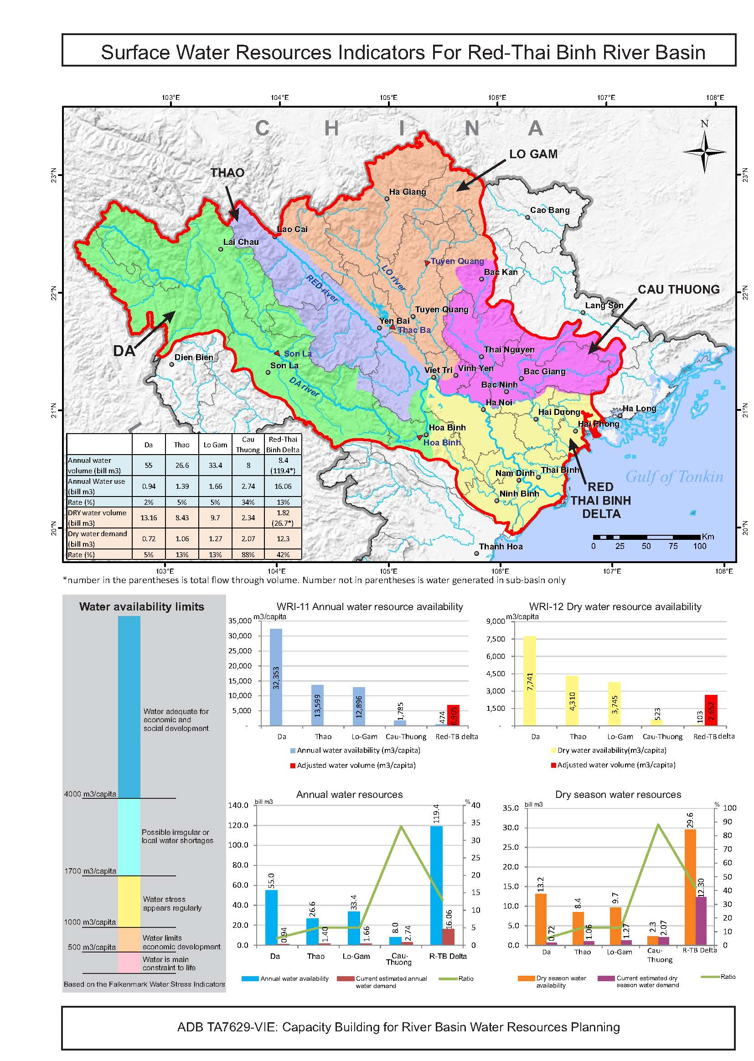

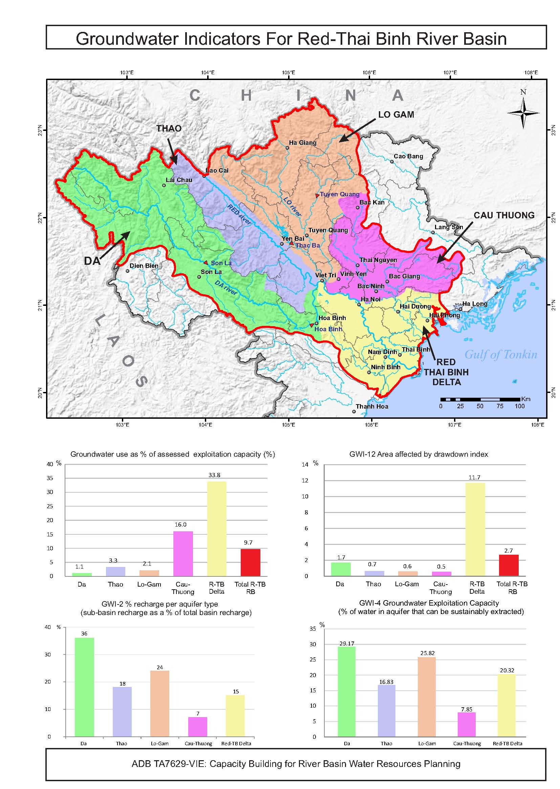

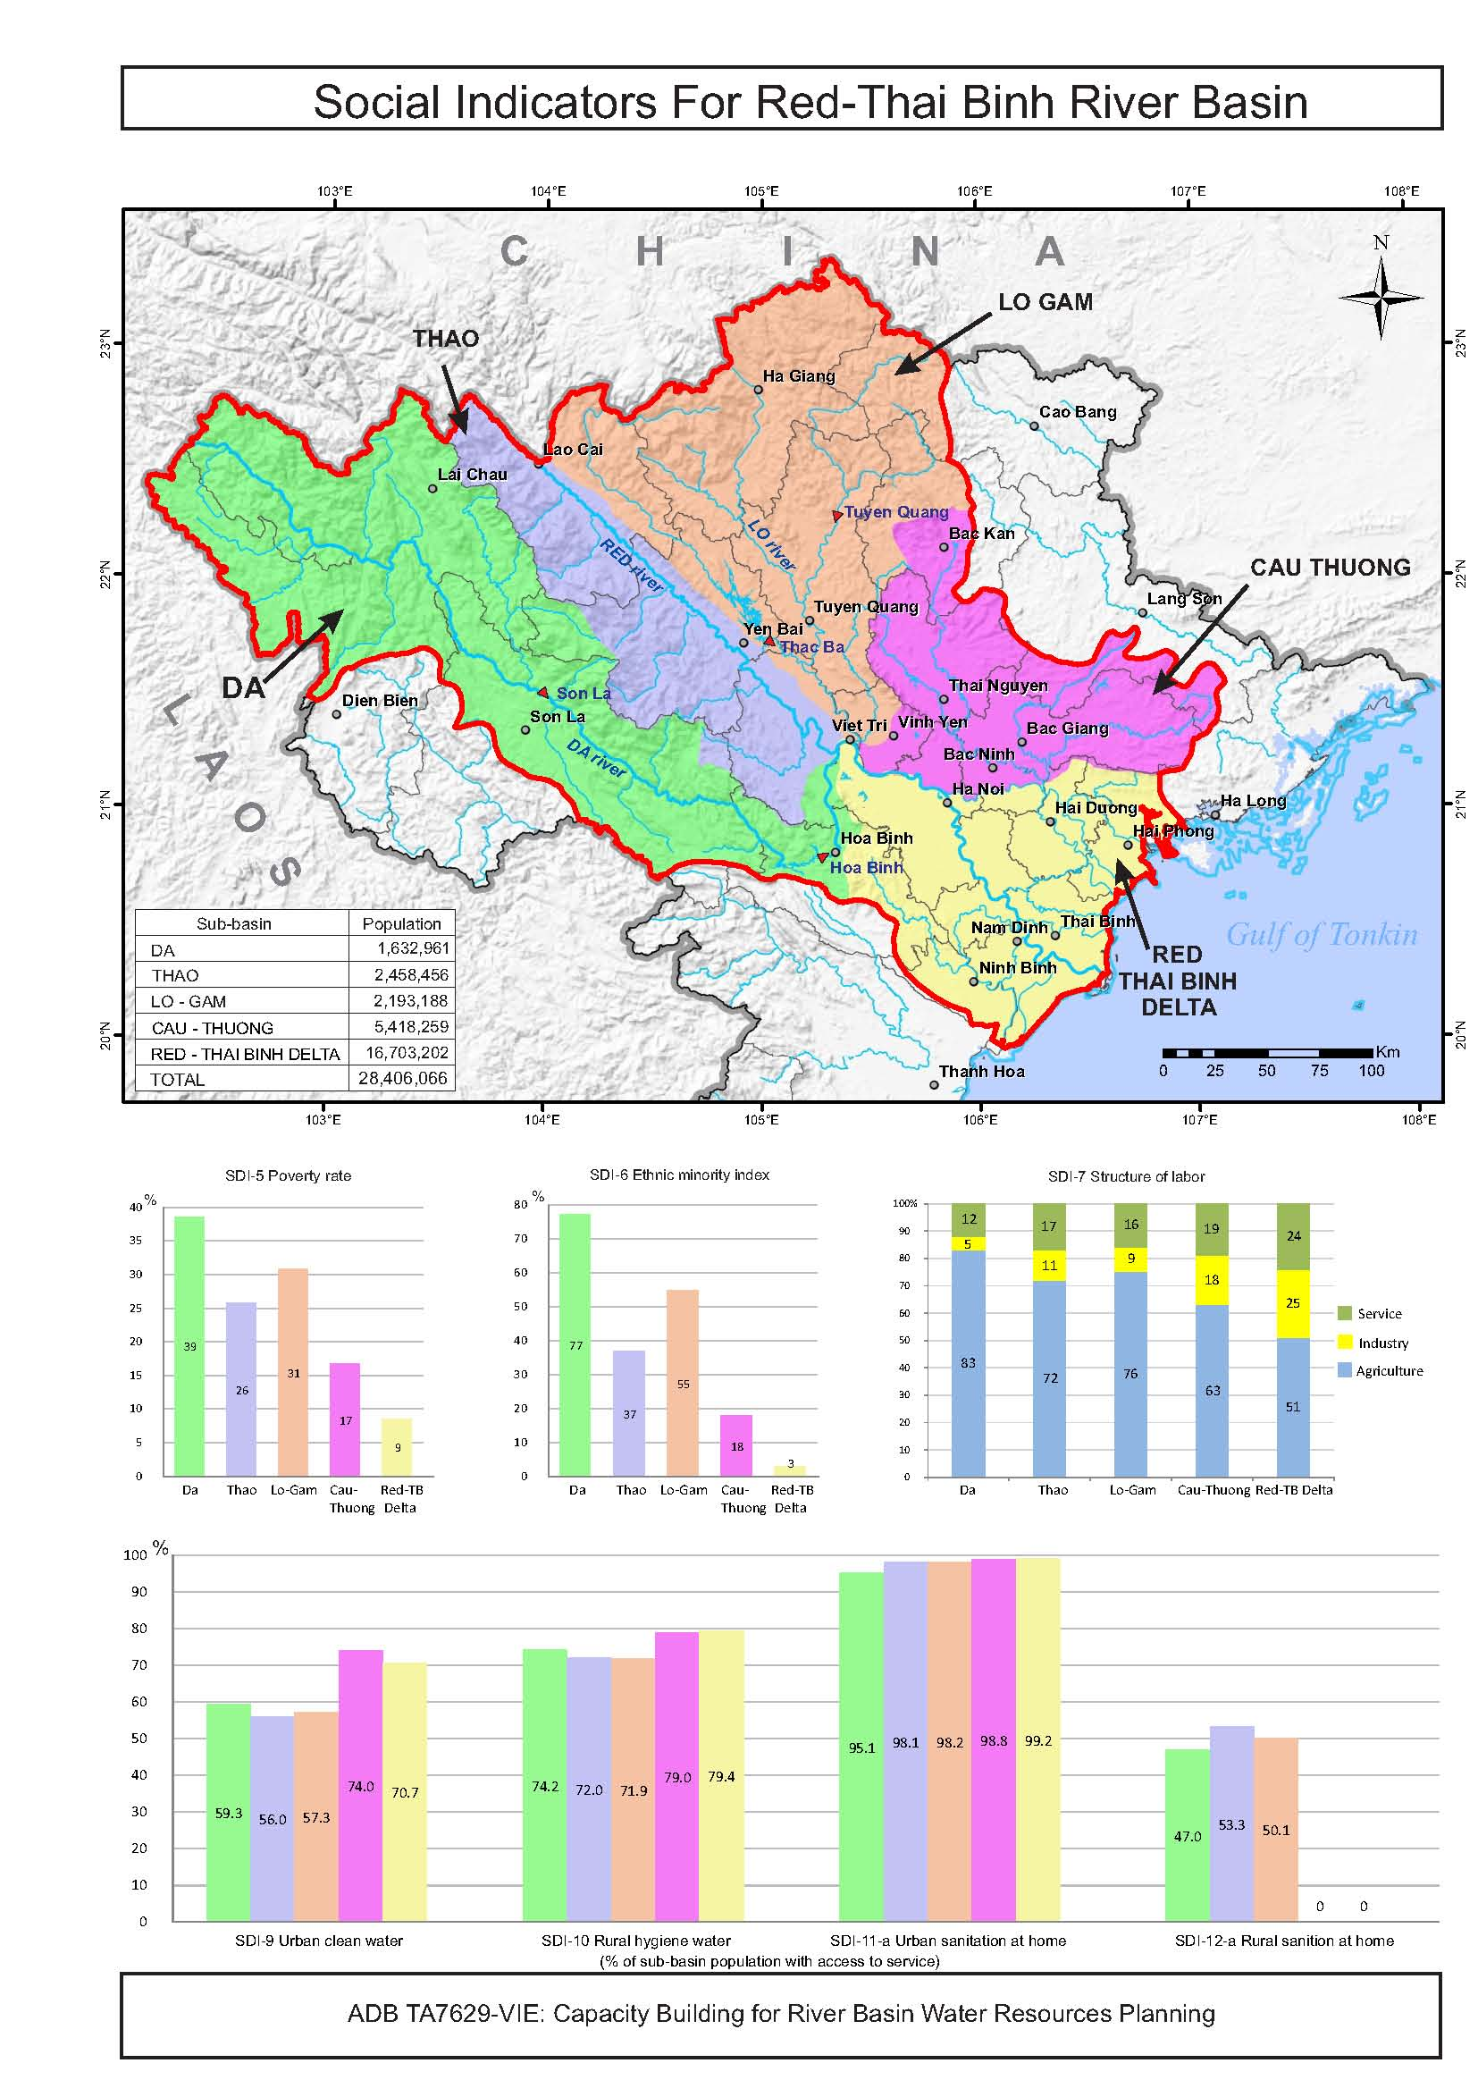

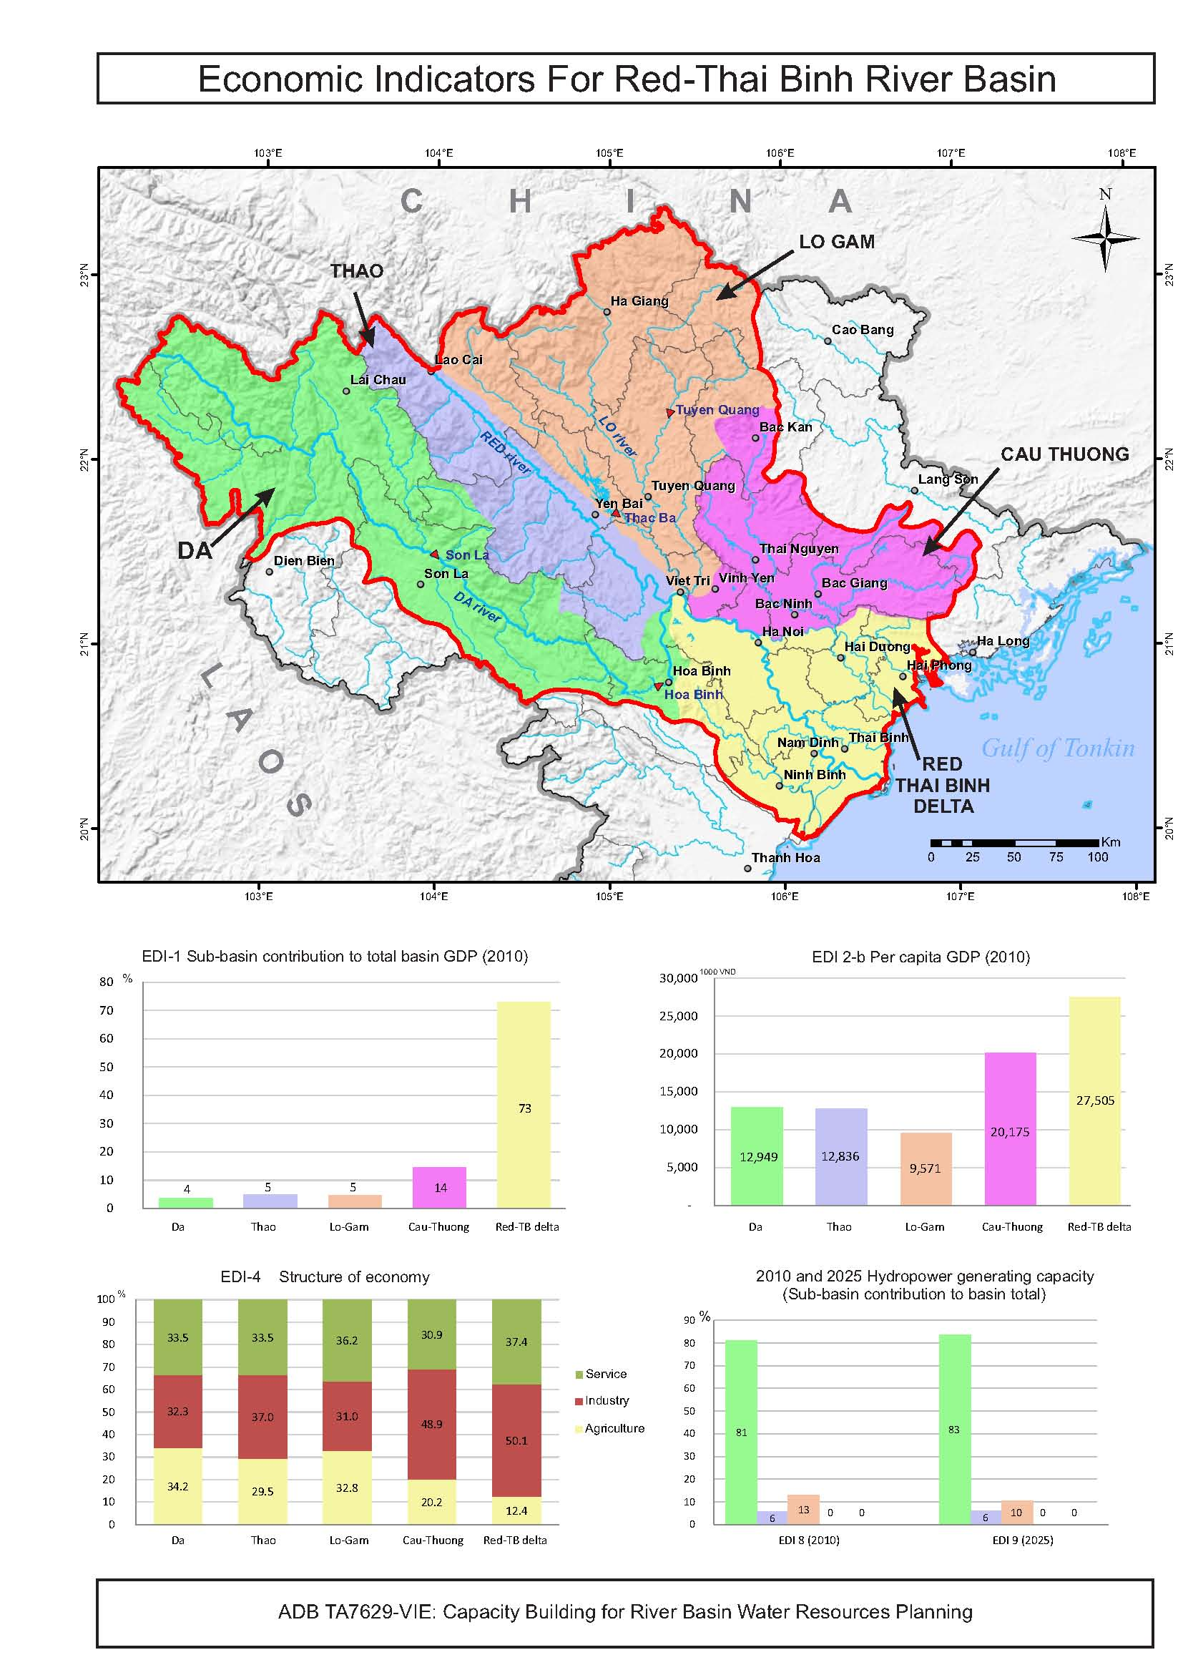

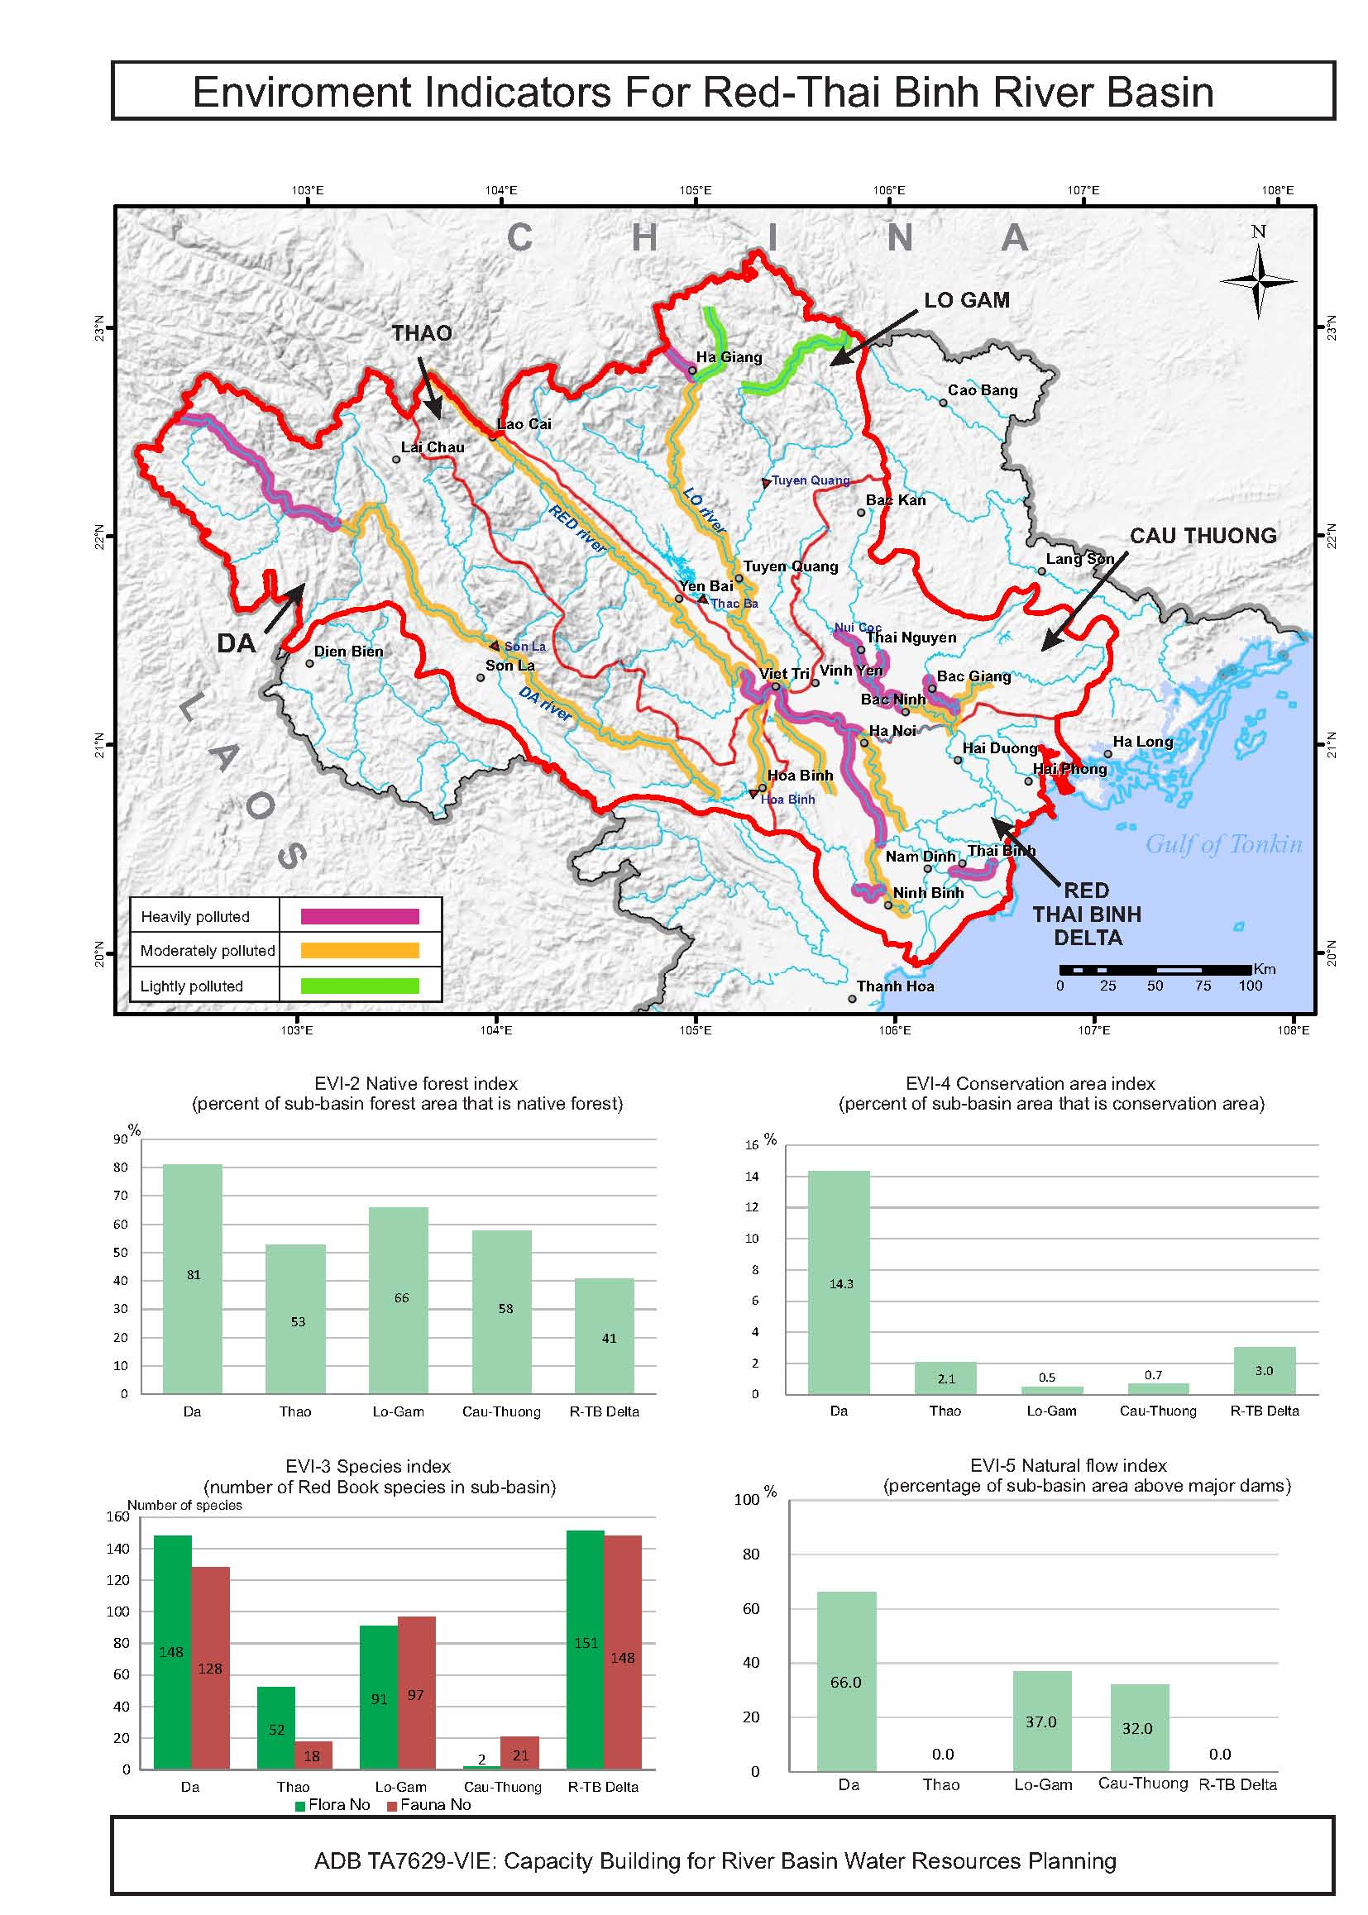

# Management.jpg

**Appendix B**

# Annex B: Guidelines for Assessment Indicators

## Water Resource Indicators

| **Water resource indicator name & code** | **Description** | **Interpretation** |
| --- | --- | --- |
| WRI-1: Sub-Basin water index | The total water volume generated in the sub-basins as a percentage of the total Basin water volume, both within Viet Nam only and including any international component. | It indicates the proportion of the Basin's total water that is generated within each sub-basin. A high percentage indicates a high contribution of surface water from a sub-basin to total water in the basin. |
| WRI-2: Sub-basin international dependency water index | The percentage of the total water resources volume generated in the sub-basin that, under current conditions and water use patterns, either comes from another country or flows to another country. | It indicates both the dependence of this sub-basin on water inflows from another country and the dependence of other countries on the water from this sub-basin. Results may indicate a need for an international agreement on water sharing and water quality to protect water security. |
| WRI-3: Inter-basin discharge index | The percentage of the total water resources volume naturally generated in the sub-basin (including international inflows and outflows) that, under current conditions and water use patterns, either flows to another sub-basin or comes from another sub-basin. | It indicates both the dependence of this sub-basin on water inflows from another sub-basin and the dependence of other sub-basins on the water from this sub-basin. Results may indicate a need for good water sharing and water quality arrangements between sub-basins. |
| WRI-4: Dry season water index | The percentage of the total annual water generated in the sub-basin that is generated in the dry season (including water in Viet Nam and international inflows). | It indicates the percentage of the total annual water volume that is available in the dry season and the length of the dry season. It provides an indication of the stress on the sub-basin during the dry season. A small percentage and a large number of months may indicate that water shortages will be serious with significant conflicts over access to water. |
| WRI-5: Dry season international water index | The percentage of the dry season water volume of the sub-basin that (a) comes from another country or (b) discharges to another country. | It indicates both the dependence of the sub-basin on water inflows from another country and the dependence of other countries on the water outflow or discharge from the sub-basin. A high percentage may indicate a need for good international agreements on water sharing and water quality. |
| WRI-6: Water Productivity Index | Total natural water volume generated in the sub-basin divided by the sub-basin area for both the full year and the dry season. | It indicates the most productive water generating areas of the basin. A high number may indicate those areas that need to be protected by catchment management activities to ensure they can continue to generate water into the future. |
| WRI-7: Water storage share index | Total active reservoir volume in sub-basin as percentage of total active reservoir volume in the RR Basin, both (a) currently and (b) for 2025. | It indicates the significance of the storage volume of this sub-basin compared to the total Basin storage volume. A high percentage may indicate the significance of the sub-basin storage to the basin as a whole. |
| WRI-8: Reservoir storage control index | Total active reservoir volume in sub-basin divided by total natural water volume for a sub-basin. | It relates the total reservoir storage volume to the total water volume of a sub-basin, indicating the amount of the water flows in the sub-basin that may be captured in reservoirs and controlled by infrastructure. A high percentage may indicate good flood control potential; but also that river health or the needs of lower river communities may not be met. |
| WRI-9: Water storage benefit index | For current and 2025, the total active reservoir volumes in the sub-basin used for hydropower, irrigation and "other" purposes; and the water storage per capita for water security (irrigation, flood mitigation, water supply, etc.) and for energy security. | It indicates the predominant use of reservoirs in the sub-basin currently and at 2025, and the water storage per capita in sub-basins which can be compared to international levels. A high ratio of single purpose storages means that generally single objectives are being met. Multi-purpose reservoirs need to be assessed against multiple objectives and may indicate a need to adjust operating rules. |
| WRI-10: Infrastructure sub-basin diversion index | The water volume diverted between a sub-basin and other sub-basins using infrastructure as a percentage of the total natural water volume in this sub-basin for (a) the total annual situation and (b) the dry season. | It indicates the percentage of sub-basin natural water volume that is diverted from a sub-basin or is diverted into another sub-basin. A high percentage diverted out indicates a significant amount of water no longer available in this sub-basin with consequential impacts on river health and basin communities. |
| WRI-11: Water availability index | Total annual water resources volume generated in the sub-basin divided by (a) current population (Viet Nam only); (b) projected population at 2025 (Viet Nam only). For any sub-basins that depend substantially on through flows from other sub-basins, this includes the through flows and the inter-basin diversions in a separate adjusted assessment. | It relates the total natural water volume to the population (m3 per capita, current and at 2025) and indicates the ability of the natural water resources to support the population now and into the future (based on current natural water which may decline under climate change). This indicates the impact water availability can have on human activity and life. |
| WRI-12: Dry season water availability index | Dry season water resource volume generated in the sub-basin divided by: (a) current population (Viet Nam only); (b) projected population at 2025 (Viet Nam only). For sub-basins that depend substantially on dry season through flows from other sub-basins, dry season volumes are adjusted to include through flows, inter-basin diversions, and reservoir storage volumes in a separate adjusted assessment. | It relates the dry season water resources with the population (m3 per capita, current and at 2025) and indicates the ability of the water resources to support the population in the dry season. This indicates the impact water availability can have on human activity and life. |
| WRI-13: Water Exploitation index | Proportion of the natural total annual water volume that is exploited and used under: (a) current levels of water demand and use; (b) projected 2025 levels of water demand and use. | It relates water exploitation and use to the natural available water in the dry season, and can identify if abstractions rates are sustainable. A high percentage indicates high stress on the water resources. |
| WRI-14: Dry season exploitation index | Proportion of the natural dry season water volume that is exploited and used under: (a) current dry season levels of water demand/use; (b) projected 2015 dry season levels of water demand/use. | It relates exploitation and use to the available natural water and can identify if abstractions rates are sustainable. A high percentage indicates high stress on the water resources. |
| WRI-15: Water exploitation per capita index | (a) Current total water use/demands in the sub-basin divided by current population (Viet Nam only); (b) Projected 2025 total water use/demands in the sub-basin divided by projected population at 2025 (Viet Nam only) | It indicates the average total water use per person in the basin at present and projected at 2025. A high figure indicates that water use could be inefficient. This indicates the pressure that water exploitation and use puts on the resource. |
| WRI-16: Sector water use index | Percentage of total water use by the major sectors - irrigation, agriculture, industry, urban, and aquaculture. | It identifies the major uses of water in the basin. A high proportion of water use for irrigation generally means potential for water efficiency gains. |
| WRI-17: Flood mitigation storage index | Total reservoir storage volume in the sub-basin used for flood mitigation compared to wet season water volume in sub-basin. | It indicates the relative size of flood mitigation reservoirs in the sub-basin, compared to wet weather water volume in sub-basin. A high ratio means a significant proportion of wet season basin flows could potentially be caught in a reservoir. |
| WRI-18: Climate change - temperature index | Percentage increase in the average summer temperature over the recent history compared to that projected for the sub-basin under climate change. | It indicates the projected and relative increase in the average summer temperatures in the sub-basins. A high percentage indicates an increase in evaporation; reduced runoff; and increased demands for water within the sub-basin. |

## Groundwater Indicators

| **Groundwater indicator name & code** | **Description** | **Implications** |
| --- | --- | --- |
| GWI-1: Groundwater area index | Size of area for each type of aquifer in sub-basin, and percentage of aquifer type areas in the Basin overall. | It indicates the proportion of the Basin's total area covered by each aquifer type; and also indicates the area of each aquifer type in the sub-basins. A high percentage may indicate the groundwater potential of a sub-basin. |
| GWI-2: Groundwater recharge index | Proportion of the Basin groundwater recharge in the sub-basins and the volume of recharge by aquifer type in each sub-basin. | It indicates the proportion of the Basin's total recharge that is provided by the sub-basin and also indicates the recharge capacity of the aquifer types in the sub-basins. A high percentage indicates that a substantial proportion of the Basin's groundwater potential groundwater is provided by a sub-basin. A low percentage indicates that the sub-basin most likely contains little usable groundwater. |
| GWI-3: Groundwater recharge potential index | This is the recharge of the aquifer types per land area. | It indicates the types of aquifer that provided the most recharge and their location in the sub-basins. It can show the more important recharge areas which may need to be protected. |
| GWI-4: Groundwater exploitation index | Proportion of the Basin groundwater exploitation capacity in the sub-basins; and the exploitation capacity in the aquifer types in the sub-basins | It indicates the proportion of the Basin's total exploitation capacity that is provided by the sub-basin; and also by aquifer types in the sub-basins. A high percentage indicates that a substantial proportion of the Basin's groundwater exploitation capacity is provided by a sub-basin. A low percentage means that the sub-basin may contain little usable groundwater. |
| GWI-5: Groundwater sustainability index | Ratio of the exploitation capacity of the aquifer to the natural recharge. | It indicates the proportion of the natural recharge of the aquifer that is exploited and used. A percentage greater than 100% means water is being extracted at greater than the recharge rate, which means that water is being taken from the aquifer storage volume, which many not be replaced. |
| GWI-6: Groundwater availability index | Exploitation capacity of the sub-basin divided by divided by: (a) current population (Viet Nam only); (b) projected population at 2025 (Viet Nam only). | It relates the sustainable groundwater to the population (current and at 2025). It indicates the ability of the water resources to support the population now and into the future according to international standards of water stress. |
| GWI-7: Overall groundwater use index | Proportion of the total Basin groundwater used within each of the sub-basins. | It indicates the proportion of the Basin's total groundwater use that is supported by the sub-basin. A high percentage indicates that a substantial proportion of the Basin's groundwater use occurs in a sub-basin. |
| GWI-8: Groundwater use per sector index | Proportion of the sub-basin groundwater use by the sectors (towns, industrial zones, rural water supply). | It indicates a sector’s dependence on groundwater. A low percentage means that the sector has alternative supplies of groundwater. A high percentage for "other/unknown" means that water use monitoring is inadequate. |
| GWI-9: Groundwater use per aquifer | Groundwater use by the sectors (towns, industrial zones, rural water supply) and by aquifer type. | It indicates the sub-basin’s use of groundwater by both sectors and by aquifer type. A high use for any of the sectors may focus the groundwater management effort onto specific aquifer types in localities to protect water supply. |
| GWI-10: Future groundwater index | 2025 proportion of the sub-basin groundwater use by the sectors (towns, industrial zones, rural water supply). | It indicates the 2025 proportion of the sub-basin's groundwater use by sector. A high percentage for any of the sectors indicates the dependence of that sector on groundwater in 2025. A high percentage for "other/unknown" means that water use monitoring is inadequate, and is poorly understood. |
| GWI-11: Groundwater use and exploitation capacity index | The ratio of groundwater use compared to the groundwater exploitation capacity, under current and 2025 conditions. | It indicates the amount of the assessed exploitation capacity that is required to meet current and projected 2025 water uses. A figure greater that 100% indicates a need to reduce groundwater use and to use water more efficiently; otherwise, groundwater use will be unsustainable and the resource will be mined. |
| GWI-12: Area affected by drawdown index | The ratio of the area of the aquifer suffering groundwater level drawdown to the total aquifer area. | It indicates the extent of the aquifer suffering from dropping water levels due to local over-exploitation. A high number indicates significant lowering of water levels. |
| GWI-13: Groundwater quality index | The % of the aquifer areas that are subject to saline water and arsenic contamination. | It indicates the significance of saline water and arsenic contamination to the aquifer. A high number indicates that major parts of the aquifer are not suitable for exploitation and use and need careful management to ensure that contaminated water does not move into good quality aquifers. |

## Economic Development Indicator

| **Economic development indicator name & code** | **Description** | **Implications** |
| --- | --- | --- |
| EDI-1: Sub-basin GDP Index | Sub-Basin GDP divided by Basin GDP at current prices. | It indicates the significance of the current levels of economic activities of the sub-basin to the Basin economy. A high indicator value means that the sub-basin is significantly contributing to the Basin economy compared to other sub-basins. |
| EDI-2: GDP per capita Index | Sub-basin GDP at current prices divided by sub-basin populations. | It indicates the current level of per capita income in the basin and sub-basins. A high indicator value indicates that the sub-basin is contributing significantly to the Basin economy. |
| EDI-3: GDP growth index | GDP average growth rate over the last 5 years (at constant 1994 prices). | It indicates the rate of growth of economic output over time. A high percentage indicates strong growth. This may have implications for river health. |
| EDI-4: Economic structure index | Percentage of GDP (current prices) provided by agriculture, industry, and services sectors. | It indicates the nature of the economic activity in the basin by sector. This identifies the economic drivers for the sub-basin and potential impacts of economic activities on water resources. |
| EDI-5: Industry sector production index | Value of industrial production divided by the water used for industrial activities. | This indicates the economic value of industrial production per unit of water used for industrial activities. A high indicator value indicates a sub-basin with relatively greater economic returns from industrial production per unit of water input compared with the other sub-basins, but not necessarily more efficient use of water. NOTE: This indicator ascribes 100% of industrial output value to water, which will over estimate the value of water as all other inputs to industry are excluded. |
| EDI-6: Irrigation sector production index | Value of irrigation production divided by the water used for irrigation activities. | This indicates the value of irrigation production per unit of water used for irrigation activities. This will generally include both surface water and groundwater, as they are difficult to separate. A high production value per unit of water use may indicate more efficient use of water. NOTE: This indicator ascribes 100% of irrigated agricultural output value to water, which will over estimate the value of water as all other inputs are excluded. |
| EDI-7: Irrigation development index | Proportion of the design area of irrigation schemes that is currently irrigated. | It indicates the current development of irrigation schemes compared to their design potential. A high percentage indicates systems are operating relatively effectively. |
| EDI-8: Current hydropower generating capacity index | Current hydropower generating capacity as a proportion of the total hydropower generating capacity of the Basin. | It indicates the percentage of the current generating capacity of the sub-basin to the Basin's total hydropower production. A high percentage indicates that this sub-basin is providing a significant contribution to the Basin hydropower generating capacity. |
| EDI-9: Future hydropower index | Projected hydropower capacity of the sub-basin at 2025 as a proportion of the projected total Basin hydropower at 2025. | It indicates the percentage of the 2025 generating capacity of the sub-basin to the Basin's total hydropower production. A high percentage indicates that a sub-basin will provide a significant contribution to the Basin hydropower generating capacity. |
| EDI-10: Hydropower development index | Proportion of the full potential for hydropower development of the sub-basin currently developed, and developed at 2025 projections. | It indicates how much of a sub-basin’s full potential is currently developed and is projected to be developed in 2025. A high percentage indicates that the hydropower development of this sub-basin will approach the maximum full development potential. This may have environmental consequences for the river system. |
| EDI-11: Navigation index | Economic value of inland cargo for the sub-basin as a proportion of total for Basin. | It indicates the economic values of the current sub-basin waterway transportation as percent of total for Basin. |
| EDI-12: Aquaculture index | Economic value of aquaculture divided by the water used for aquaculture production. | It indicates the economic returns from the current use of water devoted to aquaculture. A high number indicates a good return for investment in aquaculture production. |

## Social Development Indicators

| **Social indicator name & code** | **Description** | **Implications** |
| --- | --- | --- |
| SDI-1: Basin population Index | The sub-basin population as percentage of the Basin population, both current and in 2025. | It indicates the proportion of the Basin population that lives in the sub-basin, both current and in 2025. The higher the percentage, the greater the significance to the Basin in terms of putting pressure on the water and related natural resources. |
| SDI-2: Population growth index | Percentage of population growth experienced in the basin. | It indicates the growth of the population. A high percentage suggests a faster growing population and therefore greater potential impacts on the basin. |
| SDI-3: Population density index | Basin population divided by the basin area. | It indicates the pressure on the river basin from the density of people. A high percentage suggests greater potential impacts on the basin. |
| SDI-4: Rural urban index | Ratio of the population in rural and urban areas. | It indicates the percentage of the population that lives in urban and rural areas and, therefore, the level of water services they may require. |
| SDI-5: Poverty number index | The number of people in the sub-basin community assessed as living in poverty, and the percentage of households. | It indicates the number of people and households in poverty in the sub-basin. A high number suggests that many people in the basin live in extremely poor conditions, which affect access to safe food, safe water, and clean sanitation. |
| SDI-6: Ethnic minority index | The percentage of ethnic minority people in the total population. | It indicates a need for provision of water services and also the degree of difficulty in providing services. A high percentage suggests that this basin may need special consideration for provision of water services. |
| SDI-7: Employment index | Percentage of peopled employed in agriculture, industry, and services sectors. | It indicates the ratio of people working in the main economic sectors - this can be related to water used and GDP. A high percentage indicates relative importance of a sector for employment in the sub-basin. |
| SDI-8: Unemployment index | Percentage of people unemployed | It indicates the ratio of people without a job and therefore who live in difficult circumstances. A high percentage suggests that this basin may need special consideration for pro poor developments. |
| SDI-9: Urban clean water index | The proportion of people with access to clean water in urban areas at Central city and Provincial level. | It indicates the % people having access to clean water in urban areas, at different levels. A high percentage indicates good access to essential services. |
| SDI-10: Rural clean water index | The proportion of people with access to clean water in rural areas. | It indicates the % people having access to clean water (according the Health standards) in rural areas and the nature of that access. A high percentage indicates good access to essential services. |
| SDI-11: Urban sanitation index | The proportion of people with access to sanitation in urban area. | It indicates the access people have to sanitation services in urban areas in the sub-basin, at different levels. A high percentage indicates good access to essential services. |
| SDI-12: Rural sanitation index | The proportion of people with access to sanitation in rural areas. | It indicates the percentage of people having access to sanitation services in rural areas, and the nature of that access. A high percentage indicates good access to essential services. |
| SDI-13: Flood damage index | Total cumulative flood damages in the sub-basin over the previous 10 years as a % of sub-basin GDP | It indicates the damages to the sub-basin community from severe flooding. A high percentage indicates that a large proportion of the community is regularly exposed to severe flooding. |

## Environment Indicators

| **Environment indicator name & code** | **Description** | **Implications** |
| --- | --- | --- |
| EVI-1: Land use index | Proportion of land area in basin used for forests, agriculture, residential, special purposes, and other. | It indicates the way the basin land is being used. A high percentage for forests suggests that a sub-basin has good water retention capability and a less modified environment. |
| EVI-2: Native forest index | Native forest area as percent of Sub-basin area; Sub-basin native forest area as a percent total native forest area. | It indicates the percentage of remaining native forest and the quality of forest cover. A high percentage indicates good quality natural forests and good catchment processes. |
| EVI-3: Species index | Number of species in Red Book found in basin. | It indicates the significance of the basin for overall bio-diversity. A high number suggests a need for special protection as it makes a significant contribution to national bio-diversity. |
| EVI-4: Conservation area index | Area of national parks, significant wetlands or other conservation areas as a percentage of sub-basin area and of the Basin total. | It indicates the level of conservation provided by the sub-basin. A high percentage suggests that there are large areas of special conservation value and environmental assets in the basin. |
| EVI-5: Natural flow index | The proportion of the basin area that is located above major dams | It indicates the percentage of sub-basin area above storages. A high percentage indicates a high level of surface runoff can be captured by dams and regulated, which suggests a low degree of natural river flows in the basin. |
| EVI-6: River obstruction index | Ratio of the lengths of river upstream of river structures to the total length of the main rivers in basin | It indicates the percent of the length of river affected by a fixed blockage across the river. A natural river with few structures will have a low number. A high number indicates long lengths of river above a fixed blockage. This will restrict movement of aquatic fish/animals. It will also reduce navigation passage. |
| EVI-7: River level index | The current annual minimum river height level at key sub-basin locations compared to the past level (preferably 10 years ago). | It indicates the drop in river height over 10 years and, therefore, the amount of reduced dry season flows in the rivers of the sub-basin. A low index value means that the current water level is much lower than it used to be, resulting in less water for allocations, reduced navigation passage, possible non supply to some users if the current flow levels are below the off-take levels of the supply channel, and significantly reduced river health. |
| EVI-8: Biological water quality index | Ambient water quality for BOD5 divided by the corresponding values (Class B) - QCVN 08: 2008/BTNMT National technical regulation on surface water quality. | It is the recorded BOD level divided by the Standard. BOD indicates the amount of organic pollutants found in surface water. A high score indicates low in dissolved oxygen, which can lead to increased release of phosphorus from sediments that can fuel algal blooms. |
| EVI-9: Domestic wastewater treatment index | For domestic wastewater, the proportion treated and the level of treatment (primary and secondary). | It indicates the proportion of domestic wastewater treated before discharge, and the level of treatment. A low score for domestic wastewater, and a low secondary score, indicates a high potential for pollution and the addition of organic or other pollutants to the water source. |
| EVI-10: Hospital wastewater treatment index | For hospital wastewater, the proportion treated and the level of treatment (Primary and secondary). | It indicates the proportion of wastewater treated before discharge and the level of treatment. A low score for hospital wastewater, and a low secondary score, indicates a high potential for pollution and the addition of organic or other pollutants to the water source. |
| EVI-11: Industrial wastewater index | For industrial wastewater, the proportion treated and the level of treatment (Primary, secondary, and tertiary). | It indicates the proportion of wastewater treated before discharge and the level of treatment. A low score for industrial wastewater, and a low T score, indicates a high potential for pollution. |
| EVI-12: Solid waste index | The % of solid waste that is collected and disposed of in urban and rural areas. | It indicates the proportion of solid waste that is collected and not simply dumped at random. A low percent indicates a high potential for pollution as most solid waste is dumped near water sources, and/or can find its way to a river, lake or groundwater. |

## 

Water Management Indicators

| **Water management indicator name & code** | **Description** | **Implications** |
| --- | --- | --- |
| WMI-1: Recorded streamflow index | The number of Level 1 gauging stations (National) in the sub-basin, and the number of years of record at the station with the most years. | It indicates the extent of recorded river flow information in the sub-basin. The higher the number, the greater the level of confidence that can be held in the assessment of river flows. |
| WMI-2: Overall groundwater assessment index | The percentage of total area of aquifer in sub-basin assessed in each class (A, B, C). | It indicates the level of assessment of the aquifer providing an understanding of the reliability of the information provided from the aquifer. A high percentage for Class A indicates a high level of assessment that can be used for detailed project planning. A high percentage for Class C indicates only a general understanding of the aquifer and information for general planning only. |
| WMI-3: Monitoring bore index | Number of National level monitoring bores per sub-basin, and the number of years of record at the bore with the most years. | It indicates the extent of recorded groundwater information in the sub-basin. The higher the number, the greater the confidence in the assessment of groundwater resources. A high number in an area not suffering from over-exploitation of pollution may be a poor investment. On the other hand, a low number in areas where water tables are dropping, or where there is a growing area of saline water, will show poor management decisions. |
| WMI-4: Environmental monitoring index | The number of installed sites for monitoring water quality and ecological health. | It indicates the potential for assessing the overall health of water sources in the basin and to assess the impacts of human activities. The higher the number the greater the potential to properly assess water source health. |
| WMI-5: Central licensing index | The number of licenses for the basin issued by MoNRE for surface water extraction, groundwater extraction, and wastewater discharge. | It indicates the extent of licensing activity for the Basin undertaken at the central level for major licenses. The higher the number the greater the likelihood that major impacting activities are coming under regulatory control. |
| WMI-6: Provincial licensing index | The number of licenses for the basin issued by Provinces for surface water extraction, groundwater extraction, and wastewater discharge. | It indicates the extent of licensing activity for the Basin undertaken at the provincial level. The higher the number the greater the likelihood that major impacting activities are coming under regulatory control. |
| WMI-7: Decision 64 Index | The number of pollution establishments listed in Decision 64 that have been completed, are in the process of treatment, or have not yet been dealt with. | It indicates progress in moving on the Decision 64 requirements. A high “completed” or “in process” number means that provinces in the basin have moved to deal with polluting establishments. A high “not yet” number means that provinces have not moved significantly to meet the requirements of the Decision. |
| WMI-8: Pollution fees index | The total value of pollution fees collected under Decree 67/2003 and the proportion of this from urban and industrial polluters. | It indicates the use of economic tools for pollution control, particularly for industry. A high value generally means that pollution fees are being levied by the Provinces. A low industrial value means that most of the fees are being set on urban water users and not many industries are exposed to economic tools. |
| WMI-9: Urban pollution fee rate index | The total value of pollution fees collected under Decree 67/2003 from urban centers divided by the urban population | It indicates the scale of the financial impact of the pollution fees per person, which can be used to compare sub-basins. A high level of revenue means that fees are likely being levied effectively by the Provinces. However, a low value per person means that Provinces are not using the economic instruments effectively. |
| WMI-10: EIA index | The total number of EIA reports (Re) assessed and approved and the number of registration forms issued to establishments that achieve environment standards. | It indicates the number of establishments that have been subject to assessment by the regulatory authorities. A high value means that enterprises that may have a significant effect on the environment have been assessed by specialists and approved. |
| WMI-11: Industrial zone EIA index | The number of Industrial Zones; and the number with EIA reports (Re) assessed and approved. | It indicates the number and proportion of Industrial Zones that have been subject to assessment by the regulatory authorities. A high number with EIA reports means that most Industrial Zones have been assessed by specialists and approved. |
| WMI-12: Inspections index | The average number of inspections a year compared to the number of EIA reports and licenses issued in the sub-basin. | It indicates the extent to which the regulatory authorities inspect businesses to ensure compliance. A high number of inspections, compared to EIA reports and licenses issued, indicates there are regular inspections for compliance with conditions. |
| WMI-13: Urban cost recovery index | The percentage of the average yearly costs of urban water services that are recovered through revenue. | It indicates the cost recovery level for urban water services and the potential for financial sustainability. A high percentage means that subsidization is minimal, consumers are receiving proper price signals and service provision is increasingly sustainable. |
| WMI-14: Urban water efficiency index | The percent of water losses in the supply system. | It indicates the percentage of Unaccounted For Water (losses) and the efficiency of service delivery. A high percentage means that significant proportions of high cost treated water are lost in the system and a significant revenue loss. |
| WMI-15: Water resources management human capacity index | The number of people working on water resources management per 1 million people in the sub-basin. | It indicates the extent of human resource capacity in the sub-basin engaged in water resources management. A high number indicates better capacity to manage natural resources effectively and to respond to any major issues as required. A low number means that there is little chance that IWRM principles are being applied. |
| WMI-16: Water resources management investment capacity index | The value of the state/provincial budget applied to water resources management per sq. km of sub-basin area. | It indicates the extent of financial resource capacity in the sub-basin used for water resources management. A high number indicates good financial resources to manage natural resources on a sustainable basis and to respond to any major issues as required. A low number means that there is little chance that IWRM principles are being applied. |

**Annex C**

# Annex C: Hydro-Meteorology Observation Stations (from Decision 16)

| **No.** | **Region, province, and station name** | **Location** | **River** | **Sub-Basin** | **Latitude** | **Longitude** |
| --- | --- | --- | --- | --- | --- | --- |
|
|  |
|
| **I** | **North West** | |  |  |  |  |
|  | **Lai Chau** |  |  |  |  |  |
| 1 | Nam Giang | Chan Nua - Sin Ho | Nam Na | Da | 22o15' | 103o15' |
| 2 | Na Hu | Bum Nua-Muong Te | Nam Bum | Da | 22o24' | 102o52' |
| 3 | Muong Te | Muong Te – Muong Te | Da | Da | 22o18' | 102o36' |
| 4 | Ta Gia | Ta Gia - Than Uyen | Nam Mu | Da | 21o47' | 103o48' |
| 5 | Pa Tan | Pa Tan- Sin Ho | Nam Na | Da | 22o37' | 103o15' |
| 6 | Muong Mo | Muong Mo - Muong Te | Nam Po | Da | 22o04' | 102o53 |
|  | **Dien Bien** |  |  |  |  |  |
| 7 | Lai Chau | Muong Lay town | Da | Da | 22o04' | 103o09' |
| 8 | Nam He | Muong Tung - Muong Lay | Nam He | Da | 21o57' | 103o03' |
| 9 | Nam Muc | Pa Ham - Muong Cha | Nam Muc | Da | 21o52' | 103o17' |
| 10 | Ban Yen | Sam Mun-Dien Bien | Nam Nưa | Da | 21o16' | 103o00' |
|  | **Son La** |  |  |  |  |  |
| 11 | Ta Bu | Ta Bu - Muong La | Đà | Da | 21o26' | 104o03' |
| 13 | Quynh Nhai | Muong Chien- Quynh Nhai | Đà | Da | 21o50' | 103o33' |
| 14 | Thac Vai | Ta Bu - Muong La | Nam Bu | Da | 21o26' | 104o02' |
| 15 | Phieng Con | Phieng Con - Bac Yen | Nam Sap | Da | 21o15' | 104o28' |
| 17 | Nam Ty | Nam Ty – Ma river | Nam Ty | Da | 21o10' | 103o38' |
| 18 | Nam Cong | Huoi Mot – Ma river | Nam Cong | Da | 21o11' | 103o37' |
| 19 | Phieng Hieng | Quang Huy - Phu Yen | Suoi Sap | Da | 21o12' | 104o29' |
| 20 | Ban Nhot | Hua La - Son La town | Nam La | Da |  |  |
| 21 | Ban May | Chieng Chung - Mai Son | Nam La | Da |  |  |
| 22 | Cau 308 | Son La town | Nam La | Da |  |  |
| 23 | Ta Xa | Muong Bon - Mai Son | Nam Pan | Da |  |  |
| 24 | Hat Lot | Hat Lot town - Mai Son | Nam Pan | Da |  |  |
| 25 | Ban Po | Chieng Luong - Mai Son | Nam Pan | Da |  |  |
| 26 | Ban Chi | Chieng Luong - Mai Son | Nam Pan | Da |  |  |
| 27 | Ta Khoa | Ta Hoc - Mai Son | Hoa Binh reservoir | Da |  |  |
| 28 | Van Yen | Van Yen - Phu Yen | Hoa Binh reservoir | Da |  |  |
| 29 | Son La reservoir |  | Da | Da |  |  |
|  | **Hoa Binh** |  |  |  |  |  |
| 30 | Hoa Binh | Tan Thinh - Hoa Binh town | Da | Da | 20o49' | 105o19' |
| 31 | Lam Son | Lam Son - Luong Son | Bùi | Da | 20o52' | 105o29' |
| 32 | Hung Thi | Hung Thi - Lac Thuy | Bôi | Da | 20o30' | 105o40' |
| 33 | Cua Dap | Hoa Binh town | Hoa Binh reservoir | Da |  |  |
| 34 | Hoa Binh reservoir | Hoa Binh town | Hoa Binh reservoir | Da |  |  |
| **II** | **Viet Ba** | |  |  |  |  |
|  | **Lao Cai** |  |  |  |  |  |
| 35 | Lao Cai | Coc Leu – Lao Cai town | Red | Thao | 22o30' | 103o57' |
| 36 | Vinh Yen | Thon Ha - Vinh Yen | Nghia Do | Thao | 22o22' | 104o28' |
| 37 | Ngoi Nhu | Son Thuy - Van Ban | Ngoi Nhu | Thao | 22o08' | 104o16' |
| 38 | Bao Ha | Bao Ha - Bao Yen | Red | Thao | 22o10' | 104o21' |
| 39 | Bao Yen | Long Phuc -Bao Yen | Chay | Lo-Gam | 22o10' | 104o35' |
| 40 | Coc Ly | Coc Ly - Bac Ha | Chay | Lo-Gam | 21o31' | 104o12' |
|  | **Yen Bai** |  |  |  |  |  |
| 41 | Yen Bai | Yen Ninh - TX Yen Bai | Red | Thao | 21o42' | 104o51' |
| 42 | Ngoi Thia | Dai Phuc - Van Yen | Ngoi Thia | Thao | 21o50' | 104o39' |
| 43 | Ngoi Hut | Dong An-Van Yen | Ngoi Hut | Thao | 21o55' | 104o30' |
| 44 | Mu Cang Chai | Kim Noi - Mu Cang Chai | Nam Kim | Thao | 21o51' | 104o04' |
| 45 | Thac Ba | Thac Ba - Yen Binh | Chay | Lo-Gam | 21o44' | 105o03' |
| 46 | Thac Ba reservoir |  | Chay | Lo-Gam |  |  |
|  | **Ha Giang** |  |  |  |  |  |
| 47 | Dao Duc | Dao Duc - Vi Xuyen | Lo | Lo-Gam | 22o47' | 104o59' |
| 48 | Ha Giang | Nguyen Trai -Ha Giang town | Lo | Lo-Gam | 22o49' | 104o58' |
| 49 | Bac Quang | Tan Quang - Bac Quang | Lo | Lo-Gam | 22o29' | 104o52' |
| 50 | Vinh Tuy | Vinh Tuy - Bac Quang | Lo | Lo-Gam | 22o16' | 104o53' |
| 51 | Bac Me | Yen Phu - Bac Me | Gam | Lo-Gam | 22o44' | 105o22' |
| 52 | Thuan Hoa | Thuan Hoa- Vi Xuyen | Mien | Lo-Gam | 22o53' | 105o00' |
| 53 | Tan Thinh | Viet Hong - Bac Quang | Con | Lo-Gam | 22o20' | 104o48' |
| 54 | Minh Tan | Giang Chu Pin - Meo Vac | Nho Que | Lo-Gam | 23o10' | 105o08' |
|  | **Tuyen Quang** |  |  |  |  |  |
| 55 | Chiem Hoa | Vinh Loc - Chiem Hoa | Gam | Lo-Gam | 22o05' | 105o16' |
| 56 | Ham Yen | Binh Sa - Ham Yen | Lo | Lo-Gam | 22o03' | 105o05' |
| 57 | Ghenh Ga | Tan Long - Yen Son | Lo | Lo-Gam | 21o51' | 105o11' |
| 58 | Tuyen Quang | Minh Xuan - Tuyen Quang | Lo | Lo-Gam | 21o49' | 105o13' |
| 59 | Na Hang | Vinh Yen - Na Hang | Gam | Lo-Gam | 22o20' | 105o22' |
| 60 | Son Duong | Son Duong town | Pho Day | Lo-Gam | 21o42' | 105o23' |
|  | **Thai Nguyen** |  |  |  |  |  |
| 61 | Gia Bay | Hoang Van Th -Thai Nguyen | Cầu | Cau-Thuong | 21o35' | 105o50' |
| 62 | Cha | Dong Cao - PhoYen | Cầu | Cau-Thuong | 21o22' | 106o54' |
| 63 | Tan Cuong | Tan Cuong - Thai Nguyen | Công | Cau-Thuong | 21o32' | 105o47' |
|  | **Bac Can** |  |  |  |  |  |
| 64 | Cau Pha | Song Cau - Bac Kan town | Cau | Cau-Thuong | 22009' | 105050' |
| 65 | Thac Rieng | Xuat Hoa - Bach Thong | Cau | Cau-Thuong | 22o05' | 105o53' |
| 66 | Cho Moi | Cho Moi - Phu Luong | Cau | Cau-Thuong | 21o52' | 105o46' |
| 67 | Dau Dang | Nam Mau - Ba Be | Nang | Lo-Gam | 22o27' | 105o34' |
|  | **Phu Tho** |  |  |  |  |  |
| 68 | Vu Quang | Doan Hung - Phu Tho | Lo | Lo-Gam | 21o34' | 105o15' |
| 69 | Thanh Son | Thuc Luyen - Thanh Son | Bua | Thao | 21o11' | 105o09' |
| 70 | Viet Tri | Thanh Mieu - Viet Tri | Lo | Thao | 21o17' | 105o25' |
| 71 | Phu Tho | Phong Chau - Phu Tho | Red | Thao | 21o23' | 105o13' |
|  | **Vinh Phuc** |  |  |  |  |  |
| 72 | Quang Cu | Quang Cu - Lap Thach | Pho Day | Lo-Gam | 21o31' | 105o29' |
| **III** | **East West** | |  |  |  |  |
|  | **Cao Bang** |  |  |  |  |  |
| 74 | Bảo Lạc | Bao Lac - Bao Lac dist. | Gam | Lo-Gam | 22o58' | 105o40' |
| 77 | Quang Lam | Ly Bon - Bao Lam | Nho Que | Lo-Gam | 22o57' | 105o32' |
|  | **Lang Son** |  |  |  |  |  |
| 80 | Huu Lung | Met - Huu Lung | Trung | Cau-Thuong | 21o31' | 106o19' |
|  | **Bac Ninh** |  |  |  |  |  |
| 84 | Phuc Loc Phuong | Tam Giang - Yen Phong | Cau | Cau-Thuong | 21o17' | 105o55' |
| 85 | Ben Ho | Tan Chi - Tien Son | Duong | Cau-Thuong | 21o04' | 106o04' |
| 86 | Dap Cau | Vu Ninh - Bac Ninh | Cau | Cau-Thuong | 21o04' | 106o05' |
|  | **Bac Giang** |  |  |  |  |  |
| 87 | Chu | Nghia Ho - Luc Ngan | Luc Nam | Cau-Thuong | 21o22' | 106o36' |
| 88 | Cam Dan | Cam Dan - Son Dong | Cam Dan | Cau-Thuong | 21o20' | 106o47' |
| 89 | Cau Son | Huong Son - Lang Giang | Thuong | Cau-Thuong | 21o26' | 106o19' |
| 90 | Phu Lang Thuong | Tho Xuong - Bac Giang | Thương | Cau-Thuong | 21o17' | 106o11' |
| 91 | Luc Nam | Tien Hung - Luc Nam | Luc Nam | Cau-Thuong | 21o17' | 106o24' |
| 92 | Tam Hiep | Tam Hiep - Yen The | Soi | Cau-Thuong | 21o30' | 106o08' |
|  | **Hai Phong** |  |  |  |  |  |
| 98 | Cua Cam | Hung Vuong - Hong Bang dist. | Kinh Thay | Delta | 20o46' | 106o50' |
| 99 | Trung Trang | Quang Hung - An Lao | Van Uc | Delta | 20o50' | 106o30' |
| 100 | Tien Tien | Tien Tien - An Lao | Song Moi | Delta | 20o45' | 106o31' |
| 101 | Do Nghi | Tam Hung - Thuy Nguyen | Bach Dang | Delta | 20o56' | 106o46' |
| 102 | Dong Xuyen | Kien Thiet – Tien Lang | Thái Bình | Delta | 20o41' | 106o33' |
| 103 | Kien An | Bac Son - Kien An town | Lach Tray | Delta | 20o49' | 106o37' |
| 104 | Chanh Chu | Thang Thuy - Vinh Bao | Luoc | Delta | 20o44' | 106o24' |
| 105 | Cao Kenh | Hop Thanh - Thuy Nguyen | Kinh Thay | Delta | 20o56' | 106o35' |
| 106 | Quang Phuc | Quang Phục - Tien Lang | Van Uc | Delta | 20o43' | 106o36' |
| 107 | Cong Ro | Giang Bien - Vinh Bao | Thai Binh | Delta | 20o46' | 106o31' |
| **IV** | **North Delta** | |  |  |  |  |
|  | **Ha Noi** |  |  |  |  |  |
| 108 | Ha Noi | Phuc Tan - Hoan Kiem dist. | Hong | Delta | 21o01' | 105o51' |
| 109 | Thuong Cat | Thuong Thanh - Gia Lam | Duong | Delta | 21o04' | 105o52' |
| 110 | Phu Cuong | Thuy Loi – Dong Anh | Ca Lo | Delta | 21o10' | 105o54' |
|  | **Ha Tay** |  |  |  |  |  |
| 111 | Son Tay | Vien Son - Son Tay town | Hong | Delta | 21o09' | 105o30' |
| 112 | Trung Ha | Thai Hoa - Ba Vi | Da | Delta | 21o14' | 105o20' |
| 113 | Ba Tha | Vien An - Ung Hoa | Day | Delta | 20o48' | 105o42' |
|  | **Hai Duong** |  |  |  |  |  |
| 114 | Cat Khe | Hiep Cat - Nam Sach | Thai Binh | Delta | 21o02' | 106o17' |
| 115 | Ben Binh | Tan Dan - Chi Linh | Kinh Thay | Delta | 21o03' | 106o21' |
| 116 | Ba Nha | Hop Duc - Nam Thanh | Gua | Delta | 20o52' | 106o27' |
| 117 | Quang Dat | Ngu Phuc - Kim Mon | Rang | Delta | 20o57' | 106o28' |
| 118 | An Phu | An Phu - Kim Mon | Kim Mon | Delta | 20o59' | 106o30' |
| 119 | Phu Luong | Ngoc Chau - Hai Duong | Thai Binh | Delta | 20o57' | 106o20' |
| 120 | Pha Lai | Pha Lai - Chi Linh | Thai Binh | Delta | 21o06' | 106o17' |
|  | **Hung Yen** |  |  |  |  |  |
| 121 | Hung Yen | Le Hong Phong- Hung Yen | Red | Delta | 20o39' | 106o03' |
|  | **Thai Binh** |  |  |  |  |  |
| 122 | Trieu Duong | Tan Le - Hung Ha | Luoc | Delta | 20o09' | 106o07' |
| 123 | Quyet Chien | Bach Dang - Dong Hung | Tra Ly | Delta | 20o30' | 106o15' |
| 124 | Dong Quy | Dong Tra - Tien Hai | Tra Ly | Delta | 20o27' | 106o32' |
| 125 | Thai Binh | Phuong Hong Phong | Tra Ly | Delta | 20o27' | 106o20' |
| 126 | Tien Duc | Tien Duc - Hung Ha | Hong Ha | Delta | 20o35' | 106o06' |
| 127 | Ba Lat | Nam Hong - Tien Hai | Red | Delta | 20o19' | 106o31' |
| 128 | Cong He | An Bai - Quynh Phu | Hoa | Delta | 20o37' | 106o28' |
|  | **Ha Nam** |  |  |  |  |  |
| 129 | Phu Ly | Phu Ly - Ha Nam | Day | Delta | 20o30' | 105o54' |
| 130 | Nhu Trac | Nhan Dao - Ly Nhan | Red | Delta | 20o34' | 106o07' |
|  | **Nam Dinh** |  |  |  |  |  |
| 131 | Nam Dinh | Nguyen Trai - Phan Dinh Phung | Dao | Delta | 20o25' | 106o10' |
| 132 | Truc Phuong | Hop Thinh - Phuon Dinh | Ninh Co | Delta | 20o19' | 106o18' |
| 133 | Phu Le | Hai Chau - Hai Hau | Ninh Co | Delta | 20o03' | 106o12' |
| 134 | Phu Hao | Nam Dien - Nam Truc | Red | Delta | 20o10' | 106o14' |
| 135 | Bai Trach | Yen Phuc - Y Yen | Dao | Delta | 20o18' | 106o08' |
|  | **Ninh Binh** |  |  |  |  |  |
| 136 | Ben De | Gia Phu - Gia Vien | Boi | Delta | 20o21' | 105o47' |
| 137 | Ninh Binh | Dinh Tien Hoang - Ninh Binh | Day | Delta | 20o15' | 105o58' |
| 138 | Gian Khau | Gia Tran - Gia Vien | Hoang Long | Delta | 20o19' | 105o55' |
| 139 | Nhu Tan | Kim Tan - Kim Son | Day | Delta | 20o01' | 106o06' |
| 140 | Nho Quan | Lac Van - Nho Quan | Lang | Delta | 20o20' | 105o46' |

# Annex D: Environment Monitoring Sites (Decision 526)

| **No** | **River/stream** | **Coordinates** | | **Location** |
| --- | --- | --- | --- | --- |
| **Latitude** | **Longtitude** |
| **I, Red-Thai Binh** | | | | |
| 1 | Lung Po stream | 22°47'35,2 | 103°38'54,6 | A Mu Sung, Bat Xat, Lao Cai |
| 2 | Red river | 22°47'28,5 | 103°39'10,3 | Y Ty, Bat Xat, Lao Cai |
| 3 | Ngoi Phat stream | 22°37'08,2 | 103°49'14,2 | Ban Vuoc, Bat Xat, Lao Cai |
| 4 | Red river | 22°35'25,8 | 103°51'11,9 | Ban Vuoc, Bat Xat, Lao Cai |
| 5 | Nam Thi stream | 22°18'26,8 | 103°09'28,9 | Ha Khau, Ha Khau, Lao Cai |
| 6 | Red river | 22°29'54,7 | 103°58'23,3 | Coc Leu, Lao Cai |
| 7 | Red river | 22°20'32,9" | 104°06'58,7" | Pho Lu, Bao Thang, Lao Cai |
| 8 | Red river | 22°11'38,5" | 104°1929,6" | Bao Ha, Bao Yen, Lao Cai |
| 9 | Red river | 21°51'28,3" | 104°42'52,1" | Van Yen, Yen Bai |
| 10 | Red river | 21°49'46,8" | 104°44'34,2" | Xuan Ai, Van Yen, Yen Bai |
| 11 | Red river | 21°49'05,9" | 104°45'07,9" | Hoang Thang, Van Yen, Yen Bai |
| 12 | Red river | 21°46'47,8" | 104°4757,3" | Cong Minh, Tran Yen, Yen Bai |
| 13 | Red river | 21°44'17,3" | 104°50'14,4" | Thi tran Ha Khau, huyen |
| 14 | Red river | 21°41'46,5" | 104°52'18,2" | Ha Khau, Lao Cai |
| 15 | Red river | 21°40'48,8" | 104°55'37,1" | Yen Bai city |
| 16 | Red river | 22°12'35,7" | 104°31'30,0" | Yen Bai city |
| 17 | Red river | 21°46'39,2" | 104°48'16,7" | Yen Bai |
| 18 | Lo river | 21°52'40,83" | 104°40'43,16" | Yen Bai |
| 19 | Lo river | 22°30'04,8" | 103°58'16,1" | Ha Giang |
| 20 | Lo river | 21°37'20,9" | 105°10'57,8" | Phu Tho |
| 21 | Lo river | 21°37'12,5" | 105°10'44,0" | Phu Tho |
| 22 | Lo river | 21°37'05,7" | 105°10'14,3" | Phu Tho |
| 23 | Lo river | 21°36'41,2" | 105°1008,0" | Phu Tho |
| 24 | Lo river | 21°36'30,8" | 105°15'03,7" | Phu Tho |
| 25 | Lo river | 21°33'58,8" | 105°16'13,4" | Phu Tho |
| 26 | Lo river | 21°26'41,5" | 105°20'24,0" | Phu Tho |
| 27 | Lo river | 21°25'68,5" | 105°20'56,0" | Phu Tho |
| 28 | Lo river | 21°25'43,5" | 105°20'68,0" | Phu Tho |
| 29 | Lo river | 21°24'69,5'' | 105°20'68,7" | Phu Tho |
| 30 | Lo river | 21°24'58,4" | 105°20'44,9" | Phu Tho |
| 31 | Lo river | 21°23'46,9" | 105°23'33,0" | Viet Tri city |
| 32 | Lo river | 21°22'48,2" | 105°2326,5" | Viet Tri city |
| 33 | Lo river | 21°21'43,7" | 105°2313,0" | Viet Tri city |
| 34 | Red river | 21°20'36,8" | 105°24'23,7" | Viet Tri city, Phu Tho |
| 35 | Red river | 21°32'50,4" | 105°00'50,0" | Phu Tho |
| 36 | Red river | 21°25'35,1 | 105°09'09,5" | Phu Tho |
| 37 | Red river | 21°23'42,1" | 105°09'14,5" | Phu Tho |
| 38 | Red river | 21°23'59,7" | 105°1019,1" | Phu Tho |
| 39 | Red river | 21°32'48,1" | 105°13'20,2'' | Phu Tho |
| 40 | Red river | 21°23'52,0" | 105°14'15,3" | Phu Tho |
| 41 | Red river | 21°23'52,0 | 105°14'50,0" | Phu Tho |
| 42 | Red river | 21°23'10,1" | 105°14'59,3'' | Phu Tho |
| 43 | Red river | 21°19'10,9" | 105°1650,6' | Phu Tho |
| 44 | Red river | 21°19'09,8" | 105°16'40,1" | Phu Tho |
| 45 | Red river | 21°19'04,2 | 105°1544,6" | Phu Tho |
| 46 | Red river | 21o18,46,5„ | 105°15'47,4” | Phu Tho |
| 47 | Red river | 21°18 '35,8 " | 105°15'41,4" | Phu Tho |
| 48 | Red river | 21°17'14,8'' | 105°15'41,4" | Phu Tho |
| 49 | Red river | 21°17'12,8" | 105°15'41,4" | Phu Tho |
| 50 | Red river | 21°17'48,8" | 105°15'36,4" | Phu Tho |
| 51 | Red river | 21°17'51,1" | 105°25'30,2" | Phu Tho |
| 52 | Red river | 21°09'35,4" | 105°29'8,8" | Son Tay, Ha Noi |
| 53 | Red river | 22°47'51,1" | 106°35'30,2" | Dong Quang, Ha Noi |
| 54 | Red river | 22°42'51,1" | 106°52'30,2" | Xa Hong Da, Ba Vi, Ha Noi |
| 55 | Red river | 21°05'41,1'' | 105°46'32,0" | Chem, Ha Noi |
| 56 | Red river | 21°02'53,6" | 105°51'22,5" | Tai Phuc Xa, Long Bien |
| 57 | Red river | 21°2'16,7" | 105°51'34,8" | Phuong Long Bien, Hoan Kiem,Ha Noi |
| 58 | Red river | 21°32'26,5" | 105°12'30,5" | Dong Anh, Ha Noi |
| 59 | Red river | 21°44'21,5" | 105°34'31,5" | Long Bien, Ha Noi |
| 60 | Red river | 20°59'32,85" | 105°54'3,38" | Hoang Mai, Ha Noi |
| 61 | Red river | 20°39'23,1" | 106°52'32,08" | Xa Nhan Thinh, huyen Ly Nhan, Ha Nam |
| 62 | Red river | 20°42'13,1" | 106°45'24,08" | Hung Yen and Ha Nam |
| 63 | Red river | 20°42'29,1" | 106°45'24,08" | Nam Dinh |
| 64 | Red river | 20°21'05,9" | 106°15'22,6" | Nam Dinh city |
| 65 | Red river | 20°25'39,2" | 106°12'38,6" | Nam Dinh |
| 66 | Red river | 20°20'25,4" | 106°15'18,2" | Nam Dinh |
| 67 | Red river | 20°19'45,5" | 106°15'37,1" | Nam Dinh |
| 68 | Ninh Co river | 20°17'48,4" | 106°19'52,3" | Nam Dinh |
| 69 | Red river | 20°20'5,1" | 106°17'48,2" | Nam Dinh |
| 70 | Red river | 20°28'41,6" | 106°11'26,4" | Nam Dinh |
| 71 | Red river | 20°33'58,1" | 106°08'39,1" | Nam Dinh |
| 72 | Red river | 20°17'22,0" | 106°33'10,3" | Nam Dinh |
| 73 | Cau river | 22°9'15,59" | 105°51'53,62" | Bac Kan |
| 74 | Cau river | 21°51'26,17" | 105°48'34,03" | Bac Kan |
| 75 | Cau river | 21°48'5,33" | 105°50'19,77" | Thai Nguyen |
| 76 | Cau river | 21°35'51,64" | 105°50'14,49" | Thai Nguyen |
| 77 | Cau river | 21°33'52,95" | 105°53'38,04" | Thai Nguyen |
| 78 | Cau river | 21°29'56,95" | 105°48'55,18" | Bac Ninh |
| 79 | Cau river | 21°12'56,60" | 106°2'42,62" | Bac Ninh |
| 80 | Cau river | 21°18'55,09" | 105°53'45,97" | Bac Giang |
| 81 | Cau river | 21°7'42,31" | 106°17'30,87" | Bac Giang |
| 82 | Cau river | 21°15'44,41" | 105°55'31,72" | Hai Duong |
| 83 | Thai Binh river | 20°59'51,7" | 106°16'15,4" | Hai Duong |
| 84 | Thai Binh river | 20°58'58,3" | 106°16'45,5" | Hai Duong city |
| 85 | Thai Binh river | 20°56'37,4" | 106°21'11,8" | Hai Duong |
| 86 | Thai Binh river | 20°54'33,26" | 106°20'39,52" | Hai Duong |
| 87 | Thai Binh river | 20°52'14,4" | 106°27'33,2" | Hai Duong |
| 88 | Thai Binh river | 20°47'18,95" | 106°31'03,78" | Hai Duong |
| 89 | Thai Binh river | 20°44'27,33" | 106°34'25,61" | Hai Phong |
| 90 | Thai Binh river | 20°41'23,77" | 106°39'28,68" | Hai Phong |
| **II, Da river** | | | | |
| 1 | Nam La river | 22°36'01,7'' | 103°09'52,3" | Lai Chau |
| 2 | Da river | 21°41'30,1" | 103°04'35,7" | Son La |
| 3 | Da river | 22°11'53,8" | 102°5115,9" | Lai Chau |
| 4 | Mien river | 22°50'47,0" | 104°5913,0" | Ha Giang |
| 5 | Lo river | 22°50'06,8" | 104°58'56,3" | Ha Giang |
| 6 | Da river | 22 °29'47,6" | 104°52'28,7" | Ha Giang |
| 7 | Da river | 21°29'55,1" | 104°00'34,4" | Son La |
| 8 | Da river | 21°28'00,9" | 104°01'59,6" | Son La |
| 9 | Da river | 21°27'02,3" | 104°0309,1" | Son La |
| 10 | Da river | 20°48'49,8" | 105°19'52,2" | Hoa Binh |
| 11 | Da river | 20°49'29,7" | 105°20'26,7" | Hoa Binh |
| 12 | Da river | 20°056,02,8 | 105°20'32,2" | Phu Tho |
| 13 | Da river | 20°56'56,9" | 105°20'25,7" | Phu Tho |
| 14 | Da river | 21°04'03,4" | 105°17'47,6" | Phu Tho |
| 15 | Da river | 21°06'26,8" | 105°19'01,4" | Phu Tho |
| 16 | Da river | 21°08'41,0" | 105°17'29,8" | Phu Tho |
| 17 | Da river | 21°13'23,3" | 104°58'56,3" | Phu Tho |

# Annex E: Comparison of Sampling Parameters

| **Parameter** | **Basic Hydrologic Data (HMENC)** | **Decision 526/QD-TCMT, CEM, Surface Water Quality Monitoring** | **Decision 526/QD-TCMT, Bottom deposit, Monitoring** | **Decision 16/2007/QD-TTg Observation National Network, Background Surface Water** | **Decision 16/2007/QD-TTg Observation National Network, Surface Water for Use** | **QCVN 8: Surface Water Quality Standards** | **QCVN 38: Water Quality Standards for Aquatic Life** |
| --- | --- | --- | --- | --- | --- | --- | --- |
| Water level | X | X |  |  |  |  |  |
| Flow speed | X | X |  |  |  |  |  |
| Water discharge volume |  | X |  |  |  |  |  |
| Rainfall | X |  |  |  |  |  |  |
| pH |  | X |  | X | X | X | X |
| Temparature (T0) | X | X |  | X | X |  |  |
| Turbidity (NTU) | X | X |  | X | X |  |  |
| Electric conductivity (EC) |  | X |  | X | X |  |  |
| Total dissolved solid (TDS) |  | X |  |  |  |  | X |
| Color |  |  |  | X | X |  |  |
| Oxygenated reduction pattern (ORP) |  | X |  |  |  |  |  |
| Dissolved oxygen (DO) |  | X |  | X | X | X | X |
| Bio-oxygen demand (BOD5) |  | X |  | X | X | X |  |
| Chemical oxygen demand (COD) |  | X |  | X | X | X |  |
| Total suspended solid (TSS) |  | X |  | X | X | X | X |
| Ammonia (N-NH4+) |  | X |  | X | X | X | X |
| Nitrate (N-NO3+) |  | X |  | X | X | X | X |
| Nitrite (N-NO2-) |  | X |  | X | X | X | X |
| Phosphate (PO43-) |  | X |  | X | X | X |  |
| Flourite (F-) |  | X |  |  |  |  |  |
| Total keldan nitrate (TKN) |  | X |  | X | X | X |  |
| Total phosphate (TP) |  | X |  | X | X | X |  |
| Coliform |  | X |  | X | X | X |  |
| Zooplankton |  | X |  |  |  |  |  |
| Phytoplankton |  | X |  |  | X |  |  |
| Benthos |  | X |  |  | X |  |  |
| **Dissolved Minerals** |  |  |  |  |  |  |  |
| Ca2+ |  |  |  | X | X |  |  |
| K+ |  |  |  | X | X |  |  |
| Mg+ |  |  |  | X | X |  |  |
| Na+ |  |  |  | X | X |  |  |
| Sulphate (SO42-) |  | X |  | X | X |  |  |
| SiO32- |  |  |  | X | X |  |  |
| Iron (Fe) |  | X |  | X | X | X |  |
| Chloride (Cl-) |  | X |  | X | X |  |  |
| Alkalinity |  |  |  | X | X |  |  |
| **Heavy metals** |  |  |  |  |  |  |  |
| Lead (Pb) |  | X | X | X | X | X | X |
| Chromium (Cr3+) |  | X | X | X | X | X |  |
| Chromium (Cr6+) |  | X |  | X | X | X | X |
| Cadmium (Cd) |  | X | X | X | X | X | X |
| Zinc (Zn) |  | X | X | X | X | X |  |
| Nickle (Ni) |  | X | X |  |  | X |  |
| Mercury (Hg) |  | X | X | X | X | X | X |
| Copper (Cu) |  | X |  | X | X | X | X |
| Cyanide (CN-) |  | X |  | X | X | X | X |
| Asenic (As) |  | X |  | X | X | X | X |
| Phenol |  | X | X | X | X | X | X |
| Total oil, gease |  | X |  |  | X | X | X |
| **Chemicals for plant protection (organic chloride)** |  | **X\*** | **X\*** | **X\*** | **X\*** | **X** | **X** |
| Aldrin |  |  |  |  |  |  | X |
| Aldrin + Dieldrin |  |  |  |  |  | X |  |
| Endrin |  |  |  |  |  | X | X |
| BHC |  |  |  |  |  | X |  |
| DDT |  |  |  |  |  | X | X |
| Endosunfan (Thiodan) |  |  |  |  |  | X |  |
| Lindan |  |  |  |  |  | X |  |
| Chlordane |  |  |  |  |  | X | X |
| Heptachlor |  |  |  |  |  | X | X |
| Dieldrin |  |  |  |  |  |  | X |
| Toxaphene |  |  |  |  |  |  | X |
| **Chemical weed control** |  | **X\*** |  |  |  | X | X |
| 2,4D |  |  |  |  |  | X | X |
| 2,4,5T |  |  |  |  |  | X | X |
| Paraquat |  |  |  |  |  | X | X |
| **Chemicals for plant protection (organic phosphate)** |  | **X\*** | **X\*** |  |  | **X** |  |
| Paration |  |  |  |  |  | X |  |
| Malation |  |  |  |  |  | X |  |
| **Other** |  |  |  |  |  |  |  |
| Gross α activity |  |  |  |  |  | X |  |
| Gross β activity |  |  |  |  |  | X |  |
| E. Coli |  |  |  |  |  | X |  |
| Surface active agents |  |  |  |  |  | X | X |
| Total Organic Carbon |  |  | X |  |  |  |  |
| balancing ions |  |  |  | X | X |  |  |
| rate of Na absorption |  |  |  | X | X |  |  |
| fecal coli |  |  |  | X | X |  |  |
| Chlorophyll-a |  |  |  | X | X |  |  |
| *No Details |  |  |  |  |  |  |  |

1. ADB, 2010
2. MARD, 2010
3. The UK Viet Nam Embassy website: <http://www.vietnamembassy.org.uk/history.html>
4. Law No. 17/2012/QH13 (approved 21 June 2012)
5. Water security is the reliable availability of an acceptable quantity and quality of water for health, livelihoods and production, coupled with an acceptable level of water-related risks. Grey and Sadoff (2007)
6. Based on the Falkenmark Water Stress Indicators
7. Note that the dry season trigger levels for water availability are different to those shown in Figure 2‑11 (which is for the annual situation). The dry season levels are: 2,500 cm m per capita for adequate water, 1,062.5 for shortages, 625 for scarcity and 312.5 for a threat to life.
8. EEA, 2004
9. This section is mostly based on ADB, 2004. Other inputs are referenced.
10. This section is mostly based on ICEM, 2007b. Other inputs are referenced
11. The Day-Nhue analysis was originally conducted while the TCVN surface water quality standards were in effect. In 2008, these were replaced by the QCVN 08 standards issued by the Ministry of Natural Resources and Environment.
12. This section is mostly based on the World Bank, 2006
13. Much of this section is based on ADB, 2008
14. This section based on IMHEN, 2010
15. For example, in the first 6 months of 2009, approval was given for soft loans for 14 projects with the total amounts of approximately 50 billion VND (in which one project under Decision No. 64), disbursement is over 20 billion, original debt collection is 6.1 billion and interest collection is 1.4 billion. As well, new activities were enhanced such as deposits for environment recovery in mineral exploitation –there are now about 8 billion VND paid by 20 units for the deposit of environment recovery in mineral exploitation.
16. <http://www.eawag.ch/forschung/wut/gruppen/vietnam/index_EN>. Eawag is the Swiss Federal Institute of Aquatic Science and Technology
17. ibid
18. MPI, 2011
19. ibid
20. This section based on GSO, 2010
21. MoNRE, 2006
22. World Bank, 2009
23. Gross national income per capita at current market price in 2011 is $1,173
24. http://en.wikipedia.org/wiki/List_of_countries_by_GDP_(PPP)_per_capita
25. At constant 1994 prices.
26. ADB, 2010
27. ADB, 2010
28. World Bank, 2011
29. MPI, 2010
30. ADB, 2010
31. VWSA, 2010
32. ibid
33. ibid
34. ibid
35. ibid
36. ADB, 2010
37. ADB, 2010
38. Water Sector Review
39. VWSA, 2010
40. ADB, 2010
41. ibid
42. ibid
43. MPI, 2010
44. ADB, 2010
45. Ibid
46. ibid
47. ibid
48. ADB, 2010
49. MARD, 2010
50. ibid
51. MPI, 2010
52. MARD, 2010
53. MARD, 2010
54. ibid
55. ibid
56. MPI, 2010
57. MARD, 2010
58. SNV, 2010
59. Provincial Center for Rural Water Supply and Environmental Sanitation
60. ADB, 2010
61. MARD, 2010
62. SNV, 2010
63. MARD, 2010
64. ibid
65. MARD, 2010
66. http://eng.caexpo.org/news/t20100828_89183.html
67. ADB, 2012
68. Sources NIAPP
69. Harris, 2006
70. The data is estimated basing on the data prepared by Institute of Water Resources Planning for the year 2003.
71. In Vietnamese, there are two words for water resource Thai Nguyen Nuoc which is the natural water resources, and *Thuy Loi*, which is literally ‘profit water’ or water used for an economic activity. Thuy Loi can be broadly interpreted to mean irrigation water.
72. Source: PIM modes in Viet Nam – Experience Lesson – Nguyen Xuan Tiep
73. ADB, 2004
74. Harris, 2006
75. *Sources: National Environmental Report, for Craft village, 2008*
76. VWSA, 2010
77. ibid
78. ADB, 2010
79. MARD, 2010
80. ADB, 2004
81. Harris, 2006
82. The Guidelines for Planning Tasks can be downloaded from: http://www.vnwaterresources.com/Guidelines/.